Periodic Properties of the Elements

Reading: | Ch 8, sections 6 - 9 | Homework: | Chapter 8: 57*, 59, 61*, 63*, 63, 71, 75*, 77
* = ‘important’ homework question

Background Discussion: What do we already know about the origins of today’s modern periodic table? What periodic trends do we already know?


Dmitri Mendeleev “What was I doing back in 1869?”
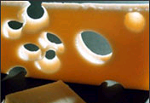
Mendeleev’s Periodic Table |  |  | Mendeleev’s Predictions (all pretty good!)
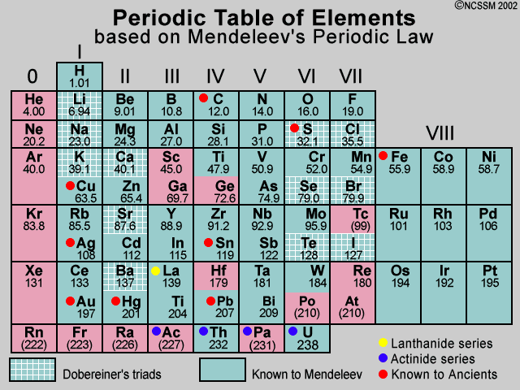 |  |  | 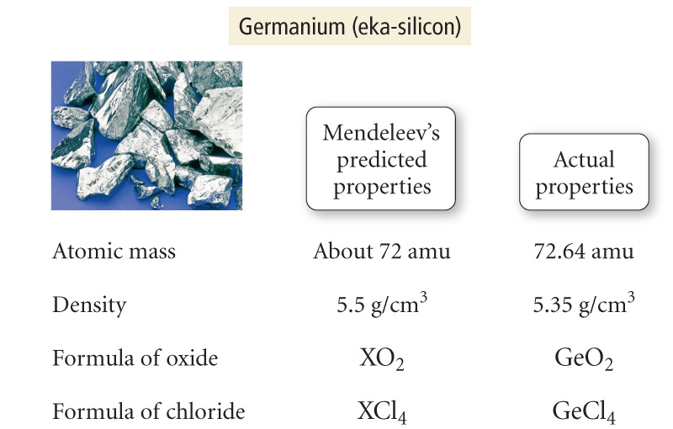
Overview of Periodic Trends

  ‘Popping the Hood’ |  Recall: The layout of the Periodic Table is directly correlated to the elements’ electronic structures.  Additional chemical and physical trends among the table’s constituents can be understood by ‘popping the hood’ on these elements and determining the relationship between atomic properties electronic structures

Essentially all periodic trends follow the same general ‘bottom left to top right’ scheme. See generic diagram the below. The periodic trends examined will be:
Electronegativity | Ionization Energy
Atomic Size (radius)* | Electron Affinity

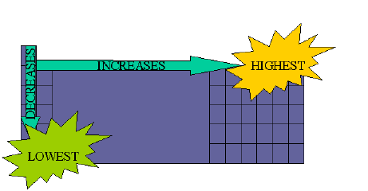

Question: Which ‘bottom left → top right trend’, mentioned above, have we already encountered? Is this a ‘real’ chemical trend?

Answer:
Trends in Electronegativity:
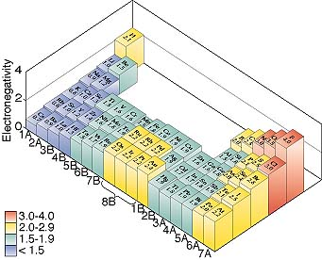
Note: Electronegativity is not a pure atomic property – it is a derived mathematically from electron affinity and ionization energy values

Discussion: What atomic scale factors do you think effect how strongly the nucleus ‘pulls’ on its ‘orbiting’ electrons (so, in turn, effecting each atomic property)? Hint: consider the analogy of the Earth and its satellites.

1.

2.

3.

 | Effective Nuclear Charge (Z_{eff}): The real ‘Man behind the Curtain’  Basic definition of Z_{eff}: The ‘pull’ orbiting valence electron(s) ‘feel’ from their respective positively charged nucleus, as modified by screening (core) electrons

Diagram

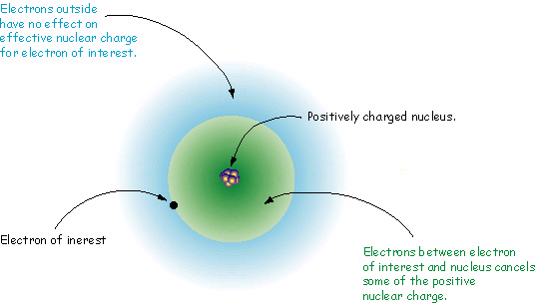

Equation:
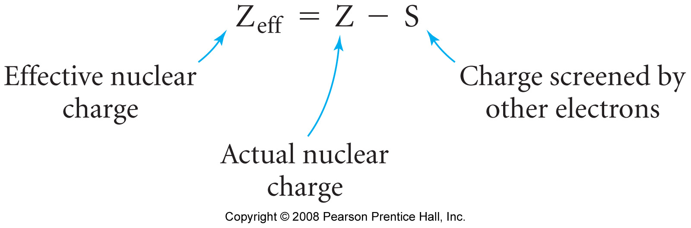
Example: Lithium

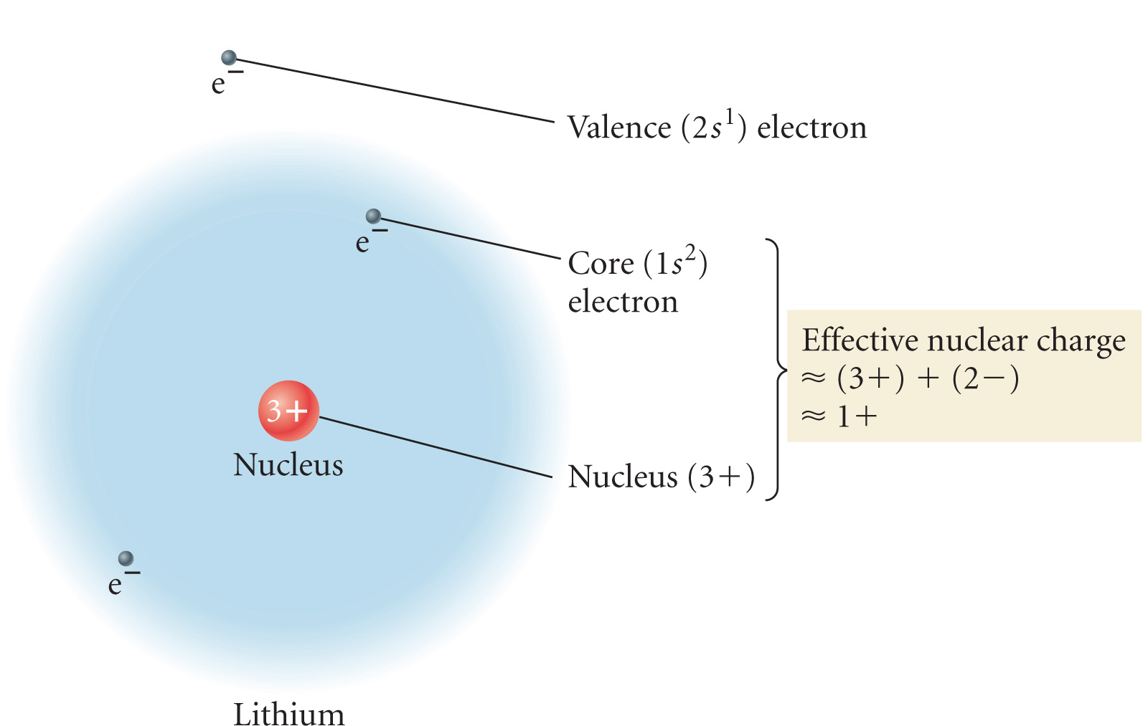

Lithium and Fluorine (example of a ‘row trend’):

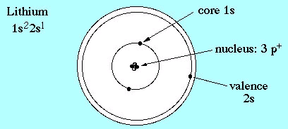 | 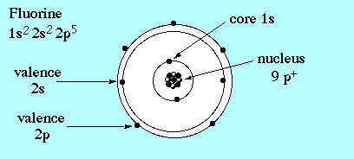
Z_{eff} = | Z_{eff} =

Fact: As Z (atomic number) increases ‘across a row’, the effect of shielding on the valence electrons AND their distance from the nucleus, remains ~constant.

Result: Effective Nuclear Charge (Z_{eff}) increases for each atom across every row in the Periodic table.
Graph of Z_{eff} vs Atomic Number

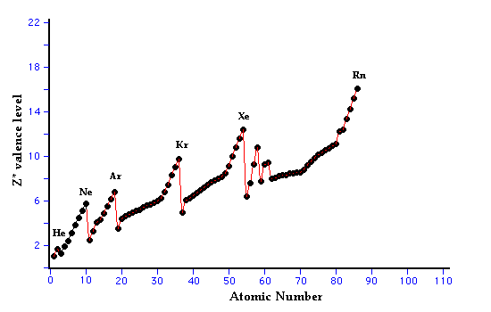
Features of the Graph:
 | Main  Subtle
‘Mesh shirt’ | Main  Subtle

Atomic Radius

Discussion: How and why do trends in Z_{eff} effect the size (radius) of atoms ‘across a row’ and ‘down a column’ in the periodic table.

1. ‘Across a Row’

2. ‘Down a Column’

Atomic Radius Trends
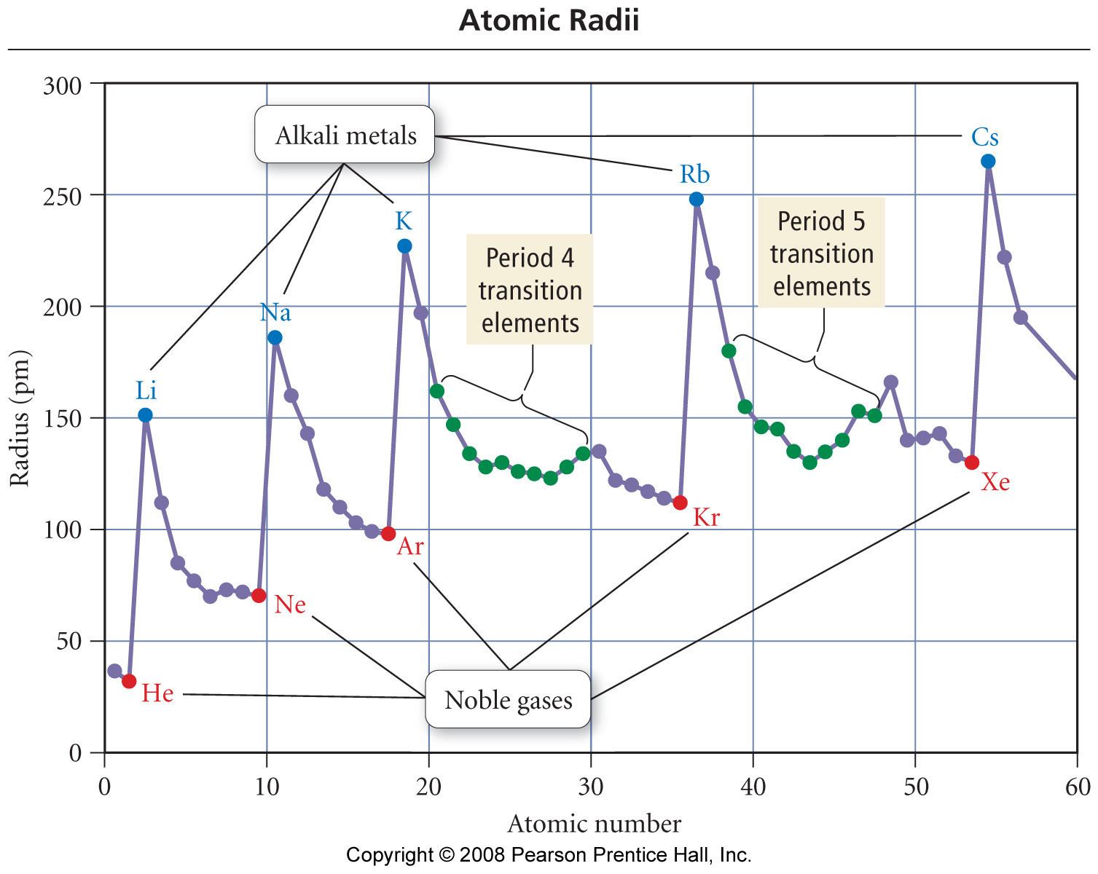

 | The atomic radii of the main group elements follow the classic ‘bottom left → top right’ periodic trend

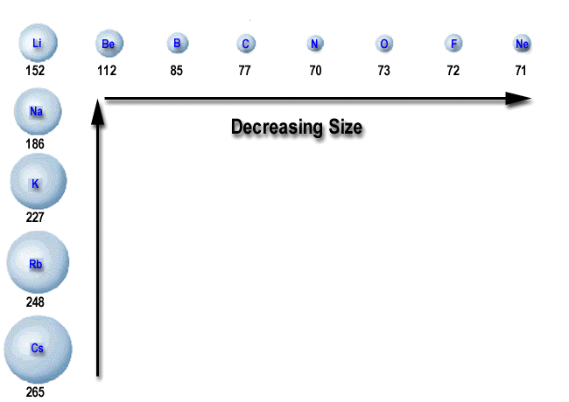 | 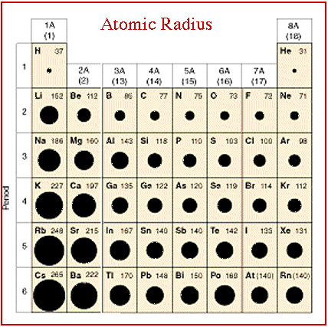

Typical Question: Arrange the following atoms in order of increasing atomic radii: Na, Be, Mg.

Questions of this type (as well as for other periodic trends) often select three elements from the periodic table that have a ‘triangular’ relationship.
Understanding the classic ‘bottom left → top right’ periodic trend allows for the answer to be determined.
 | Be
Na | Mg

Answer:

Ionization Energy

Discussion: What is ionization? What then is 1st ionization energy?

1st Ionization Energy: Energy required to remove the first electron from a gaseous atom or ion.

Example: Sodium

Na (g) → Na⁺ (g) + e⁻ ; I₁ = 496 kJ/mol

Task: Draw electron dot diagrams illustrating this process

Discussion: How do you think trends in Z_{eff} and atomic radius effect trends in 1st ionization energy ‘across a row’ and ‘down a column’ in the periodic table. Who wins!?

1. ‘Across a Row’

2. ‘Down a Column’

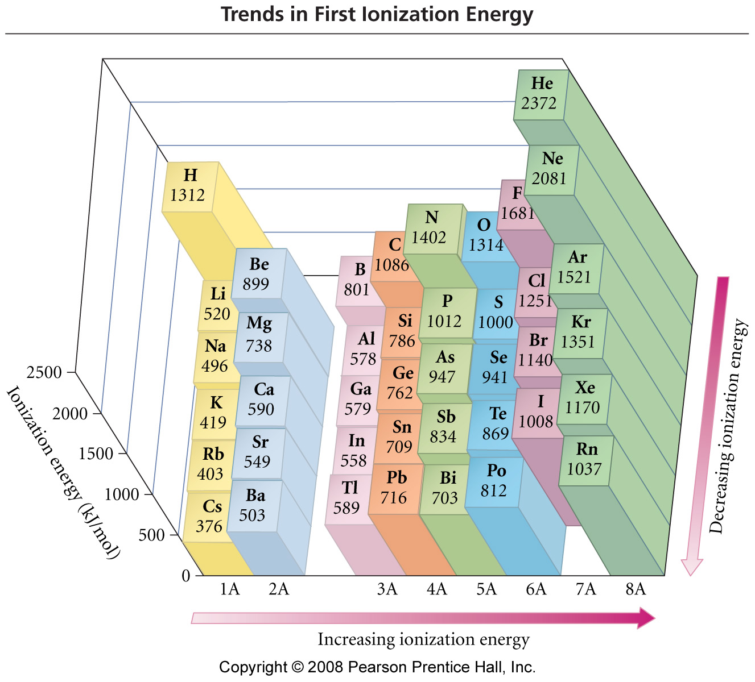

The 1st I.E. of the atoms generally follow the classic ‘bottom left → top right’ periodic trend*
Subtle Trends in 1st I.E.: How can subtle deviations (‘peaks’) from the general trend across any row be rationalized for the group II, III and group V, VI elements?
Task: Draw out ground state orbital ‘box’ diagrams for Be and B, as well as N and O. What differences do you notice between the two diagrams? How do these features correlate with the unexpected ‘peaks’.

‘Box’ Diagram for Be | ‘Box’ Diagram for B
  Be:
   | 1s |  | 2s |  | 2p
  B:
   | 1s |  | 2s |  | 2p

‘Box’ Diagram for N | ‘Box’ Diagram for O
  N:
   | 1s |  | 2s |  | 2p
  O:
   | 1s |  | 2s |  | 2p

Notes:

Removing electrons from full or half full (p or d) SUBSHELLS requires more energy than that required to remove electrons from ‘adjacent’ atom’s incomplete SUBSHELLS

Typical Question: Using only the periodic table as a guide, list the following atoms in order of increasing 1st ionization energy: O, N, Li, Na. Hint: consider both general and subtle trends.

Subsequent Ionization Energies

Discussion: What is the definition of second ionization energy (I₂)? Would you expect this value to be higher or lower than I₁ for Na? Why?

Na⁺ (g) → Na²⁺ (g) + e⁻ ; I₁ = _________ kJ/mol

Electron dot diagram:

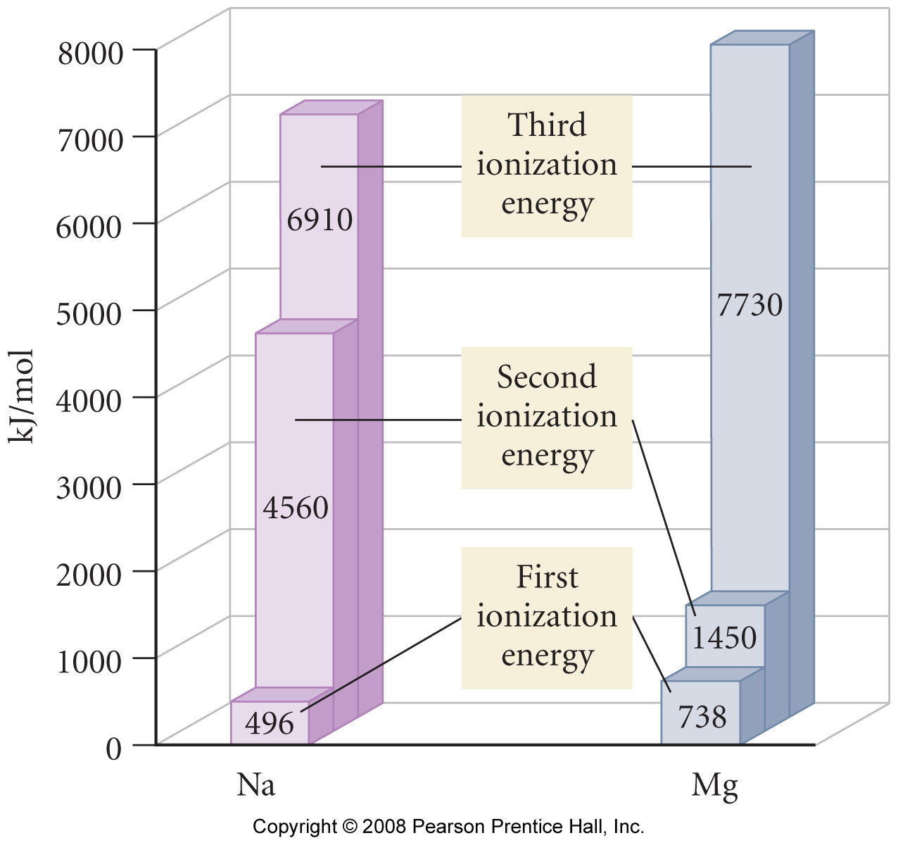 | Notes:

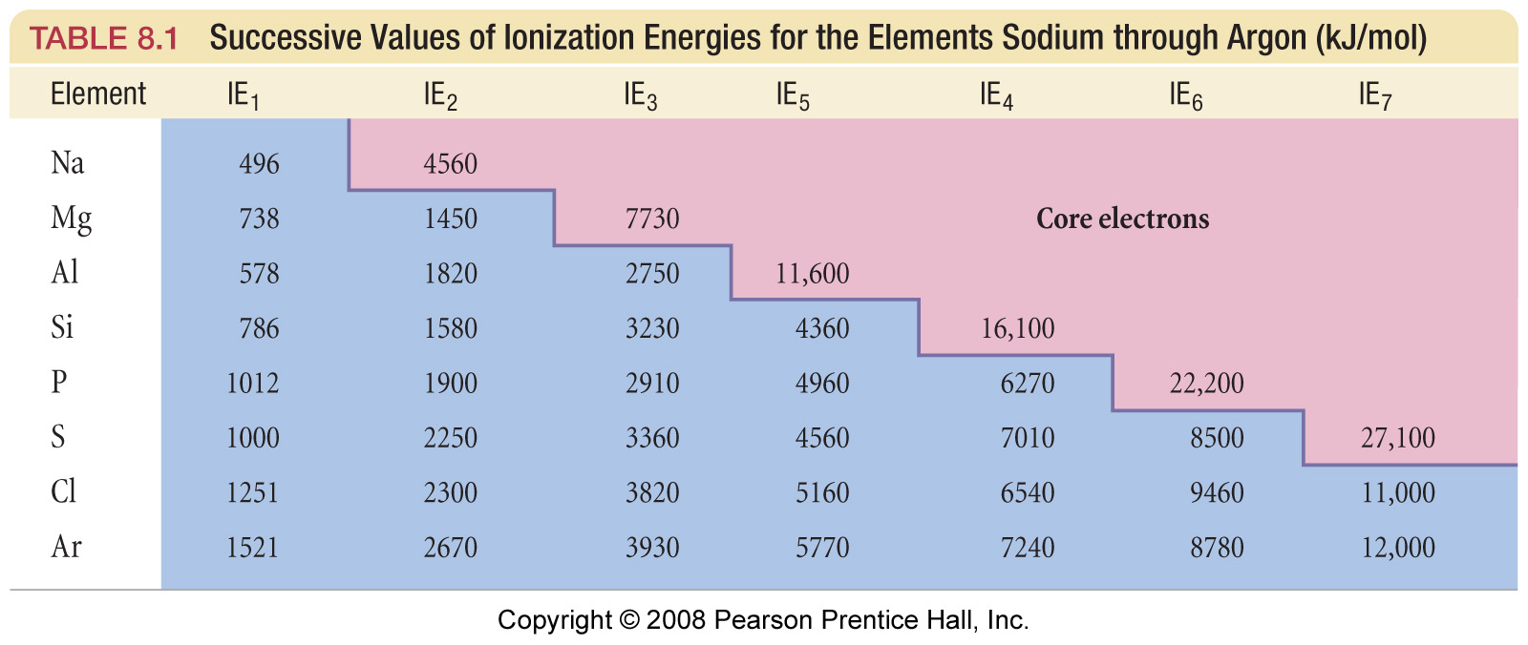
Electron Affinity

Discussion: What is electron affinity?

Electron Affinity: Energy released when an electron is added to a gaseous atom or ion.

Example: Chlorine

Cl (g) + e⁻ → Cl⁻ (g) ; ΔE = -349 kJ/mol

Task: Draw electron dot diagrams illustrating this process

Trends in Electron Affinity

Electron affinity and electronegativity are similar, except that electron affinity is measured experimentally, while electronegativity is determined mathematically.

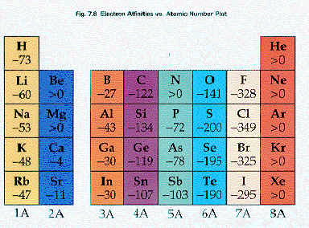 | 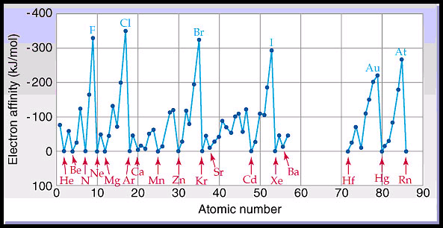
Periodic style representations of atomic electron affinity trends. Note both the general and
subtle features ‘across each row’
Discussion: Why do certain elements, such as Be, N, He and Ne, have negligible electron affinity values? Hint: draw out their respective ‘box’ diagrams
  Be:
   | 1s |  | 2s |  | 2p
  N:
   | 1s |  | 2s |  | 2p

  He:
   | 1s |  | 2s |  | 2p
  Ne:
   | 1s |  | 2s |  | 2p

Answer:

While electron affinity and electronegativity share a similar general periodic trend, ‘subtle’ subshell factors must also be taken into account with electron affinity

 | "Trends"  The following question was taken from your 3rd practice midterm:

List the following properties of Li, K and Ne in order of:

Increasing atomic radius (smallest first)

Increasing effective nuclear charge, Z_{eff}, (smallest first)

Decreasing 1st ionization energy (largest first)

Appendix:

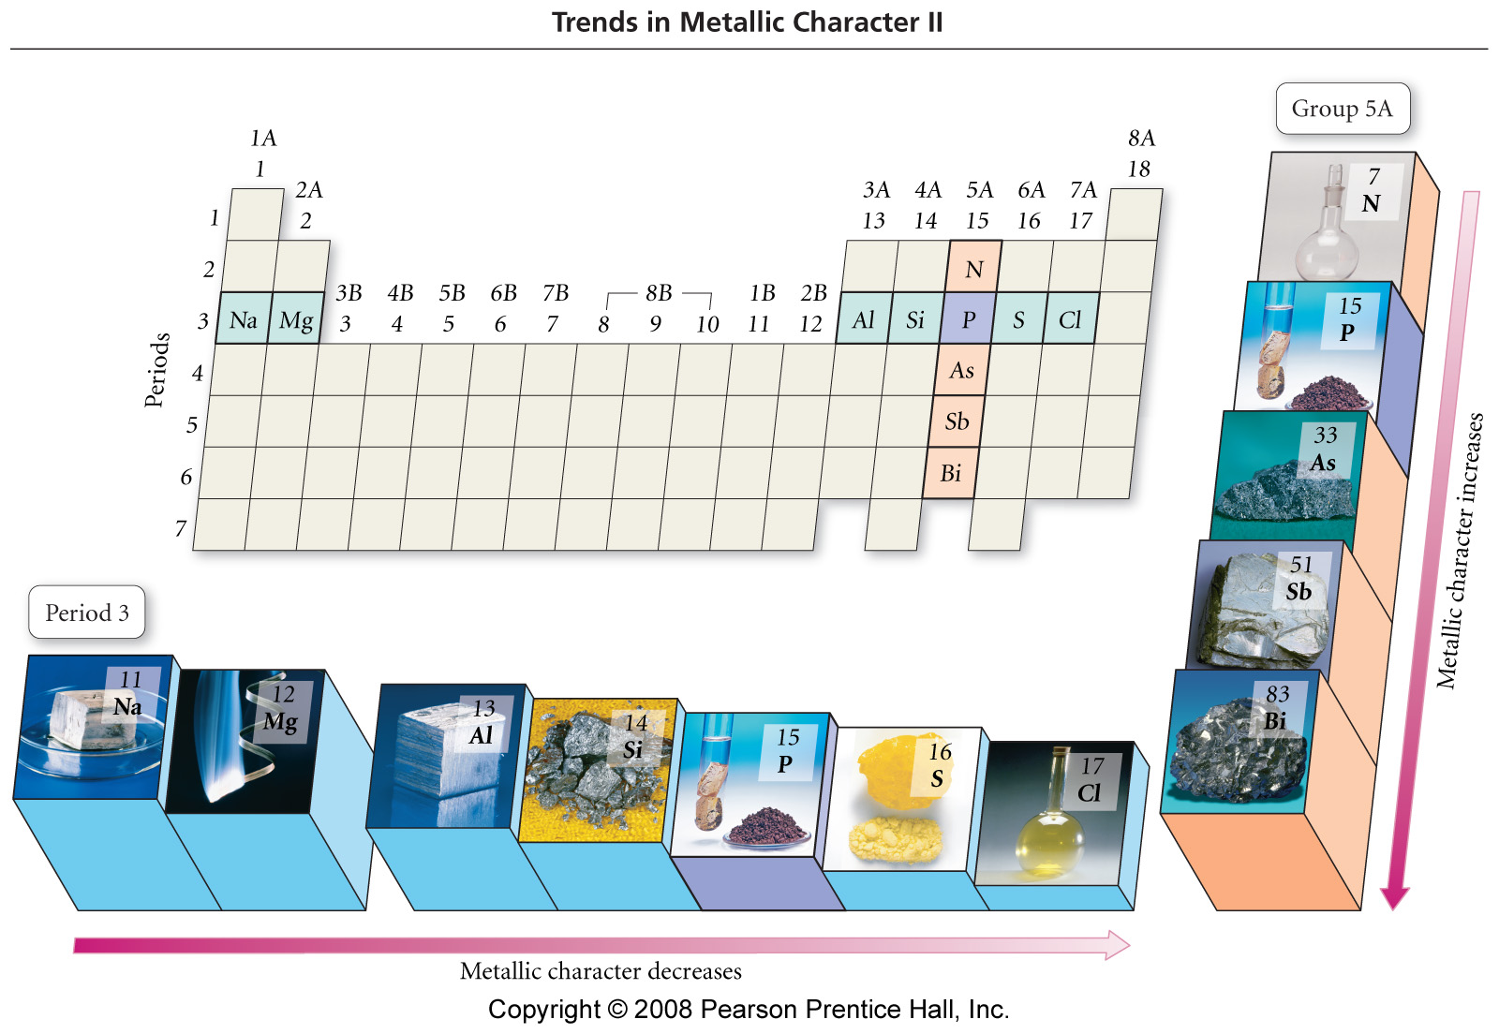

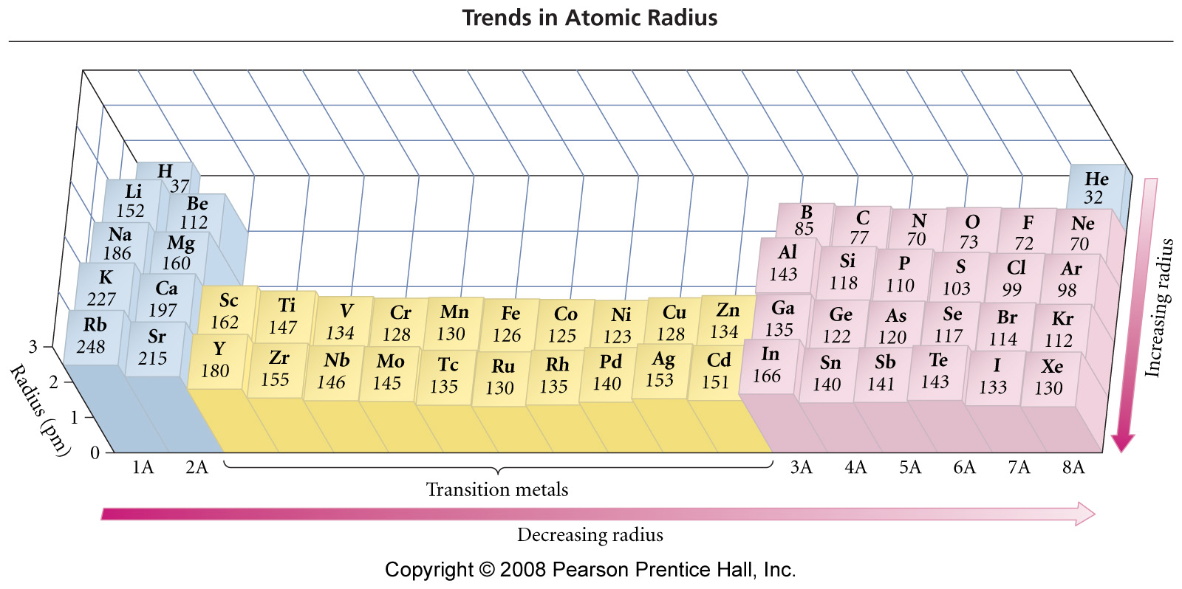
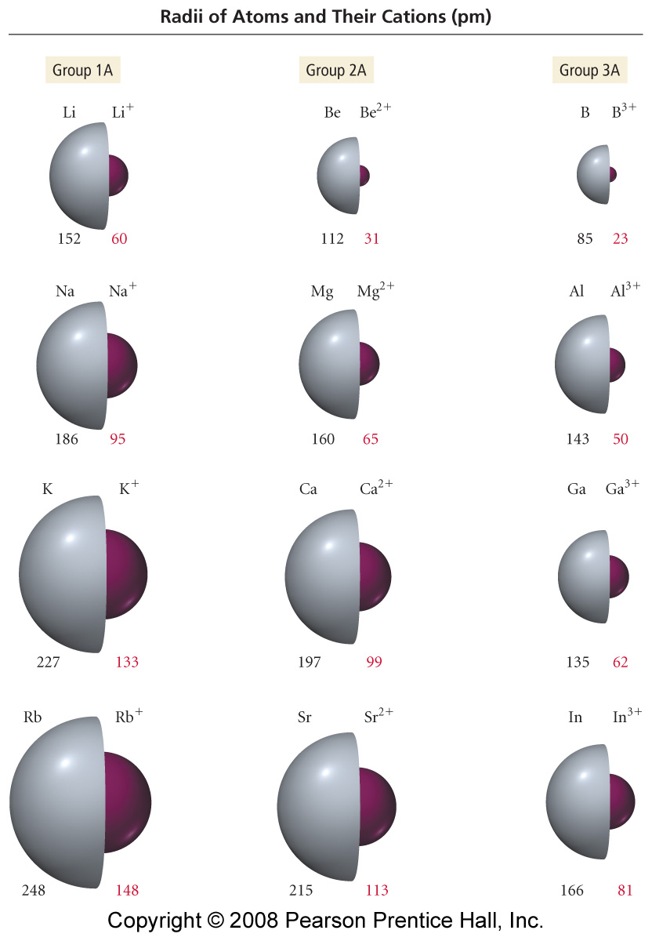 | 