REDOX Reactions

Reading: | Ch 4 section 9 | Homework: | Chapter 4: 87*, 89, 91*
* = ‘important’ homework question

Background

 | ‘REDOX’ reactions are chemical processes in which REDuction and OXidation simultaneously occur  Oxidation Is Loss of electrons. An element or compound that loses electron(s) during a chemical process is said to be OXIDIZED  Reduction Is Gain of electrons. An element or compound that gains electron(s) during a chemical process is said to be REDUCED

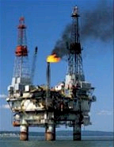 | TRICK: Remembering the difference between oxidation and reduction is easy, just remember….  OIL RIG of electrons  Oxidation Is Loss, Reduction Is Gain of electrons

Overview Example of a Simple REDOX (combustion) reaction:

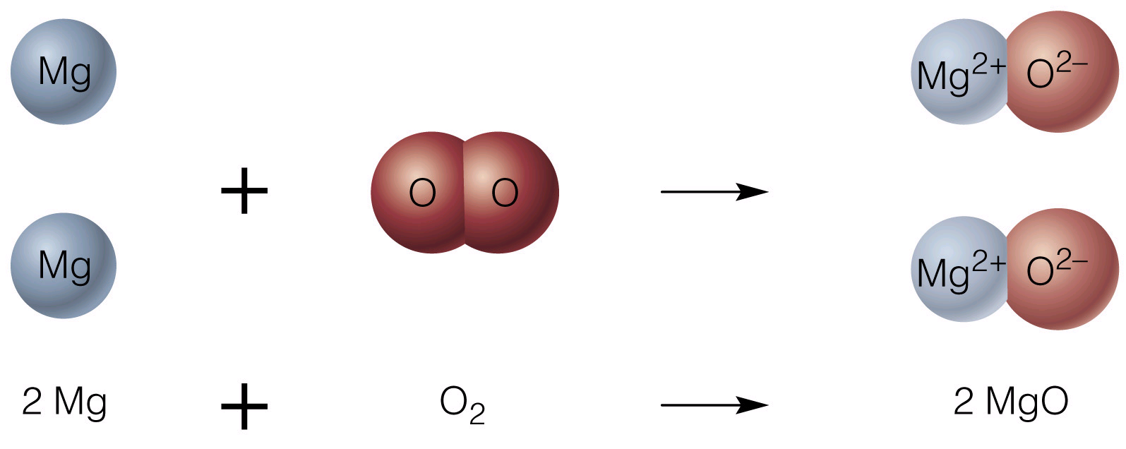

Discussion: Which chemical species has lost electrons during this process (i.e. been oxidized)? Which has gained electrons (been reduced)? How can you figure this out?

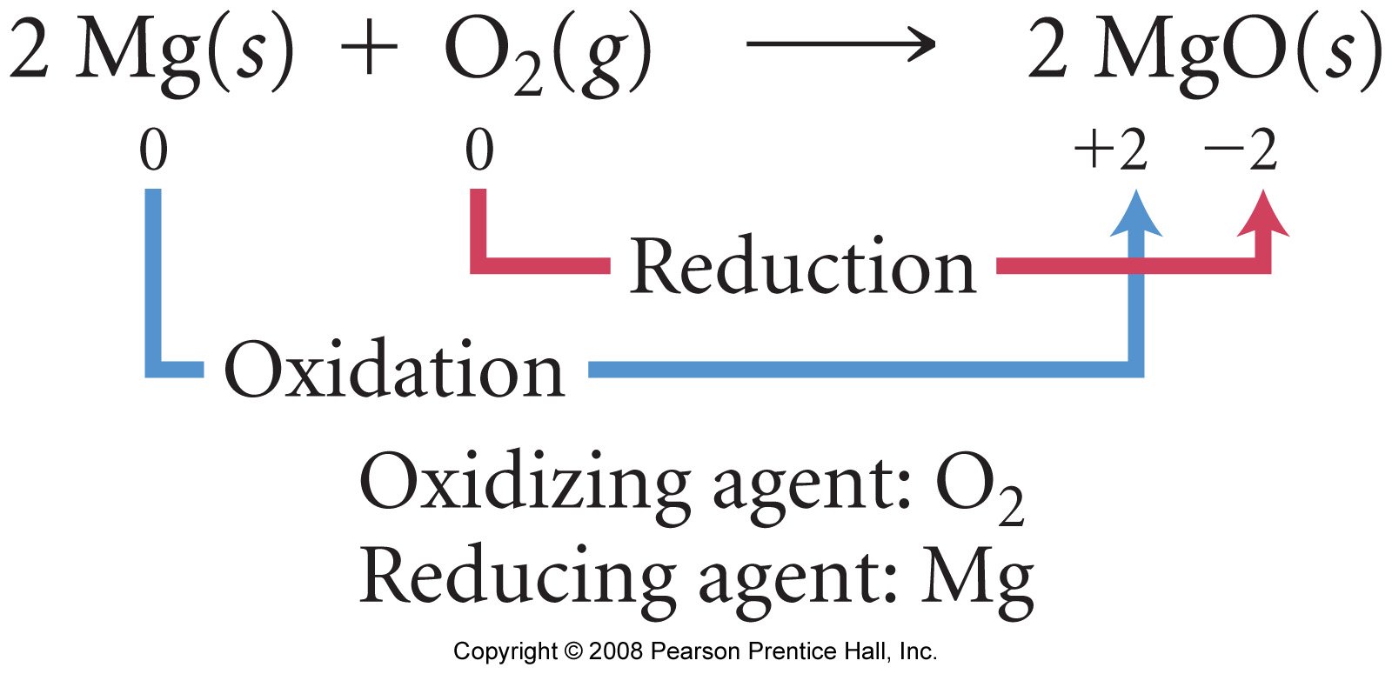

Oxidized SPECIES = | Oxidizing AGENT =
Reduced SPECIES = | Reducing AGENT =

Notes
Oxidation Numbers

Oxidation Number or Oxidation State – the ‘charge’ on an atom in a substance as if it were a monatomic ion

A change in oxidation state during a chemical process indicates that a specie has either been oxidized (number goes up), or reduced (number goes down). Recall the previous MgO example.

Rules for assigning oxidation numbers

1. For materials that form atomic ions, the oxidation state is the same as the ‘regular’ ionic charge

Task: State the oxidation state of the following:

Na in NaCl |  | Cl in AlCl₃
Mg in MgCl₂ |  | Fe in Fe₂O₃

 | Since you know the charge of a great many atomic ions, you also know their oxidation states, i.e.:  Note: Oxidation states / numbers are expressed with Roman Numerals (this differentiates them from ‘pure’ ionic charges)
  Group I = I (Li⁺, Na⁺…)  Group II = II (Mg²⁺, Ca²⁺…) | Group VII = -I (F⁻, Cl⁻…)  Group VI = -II (O²⁻, S²⁻…)

2. For ANY elemental atom, its oxidation state is ZERO. Why?

E.g. Elemental chlorine, Cl₂ ( Cl ― Cl )

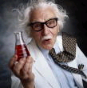 | 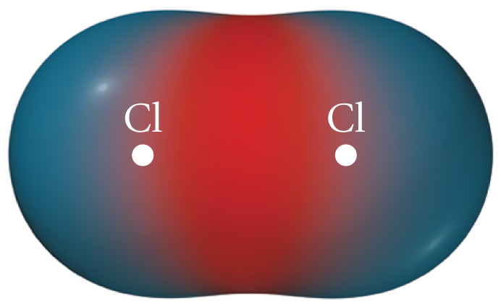 | 

Hint: Recall the trend in Electronegativity values (see appendix)

Any atom bonded to other identical atom(s) must have an oxidation state (oxidation number) of ZERO
ALL ELEMENTS must by definition posses zero oxidation states

Examples: Any diatomic element (O₂, F₂), any metallic element (Pb(s), Al(s)) etc.

3. All other atoms’ oxidation states must be determined mathematically using the ‘Sum of Oxidation States’ Rule:

For molecules: The sum of the molecule’s component atoms individual oxidation numbers = ZERO

Example: Nitric acid, HNO₃

For polyatomic ions (‘charged molecules’): The sum of the polyatomic ion’s component atoms individual oxidation numbers = overall ionic charge

Example: The nitrate ion, NO₃⁻

Exceptions:

Oxygen always has a -II oxidation state, except when bonded to either fluorine or itself. Why? Hint: Think of the periodic trend in electronegativity (appendix).

Examples:

H₂O₂ | OF₂

F always has a –I oxidation state, except when bonded to itself. Other Halogens (Cl, Br, I) are also –I, except when bonded to F or O. Why?

Examples:

ClO₂ | ClO₃⁻

More Examples: Calculate the oxidation state of:

S in SO₃ | Xe in XeF₆
S in SO₄²⁻ | Cr in CrO₄⁻
Na in NaH (Hint: think electronegativity) | N in Mg₃N₂
Understanding REDOX reactions

Since ‘battery’ and single replacement reactions are examples of REDOX processes, oxidation numbers can be assigned.

Comparing oxidation numbers of reactants and products shows which species have been oxidized and which reduced.

Example: Zn/Fe²⁺ ‘battery’ style REDOX reaction

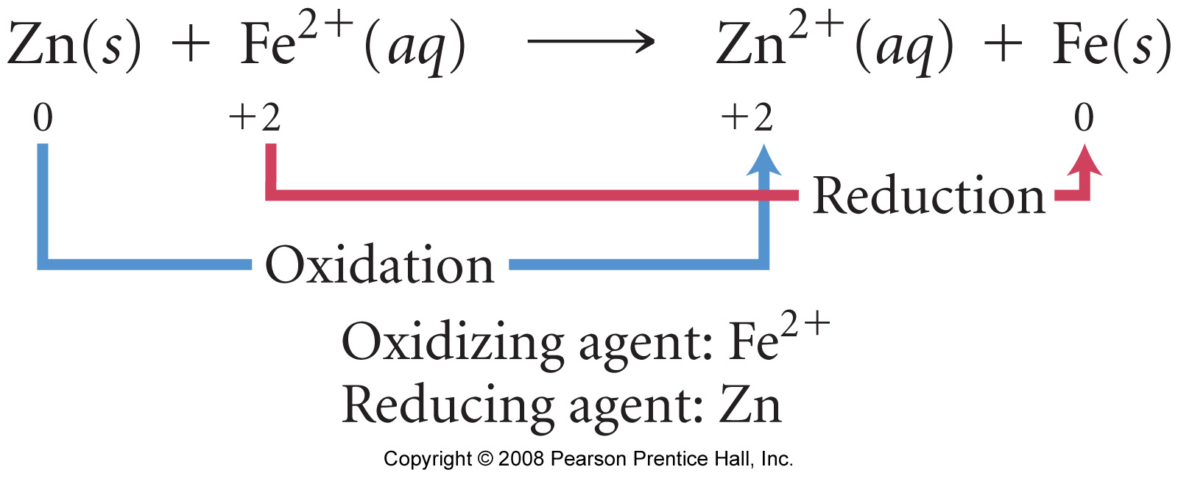

Recall: For single replacement (‘prom’) reactions, the more reactive specie (A) undergoes oxidation when replacing the less reactive one (B), which is reduced.

A + BX → AX + B

Example:

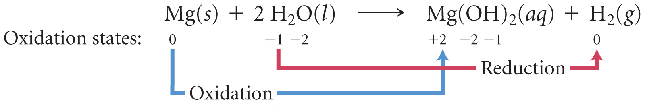
Tasks:

Assign oxidation numbers to the reactants and products in the following examples. State which specie is oxidized and which is reduced in each case.

Zn (s) + Cu²⁺ (aq) → Cu (s) + Zn²⁺

Ca (s) + 2 HCl (aq) → CaCl₂ + H₂ (g)

Fe (s) + Ni(NO₃)₂ (aq) → Ni (s) + Fe(NO₃)₂ (aq)

SO₃ (g) + H₂O (l) → H₂SO₄(aq)

Appendix: Electronegativity values



