Acid – Base Reactions

Reading: | Ch 4 section 8 | Homework: | Chapter 4: 79, 81*, 83*, 108 (optional)
* = ‘important’ homework question

Background

Recall: Acids and bases are ‘special’ in two ways:

What is special about their formulas?

Acids: | Bases:

What is special about the state of matter they (typically acids) exist as in the: (a) pure and (b) aqueous (dissolved) states?

Pure: | Dissolved (aq):  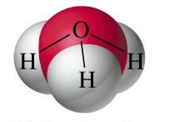

Task: Write formulas for the following common lab reagents:

Hydrochloric acid |  | Sodium hydroxide
Nitric acid |  | Calcium hydroxide
Sulfuric acid |  | Potassium hydroxide
Assuming each of the above is of the same concentration, which acid and which base are the ‘strongest’? Why?
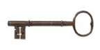 | Monoprotic acids dissociate to give 1 H⁺(aq) ion per formula unit  e.g.: HCl, HNO₃  Diprotic acids dissociate to give 2 H⁺(aq) ions per formula unit  e.g. H₂SO₄

Details: Polyprotic acids undergo sequential dissociation when dissolved in water. For Sulfuric acid:

H₂SO₄(aq) → H⁺ (aq) + HSO₄⁻ (aq)

HSO₄⁻ (aq) → H⁺ (aq) + SO₄²⁻ (aq) | +

(Combine theequations to obtain the overall reaction for the dissolution of Sulfuric acid)

Similarly….

Monobasic alkalis dissociate to give 1 OH⁻(aq) ion per formula unit e.g.: NaOH, KOH

Dibasic alkalis dissociate to give 2 OH⁻(aq) ions per formula unit
e.g. Ca(OH)₂

Example: The dissociation of calcium hydroxide

Strong and Weak Acids and Bases (recall previous packet)

Strong (mineral) acids undergo complete (~100%) dissociation, so give a high conc. of H⁺(aq) ions in solution. E.g. HCl, HNO₃

Weak (organic) acids undergo partial (<<100%) dissociation, so give a low conc. of H⁺(aq) ions in solution E.g. H(C₂H₃O₂)

Discussion: A student measured the pH of equal volumes of 0.5 M HCl (hydrochloric acid) and 0.5M HC₂H₃O₂ (acetic acid). Which solution would you expect to have the lower pH (i.e. the highest conc. of H⁺ (aq) in solution)? Hint: Recall analogous ICF tables for strong and weak electrolytes.
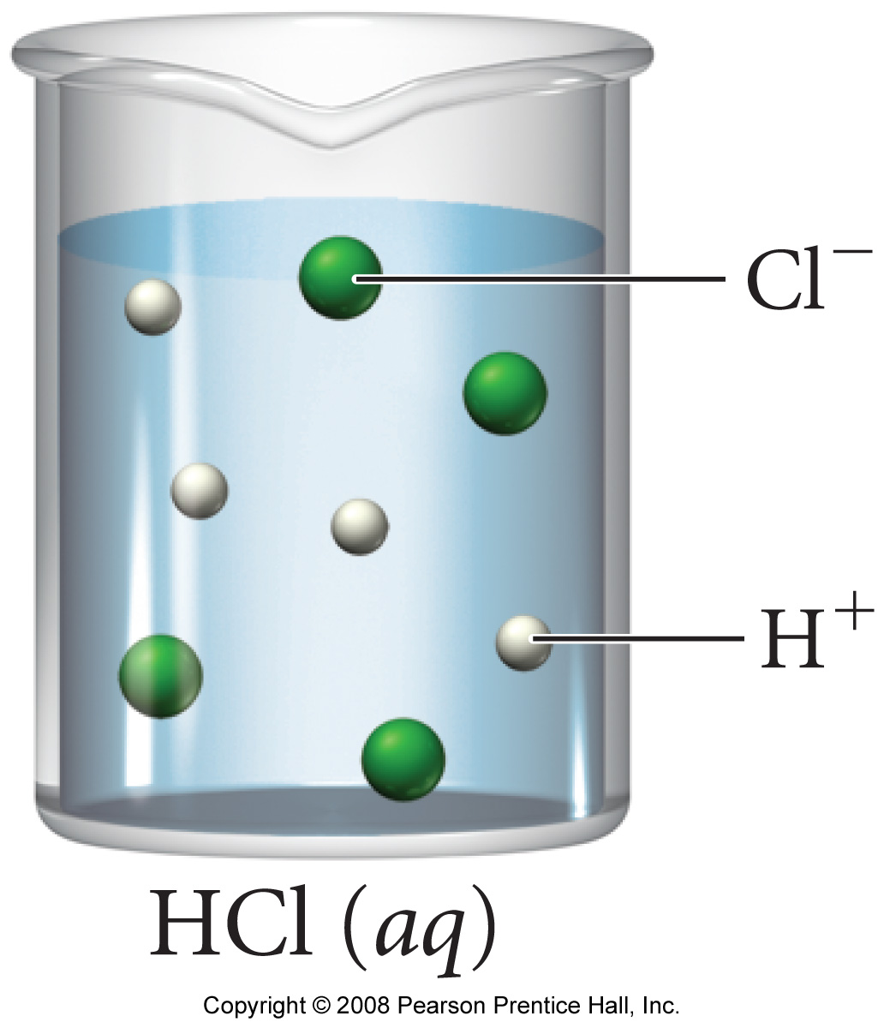 | 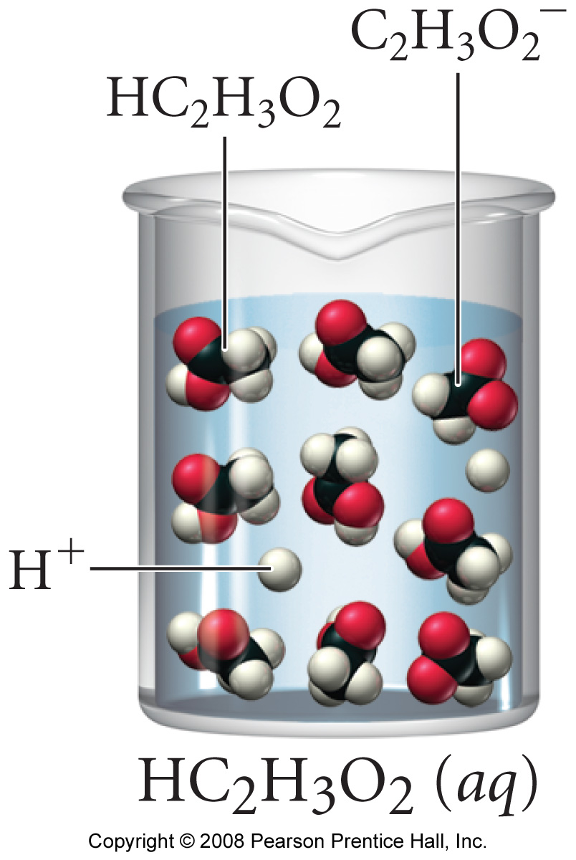

 | Strong (mineral) acids and bases give the best ‘bang for the buck’ (most H⁺(aq) or OH⁻(aq) ions respectively in solution per formula unit), so are used as lab reagents.
OK, what about weak bases then….

Case study: The weak base, aqueous ammonia (NH₃ (aq))

Background: You may have noticed in lab that aqueous ammonia is used as a ‘gentle’ base, (i.e. it is a weak base). How can this be? Can NH₃ (aq) dissociate to give OH⁻ (aq) ions??

Answer:

Explanation:

Equation:

Task: Write a ICF table for a solution of NH₃ (aq) that is ‘10% basic’

Eqn.
I
C
F

Neutralization Reactions

Recall: Acids and bases react with each other (often via a titration) in a ‘special’ double replacement reaction called a neutralization reaction.

Word Equation:

Generic Equation:

Task: Write balanced, complete and net ionic equations for the reaction of hydrochloric acid solution with sodium hydroxide solution.

Summary

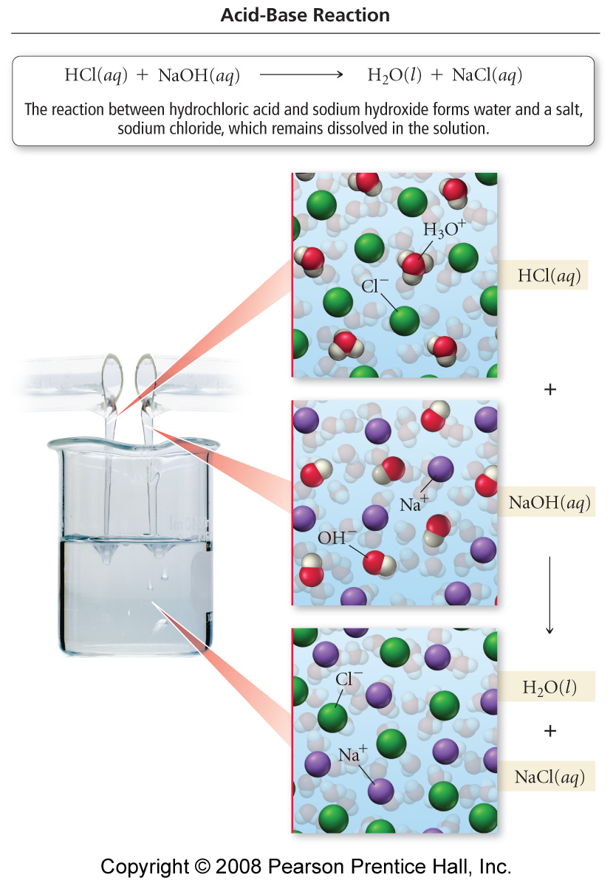

Review of Titrations

In practice, an acid sol^{n} (eg. HCl) is placed in a flask, with a few drops of an indicator, and then titrated with a base sol^{n} (eg. NaOH) via a buret:

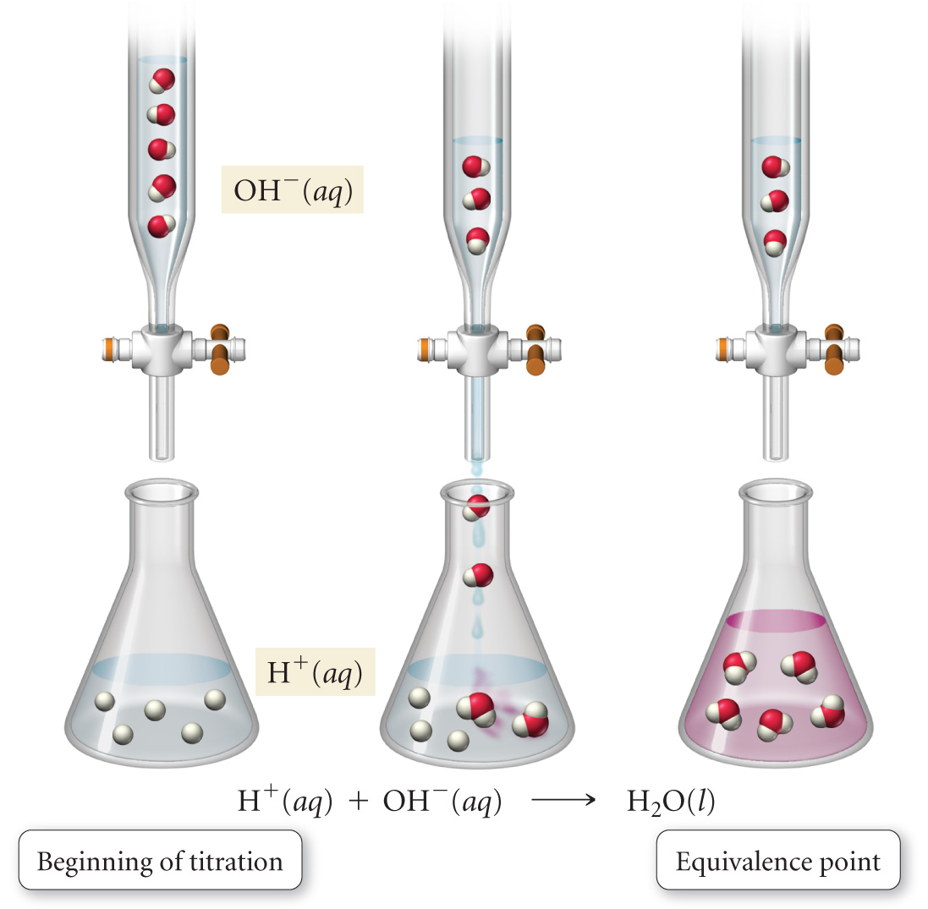

The equivalence point of any acid plus base titration (reaction) is reached when:

Moles acid (H⁺) = Moles base (OH⁻)
i.e. when (for a pair of mono reagents):
C_{acid} V_{acid} = C_{base} V_{base}

The indicator in an acid base titration changes color at the equivalence point – i.e. where the moles of acid (H⁺) is equivalent to the moles base (OH⁻) added – this is when you stop the buret!!

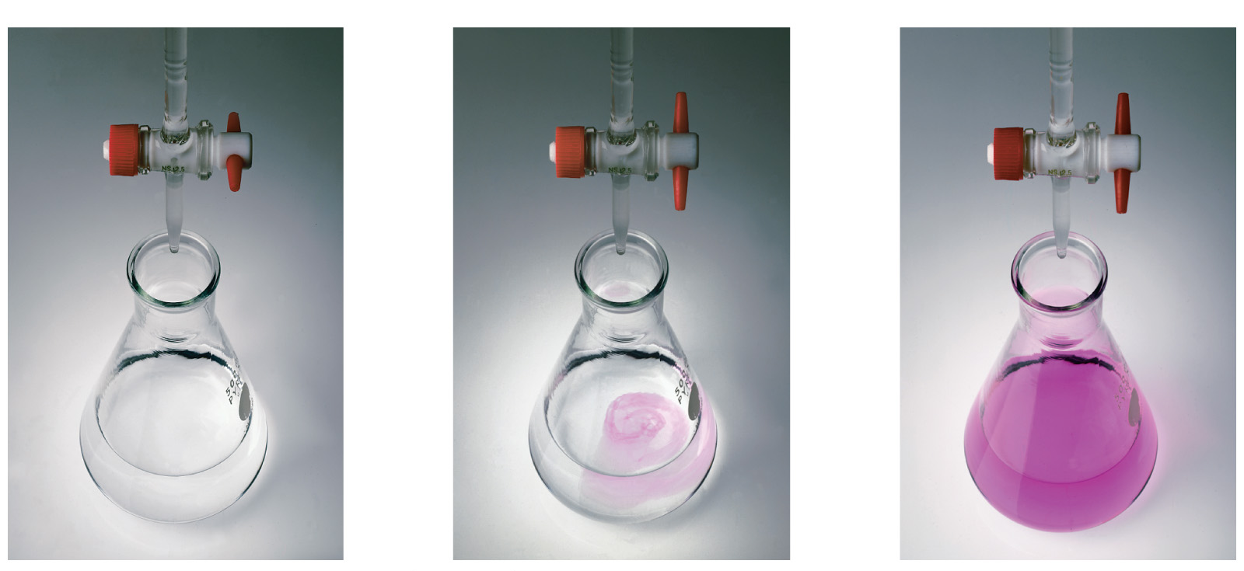

Titrations are just a specific application of slides and ladders – the reactants are always an acid and a base (while the products are always a salt and water)

Example: What volume of 0.128 M HCl (aq) is needed to neutralize 2.87 g of Mg(OH)₂ ? Careful! – the alkali is dibasic.
__ HCl (aq) + __ Mg(OH)₂ (s) → __ MgCl₂ (aq) + __ H₂O (l)

Acid plus Carbonate Reactions

An acid plus carbonate reactions always produce a salt, water and carbon dioxide gas. The word equation is:

ACID + CARBONATE → SALT + WATER + CO₂ (g)

Example question: Write an equation illustrating the reaction between solid calcium carbonate and hydrochloric acid solution*.

*See the ‘Aqueous Reactions’ notes for details on a slides and ladders exercise using this equation

Details: ‘Acid plus carbonate’ reactions are really a sequential double replacement / decomposition series:

Task: Balance and then combine the double replacement and decomposition reactions featured in the above example:

__ HCl (aq) + __ CaCO₃ (s) → __ CaCl₂ (aq) + __ H₂CO₃ (aq)

__ H₂CO₃ (aq) → __ H₂O (l) + __ CO₂ (g) | +

