Acid - Base Equilibria 2

Reading: | Ch 15 sections 8 – 12 | Homework: | Chapter 15: 41, 57, 61*, 63, 65*, 67*, 73*, 85, 87*, 89, 91
* = ‘important’ homework question

Weak Acids

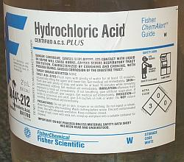 | 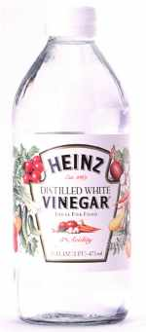 | Review / Discussion: What is ‘stronger’ – HCl (aq) or vinegar (acetic acid)? What are the differences?

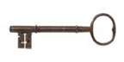 | Strong (mineral) acids, such as HCl, dissociate completely in water:  Weak (organic) acids undergo partial dissociation in water (much more on this later):

 | Because any weak acid and its respective dissociation products (H⁺ and conjugate base) are in equilibrium, ‘equilibrium math’ can be used to define K

Task: Determine an equilibrium expression (K) for the generic weak acid equilibrium:

HA (aq) | + | H₂O (l) | ⇔ | H₃O⁺ (aq) | + | A⁻ (aq)
Weak Acid |  | Water |  | Hydronium ion |  | Conjugate Base

Note: Since, in this case, K pertains to the dissociation of a weak acid only, it is called the acid dissociation constant and assigned a suitable subscript:
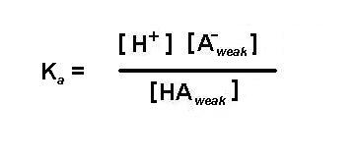
Discussion: Will strong acids (like HCl) have large or small values for K_{a}? Will weak acids (like acetic acid) have large or small values for K_{a}?

Task: Complete the following table:

Acid | Type | Reaction with water | K_{a}
HCl | strong | HCl (aq) → H⁺ (aq) + Cl⁻ (aq) | ‘∞’
HNO₃

HF |  |  | 6.8 x10⁻⁴
HC₂H₃O₂  (acetic) |  |  | 1.8 x10⁻⁴
HCN |  |  | 4.9 x10⁻¹⁰

Discussion: Of all the weak acids listed above, which is the ‘strongest’, weakest? Why?

The Relationship Between K_{a} and pH

 | Overview: Since any weak acid is in equilibrium, a modified I.C.E. method can be used to determine either pH or K_{a}  Vanilla I.C.E., noted chemical philosopher

Worked Example: A sample of 0.10 M formic acid (HCHO₂) has a pH of 2.38. Determine K_{a} for formic acid and the % to which formic acid is dissociated.

Plan:

- Find [H⁺]

- Set up and solve an I.C.E. table in order to find the equilibrium concentrations of HA, H⁺, A⁻. ‘Insert and evaluate’ to find K_{a}

- Find % dissociation

Using K_{a} to find pH (the ‘reverse’ problem)

Question: What is the pH of 0.2 M HCN (aq) (K_{a} = 4.9 x10⁻¹⁰)

Plan:

Execution:

IMPORTANT: The weak acid approximation: when K_{a} ≤ 10⁻³

[HA] – [H⁺] ≈ [HA]

This greatly simplifies the I.C.E. method, which is usually not undertaken unless the above is true (would otherwise require a quadratic equation to be solved)

Group work: Skip ahead to the end of this handout and work through the first two practice exam problems

Weak Bases

Weak base problems are very similar to the I.C.E. weak acid examples, except that [OH⁻] and pOH (rather than [H⁺] and pH) are found initially

Generic Equilibrium:

B (aq) | + | H₂O (l) | ⇔ | HB(aq) | + | OH⁻ (aq)
Weak base |  | Water |  | Conjugate Acid |  | Hydroxide ion

For ammonia dissolved in water:

NH₃ (aq) + H₂O (l) → NH₄⁺ (aq) + OH⁻ (aq)

Task: Determine K for the above ammonia equilibrium

Note: Since, in this case, K pertains to the dissociation of a weak base only, it is called the base dissociation constant and assigned a suitable subscript:

Task: Complete the following table:

Base | Type | Reaction with water | K_{a}
NaOH | strong | NaOH (aq) → Na⁺ (aq) + OH⁻ (aq) | ‘∞’
KOH

NH₃ |  |  | 1.8 x10⁻⁵
HS⁻ |  |  | 1.8 x10⁻⁷
CO₃²⁻ |  |  | 1.8 x10⁻⁴

Discussion: Of all the weak bases listed above, which is the ‘strongest’, weakest? Why?

Example: Find [OH⁻] and pH for 0.15 M NH₃ solution (K_{b} = 1.8 x10⁻⁵)

Plan:

Recall that [OH-] and pOH can be found initially, then pH can be determined via:
pH + pOH = 14

Execution:

Group Task: An NH₃ (aq) solution has a pH of 10.50. What is [NH₃] in this solution?

The Relationship between K_{a} and K_{b}

Recall: All weak acids and bases are in equilibrium with their respective conjugates. Each will also have an equilibrium (K) expression, e.g.:

NH₄⁺ (aq) → H⁺ (aq) + NH₃ (aq); K_{a} =

NH₃ (aq) + H₂O (l) → NH₄⁺ (aq) + OH⁻ (aq); K_{b} =

‘Equilibrium constant math’ can be applied to the above pair of equations.

Task: Add the above equations and find an expression for K in terms of K_{a} and K_{b}. Do you notice something familiar?

For any weak acid or weak base:

K_{a}K_{b} = K_{w} = 1 x 10⁻¹⁴ = [H⁺][OH⁻]

Also, since K_{a}K_{b} = K_{w}:

pK_{a} + pK_{b} = pK_{w}

Quick Question: What is K_{a} for NH₃ (aq)?

Group work: Skip ahead to the last page of this handout and work through the practice exam problem ‘Weak Base’
“What’s the pH?”

Question 2 (25 points): Calculate the pH of each of the following solutions:

- 0.015 M HCl (aq) (assume complete dissociation)

- 0.015 M H₂SO₄ (aq) (assume complete dissociation)

- 0.015 M NaOH (aq) (assume complete dissociation)

- 0.015 M HC₂H₃O₂ (aq), K_{a} = 1.8 x 10⁻⁵
“Weak Acid”

Question 3 (25 points): A 0.200 M solution of a weak acid HA (aq) is 9.4 % ionized (dissociated) at equilibrium. Use this information to calculate [H⁺], [HA] and K_{a} for HA.

“Weak Base”

Codeine (C₁₈H₂₁NO₃) is a weak organic base. A 5.0 x 10⁻³ M solution of codeine has a pH of 9.95.

Question 4a (20 points): Calculate K_{b} for codeine.

Question 4b (5 points): Calculate pK_{a} for codeine.

Appendix:

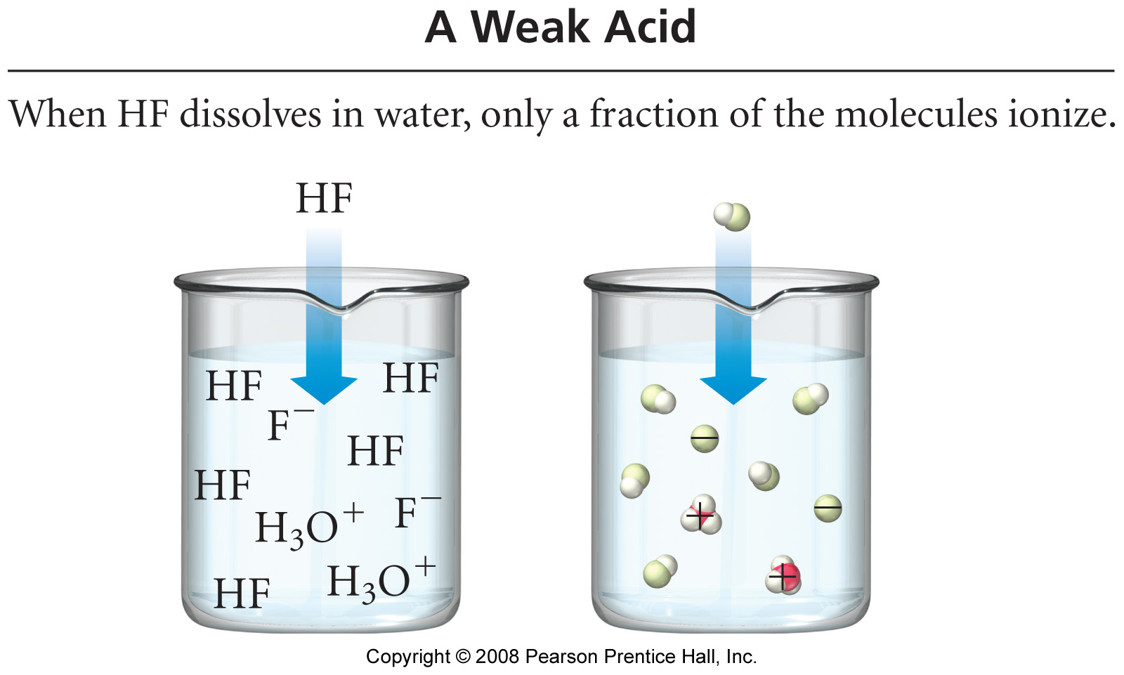

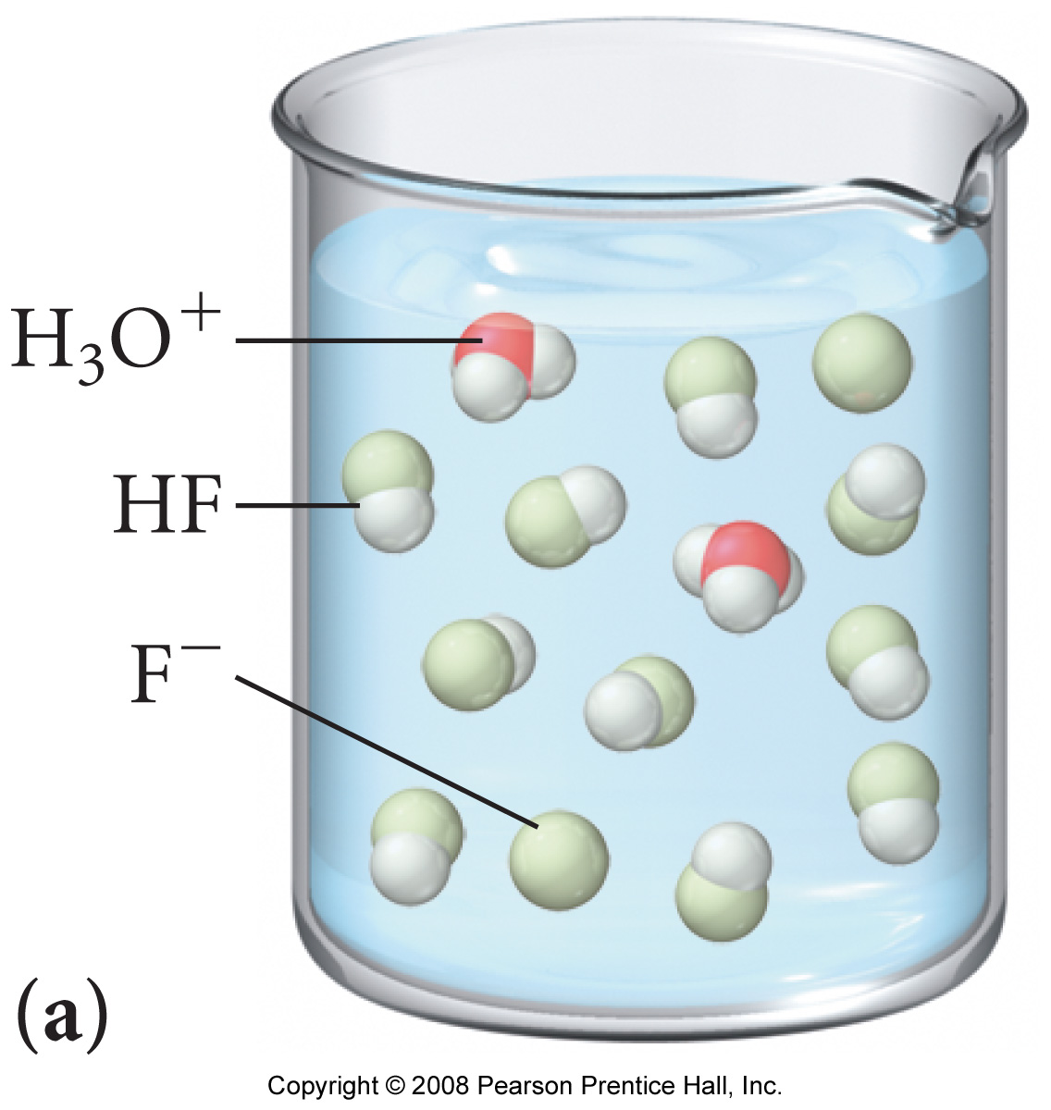 | 

