Acid - Base Equilibria 3

Reading: | Ch 15 sections 8 – 9  Ch 16 sections 1 – 7 | Homework: | Chapter 15: 97, 103, 107,  Chapter 16: 29*, 33*, 35, 37*, 39*, 41, 43*, 49, 55, 57, 61, 65, 81, 85*, 87*, 89*, 93, 95*, 101, 103
* = ‘important’ homework question

Additional Aspects of Acid-Base Equilibrium

Salts and Polyprotic Acids

Discussion: What happens, on a molecular level, when sodium acetate (or any salt of a weak acid and a strong base) is dissolved in water?

Equation 1:

Would you expect the resulting solution to be acidic, basic or neutral? What’s the trick??
(K_{a} HC₂H₃O₂ = 1.8 x 10⁻⁵).

Equation 2:

Task: Calculate the pH of a solution made by dissolving 10.0 grams of NaC₂H₃O₂ (s) in water, making the final solution volume equal 1.0 L

Discussion: What is the difference between a monoprotic and a polyprotic acid? Give an example of each.

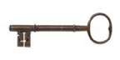 | Recall your lab: Polyprotic acids are amphoteric, so will have several equivalence points when titrated - each acidic proton is either removed (NaOH titration of the acid form) or added (HCl titration of the base form).  Each deprotonation step will have a specific K_{a} (or pK_{a}) value associated with it (see slide / handout)

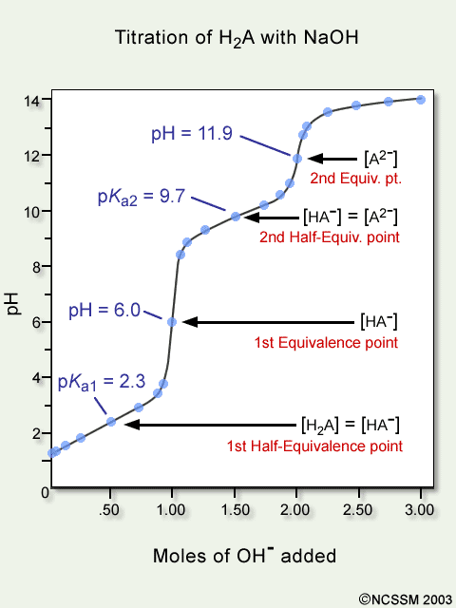 | Equivalence Point 1  H₂A ⇔ H⁺ + HA⁻  pK_{a1} = 2.3  K_{a1} = ________________  Equivalence Point 2  HA⁻ ⇔ H⁺ + A⁻  pK_{a2} = 9.7  K_{a2} = ________________  Note: Titration plots can be used to determine K_{a} values – this will be covered in more detail below.

Generic titration plot for a diprotic acid (H₂A) with a strong base

Questions: Which indicators would be best for detecting the two titration endpoints, observed for H₂A (above), when this diprotic acid is titrated with NaOH (aq)? What color changes would be observed?

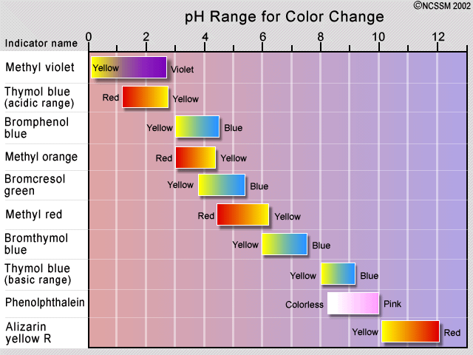

The common Ion effect

Consider the following equilibrium for acetic acid:

HC₂H₃O₂ (aq) ⇔ H⁺ (aq) + C₂H₃O₂⁻ (aq)

Discussion: according to Le Châtelier’s Principle, what would happen to the position of the above equilibrium if a large amount of C₂H₃O₂⁻ (aq) (from, for example, NaC₂H₃O₂) were added?

Your description:

 | (an unnecessarily wordy) Dictionary Description  The extent of ionization of a weak electrolyte is decreased by adding a strong electrolyte (such as a salt) that has a common ion with the weak electrolyte in solution

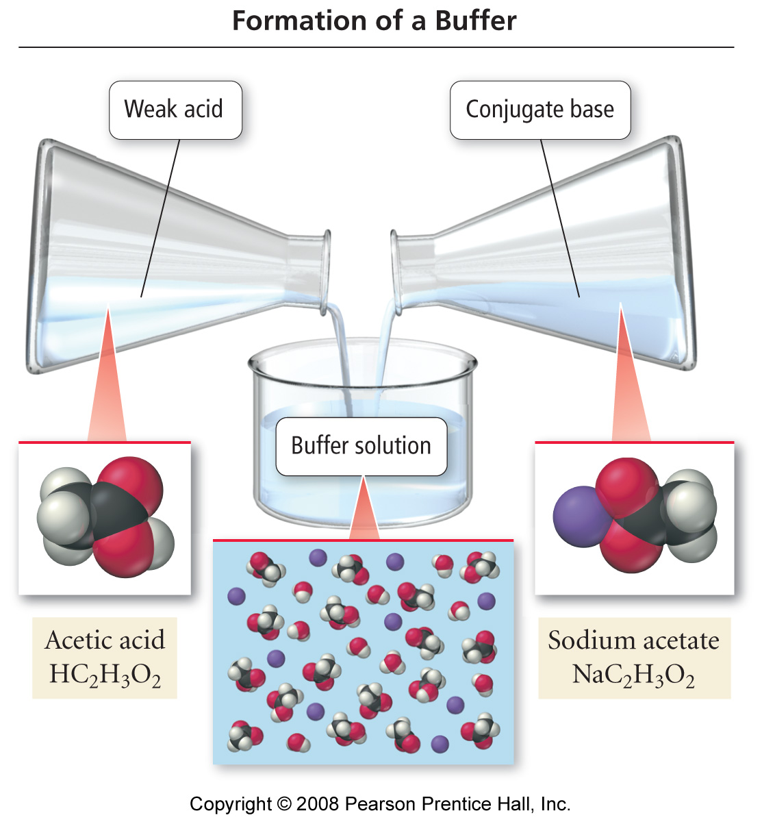 | Worked Example: What is the pH of a solution made by adding 0.125 mol. of HC₂H₃O₂ and 0.075 mol. of NaC₂H₃O₂ to enough water to make a 1.0 L solution? K_{a} acetic acid = 1.8 x10⁻⁵
   | Use the standard I.C.E. method for weak acids, BUT include the (now non-zero)
  initial concentration of the conjugate base introduced via dissolving it’s salt.

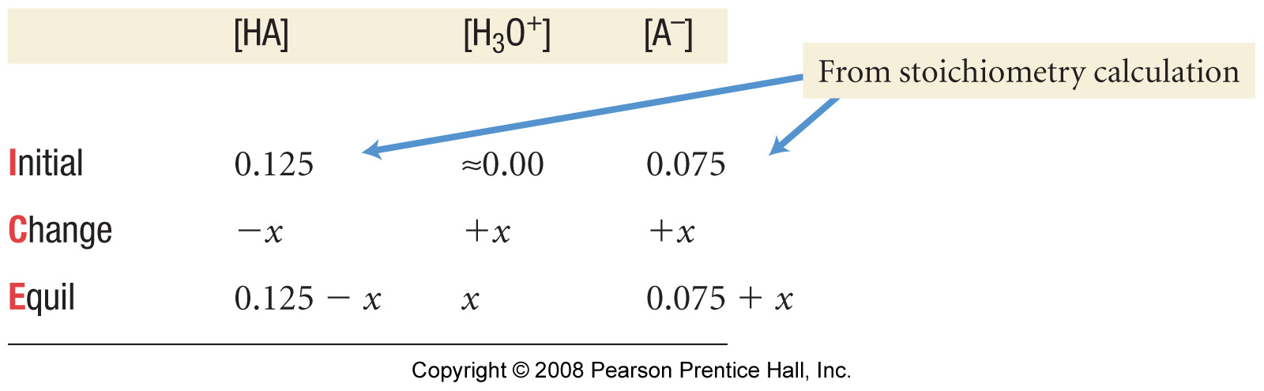

ANS =

Task: Calculate [F⁻] and pH of a solution that is simultaneously 0.20M in HF (aq) and 0.10 M in HCl (aq). K_{a} for HF = 6.8 x10⁻⁴

ANS: [F⁻] = 1.4 x10⁻³ M
pH = 1.0

Comment:

Buffered Solutions

Buffered solutions (buffers) are weak acid / base conjugate pairs that resist drastic changes in pH upon addition of strong acids or bases from external sources.

This is simply a specific application of the common ion effect – the common ion introduced from an external source is always either H⁺(aq) (from a strong acid) or OH⁻(aq) (from a strong base)

Discussion / Background: consider the following generic weak acid /conjugate base equilibrium (see appendix):

HA (aq) ⇔ H⁺ (aq) + A⁻ (aq)

According to Le Châtelier’s Principle, what would happen to the position of the above equilibrium if:

- A large amount of H⁺ (aq) from an external source (such as a strong acid like HCl (aq)) were added?

Equation:

- A large amount of OH⁻ (aq) from an external source (such as a strong base like NaOH (aq)) were added?

Equation:

Buffering capacity and Buffer pH

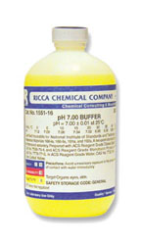 | A buffer will resist changes in pH (i.e. increases in either [H⁺] or [OH⁻]) by ‘reacting away’ these chemical species.  The buffering capacity of the buffer is determined by the relative concentrations of the weak acid (HA) and conjugate base (A⁻) at equilibrium. For example, a buffer with HA: A⁻ in a 10:1 ratio will be able to ‘react away’ x10 more OH⁻ than can H⁺ before the buffer becomes exhausted.  The chemical makeup of the buffer (i.e. K_{a} or K_{b} for the weak acid/base system) determines the ‘natural’ pH the buffer. Buffers of virtually any pH between ~2 and 13 can be constructed.

Titration curves for non-buffered and buffered systems (see appendix)

Titration of a strong acid with NaOH (non-buffered) | Titration of a weak acid /conjugate base buffer with NaOH

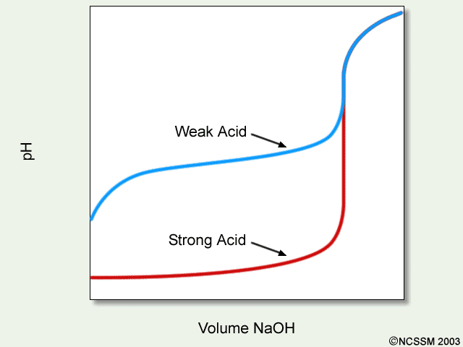 | Diagram illustrating the ‘buffer region’ for a weak acid undergoing titration with NaOH (aq).  Recall:  HA + OH⁻ → A⁻ + H₂O  Equivalence is reached when moles HA present = moles OH added. Before equivalence, the ‘natural’ pH of the buffer is maintained
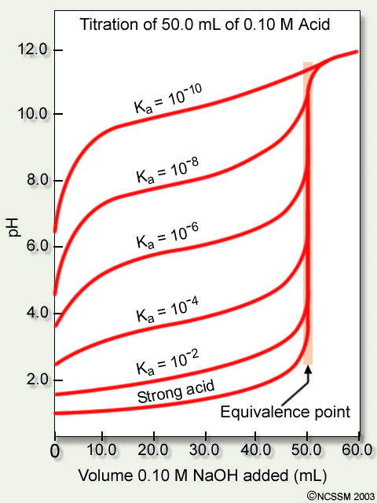 | Diagram illustrating the ‘buffer region’ for weak acids of specific Ka values undergoing titration with NaOH (aq).  Discussion: What do you notice with regard to the relationship between K_{a} and the ‘natural’ pH of the buffer?  Note: The mathematical relationship between pH and K_{a} is discussed further below

Because buffers are essentially just either a weak acid or a weak base and their respective conjugate in equilibrium, a standard ‘common ion’ I.C.E. approach can be used to find the ‘natural’ pH of a buffer (recall the HC₂H₃O₂ / NaC₂H₃O₂ system discussed previously).

Example (group work): What is the pH of a buffer that is 0.12 M in lactic acid (HC₃H₅O₃) and 0.10M in sodium lactate? K_{a} = 1.4 x10⁻⁴.

  The Verve had a good handle on weak acid / base equilibria. Kind of…. | Drugs are typically either weak acids or weak bases (more on this later), so their pH - which relates to solubility, and ultimately if the drug should be taken orally or intravenously – is of great interest to MCAT and PCAT examiners!  Problem: Do you think ‘they’ intend for you to employ a time consuming modified I.C.E. methodology on the ‘CAT’ test?  Answer:  Solution: There is a quicker and much more convenient method to find the pH of a buffer solution: the Henderson –Hasselbalch equation.

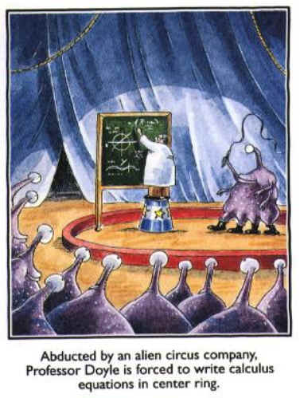 | Derivation of the Henderson –Hasselbalch equation  Since, for any weak acid conjugate base buffer:  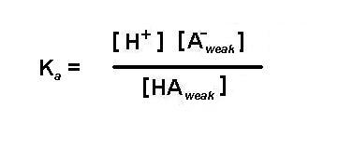  Then:

Henderson –Hasselbalch equation

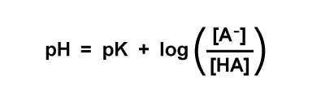
Task: Assume you are taking the PCAT or MCAT- use the H-H equation to quickly answer the previous lactic acid buffer question:

What is the pH of a buffer that is 0.12 M in lactic acid (HC₃H₅O₃) and 0.10M in sodium lactate? K_{a} = 1.4 x10⁻⁴.

Discussion: When you perform a titration, what is true in terms of the moles of acid and base present at equivalence? What then must be true at half- equivalence?

What happens to the H-H equation at half-equivalence for the titration of a weak acid with NaOH? (i.e. when moles HA unreacted = moles A⁻ formed)?

pH = pK_{a} for a buffer at half- equivalence (i.e. when [HA] = [A⁻])

(see titration cure examples, above (H₂A), and in Appendix)
Mr. Buffer’s buffer (buffers in the body)

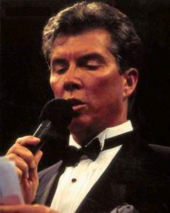 | Blood has a regulated (buffered) pH of 7.4. The buffer responsible for maintaining the pH of blood is the carbonic acid / hydrogen carbonate system – i.e. the same one studied in your recent lab:

H₂CO₃(aq) ⇔ H⁺ (aq) + HCO₃⁻(aq)

Group work: If H₂CO₃(aq) has a concentration of 0.0012 M in human blood, what is [HCO₃⁻] in blood? Is blood better at resisting changes in [H⁺] or [OH⁻]? K_{a} = 4.3 x10⁻⁷

Lewis acids/bases and more about Drugs

The Lewis lone–pair transfer model

In the Lewis model:

Lewis Acids are identified as lone pair electron acceptors

Lewis Bases are identified as lone pair electron donors

Just like proton transfer, but viewed in terms of what the proton ‘sticks to’

Example: NH₃ (aq) as Lewis base

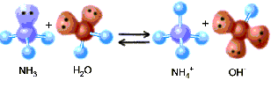

Question: Why worry about Lewis base behavior, when it is essentially just B-L theory from a different point of view?

Answer: Most ‘interesting’ drugs (be they legal or illegal) are Lewis bases – they contain N: group(s) (just like ammonia).

Problem: Most ‘free bases’ (where have you heard that term before?) are volatile and not too soluble in water – not good candidates for turning into oral (or other) medication.

Solution: Turn ‘free bases’ into acids salts – acid salts are soluble and non-volatile, so have long shelf lives and can be taken orally.
Generic example of forming the acid salt of a ‘free base’

D: + HCl (aq) → [D: H]⁺[Cl]⁻

A great many drugs, both legal and illegal, are manufactured and sold as the acid or other salts

Levitra (vardenafil HCl):
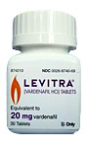

‘Crack’ (cocaine sodium hydrogen carbonate):

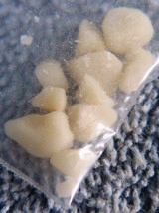

 |  | Social commentary: I don’t want to go off on a rant here, but…

Solubility Equilibria

 | Background: What is a saturated solution?

Official definition: A solution in which undissolved solute and dissolved solute are present in equilibrium

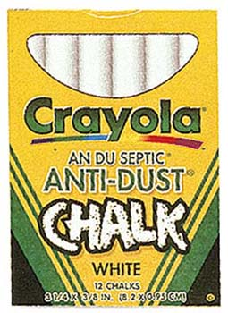 | Most apparently insoluble solids (such as chalk, for example) are sparingly soluble – they dissolve to a tiny degree:  CaCO₃ (s) ⇔ Ca²⁺ (aq) + CO₃²⁻ (aq)

Task: Derive a simple ‘products over reactants’ expression for the above equilibrium featuring solid chalk (calcium carbonate) and it’s dissolved ions. What ‘cancels’?

Any sparingly soluble salt (ionic compound) will have a related solubility product (K_{sp}) expression. K_{sp} values are known for most compounds at 25ºC. For chalk (calcium carbonate):

K_{sp} = [Ca²⁺][CO₃²⁻] = 4.5 x 10⁻⁹

Note: Since the ionic materials we are dealing with are sparingly soluble, their K_{sp} values are necessarily very low

Compound | K_{sp} | Compound | K_{sp}
BaSO₄ | 5.0 x10⁻⁹ | CaF₂ | 3.9 x10⁻¹¹
Ag₂SO₄ | 1.5 x10⁻⁵ | AgCl | 1.8 x10⁻¹⁰
See the Appendix for a more complete list

Task: Write solubility product expressions for the following equilibria

- Dissolution of barium sulfate

- Dissolution of calcium fluoride

- Dissolution of silver sulfate

As with all other equilibria, the concentration of a reactant is raised to the power of its stoichiometic coefficient in the expression

Solubility and K_{sp}

Group work: You drop a stick of chalk into some pure water. What will the concentration of the Ca²⁺ (aq) ions be in the resulting saturated solution after the solid and its aqueous ions have attained equilibrium? Hint: Use the K_{sp} expression

Harder example: A saturated solution of magnesium hydroxide has a pH of 10.17. Find K_{sp} for Mg(OH)₂. See appendix for equation.

Solubility

The solubility (s) of any sparingly soluble salt (ionic compound) is expressed in terms of the solvated metal cation

For the dissolution of AgCl:

AgCl (s) ⇔ Ag⁺ (aq) + Cl⁻ (aq)

solubility (s) = [Ag⁺] (which also = [Cl⁻] in this example)

Task: Derive an expression for s in terms of K_{sp}, given that, for silver chloride:

K_{sp} = [Ag⁺][ Cl⁻]

Group Task: Determine K_{sp} and solubility (s) expressions for the following equilibrium:

CaF₂ (s) ⇔ Ca²⁺ (aq) + 2F⁻ (aq)

Worked (quantitative) Example: What is the solubility of calcium fluoride in g/L? K_{sp} = 3.9 x10⁻¹¹

Plan:

Note: Solubilities (especially in the biochemical and medical fields) are often quoted in g/L or mg/mL
K_{sp} and the Common Ion Effect

 | Recall: According to Le Châtelier’s Principle, increasing the concentration of a dissolved reactant or product in equilibrium will cause the equilibrium to shift in order to remove that material. The same is true for K_{sp} equilibria

Worked Example: Calculate the molar solubility (s, in mol/L) of CaF₂ in a solution that is 0.010M in Ca(NO₃)₂ (aq)

Plan: set up a modified I.C.E. grid, then insert and evaluate in the K_{sp} expression.

Notice that any compound that undergoes partial dissociation (weak acids, weak bases, buffers, and now sparingly soluble salts) can be modeled using the I.C.E. method coupled with the appropriate equilibrium expression – it’s just a case of same math, different application….

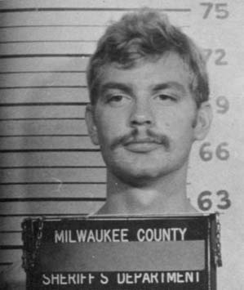 | Discussion / Observation: As the infamous serial killer Jeffery Dahmer would have told you, the easiest way to get sparingly soluble salts (like calcium phosphate (bone)) into solution is to dissolve them in an acid.  Jeffery obviously paid attention in Gen. Chem., as this is a standard lab ‘trick’:

Example: Consider the dissolution equilibrium of the sparingly soluble salt material magnesium carbonate:

MgCO₃ (s) ⇔ Mg²⁺ (aq) + CO₃²⁻ (aq)

If HCl (aq) is used as a solvent, then:

HCl (aq) → H⁺ (aq) + Cl⁻ (aq) (complete dissociation)

Now, the H⁺ ions will enter into equilibrium with the carbonate anion, which is the conjugate base of the weak acid HCO₃⁻:

H⁺ (aq) + CO₃²⁻ (aq) ⇔ HCO₃⁻ (aq)

Question: What happens to the original magnesium carbonate equilibrium when carbonate ions are removed in this way? What will happen to the value of [Mg²⁺] (s) and the amount of sold magnesium carbonate present?

“Common Ion”

Question 2 (25 points): A solution contains 2.5 x 10⁻⁴ M Ag⁺(aq) and 1.7 x 10⁻³ M Pb²⁺(aq).

- If NaI (aq) is added, will AgI (K_{sp} = 8.3 x 10⁻¹⁷) or PbI₂ (K_{sp} = 7.9 x 10⁻⁹) precipitate first?

- Specify the concentration of I⁻ (aq) needed to begin precipitation of the material you determined would precipitate first in part A.

Appendix:



