Chemistry 102
The Complete Notes

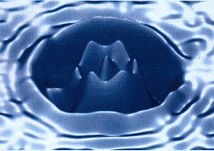

Dr. Patrick Mills, Joliet Junior College

Notes

Contents
Notes | Page | Notes | Page
What is Chemistry | 2 | Acid-Base Equilibria 2 | 176
Review Topics | 7 | Acid-Base Equilibria 3 | 193
Solutions | 15 | Chemical Thermodynamics | 226
Kinetics 1 | 43 | Electrochemistry | 239
Kinetics 2 | 61 | Nuclear Chemistry | 263
Kinetics 3 | 90 | Final Exam Review | 277
Equilibria 1 | 116 | Blank Practice Exams | 284
Equilibria 2 | 125 | Note Space | 298
Acid-Base Equilibria 1 | 151 | Periodic Table | Back cover
See the Course Website (http://ww3.jjc.edu/staff/pmills) for specific test dates and other important information

Legend
You will often find specific icons embedded within the notes. These respective symbols alert the student to the following:
 | Represents a key fact or other piece of information, such as the definitions of an element and a compound.
 | Represents a useful trick the student will likely find useful, such as an 'EZ' way to convert between grams and moles for a substance
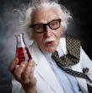 | Alerts the student to an important relationship between micro and macro scale properties or phenomena with respect to the material under discussion
* | Such material provides a link to interesting (briefly discussed) supplemental material, often beyond the scope of the course syllabus

Disclaimer: This document may only be downloaded, without charge, by students enrolled in Dr. Mills’ CHM 100 course(s) at Joliet Junior College. This document MAY NOT be resold, or in any other way utilized for profit, by any third party interest.

Cover Art: The ‘STM Well’ STM image

What is chemistry?
Task: In your own words describe what you consider chemistry to be, plus make a list of what you think the job of a chemist is:

What is chemistry?

“Official” definition of what chemistry is:

Key words:

Matter: “Stuff” – anything with mass and volume. Can you think of anything without mass or volume?

What are the three STATES of matter? Are there any more?

What are the basic building blocks of all matter, be it a diamond, a tree or the air around us? List as many types of matter as you can:
Matter Flow Chart

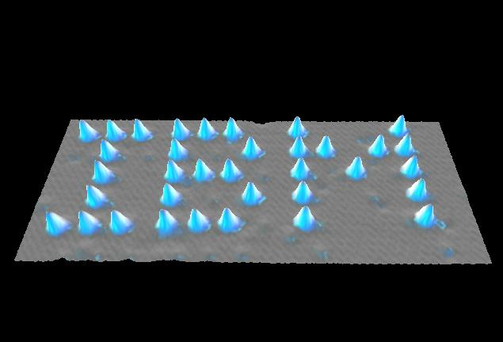
‘High Tech’ science (STM or AFM, top left) is often based on simple ideas (gramophone, top right).
Click logo for ‘flyby’.
More recent atomic (STM) images
 | 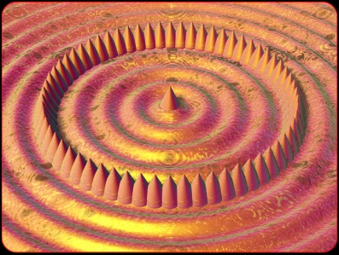 |  | 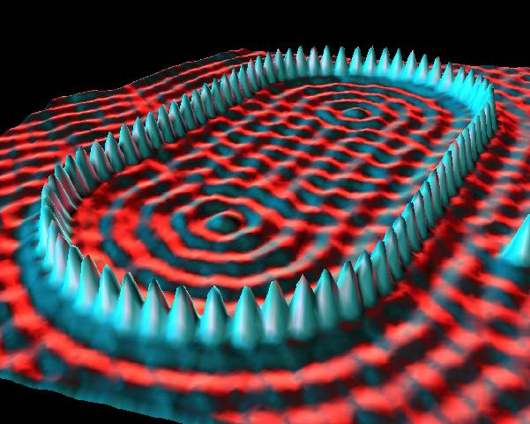
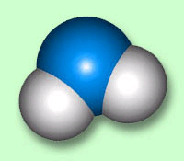 |  | Example: What is water made up from? How do you know?
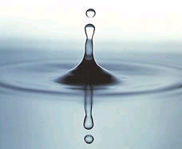

Summary:

Atoms and molecules are MICROSCOPIC particles (they are very small)

A drop of water is a MACROSCOPIC particle (because you can see it, hold it in your hand etc.)

“Official” definition of what chemists do:

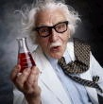 | Chemistry in action: Explaining what happens on your BBQ grill.  The burning of a charcoal brick on your backyard grill (MACRO) explained in terms of a balanced chemical equation (MICRO)

ANY large (MACRO) scale chemical process can be described using a MICRO scale chemical equation featuring individual atoms and/or molecules

Cartoon representation of the reaction of the pertinent atoms and molecules

The Chemists’ description – a balanced chemical equation. This process is repeated many billions of times (MICRO) for the burning of a charcoal briquette (MACRO)

Review Topics

Reading: | Ch 1, sections 1 - 2  Ch 3 & Ch 4 | Homework: | Chapter 3: 35, 37, 47, 49*, 51*, 57*, 59*, 63*, 93, 97*  Chapter 4: 25*, 27, 33*, 43*, 49, 57*
 | Review Atomic Structure, Molecular Structure, Stoichiometry, States of Matter and Descriptive Chemistry chapters throughout the semester*
* = ‘important’ homework questions

Review: What follows is a recap of the most important topics covered in CHM 101. We will use this material throughout CHM 102, so please ensure that you are familiar with the following questions, as well as the Ch3 & 4 HWK questions, before we move on to the Ch 11 material.
Top Tip: Committing to a rolling review of the ACS / Chem. 101 material is a potentially grade altering decision – this cannot be over stressed (see below)

1. The Mole

What is a mole (in chemistry terms)?

How is the mole defined?

When is nation nerd, sorry, Mole Day?

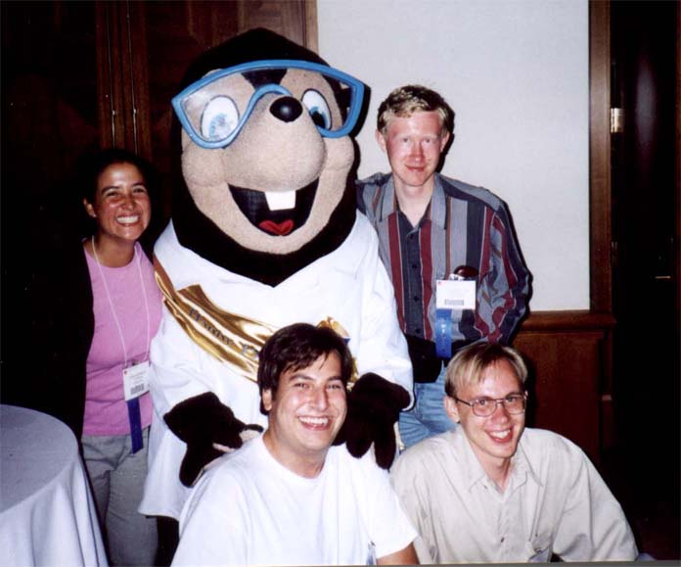

Question: How many atoms of oxygen in 1.5 moles of O₂?

2. Molar Mass

What is the definition of molar mass (M)?

How can you find the molar mass of any chemical using just the periodic table?

Question: What is the molar mass of carbon dioxide (M_{CO2})?

What is the relationship between molar mass, #grams and # moles of any chemical?

Question: How many moles of carbon dioxide are there in 27.4 grams of CO₂?

3. Balancing Chemical Equations

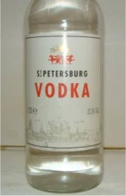 | Write a balanced chemical equation for the combustion of ethanol (C₂H₆O). Hint: what are the products of combustion for natural (organic) materials?

4. ‘Slides and Ladders’ (Limiting Reactant Problems)

What mass of CO₂ (g) is formed from the combustion of 4.05 g ethanol? What volume of CO₂ (g) is formed at STP?

5. Concentration / Volume Relationships for Solutions

What is the relationship between the concentration of a solution, the # moles of solute it contains and the volume it occupies?

Question: How many grams of HNO₃ (aq) are there in 100 mL of a 6M nitric acid solution?

Question: What volume of 12 M H₂SO₄ (aq) is needed to completely neutralize 25.0 grams of NaOH(s)? Hint: Use a combined slides and ladders approach.

Recap: The Importance of the mole

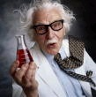 | Most of the equations we have met in this handout feature # moles as a variable. Thus, moles can in many ways be considered the chemists’ link between macro and micro scale quantities.

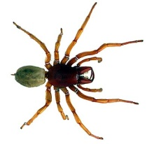 | Task: Write down as many equations you can featuring the mole. Use this information to construct a ‘spider’ (flow) chart illustrating how all these conversions ‘go through’ moles.

“A little review”

The following questions were taken from your 1st practice midterm:

Question 4a (5 points): The products of combustion for any carbohydrate in oxygen gas are carbon dioxide and water. Use this information to write a balanced equation for the combustion of sugar (C₆H₁₂O₆ (s))

ANS: C₆H₁₂O₆ (s) + 6O₂ (g) → 6 CO₂ (g) + 6 H₂O (g)

Question 4b (10 points): What mass of carbon dioxide gas would be collected from the complete combustion of 5.00 grams of sugar (C₆H₁₂O₆ (s))?

ANS: 7.33 g (3 sf)

Question 4c (10 points): What volume of carbon dioxide gas (at STP) would be collected from the complete combustion of 5.00 grams of sugar (C₆H₁₂O₆ (s))?

ANS: 3.74 L (3 sf)

Top Tip

A great way to ensure a good grade on your final exam is to practice ACS style questions*. To help you with this, a pair of ACS study guides have been put on reserve in the library. Additionally, if you are going to take the MCAT or PCAT etc., the ACS guide is makes for an excellent resource for these tests' respective chemistry sections. If you wish to purchase a copy ($12 ea.) log on to: http://www3.uwm.edu/dept/chemexams/guides/details_guides.cfm?ID=162
*Ask me to tell you the ‘BB’ story

Sample Final Exam Questions (CHM 101 syllabus, taken from the ‘Final Exam Review’ Lecture Notes)

1. In all neutral atoms, there are equal numbers of:

a. | electrons and protons | c. | electrons and neutrons
b. | protons and neutrons | d. | electrons and positrons

2. Which pair of particles has the same number of electrons?

a. | F⁻, Mg²⁺ | c. | P³⁻, Al³⁺
b. | Ne, Ar | d. | Br⁻, Se

3. What is the mass percent of oxygen in Ca(NO₃)₂?

a. | 29.3 % | c. | 58.5 %
b. | 47.1 % | d. | 94.1%

4. A 24.0 g sample of carbon contains how many atoms:

a. | 6.02 x10²³ | c. | 3.01 x10²³
b. | 1.20 x10²⁴ | d. | 2.04 x10²⁴

5. When 1.187 g of a metallic oxide is reduced with excess hydrogen, 1.054 g of the metal is produced. What is the metallic oxide?

a. | Ag₂O | c. | K₂O
b. | Cu₂O | d. | Tl₂O

6. A single molecule of a certain compound has a mass of 3.4 x10⁻²² g. Which value comes closest to the mass of a mole of this compound?

a. | 50 g | c. | 150 g
b. | 100 g | d. | 200 g

7. The electronic configuration for the Ca atom is:

a. | 1s²2s²2p⁶3s²3p⁶4s²3d² | c. | 1s²2s²2p⁶3s²3p⁶4s²
b. | 1s²2s²2p⁶3s² | d. | 1s²2s²2p⁶3s²3p⁶4s²3d¹⁰4p²

8. Two moles of any gas will occupy what volume at STP?

a. | 22.4 L | c. | 4.48 L
b. | 11.2 L | d. | 44.8 L

Answers:
1. | a. | 5. | b.
2. | a. | 6. | d.
3. | c. | 7. | c.
4. | b. | 8. | d.

Properties of Solutions

Reading: | Ch 11, section 8  Ch 12, sections 1-8 | Homework: | Chapter 11: 85*, 87  Chapter 12: 29, 33, 35, 41, 51*, 53, 55, 63*, 65, 67*, 69, 71, 75*, 79*, 81
* = ‘important’ homework question

Types of Solutions and Solubility

Discussion: What very ‘general’ kinds of solutes can you dissolve in a solvent (say water) to make a solution? Provide examples.

__________ + water | __________ + water | __________ + water

Quick aside: What happens when one solution is mixed with another, or a solution is mixed with more additional solvent?

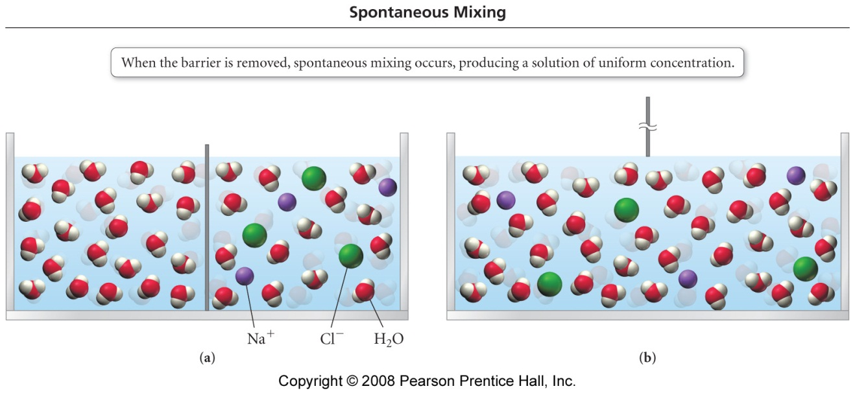

Why do the solutions mix, what’s the ‘pay off’?

On a molecular level the final solution is more ‘randomized’ (has more ENTROPY*). Chemical systems that possess a higher degree of entropy are more thermodynamically stable. ‘Nature likes stable’!
*More on Entropy in Chemical Thermodynamics

OK, back to it….

Based on your current knowledge (recall the intermolecular forces work from CHM 101), simply explain why certain classes of compounds will or will not dissolve in water.
Hint: ‘like dissolves in like’ - old chemistry saying*

*Recall the ‘ions’ slide, plus basic details on solutions (see Appendix).

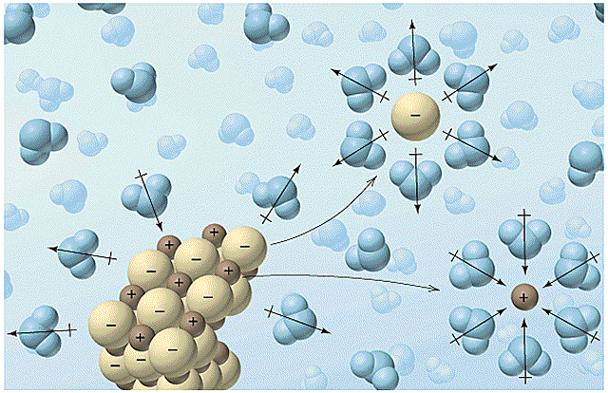
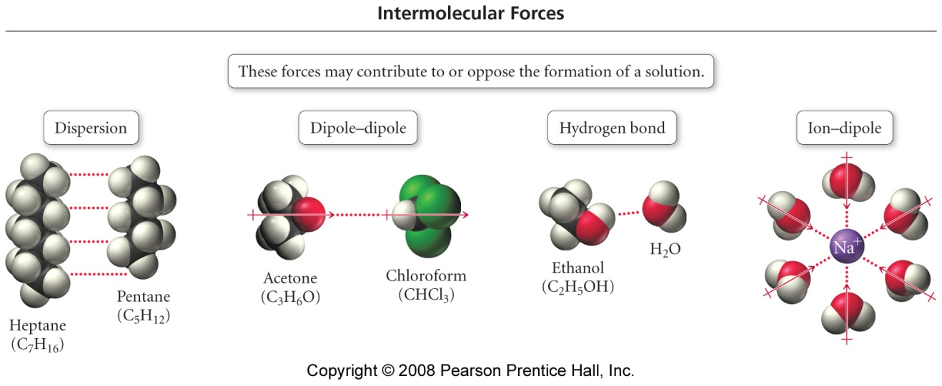

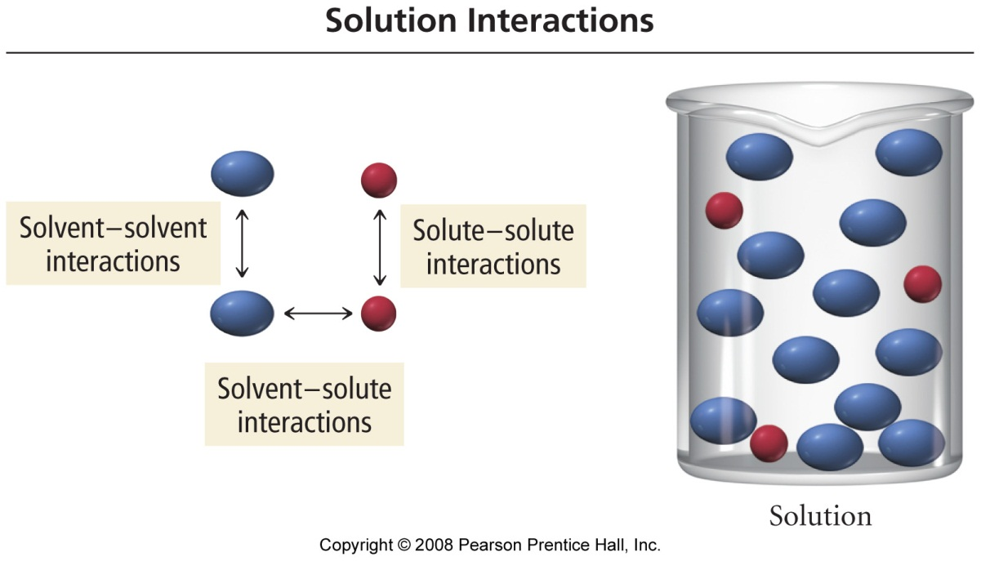

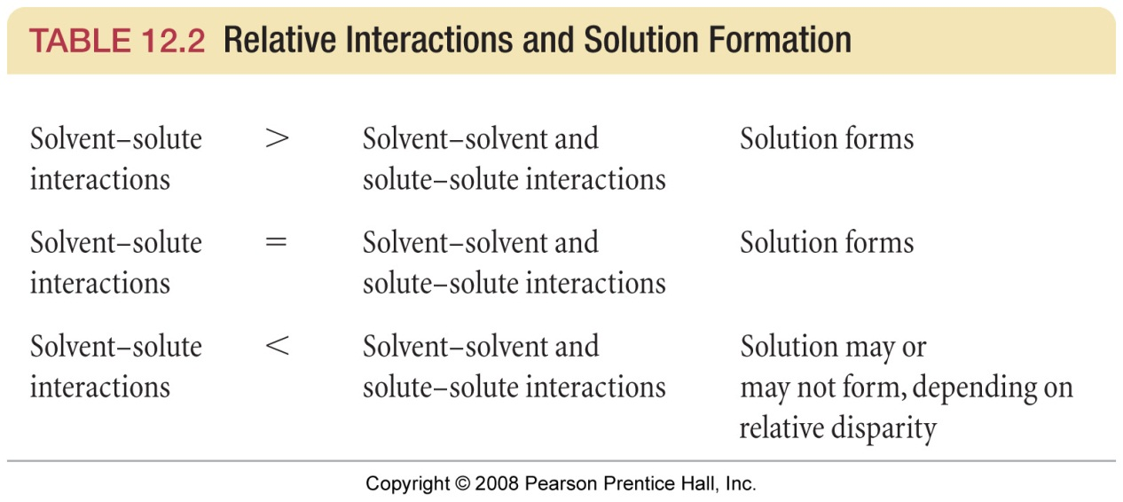
Task: predict whether the following pairs of compounds are soluble, insoluble, miscible or immiscible. What’s the difference??

Mixture | Details
Salt (NaCl) with water
Sugar with water
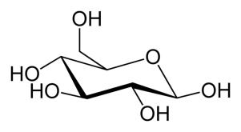
Sugar with hexane
Hexane with water
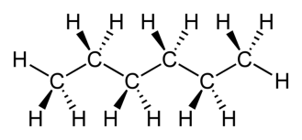
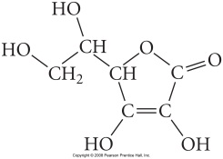
Vitamin C with water
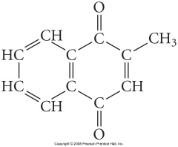
Vitamin K₃ with water

Summary: Recall that ‘Nature likes stable’! Or, in other words, the ‘winner’ (in terms of the relative strengths of respective intermolecular force combinations) typically determines whether the solute /solvent pair are soluble or insoluble.

Solution Energetics

Recall from the CHM 101 Thermochemistry material that a difference in stored chemical potential energy (∆H) – i.e. the change in the amount of energy stored within chemical bonds when reactants → products in a reaction is either released (exothermic) or absorbed (endothermic) as an equivalent amount of heat energy (q). This leads to the First law of thermodynamics:

-∆H = +q (exothermic reaction)

A similar approach can be applied to the formation of solutions, and (similarly) be represented in terms of familiar enthalpy (Hess’ Law) relationships and diagrams

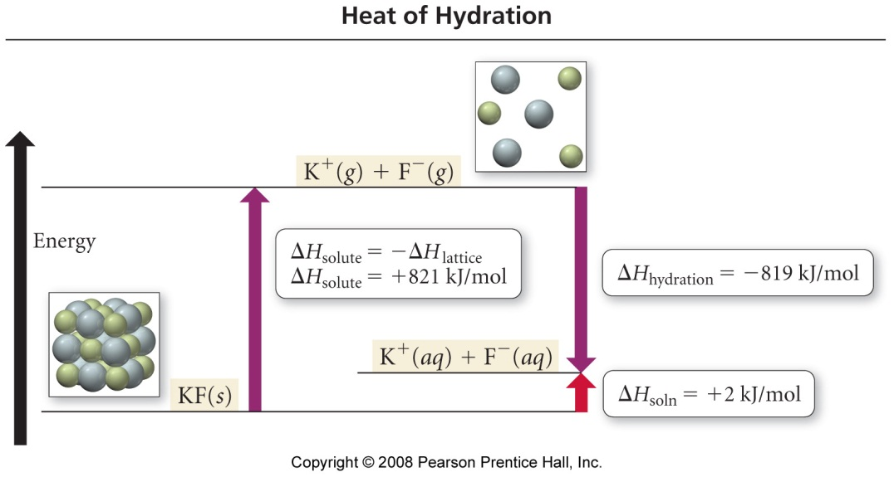
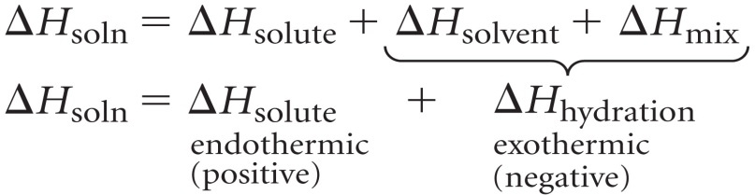

Task: Prove it to yourself; calculate ∆H_{soln} using the ∆H_{solute} and ∆H_{hydration} values listed above.
Factors Affecting Solubility

Or, in other words, stuff you already know from everyday observation……

Temperature

How are the solubility of solids and gasses typically affected by an increase in temperature?

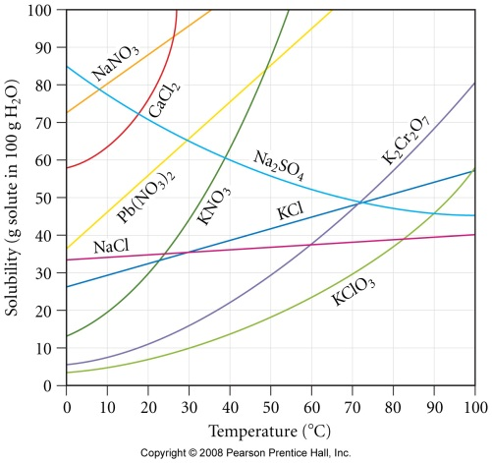 | Solids:

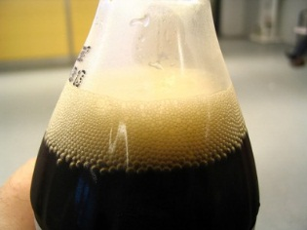 | Gasses:

Pressure

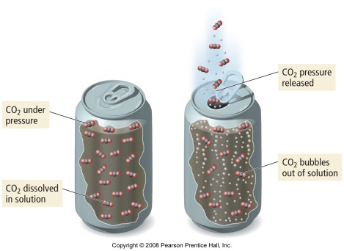 | 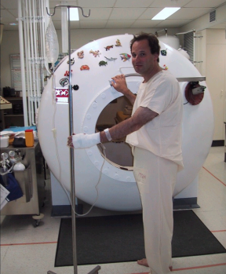 | How is the solubility of a gas affected by an increase or decrease in pressure?

Expressing Solution Concentration

Overview: There are four ways of expressing the concentration or ‘strength’ of a solution – Molarity (M, mols/L), % mass, ppm (parts per million) and Molality (mols/kg). It is important to know how to determine and convert between these concentration types.

Familiar Units – Molarity and % mass

1. Molarity:

Molarity* (M) = number moles of solute per Liter of solution
* The Molarity (mol/L conc.) is most often printed on lab reagent solution bottles, e.g. 9.0 M H₂SO₄ (aq)

i.e. Molarity = | Moles Solute | Units: mol/L or just M
 | Liters Solution

Example: What is the concentration (molarity, M) of a solution made by dissolving 25 g of NaCl in water and making the final volume of the solution equal to 750 mL?

2. % Mass

% Mass = | Mass Solute | x 100 % (units of %)
 | Mass Solution

Example: What is the % mass concentration of an NaCl in a solution made by dissolving 25 g of NaCl in water and making the final volume of the solution equal to 750 mL? Assume the final solution has a density of 1.15 g/mL

New Units – ppm and Molality

Discussion: Why learn these new unit types? What are they used for?

3. ppm (parts per million)

The ppm unit is simply a mass ratio: ‘grams per million grams’, i.e. there is a ‘difference factor’ of 10⁶ between mass solute and mass solution. A better way to express this would be mg solute per kg solution

Parts per million = ppm = mg solute per kg of solution

i.e. ppm = | mg solute | Units: ppm or mg/kg
 | kg solution

Regular molarity (mol/L) concs can be easily converted to ppm if the density of the solution is known. Recall that mass = density x volume

Example: What is the ppm concentration of NaCl in a solution made by dissolving 25 g of NaCl in water and making the final volume of the solution equal to 750 mL? Assume the final solution has a density of 1.15 g/mL

Find mass solution

Divide mass of solute (in mg) by mass solution (in kg)

4. Molality:

m = Molality = number moles of solute per kg of solvent

i.e. molality = | Moles Solute | Units: mol/kg or m
 | kg solvent

Example: What is the molality of an HCl solution that is 36% by mass?

When presented with a % mass concentration, assume that you have 100 g of this solution. The % mass of solute is than the same numerical value as the mass (in g) of solute in the solution

Mass solute =

Mass SOLVENT =

Molality of solution

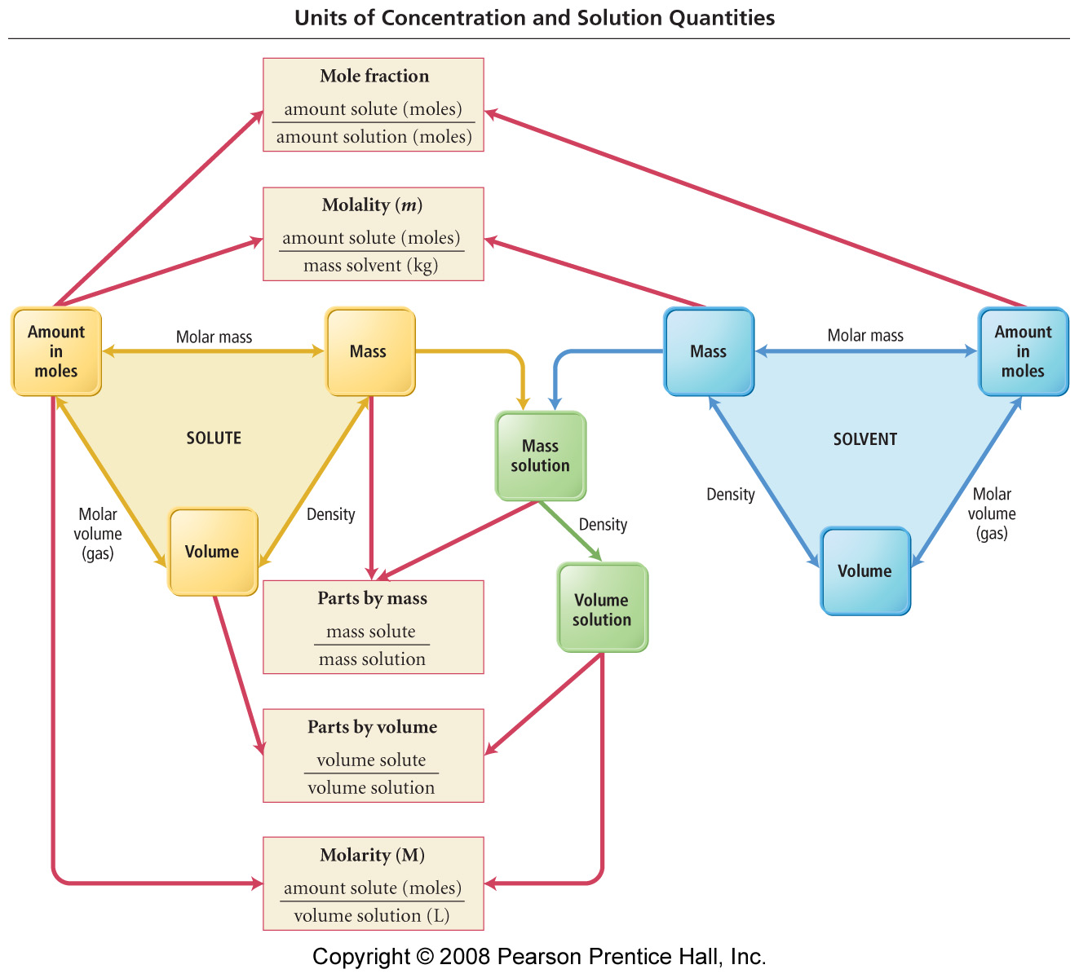

Colligative Properties

Definition: A property of a solution that only depends on the number of particles dissolved in solution (i.e. concentration), not the type of particle or their respective chemistries (ions, molecules etc.)
Application 1: Boiling Point Elevation / Freezing Point Depression

Discussion: Why is salt added to pasta water, why is salt spread on the roads in winter?

The change in bpt. or fpt. (ΔT) of a solution is proportional to its molality. Bpt. elevation and fpt. depression are colloidal properties – they depend only on the number (molality) of solute particles disrupting intermolecular forces between the solvent molecules. It is the solvent’s bpt or fpt that is affected.

Equations

Bpt. Elevation  ΔT = K_{b} m |  | Fpt. Depression  ΔT = K_{f} m

Where: | ΔT = change in bpt. or fpt. of the solution compared to the pure solvent
 | K_{b} = boiling point elevation constant for the solvent
 | K_{f} = freezing point depression constant for the solvent
 | m = molality of the solution

Water is the most common solvent. Its cryoscopic constants are:

 | K_{b} (H₂O) = 0.51 ºC/m |  |  | K_{f} (H₂O) = 1.86 ºC/m
 |  | Because a difference in either bpt. or fpt (ΔT) is determined, either ºC or K can be used to measure temperature.

Example: Calculate the fpt. of a 30 % by mass ethylene glycol (C₂H₆O₂) solution (this is what you probably have in your car, or perhaps in your wine rack)

Ionic Solutes

Unlike molecular solutes (like ethylene glycol), ionic solutes dissociate into more than one solvated particle when dissolved.

Eg: NaCl(s) → Na⁺ (aq) + Cl⁻ (aq) (x2 as many ions in solution)

The higher concentration of solvated particles (ions) in solution must be accounted for in elevation / depression problems

Example: What is the boiling point of a solution that has a 2.5 m NaCl conc? What about 2.5 m CaCl₂ (sold as ‘Quick Melt’)

Recall: Phase Diagrams

A Phase Diagram relates the physical state (s, l, g) of a material to pressure and temperature conditions.

Generic Phase Diagram (see appendix)
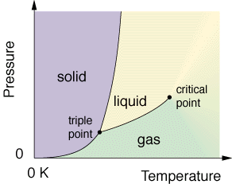

Features of the Graph

Boiling point (l ↔ g) | Triple point
Freezing point (s ↔ l) | Critical point
Sublimation Point (s ↔ g)

Discussion: How would the phase diagram of water be affected if some NaCl was dissolved in the water being studied? Hint: Think about the effects of bpt. and fpt. changes.

Phase Diagrams for an NaCl (aq) solution (see appendix)

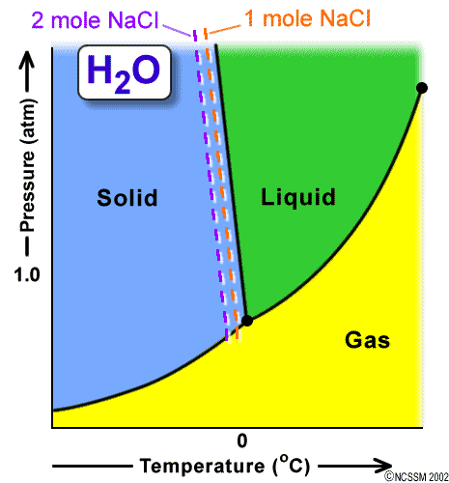 | 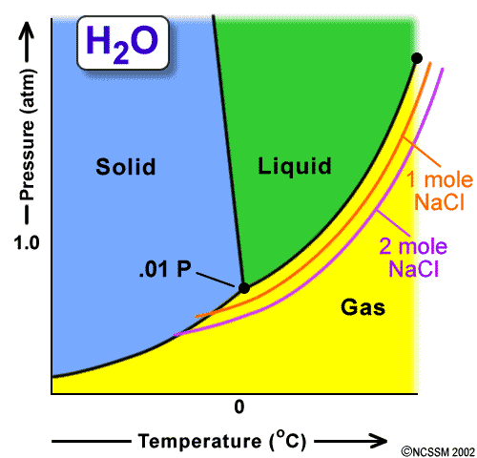

Application 2: Vapor Pressure Lowering

Vapor Pressure = pressure of a gas ‘above’ a liquid when the two are in dynamic equilibrium*
*more on this in the Equilibrium packet, also recall Ch.11.

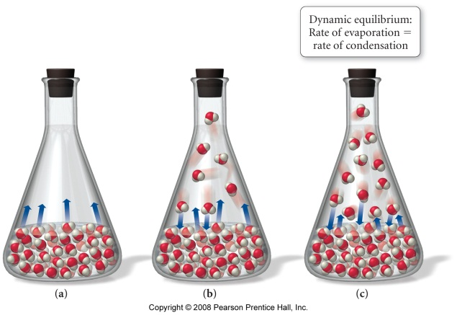 | 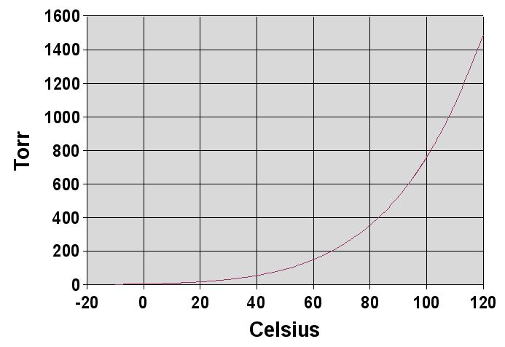

Think of vapor pressure like humidity – there is always a fixed amount (partial pressure) of gaseous material ‘above’ any liquid (in a closed container) at a specific temp – recall the CHM 101 ‘humidity’ plot… What is the vapor pressure of water at 100ºC?

Think about it. Does the vapor pressure / equilibrium idea help to explain why clothes on a washing line dry faster on warm and windy days??

Raoult’s Law Definition: (Recall partial pressure work from CHM 101)

- Volatile solutes (e.g. ethanol, benzene)

‘Using words’

1.

2.

‘Using math’  1. | 2.

Worked Example (HWK 12.73): A solution contains 50.0 g heptane (C₇H₁₆) and 50.0 g of octane (C₈H₁₈) at 25ºC. The vapor pressures of pure heptane and pure octane at 25ºC are 45.8 Torr and 10.9 Torr, respectively. Assuming ideal behavior, calculate:

- The vapor pressure of each of the solution components in the mixture

- The total pressure above the solution

- The composition of the vapor in mass percent

Recall that p ∝ n, and then let 1 mole. = 1 torr

- Why is the composition of the vapor different than that of the solution

Deviating from Raoult’s Law

Solutions do not necessarily follow IDEAL (i.e. pure solute or solvent) behavior with regard to their Vapor Pressure v Composition plots – this is called deviating from Raoult’s Law.

Discussion: What microscopic events would cause a deviation from Raoult’s Law, i.e. the vapor pressure for the solution to become greater or less than the partial pressure contributions expected from its pure components?

Positive Deviation | Negative Deviation
Ans: | Ans:

Summary

- Non-Volatile solutes (e.g. sucrose, table salt)

Since non-volatile solutes will not generate a respective vapor above the mixture, only the solvent (now with a reduce mole fraction) will generate a slightly reduced, (compared to its pure state) vapor pressure.

Worked Example: Calculate the vapor pressure at 25ºC of a solution containing 95.5 g sucrose (C₁₂H₂₂O₁₁) and 300.0 mL water. The vapor pressure water at 25ºC is 23.8 Torr, assume density H₂O = 1.00 g/mL

Plan:

Execute:

Task: Calculate the vapor pressure at 25ºC of a solution containing 55.3 g ethylene glycol (C₂H₆O₂) and 285.2 mL water. The vapor pressure water at 25ºC is 23.8 Torr, assume density H₂O = 1.00 g/mL.

Recall that for ionic solutions, the concentration of colloidal particles in solution is ‘multiplied out’ by the number of ions of the formula unit. Be sure to remember this when answering questions pertaining to ionic solutes.

e.g. Since NaCl(s) → Na⁺(aq) + Cl⁻(aq) ( i ≈ 2), the effective concentration of particles in 0.20 M NaCl (aq) is…

 | 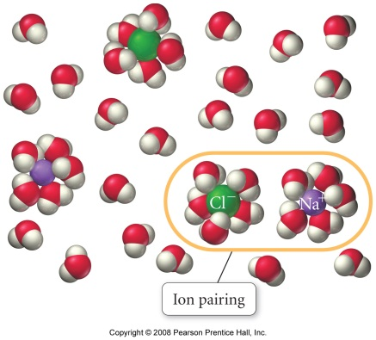 | *see appendix for measured i values

Application 3: Osmotic Pressure

Discussion: Please explain the joke / observation that: “I’m learning through osmosis”
Scientific hint: recall the earlier discussion about mixing solutions

Observation: ‘Seawater and Hangovers’

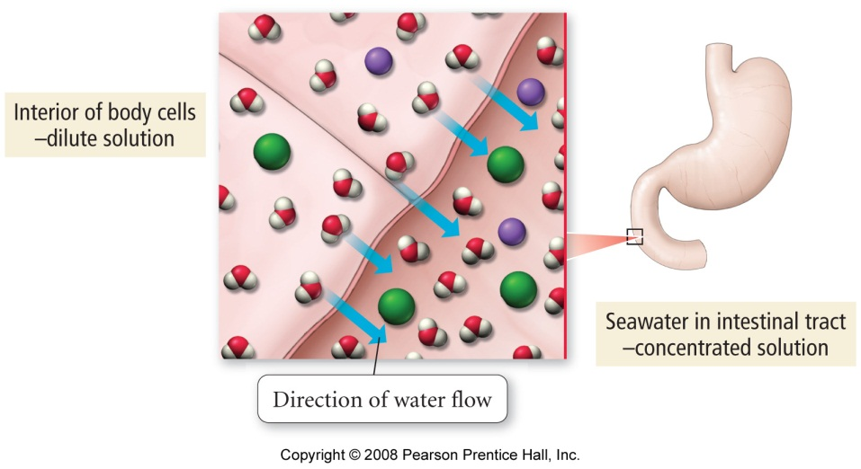

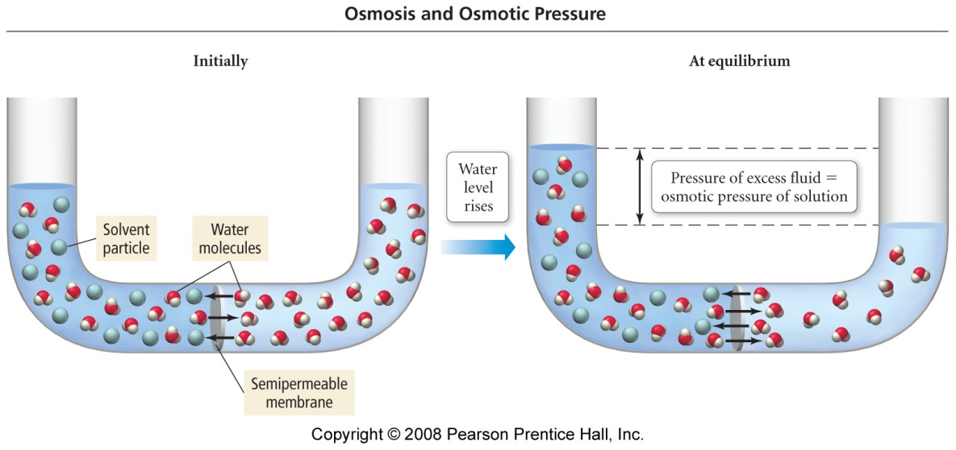
Osmotic Pressure Math

Π = iMRT

Where: | Π = osmotic pressure
 | i = number of ions per formula unit (ionic solutes only)
 | M = Molarity (mol/L)
 | R= gas constant (0.0821 Latm/mol K)
 | T= temp in K

Worked Example: The osmotic pressure of a solution containing 5.87 mg of an unknown protein (per 10.0 mL of solution) was 2.45 Torr at 25ºC. Find the molar mass of the protein.

Extra credit (2 points): Type a brief (less than 100 words) report detailing how reverse osmosis works. Include at least one diagram.
““Bloody Solution”

The following question was taken from your 1st practice midterm:

Question 5 (30 points): Calculate the osmotic pressure of a solution containing 20.5 mg of hemoglobin in 15.0 mL of solution at 25ºC. The molar mass of hemoglobin is 6.5 x10⁴ g/mol.

Appendix

Chem. 101 Review Material: Strong, Weak and Non-Electrolytic solutions
Strong Electrolytes: Salts

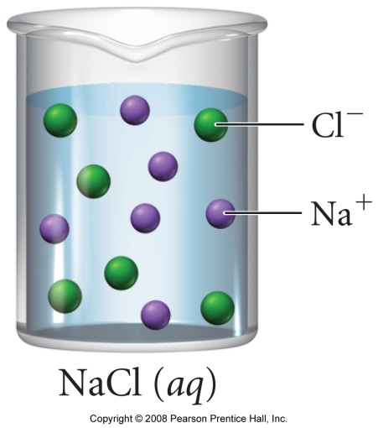 | Strong electrolytes contain very large numbers of dissociated ions when dissolved  Strong electrolytes are formed from the dissolution of SALTS (e.g. NaCl), which typically undergo complete (100%) dissociation

Weak Electrolytes: Molecular acids

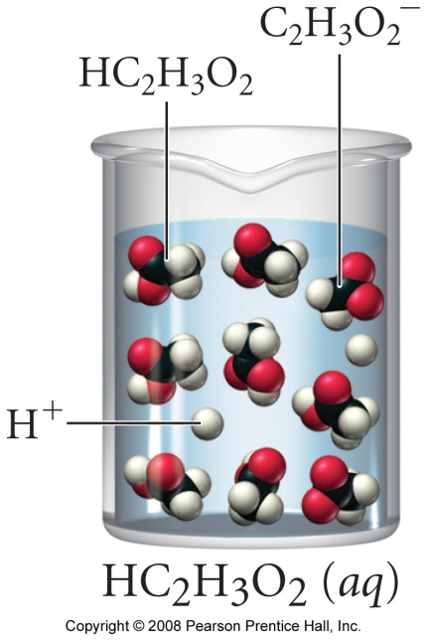 | Weak electrolytes contain ‘smaller’ numbers of dissociated ions when dissolved  Weak electrolytes are formed from the dissolution of MOLECULAR ACIDS (generic formula HA, e.g. H(C₂H₃O₂) or HCl), which typically undergo partial (<100%) dissociation

Non Electrolytes: Molecular Materials

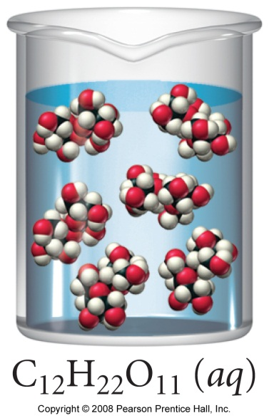 | Non-electrolytes contain NO dissociated ions when dissolved, so CANNOT conduct electricity.  ⇒ Since non-electrolytes do NOT contain ions they must be MOLECULAR. As it cannot dissociate, molecular material remains INTACT when it dissolves (see below comparison)

Comparison of (a) ionic and (b) molecular dissolution processes
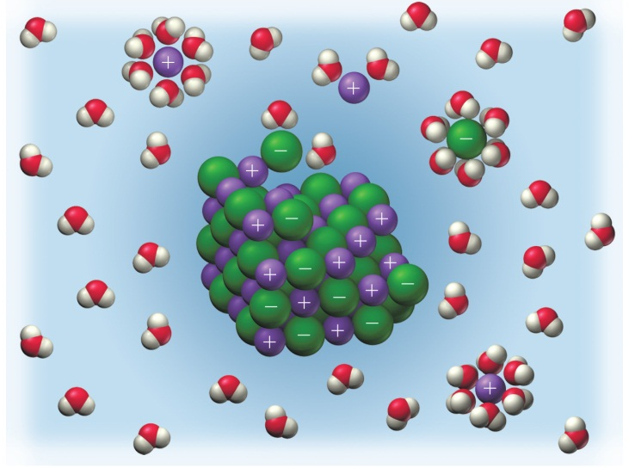 | 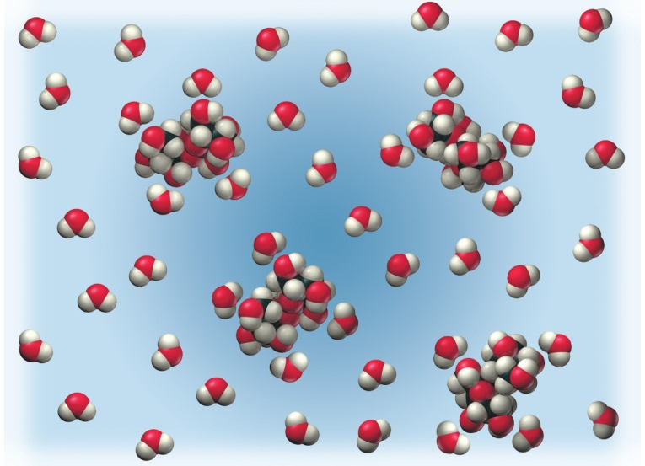
NaCl(aq) | ‘Sugar’ (C₁₂H₂₂O₁₁ (aq))

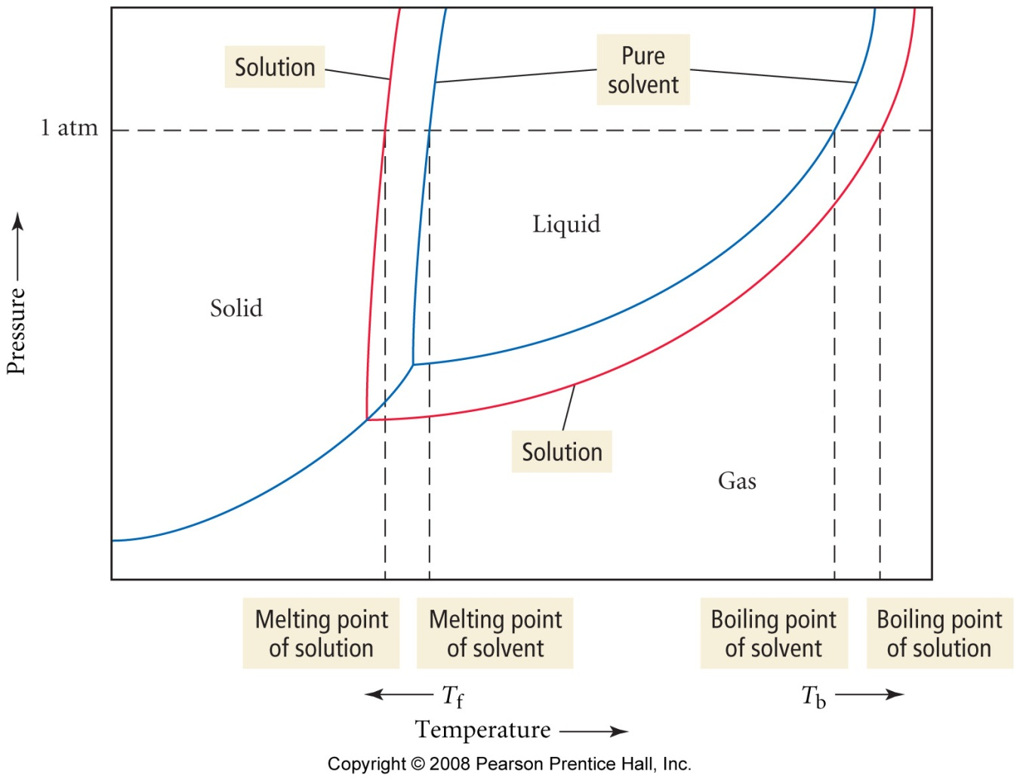

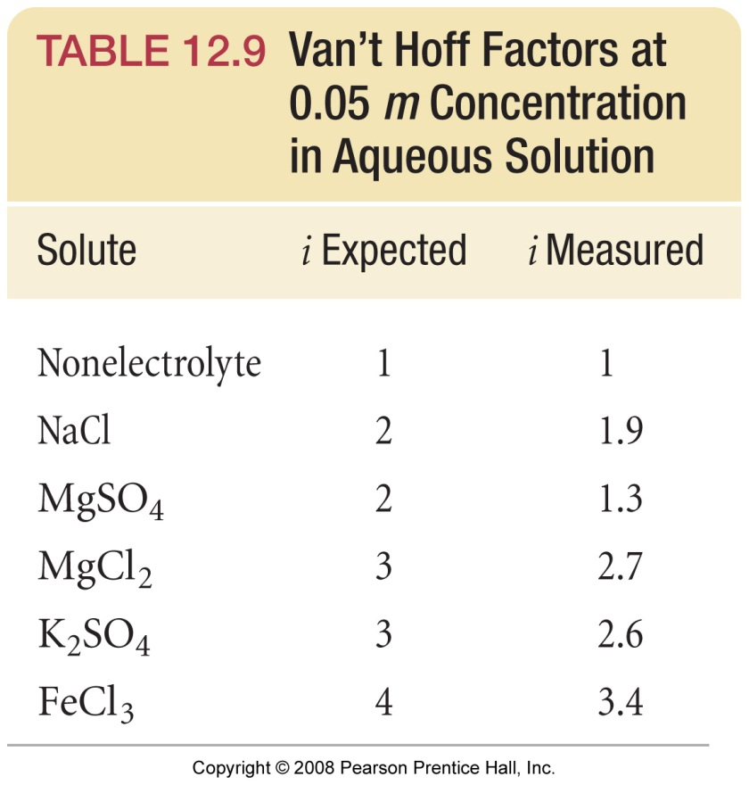

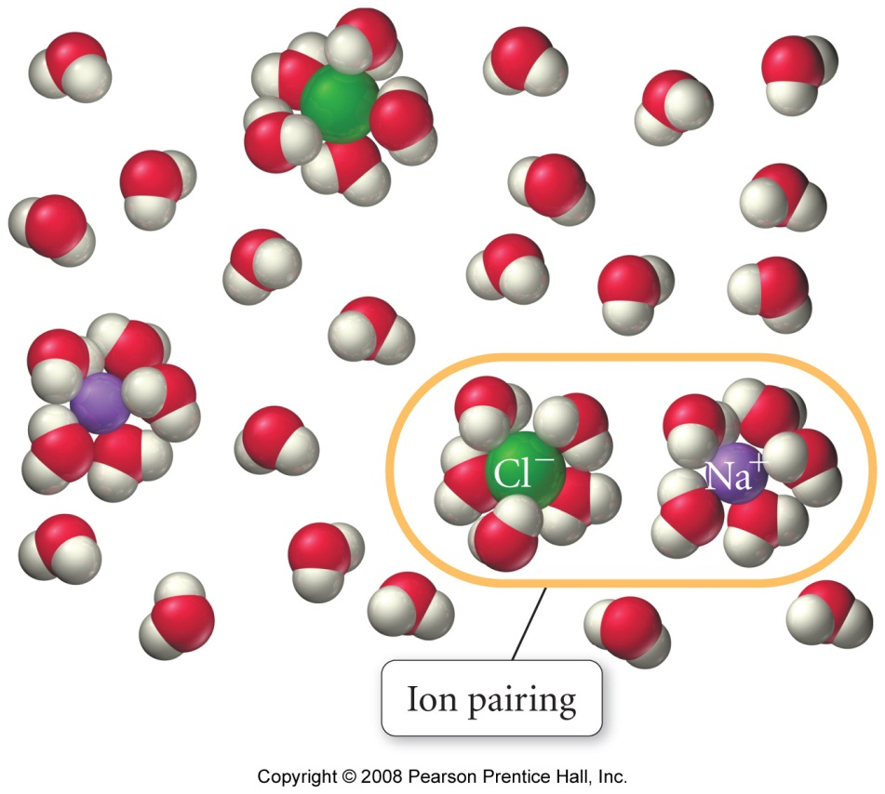

Chemical Kinetics 1

Reading: | Ch 13, sections1 - 2 | Homework: | Chapter 13: 3, 5, 25*, 27, 29*, 31*
* = ‘important’ homework question

Factors that Affect Reaction Rates

General Discussion: Fundamentally speaking, what must happen at the microscopic level during a chemical reaction for ‘new’ chemical(s) to be formed?

Remember Dr. Mills favorite saying……

 |  |  | “Chemistry is a bit like Scottish soccer – it’s basically a bunch of round things bumping into one another”
One time British soccer icon ‘Gazza’ with a gyro |  |  |  | Gazza playing out his career with Glasgow Rangers
A fixed fraction of all molecular collisions are fruitful.

These fruitful collisions result in the formation of ‘new’ product species

Question: What would happen to the rate of reaction (i.e. the speed of the reaction) if the number of molecular scale collisions among the reactants were:

a. Increased? | b. Decreased?

Always remember that the speed (or rate) of a chemical reaction is directly proportional to the number of molecular* collisions per second occurring among the reactants – some fixed fraction of which will be fruitful

Discussion: Which macro scale variables (i.e. in lab) can chemists alter to ultimately increase the number of molecular collisions among chemical reactants per second; thereby increasing the reaction rate? List them:

1. | 2.
3. | 4.
1. Concentration of Reactants

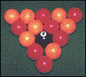 | Observation: Which would result in a greater number of ball-on-ball collisions – your break in 9-ball or ‘regular’ 15-ball pool? Why?

2. Presence of a catalyst

Discussion: What is a catalyst / what does a catalyst do?

Example: the Pt/Pd catalyst in your car’s muffler, a two-way catalyst

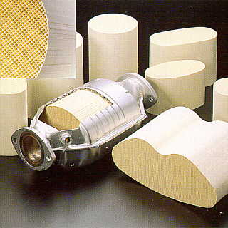 | Questions: Which two ‘unpleasant’ gasses are produced through the incomplete combustion of gasoline? How are these gases converted to more benign products?
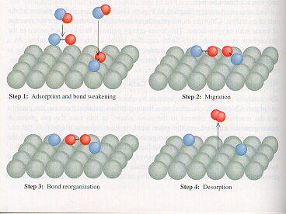

3. Temperature at which the reaction occurs

Discussion: What happens to the rate of molecular collisions (therefore the rate of reaction) when the temperature of the reaction vessel is increased? Why?

The kinetic energy (K.E.) of a molecular* species is proportional to the ambient temperature.

Molecular KE = ½ mv² = kT (k is the Boltzmann constant)

i.e. Temp ∝ v² ∝ (reaction rate)²

4. Surface Area of a Solid Reactant

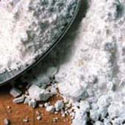 | Why does powdered sugar dissolve much more quickly than ‘trendy’ crystalline sugar swizzles? What’s happening on the micro scale?

Definition of Reaction Rate

Discussion Questions

1. How do you know that a reaction is occurring or has finished?

2. How then, would you measure the speed (or rate) of reaction? Hint: How is rate of distance traveled (speed) measured by your car’s ‘speedo’?

Definition of Reaction Rate

3. How would you define ‘reaction rate’ or ‘rate of reaction’ mathematically? Hint: Think about expressing rate of change in calculus.

Example: The decomposition of dinitrogen pentoxide

2 N₂O₅ (g) → 4 NO₂ (g) + O₂ (g)

The rate of reaction can be expressed in terms or either the decrease in [N₂O₅] with time or the increase of [NO₂] or [O₂] with time.

Task: write calculus style relationships illustrating the above

Rate of formation wrt. O₂ =

Rate of formation wrt. NO₂ =

Rate of loss wrt. N₂O₅ =

Application: AVERAGE reaction rates

Average reaction rates are ‘as advertised’ - the average speed (rate) of a reaction over an extended (measurable) period of time

Worked Example: If it takes 32 seconds to see the appearance of 2 moles O₂ (g) (within a 1.0 L container) from the above reaction, what is the average rate of reaction over this time period?

Difference is always found by subtracting the initial condition from the final condition in chemistry problems

i.e: Δ(variable) = final value variable – initial value variable

Calculations

Δ [O₂] =

Δt =

⇒ Average rate of reaction = | Δ [O₂] | =
 | Δt

Note: The unit for rate of reaction is always mols L⁻¹/s (mols L⁻¹ s⁻¹)
Instantaneous Rates of Reaction

Analogy: The difference between average and instantaneous rates

Average rate analogy: It takes ~60 minutes to travel the 60 miles from JJC to downtown Chicago. What is the average speed during the journey?

Instantaneous rate analogy: Is it likely that you will travel at exactly 60 miles/hr for the entire duration of the journey?

Open road speed ≈

Congested expressway speed ≈

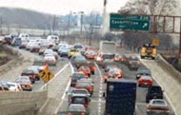

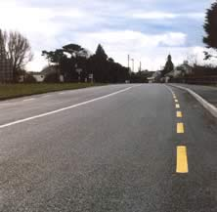

Discussion: How would you expect the instantaneous rate of reaction to vary through the course of any reaction? What molecular level events are responsible for this trend?

Generic Graph of Concentration Reactant v Time for a chemical reaction

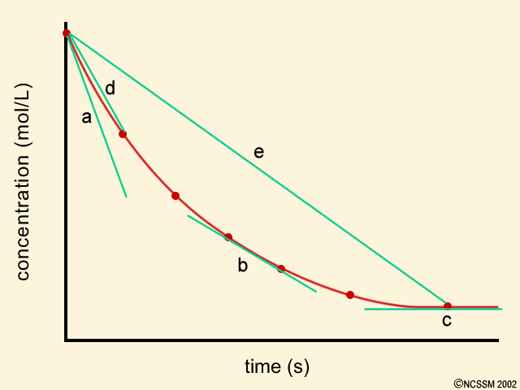

Features of the graph

Discussion: If the [reactants] decreases with time for any reaction (above), then: 1) How does [products] vary with time? 2) How does the rate of formation of products vary with time?

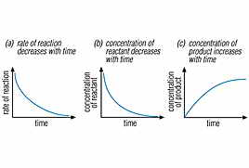
Overview Example: Graph of product conc. v time – measuring the rate of HI (g) formation and the rate of H₂ (g) disappearance for the reaction:

H₂ (g) + I₂ (g) → 2 HI(g)
i.e.
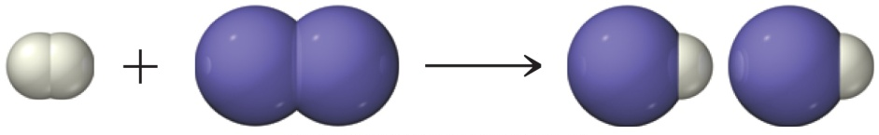
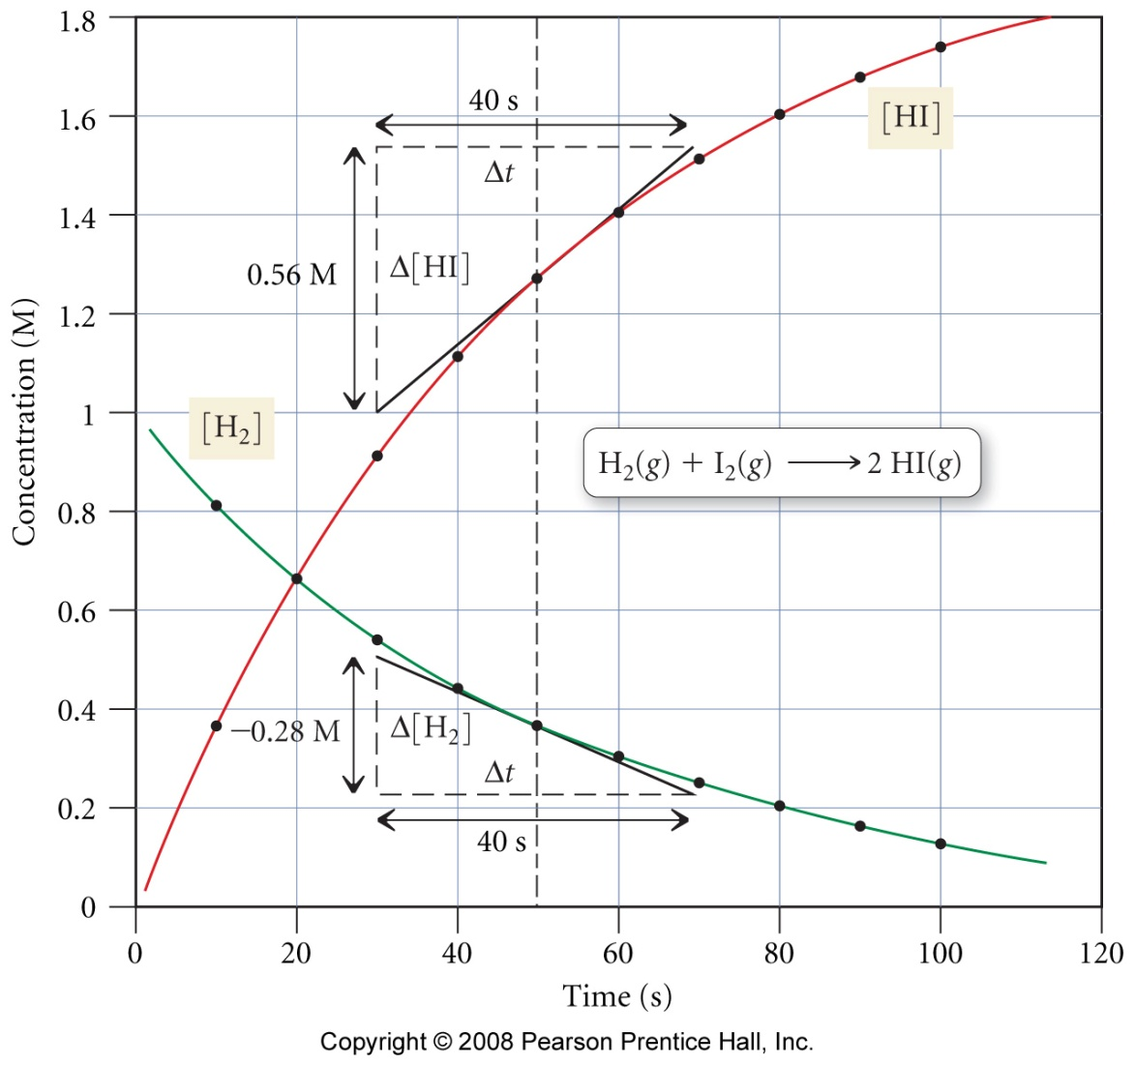
General Features of the graphs

Calculating the instantaneous rates of reaction

Recap: While a ‘true’ instantaneous rate can only be found by determining the exact gradient (slope) of the rate of reaction ([conc] v time) graph at a specified time (how?), a good approximation can be found through

either:

Graphical Method: Draw a tangent line to the experimental rate of reaction graph at the time of interest, and then find its gradient (by hand, or modern computer programs and/or graphical calculators can also do this)

Task: Use the ‘graphical’ method to find the instantaneous rate of reaction at t= 50 seconds in terms of change in [HI] with time

or

Equation of a Line Method: Use the equation of a line equation, i.e. y₂ – y₁ = m(x₂ – x₁), to solve for the gradient of the curve (m) given a pair of adjacent experimental data points

Determine Δ[conc] and Δt values using ‘equidistant’ data points either side of the required time. Divide these determined values to find the instantaneous rate at the desired time

Task: Use the ‘equation’ method to find the instantaneous rate of reaction at t= 50 seconds in terms of change in [H₂] with time (see p 566 or appendix for data table). Discussion: why are your two answers different (more later)?

Wrap Up Example: Consider our previous example (see p 566 and appendix for graph and data table).

H₂ (g) + I₂ (g) → 2 HI(g)

Experimental: As you will discover in lab, for most kinetic studies the concentration of a reactant, or product, is monitored with time; i.e. [conc] values are recorded at for a series of regular time intervals during the experiment. This raw data is then either used directly or plotted as a standard ‘reaction rate’ or [conc] v time graph shown here – see HWK for examples.

Wrap up: Using the tabulated experimental data and/or graph from p 566 of Tro (see appendix too), determine the instantaneous rate of the reaction, with respect to the disappearance of H₂(g), at t = 80 s.

Summary:

The instantaneous rate of reaction is a measure of either the rate of change of [reactant] or [product] at a fixed point in time (some fixed time after the reactants are mixed)

The instantaneous rate is found by determining the slope (gradient) of the [conc] v time reaction rate graph at a specified time after the reaction has commenced.

Reaction Rates and Stoichiometry

Discussion: For the reaction:

C₄H₉Cl (aq) + H₂O (l) → C₄H₉OH (aq) + HCl (aq)

Is the rate of appearance C₄H₉OH (aq) = rate of appearance HCl (aq)? How do you know? Write a rate expression illustrating this relationship

Is the rate of disappearance C₄H₉Cl (aq) = rate of disappearance H₂O (l)? Write a rate expression illustrating this relationship

Write a rate expression illustrating the relationship between the rate of disappearance C₄H₉Cl (aq) and the rate of appearance HCl (aq)

Stoichiometric factors (balancing numbers) indicate the relative number of molecules (∝ [conc]) of a reactant or product that are consumed or formed, respectively, per unit time for any reaction

Example: For the reaction:

2 N₂O₅ (g) → 4 NO₂ (g) + O₂ (g)

The rate of reaction can be expressed in terms of either [N₂O₅], [NO₂] or [O₂]

Does [NO₂] increase at a faster, slower, or at the same rate as [O₂]? Express this relationship as a rate expression

Does [N₂O₅] decrease at a faster, slower, or at the same rate as [O₂]? Express this relationship as a rate expression

Balanced chemical equations and rates of reaction are related via the following generic expressions:

For aA + bB → cC + dD

Rate = | -1 | Δ[A] | = | -1 | Δ[B] | = | 1 | Δ[C] | = | 1 | Δ[D]
 | a | Δt |  | b | Δt |  | c | Δt |  | d | Δt

“Expressing reaction rates”

The following question was taken from your 1st practice midterm:

The reaction between hydrogen and nitrogen to form ammonia is known as the Haber process:

N₂ (g) + 3H₂ (g) → 2NH₃ (g)

Question 1a (3 points each): Express the rate of the above reaction in terms of changes in [N₂] with time, [H₂] with time, and [NH₃] with time.

Question 1b (16 points): When [H₂] is decreasing at 0.175 molL⁻¹s⁻¹, at what rate is [NH₃] increasing?

Appendix
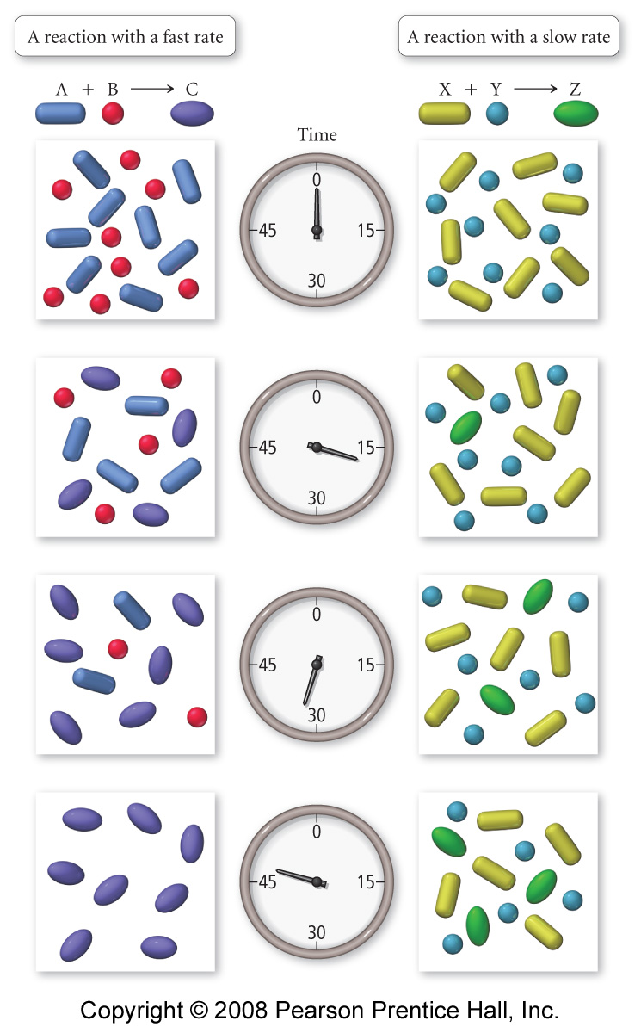

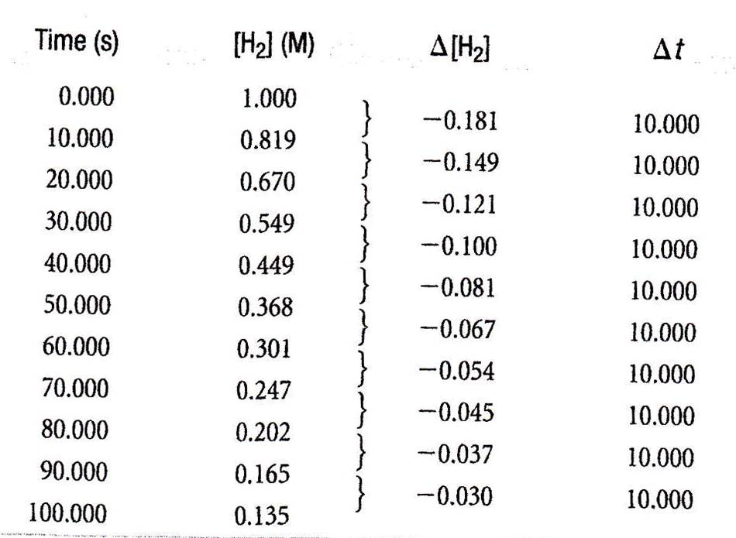

Chemical Kinetics 2

Reading: | Ch 13 sections 3-4 | Homework: | Chapter 13: 33, 35*, 37, 39*, 41*, 43, 47*, 49*, 51*
* = ‘important’ homework question

Either the concentration of reactants or the temperature at which a reaction occurs is typically varied when performing kinetic studies.

Concentration (the rate equation / initial rate method) and temperature effects (the Arrhenius equation) will be covered separately in ‘Chemical Kinetics 2’ & ‘Chemical Kinetics 3’, respectively.

Concentration and Rate – The Initial Rate Method

Recap: What happens to the rate of any reaction when [reactants] is increased? What fundamental microscopic events lead to this macroscopic observation?

Overview: The initial rate method involves measuring the initial rate of reaction (gradient of the [conc] v time plot at t=0) of either the disappearance of reactant(s) or the initial rate of appearance of product(s) for a set of experiments featuring reactants of various starting concentrations.

This data allows for the determination of the Rate Law Equation (discussed below). Determining the Rate Law Equation is the primary objective of most kinetic studies.

Recall: Generic Graph of Concentration Reactant v Time for a chemical reaction:

The initial rate of reaction ((a), gradient of the curve at t=0) is typically extrapolated. In contrast, instantaneous rates (b), (c) and (d) are calculated via the graphical and/or tabular methods discussed in ‘Chemical Kinetics 1’. Therefore:

The INITIAL RATE ≈ the INSTANTANEOUS RATE at t= 0

Determining the Rate Law

Discussion:

How would you expect the initial rate of reaction of any chemical process to vary with the concentration of the reactants? Express this with an equation.

Would you expect all of the reactants to be equally important with regard to the overall rate of reaction? Express this with an equation.

A chemical equation and its respective rate law equation are related via the following generic expression:

For: aA + bB → cC + dD

Rate = k[A]^{m}[B]^{n}

Graphical Examples (details later)

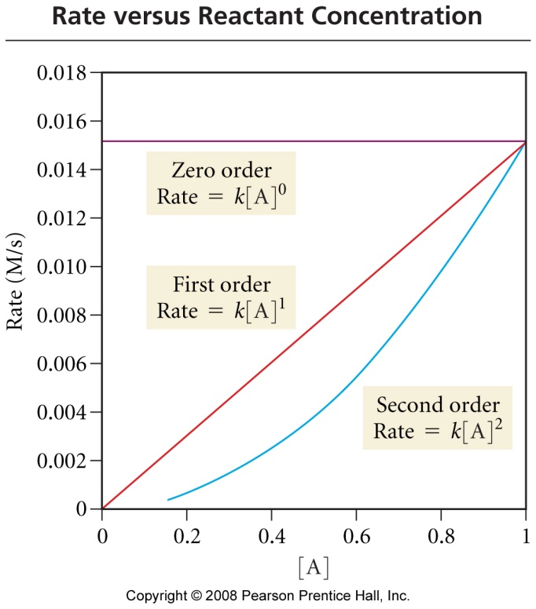 |  | 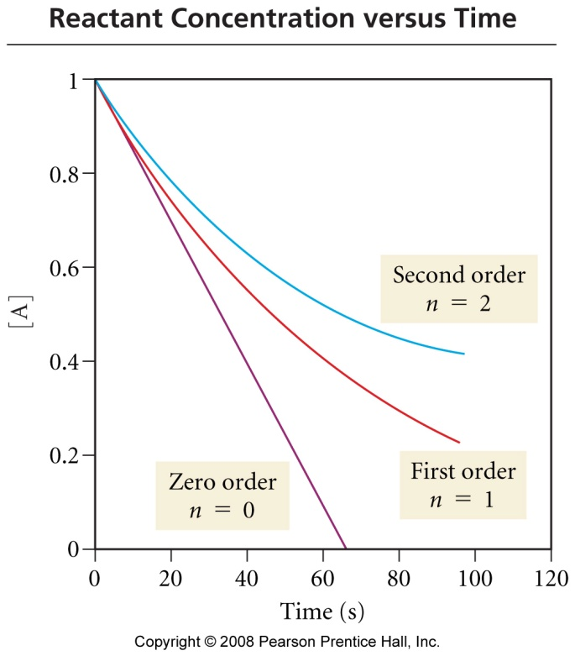
Where:

(initial) rate of reaction = | Δ [Chemical]
 | Δt
k = | Rate constant – determined from initial rate data
[A], [B] = | Reactant concentrations
m, n = | Experimentally determined (from initial rate data) reactant ‘orders’. The stoichiometic constants (a, b etc) are not the same as the order determined for their respective concentrations (e.g. [A]^{m}, [B]^{n}) although they may coincidently have the same numerical value (0, 1 or 2)

The Rate Law is an equation that relates the rate of reaction to the [reactant(s)] raised to various powers ([reactant(s)]^{n}).

The power to which each [reactant] is raised is known as it’s ‘order’. The larger the order, the more the [reactant] influences the overall rate of reaction

Orders values are typically determined to be 0, 1, or 2. Non-integer values are occasionally encountered, but this is rare

The rate law can only be determined through initial rate data obtained experimentally

Worked Example:

For the reaction: A + B → C, the following data was obtained experimentally:

Experiment# | [A] | [B] | Initial rate (M/s)
1 | 0.100 | 0.100 | 4 x 10⁻⁵
2 | 0.100 | 0.200 | 4 x 10⁻⁵
3 | 0.200 | 0.100 | 16 x 10⁻⁵

Find: | a. | The rate law expression for this process
 | b. | The numerical value and units of the rate constant, k
 | c. | The rate of reaction when [A] = 0.05M and [B] = 0.10M

‘Right off the bat’ - by looking at the table, which reactant has the biggest affect on the initial rate of reaction?

Which reactant has no affect on the initial rate of reaction?

What does this mean in terms of what’s happening on the microscopic level?

Game Plan: Assume Rate = k[A]^{m} [B]^{n}, then:

1. | Determine the values of m and n through ‘observation’ (easy problems) or by manipulating rate law expressions for specific experimental sets – ‘math’ method
2. | Find k via ‘insert and evaluate’ for an experimental data set
3. | Use the completed rate law expression to find reaction rate when  [A] = 0.05 M and [B] = 0.10 M

1. Finding the order of reaction with respect to each reactant

To find the order of reaction for a reactant, two experimental data sets must be compared. This can be done in either of two ways - via ‘Math’ or though simple ‘Observation’

- ‘Mathematical’ Method for Determination of Reaction Orders

Substitute values of [reactant] and initial rate directly into the respective rate expressions for a pair of experimental data sets (Note: the first data set is usually the ‘denominator’ – see below example)

Divide these two equations by one another to find the value of the order of reaction for a reactant.

Repeat the process for remaining data sets in order to determine each order of reaction for each reactant

Walk through Recall that: Rate = k [A]^{m} [B]^{n} (just substitute the numbers)

(2)

(1)

Now, for the missing order, divide a pair of data sets where the required reactant’s conc. is altered:

(3)

(1)

B. ‘Observation’ Method for Determination of Reaction Orders

For easy numbers (like those in the example) simply use the following relationship for a pair of experimental data sets:

(Factor [reactant] is multiplied) ^{order wrt that reactant} | = | Factor rate is multiplied

Note: This method ONLY works if one [reactant] is varied (by an integer multiple) with all other [reactant(s)] remaining fixed.

e.g: For experiments (1) and (3)

[A] is doubled, while [B] remains constant. The rate increases by a factor of x4 between the two data sets (4 x 10⁻⁵ M/s compared to 16 x 10⁻⁵ M/s)

Therefore:

2^{m} = 4

Question: What is the value of m, i.e. the order wrt [A]?

Answer:

Task: Analyze data sets 1 and 2, determine the order of reaction wrt [B]

The ‘orders’ can now be included in the rate law expression:

i.e. Rate = k[A]²[B]⁰

The reaction is said to be ‘second order wrt A’ and ‘zero order wrt B’

Discussion: What does this statement mean in terms of how each reactant affects the overall rate of reaction? Recall previous graphs.

The reaction is said to be ‘second order overall’.

Discussion: How is the overall rate of reaction related to the individual orders of reaction for each reactant?

2. Finding the numerical value and units of k (the rate constant)

A. Substitute values of initial rate, [reactant(s)] and respective order(s) from any experimental data set into the rate expression.

B. Rearrange the equation obtained to make k the subject. Solve for k. Keep the units of each quantity in the equation – these will be determine the units of k

Note: Since the order of reaction wrt B is zero it can now be excluded from the rate expression. Why?

rate = | k [A]²
k = | rate
 | [A]²

Substituting values from Experiment #1(line 1):

k = | 4.0 x10⁻⁵ M/s
 | [0.100M]²
= | 4.0 x10⁻³ M⁻¹/s

UNITS:

The units of k depend on those of the other variables – be sure to derive the units of k work them out each time you find its numerical value

3. Use the completed rate law expression to find reaction rate for defined values of [A] and [B]

The complete quantitative form of the rate equation can now be written out – simply substitute values for k and the orders wrt each reactant into the equation’s generic form:

Rate = k[A]^{m} [B]^{n}

Rate = 4.0 x10⁻³ M⁻¹/s [A]²

Task: Determine the rate of reaction when [A] = 0.05 M and [B] = 0.10 M

The rate of reaction for any condition of [reactant(s)] can be determined from the quantitative form of the rate equation - simply ‘insert and evaluate’.

Note: Recall that the units of reaction rate are always M/s

ANS = 1.0 x10⁻⁵ M/s

Task: Determine the quantitative rate law expression, including the numerical value of k, for the following process:

H₂O₂ (aq) + 3I⁻ (aq) + 2H⁺ (aq) → I₃⁻ (aq) H₂O (l)

Initial rate data:

Experiment | [H₂O₂] | [I⁻] | [H⁺] | Initial rate (M/s)
1 | 0.01 | 0.01 | 0.0005 | 1.15 x10⁻⁶
2 | 0.02 | 0.01 | 0.0005 | 2.30 x10⁻⁶
3 | 0.01 | 0.02 | 0.0005 | 2.30 x10⁻⁶
4 | 0.01 | 0.01 | 0.0010 | 1.15 x10⁻⁶

Recall: rate = k [H₂O₂]^{m}[I⁻]^{n}[H⁺]^{p}, so values for each order (n, m and p) must be determined.
Concentration and Rate – Integrated Rate Law Expressions

Recap: The initial, average and/or ‘instantaneous’ rate(s) of reaction are calculated by finding the gradient of the experimentally determined [conc.] v time plot by either:

Finding the gradient of a tangent line applied to the data at the point of interest or

Finding the gradient between a pair of data points straddling the point of interest

Recall: initial rate and [reactant] data acquired for a series of experimentally determined [conc.] v time plots are utilized in the determination of the reaction’s respective rate law expression:

Generically: | aA + bB → cC + dD | Rate = k[A]^{m}[B]^{n}

Discussion: Consider the following simple, generic decomposition reaction:

A → B

For such a reaction, which is typically either first or second order, the following respective rate expressions would apply:

1st order rxn: | Rate = k[A]¹ | 2nd order rxn: | Rate = k[A]²

Which reaction would proceed at a faster rate (assuming k was similar in each case) – the 1st or 2nd order process? Why?

In the boxes below, sketch simple [reactant] v time plots for chemical processes that are 1st and 2nd order overall, respectively. Recall previous slides.

First order overall |  | Second order overall

First order processes have ‘shallow’ rate of reaction curves

Second order processes have ‘steep’ rate of reaction curves

Discussion: Which mathematical functions (when graphed) have similar features to the first and second order rate of reaction curves?

First and second order reaction processes may be described by y = e^{-x} and y = ¹/_{x} functions, respectively

Linear (y = mx + b) versions of either the first or second order rate plots may be obtained through integration of their respective line-shapes.

These important results yield equations that allow k and [reactant] to be found at any time during the reaction

Integrated Rate Equation for 1st Order Reactions

Process: A → B | Rate | = | - Δ [A] | = | k[A]¹
 |  |  | Δt

Derivation:
Result: ln [A]_{t} - ln [A]₀ = -kt or ln [A]_{t} = -kt _{t} + ln [A]₀

Interpretation:

ln [A]_{t} | = | -kt | + | ln [A]₀
y | = | mx | + | b

A plot of In (or log₁₀) [reactant] v time will yield a LINEAR plot for a 1st order process.

The plot will have a slope of -k and an intercept of ln[A]₀ (natural log of [reactant] at t=0)

Generic Graph

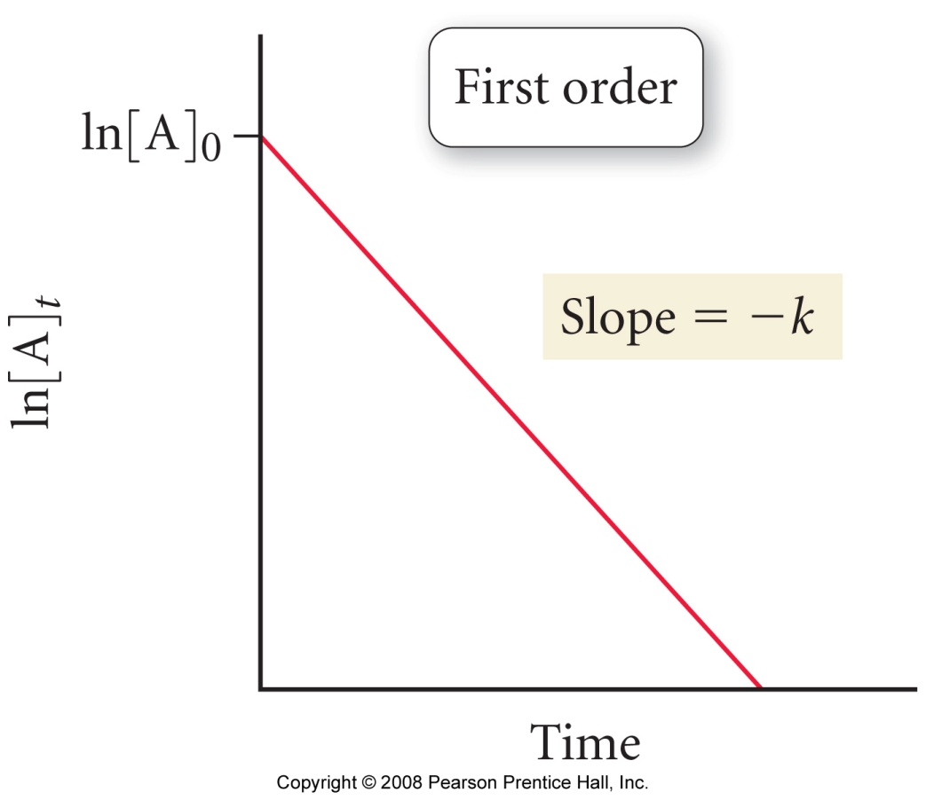

Example (p581 & appendix): the decomposition of SO₂Cl₂

SO₂Cl₂ (g) → SO₂ (g) + Cl₂ (g)
Integrated Rate Equation for 2nd Order Reactions

Process: A → B | Rate | = | - Δ [A] | = | k[A]²
 |  |  | Δt

Derivation:

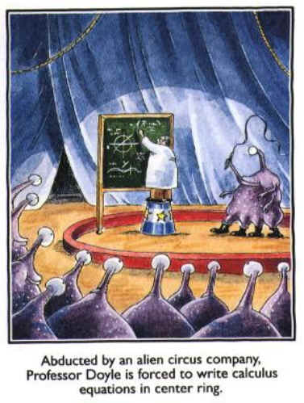

Result: | 1 | = | kt | + | 1
 | [A]_{t} |  |  |  | [A]₀

Interpretation: | 1 | = | kt | + | 1
 | [A]_{t} |  |  |  | [A]₀
 | y | = | mx | + | b

A plot of 1/[reactant] v time will yield a LINEAR plot for a 2nd order process.

The plot will have a slope of k and an intercept of 1/[A]₀ (reciprocal of [reactant] at t=0)

Generic Graph

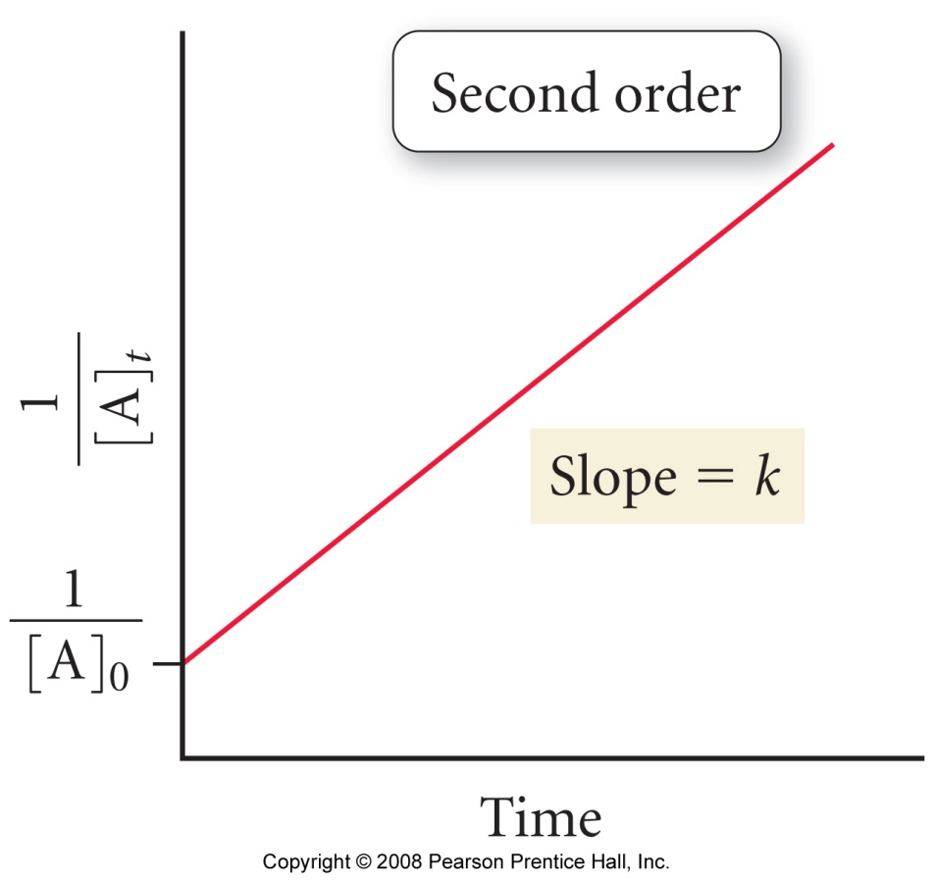

Example (p 583 & appendix): experimental data for the decomposition of nitrogen dioxide
2 NO₂ (g) → 2 NO (g) + O₂ (g)

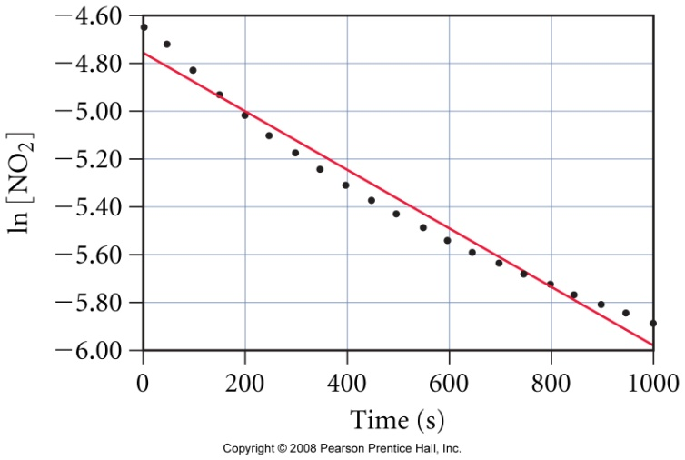 | 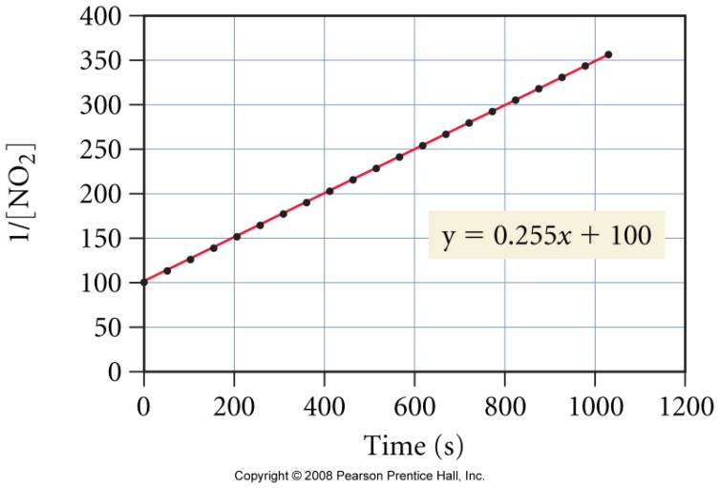
1st order plot is non liner – reject | 2nd order plot is liner – ‘good to go’!

Worked Example: For the reaction:

2 N₂O₅ (g) → 4 NO₂ (g) + O₂ (g)

The following data was acquired via an initial rates experimental analysis:

Rate = k [N₂O₅]¹, where k = 4.8 x 10⁻⁴ s⁻¹

Task: If the initial concentration of dinitrogen pentoxide is 5.0 x 10⁻³ M, what is this reactant’s concentration after 625 seconds?

Discussion: How would you solve this problem (there are two methods)?

Plan and execution:

ANS: 3.7 x 10⁻³ M

Reaction Half-Life

Discussion: What do you understand by the phrase ‘half-life’

Relationship between [reactant] and time for 1, 2 and 3 half-lives
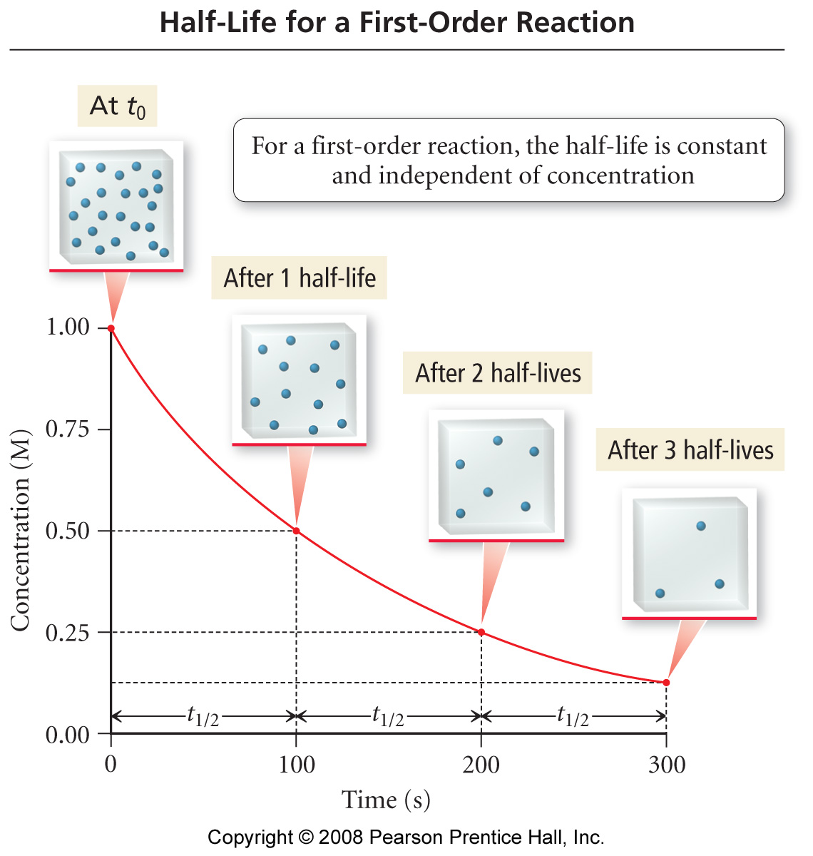
Half–life expressions

By definition, the [reactant] ([A]_{t}) is exactly half it’s initial value ([A]₀) after one half-life for any reaction.

This fact allows for relationships between half-life (t_{½}), k and (for second order processes) [A]₀ to be determined

Derivation: 1st order reactions

Task: Derive an expression for the half-life of a 2nd order process in terms of k and [A]₀
Summary: (p 587 & appendix)

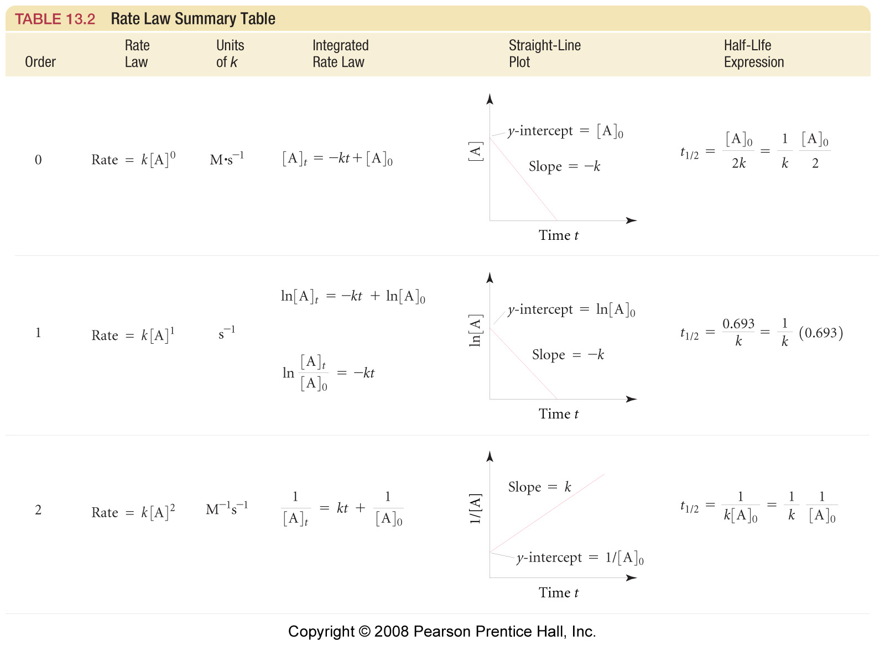
Example: For the reaction:

SO₂Cl₂ (g) → SO₂ (g) + Cl₂ (g)

Assuming the reaction is first order overall and k = 2.20 x 10⁻⁵ s⁻¹, then:

1. What is the half-life of SO₂Cl₂ (g)?

2. How long would it take for 50% of the sample to decompose?

3. How long would it take for 75% of the sample to decompose? Trick??

“Standard question”

The following question is a great example of the type asked on standardized tests like the MCAT etc. As is often the case, once you know the trick they are easy….

Question (14.19)

For the reaction: A + B → C

The rate equation has the form: rate = k [A]^{x}. What is the value of x if:

- The rate triples when [A] triples?

- The rate increases eightfold when [A] is doubled?

- There is no change in rate when [A] is tripled?

Discussion: What is the ‘trick’ (i.e. what underlying theory is being tested?)

“Initial rates”

The following question was taken from your 1st practice midterm:

Consider the generic reaction:

A + B + C → D

Assuming the above reaction was analyzed using the initial rate method at 25ºC, use the data below to determine:

- The order of reaction with respect to each reactant and the overall order of the reaction. Summarize your findings in the form of a complete rate equation.
- The value of k at this temperature.
- What is the rate of reaction when the concentrations of each reactant is 0.50 M,

Experiment | Initial concentrations (molL⁻¹) |  |  | Initial rate
 | A | B | C | (molL⁻¹s⁻¹)
1 | 0.10 | 0.10 | 0.50 | 1.5 x 10⁻⁶
2 | 0.20 | 0.10 | 0.50 | 3.0 x 10⁻⁶
3 | 0.10 | 0.20 | 0.50 | 6.0 x 10⁻⁶
4 | 0.10 | 0.10 | 1.00 | 1.5 x 10⁻⁶

“Half - life”

The following question was taken from your 1st practice midterm:

Question 3a (10 points): The decomposition of N₂O₅ (g) is a first order process:

2N₂O₅ (g) → 4NO₂ (g) + O₂ (g)

The concentration of N₂O₅ (g) may be monitored with time using a simple diode colorimeter. If, during such an experiment, k is determined to be 5.2 x 10⁻⁴ s⁻¹, then what is the half-life of the reaction measured in minutes?

Question 3b (15 points): If, in the above experiment, an absorbance of 0.84 is recorded immediately prior to the commencement of N₂O₅ (g) decomposition (i.e. at t = 0), then what absorbance value will be recorded record after exactly one half-life has passed? Recall that Abs ∝ [N₂O₅]

For the above reaction, what Abs value would be detected by the colorimeter after exactly three half-lives had passed?

Appendix

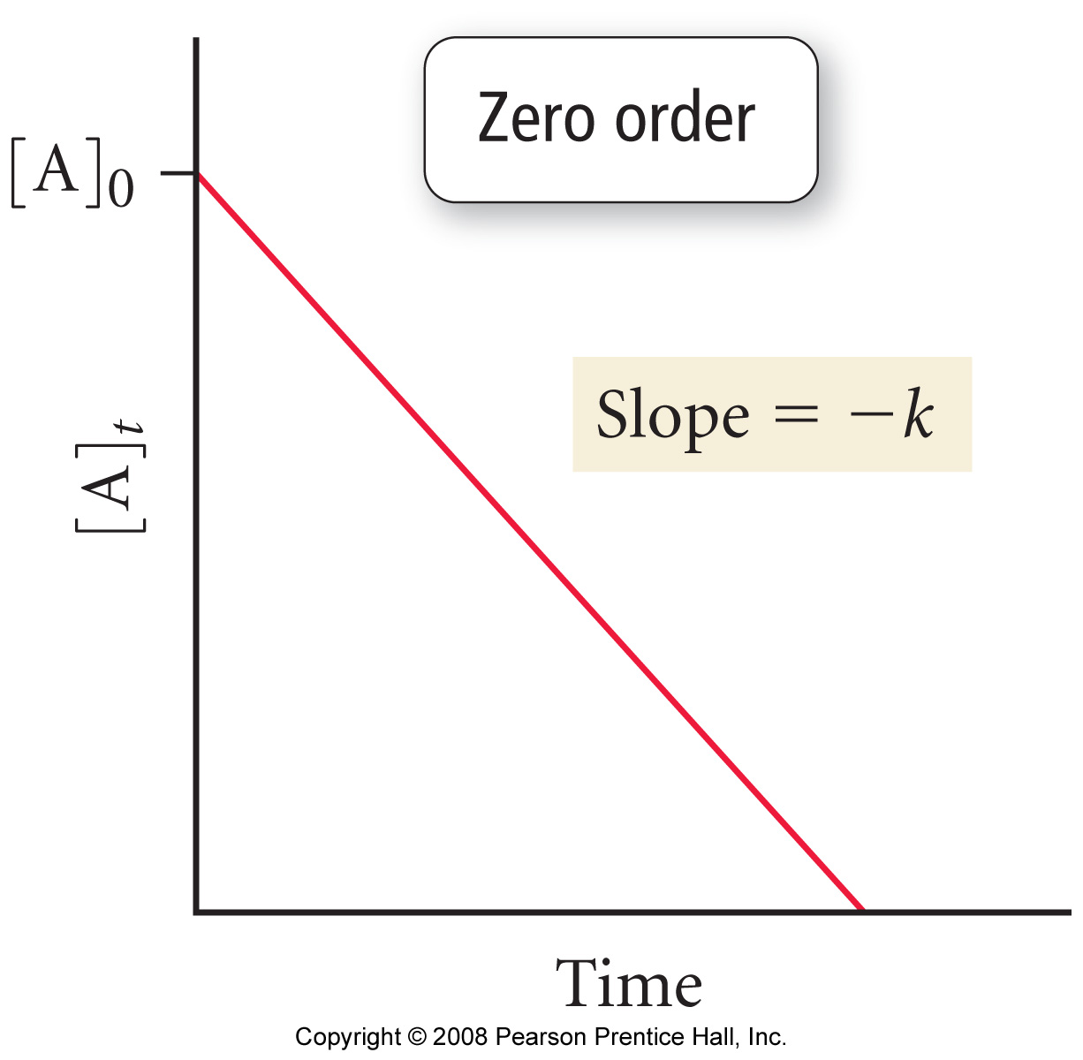
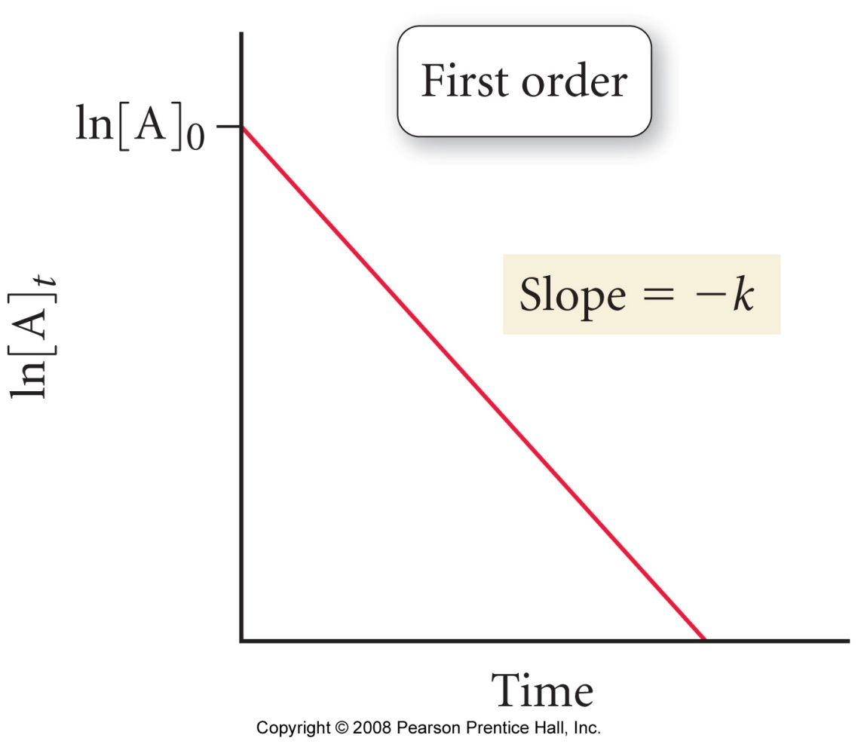

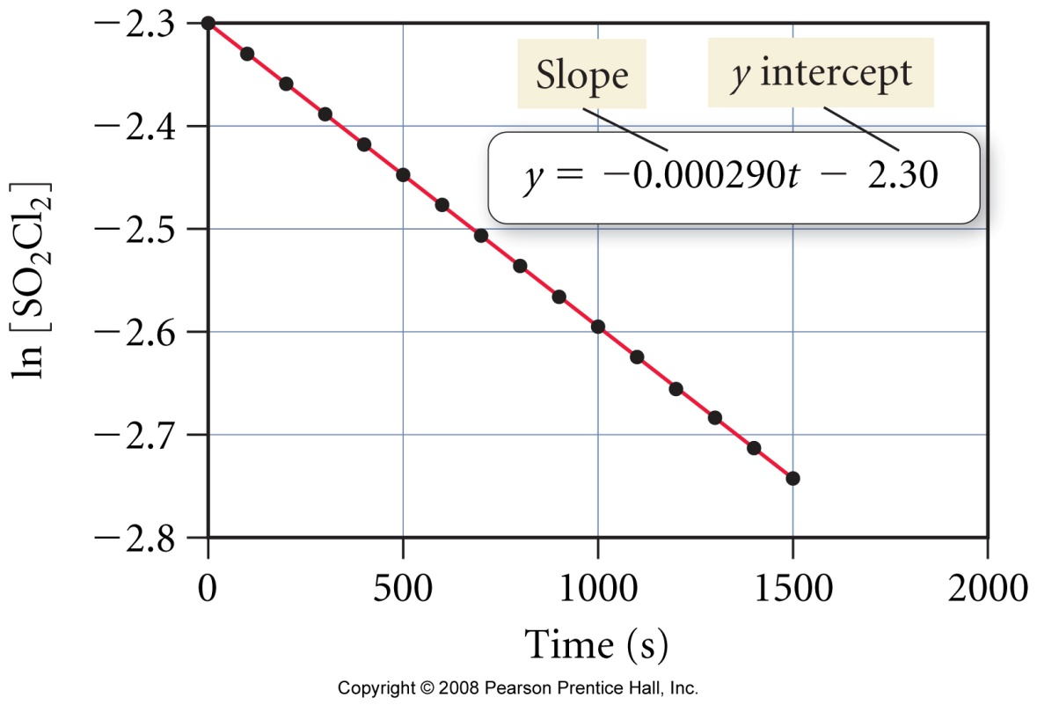
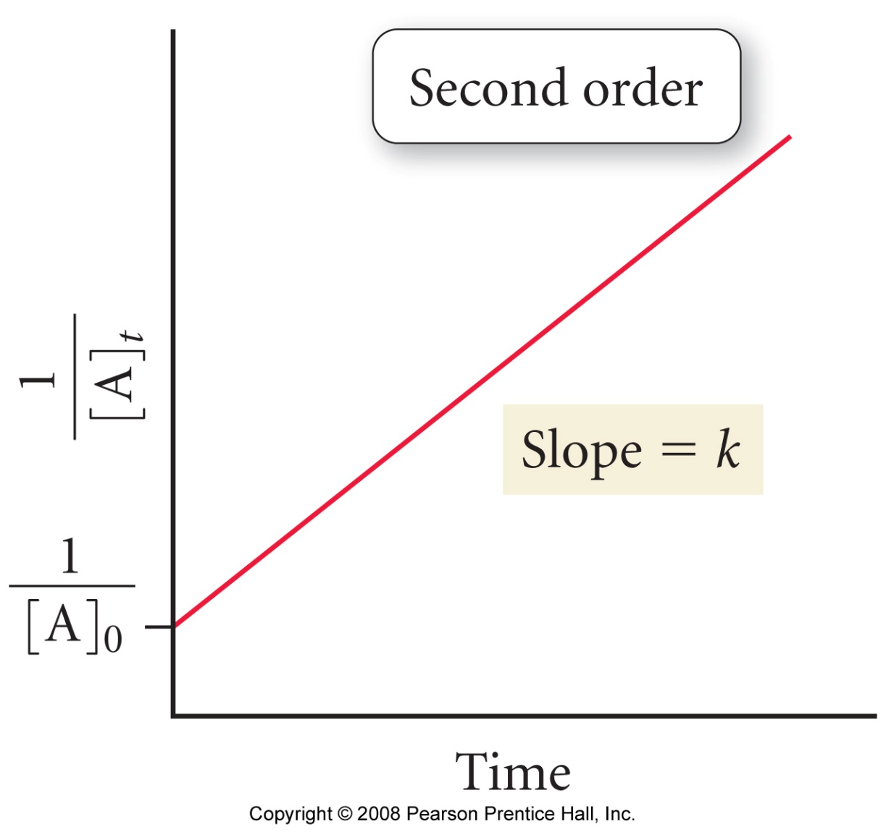

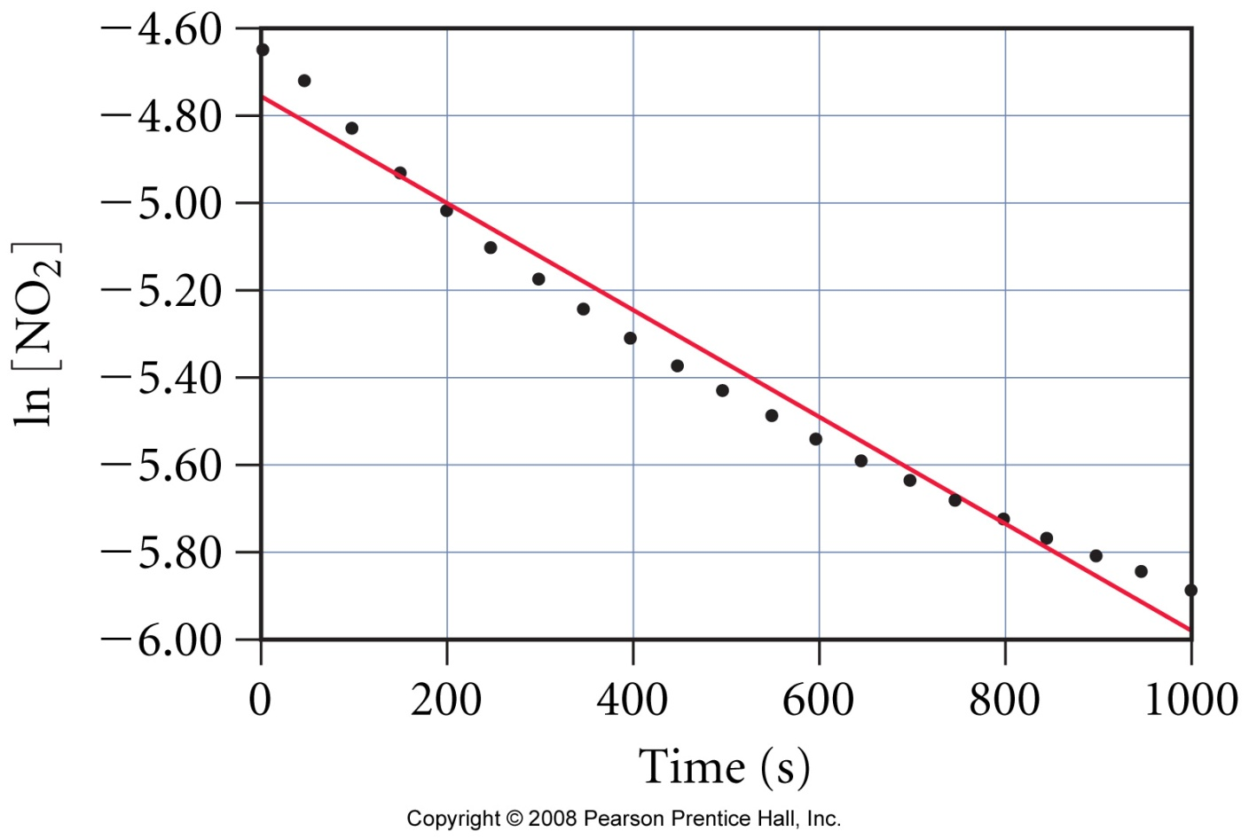
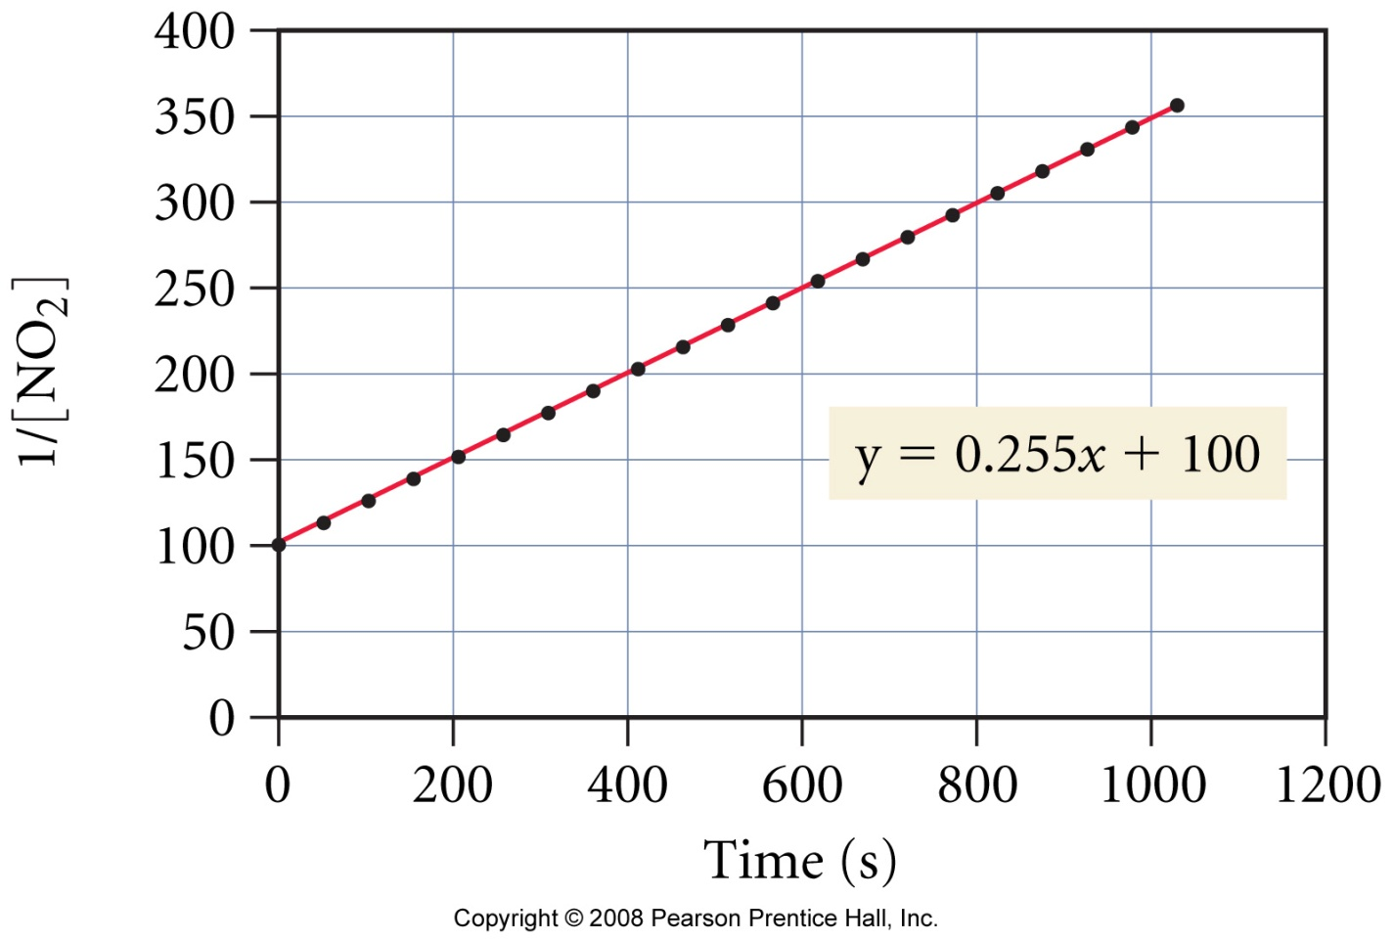

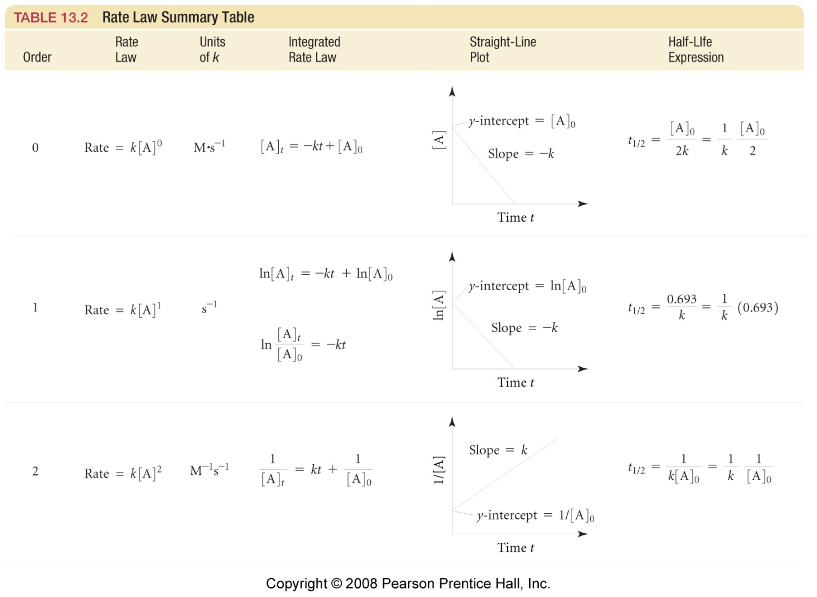

Chemical Kinetics 3

Reading: | Ch 13 sections 5-7 | Homework: | Chapter 13: 57*, 59*, 61*, 63*, 65*, 69, 73, 75 Excel assignment*  (see assignments for link)
* = ‘important’ homework question

Temperature and Rate – Transition State Theory and the Arrhenius
Equation

Background: Recall that the number of ‘fruitful’ collisions per unit time among the reactant(s) determine the overall rate of reaction.

Discussion: What factors determine if a single collision will be fruitful?

1.
2.
3.

The above are the three basic assumptions of collision theory

Collision Theory

For a reaction to occur, the reactant molecules must collide with energy greater than some minimum value (E_{a}) and have the correct spatial orientation. E_{a} is the activation energy.

Recap: At a defined temperature, a reaction rate is described by the rate equation:

Generically: | aA + bB → cC + dD | Rate = k[A]^{m}[B]^{n}
Observation: Rates of reaction typically increase substantially for a relatively small elevation of temperature.

Discussion: How does increasing temperature effect the rate equation?

(see slide of k v temp)

The makeup of k

The three collision theory variables (energy of reactants, frequency of collisions and orientation of reactants), when combined, give rise to the rate constant k. Clearly, the value of k varies with temperature(!)

Mathematically:

k = Zpf | where: | k = rate constant
 |  | Z = frequency of collisions
 |  | p = fraction of molecules with correct orientation
 |  | f = fraction of molecules with E_{a} or greater
Discussion: To what extent are Z, p and f affected by temperature?

Collision Frequency (Z) – recall Chemical Kinetics 1

KE = ½ mv² = kT (k is the Boltzmann constant). i.e. Temp ∝ v²

Reactant Orientation (p)

Random (see slide) – temp has NO effect, some fixed fraction of reactant(s) will have the correct orientation

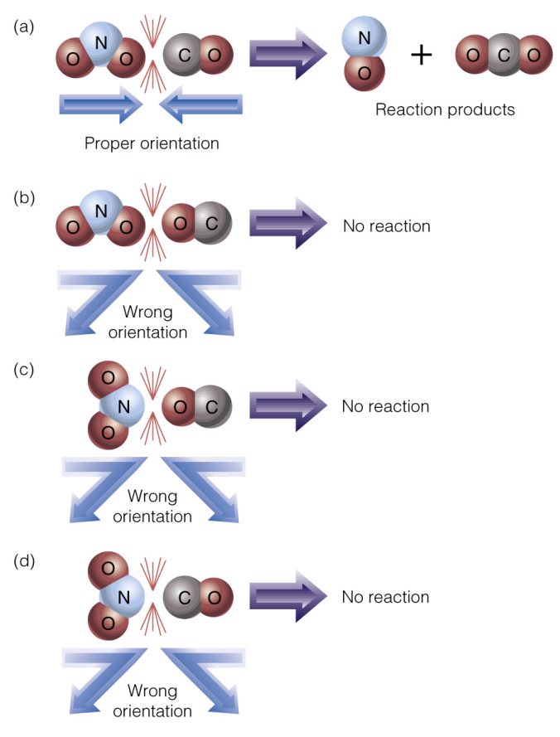 | Transition State Theory  Only reactants colliding with the correct orientation (a) may give rise to an activated complex, or transition state species  The reactants must also have greater than a minimum amount of ‘collision energy’ (E_{a}, see next) in order to form an activated complex (see additional slide).  We will return to this topic later in the handout
Fraction of molecules with E_{a} or greater (f)

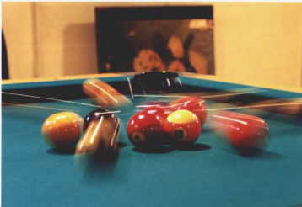 | Q: Do all molecules of a compound have the same speed at, say, room temperature?  A:

The distribution of molecular speeds - the Boltzmann distribution
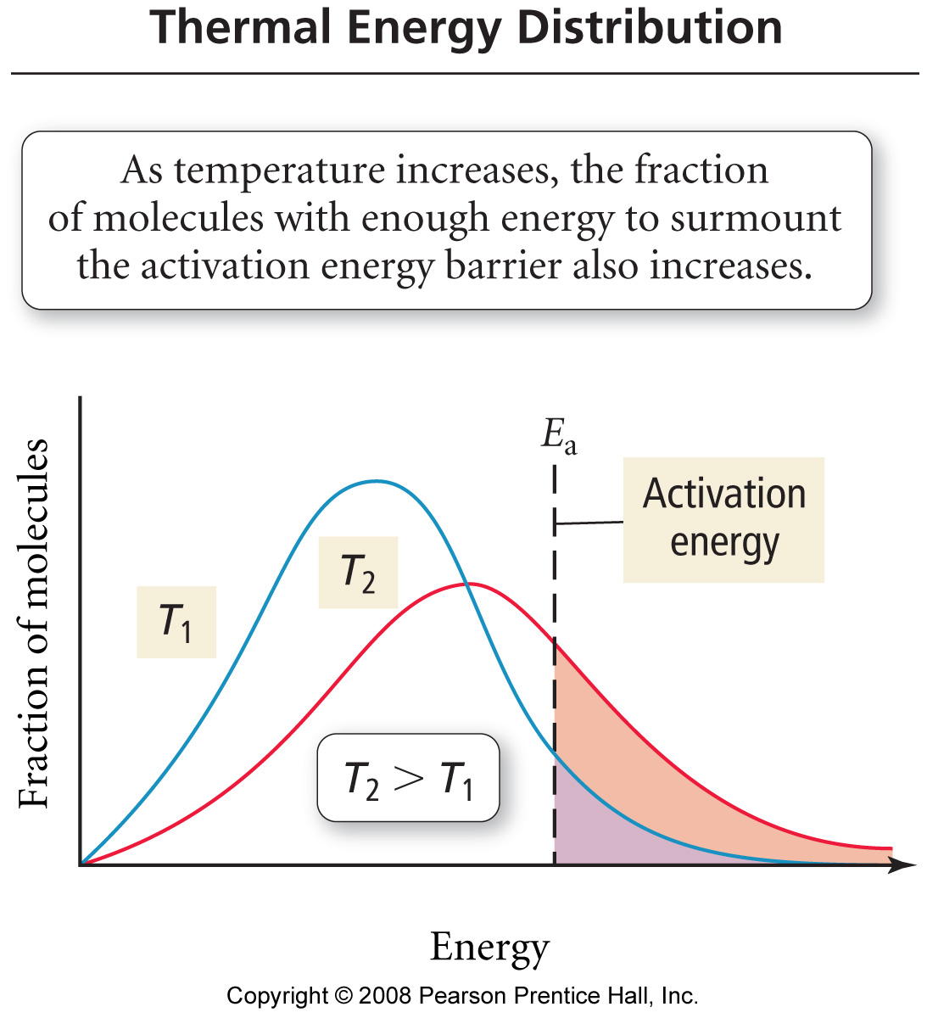

Features

Due to the line shape of the Boltzmann distribution, the fraction of molecules with E_{a} or greater has an exponential relationship with temperature:

Since the fraction of molecules with the correct orientation (p) is fixed and the frequency of collisions (Z) does not vary significantly for a small change in temperature, these two variables are combined into a single constant called the ‘frequency factor’ (A):

The Arrhenius Equation

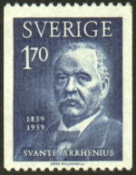 | The Arrhenius Equation combines the above variables and, so, relates k to activation energy and temperature for any reaction  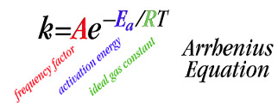

We will return to the Arrhenius equation soon, but first, more on transition state theory and activated complexes….

Definition of an Activated Complex

An unstable grouping of atoms, formed during a fruitful collision, that breaks apart to form reaction product(s)

A short lived activated complex (transition state) is formed during a fruitful collision

The activated complex, once formed, quickly decomposes to give reaction products

The energy needed to form an activated complex is equal to or greater than the respective reaction’s activation energy (E_{a})

“If you think about it, reactions are really all about making activated complexes”

Example: The isomerization of methylisonitrile (see slide and appendix)

CH₃NC (g) → [activated complex ]‡ → CH₃CN (g)

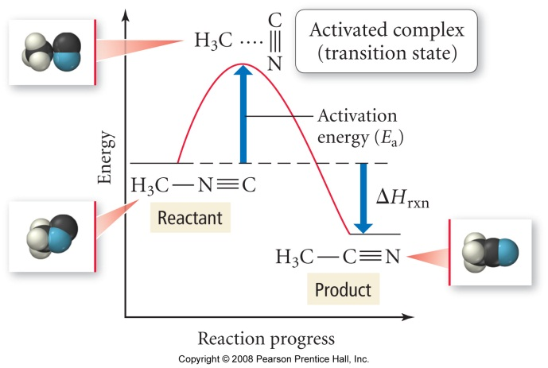
Reaction Pathway (coordinate) diagram | Analogy

“Activation energy gets you over the ‘hump’ needed to start a reaction” - think about this in terms of why you have to strike a match or spark your stove.

A reaction cannot proceed unless the reactants have achieved or surpassed the necessary activation energy (E_{a}) for the chemical process

OK, back to the Arrhenius Equation….

A LINEAR version of the Arrhenius Equation, in terms of k and T, is required to determine the activation energy (E_{a}) for a chemical process.

Derivation: The two linear forms of the Arrhenius equation

Interpretation

ln k | = | -Ea | 1 | + | ln A | OR | ln k₂ | - | ln k₁ | = | -Ea | ⎧1 | - | 1 ⎫
 |  | R | T |  |  |  |  |  |  |  | R | ⎩T₂ |  | T₁⎭
y | = | m | x | + | b |  | (y₂ | - | y₁) | = | m | (x₂ | - | x₁)

A plot of ln k v 1/T (for k determined at different temperatures) for any chemical process will yield a LINEAR plot with slope equal to -E_{a}/R. OR
Two points from the Arrhenius data (ln k₁, 1/T₁) and (ln k₂, 1/T₂) may be used to find E_{a} mathematically

Generic Arrhenius Plot of ln k v 1/T

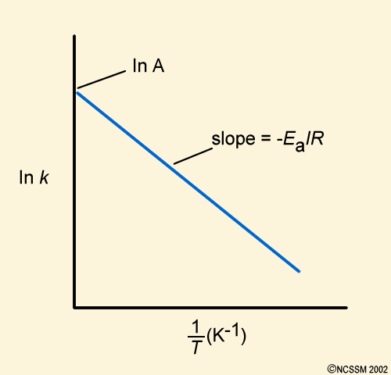

The following data was determined:

Experiment | k | T (K)
1. | 1.05 x10⁻³ | 759
2. | 2.14 x 10⁻² | 836

Questions: What is E_{a}? What is k at 865 K?

Discussion: How would you solve these problems (there are two general methods)?

Plan and execution:

“Standard question”

The following question is a great example of the type asked on standardized tests like the MCAT etc. Again, as is often the case, once you know the trick they are easy….

The rate of a particular reaction is quadrupled when the temperature was increased from 55ºC → 60ºC. What is E_{a} for this process?

Work in groups of 3 or 4 – try to figure out the ‘trick’

Reaction Mechanisms

Definition of Reaction Mechanism: A combination of elementary steps resulting in the formation of product(s) from reactant(s)

Example: The following reaction has a single, bimolecular, elementary step:

NO (g) + O₃ (g) → [NOO₃] ‡ → NO₂ (g) + O₂ (g)

bimolecular – involves the collision of two reactant molecules (NO and O₃)

elementary step – ONE collision or other molecular scale event

molecularity – the number of molecules involved in an elementary step

Note: Reactions can also feature unimolecular (e.g. isomerization of methylisonitrile, any nuclear decay) or (rarely, why?) termolecular elementary steps.

Elementary Steps and their rate laws (fill in the blanks)

Molecularity | Elementary Step | Rate Law
Unimolecular | A → products | Rate = k[A]¹
Bimolecular | A + A → products | Rate = k[A]²
Bimolecular | A + B → products | Rate = k[A]¹[B]¹
Termolecular | A + A + A → products | Rate = k[A]³
Termolecular | A + A + B → products | Rate =
Termolecular | A + B + C → products | Rate =

Discussion: For the above reactions, which feature single elementary steps, do you see any correlation between the molecularity and the overall order in each case?

DANGER! DANGER! WILL ROBINSON…

DO NOT assume molecularity (stoichiometry) and reaction order are numerically identical for all reactions. This IS true for elementary steps, but not for multi-step reactions (discussed below).

Recall from Chemical Kinetics 2 that orders of reaction must be determined from initial rate (experimental) data

Multiple Step Reactions

Most reactions feature two or more elementary steps – these are called multi-step reactions

The mechanism (and balanced chemical equation) for a multi-step reaction is the sum of its individual elementary steps.

Example: The formation of NO and CO₂ from NO₂ and CO

Elementary step 1: NO₂ + NO₂ → NO₃ + NO (slow)

Elementary step 2: NO₃ + CO → NO₂ + CO₂ (fast)

Combine steps: | NO₂ + NO₂ + NO₃ + CO → NO₃ + NO + NO₂ + CO₂

What’s that itch??

Net Reaction:

The overall rate of a multi-step reaction is limited by its slowest single elementary step (the rate limiting step) – this fact was utilized in your recent clock reaction lab. How?

Analogy: A production line is only as fast as its slowest person – “quit showing off Frank, these pies need to go in the oven!”

Catalysis

Background: As we saw in Chemical Kinetics 1, a catalyst speeds up the rate of reaction without being consumed in the process. We discovered that, in part, this is due to the catalyst (be it homogeneous or heterogeneous) increasing the local reactant concentration. However, this is only part of the story - what’s really going on behind the curtain?
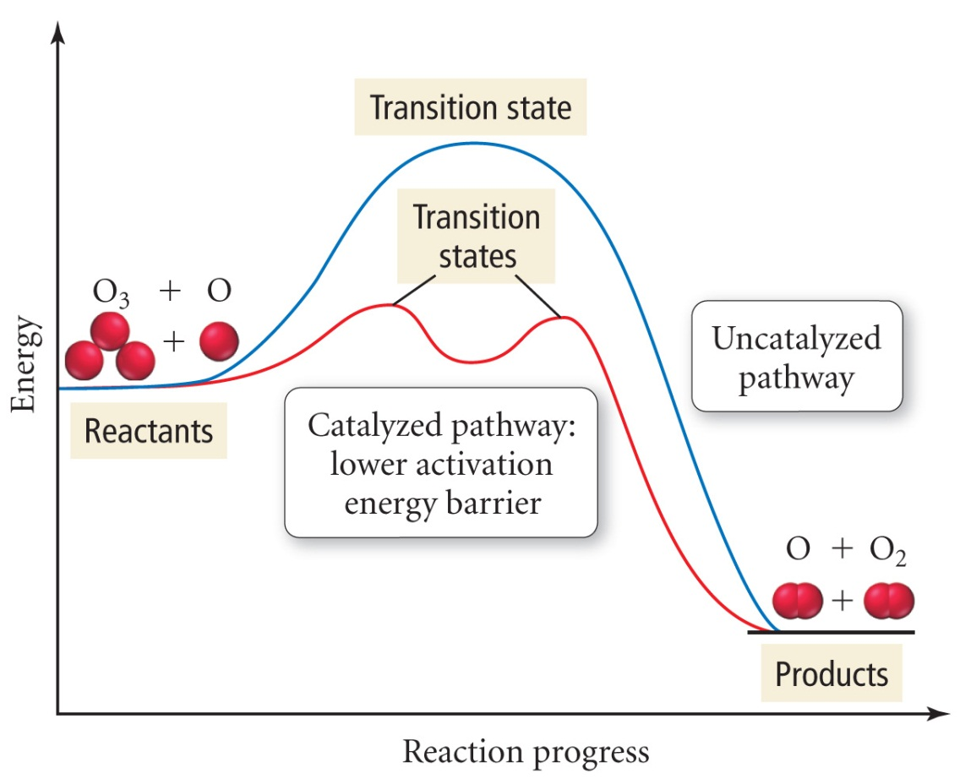

A catalyst provides an alternate reaction pathway, which, in turn, consists of two or more elementary steps.

While the total activation energies for the uncatalyzed and catalyzed pathways are the same, that of the catalyzed process is made up from the sum of each elementary step’s activation energies.

A greater fraction of molecules (recall the Boltzmann distribution) will have kinetic energy greater than, or equal to, that of the largest E_{a} for the catalyzed reaction’s elementary steps

Case study: The conversion of NO₂ (g)→ N₂ (g) + O₂ (g) by your car’s catalytic converter

The (catalyzed) reaction is now composed of four(+) individual processes, each with its own E_{a}, that occur at the catalyst surface:

a. NO₂ (g) → NO₂ (ads)
b. 2 NO₂ (ads) → O₂(ads) + 2 N (ads)
c. O₂ (ads) → O₂(g)
d. 2 N (ads) → N₂(ads) (not shown)
e. N₂ (ads) → N₂(g) (not shown)

The sum of these reactions E_{a}s equals that of the uncatalyzed reaction

Homogeneous Catalysis

Homogeneous catalysts ‘do the same job’ as heterogeneous catalysts, but are in the same phase as the reactants – typically in solution.

Examples of homogeneous catalysts include aqueous ions, such as H⁺, or aqueous transition metal complexes, such as TiCl₄.

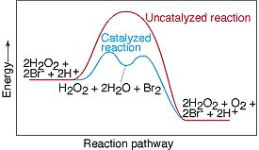

“Arrhenius”

The following question was taken from your 2nd practice midterm:

Question 1 (25 points): The activation energy for a certain reaction is 65.7 kJ/mol. How many times faster will the reaction occur at 50ºC than 0ºC?

Appendix

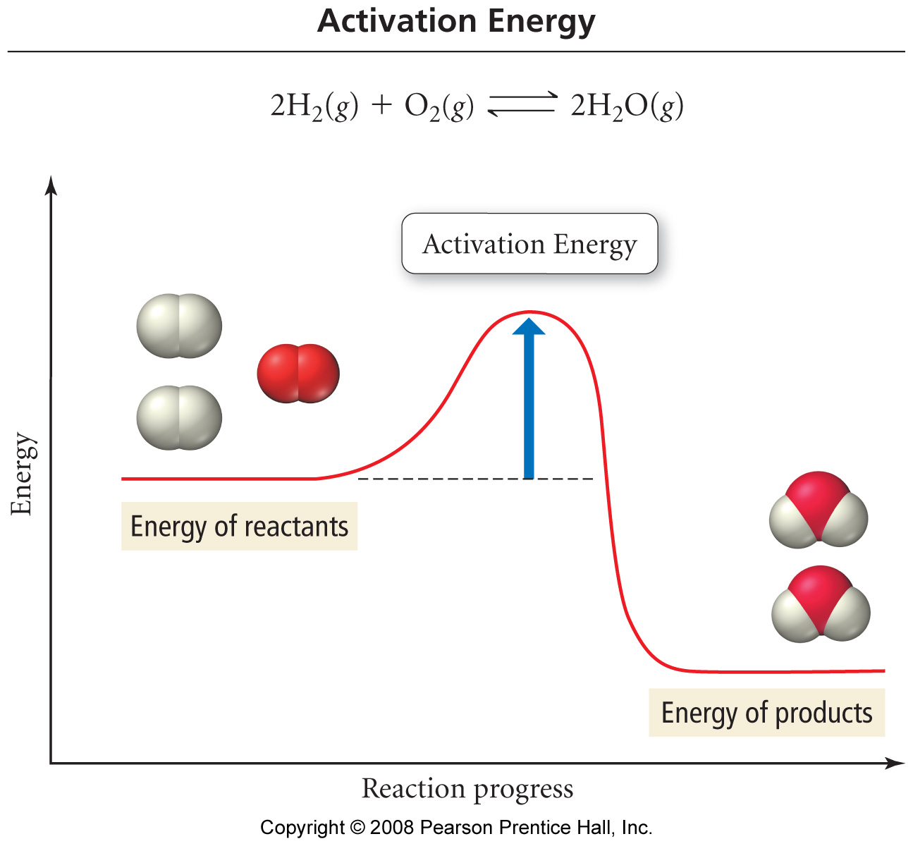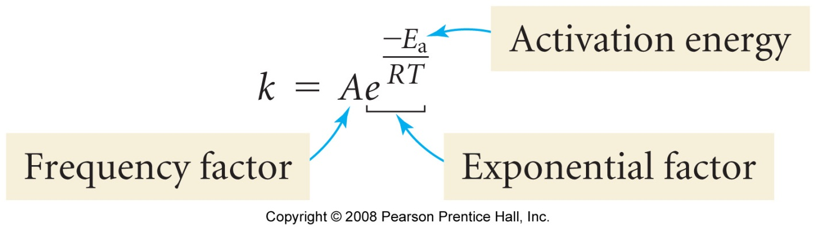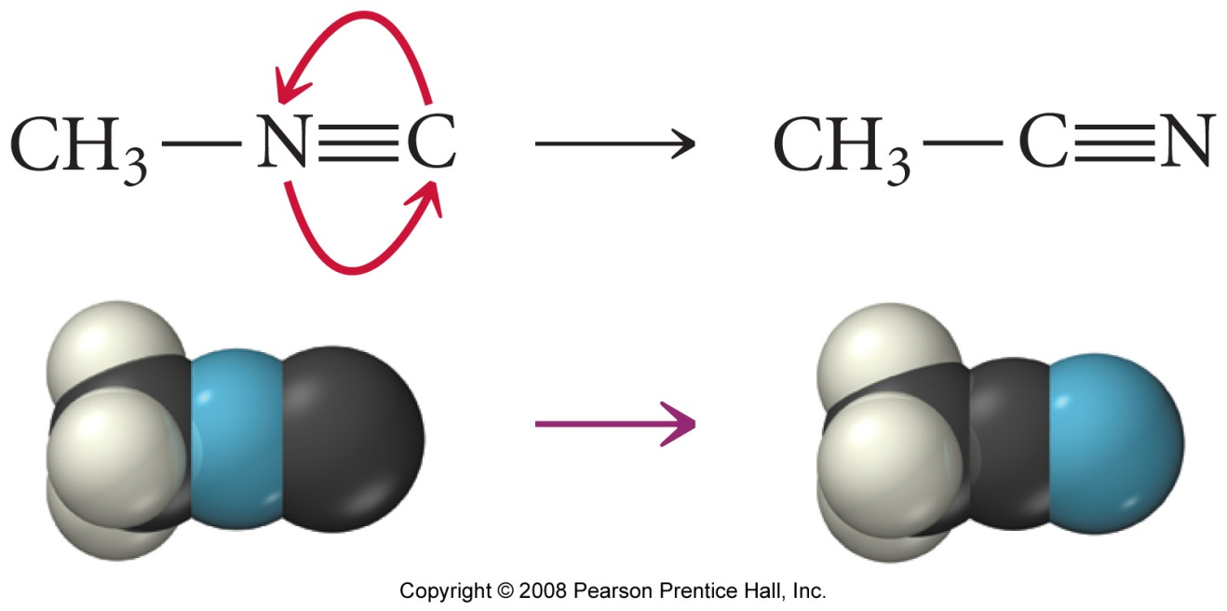

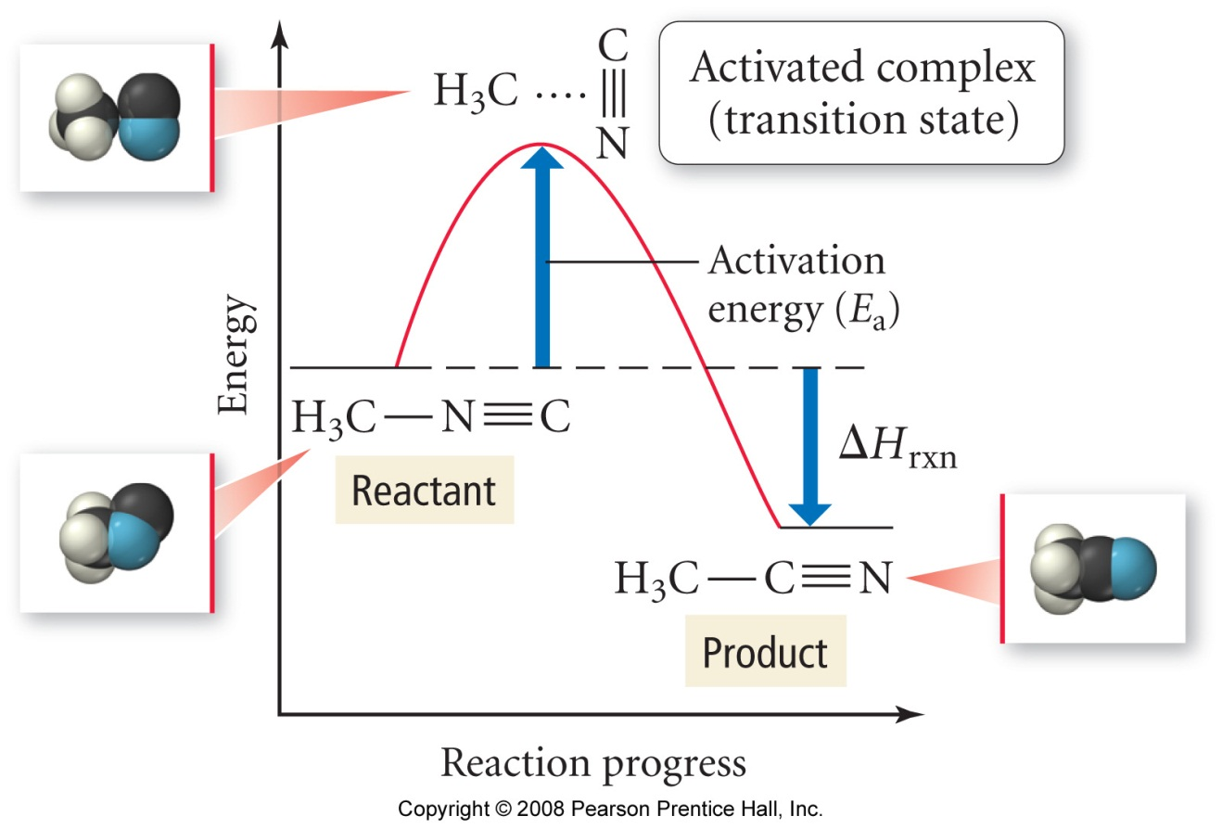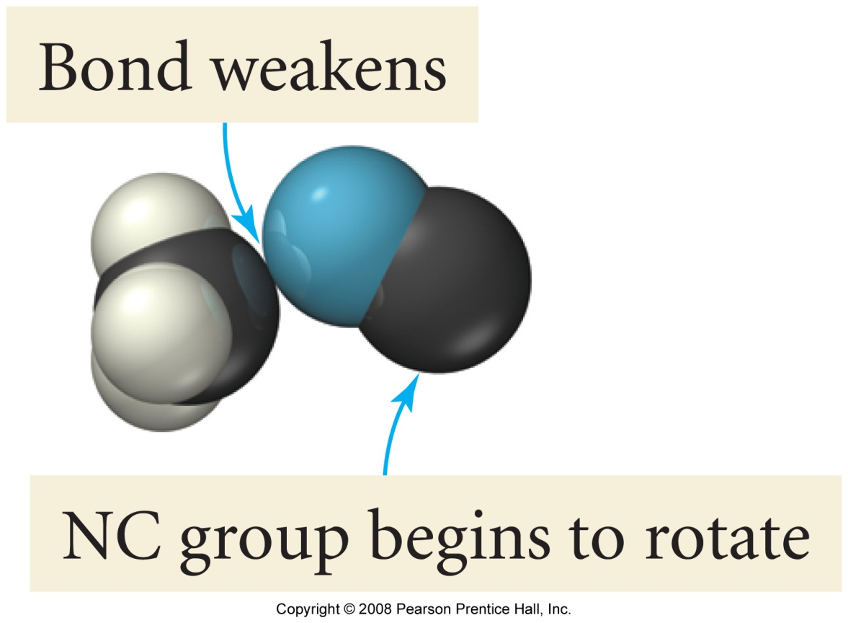
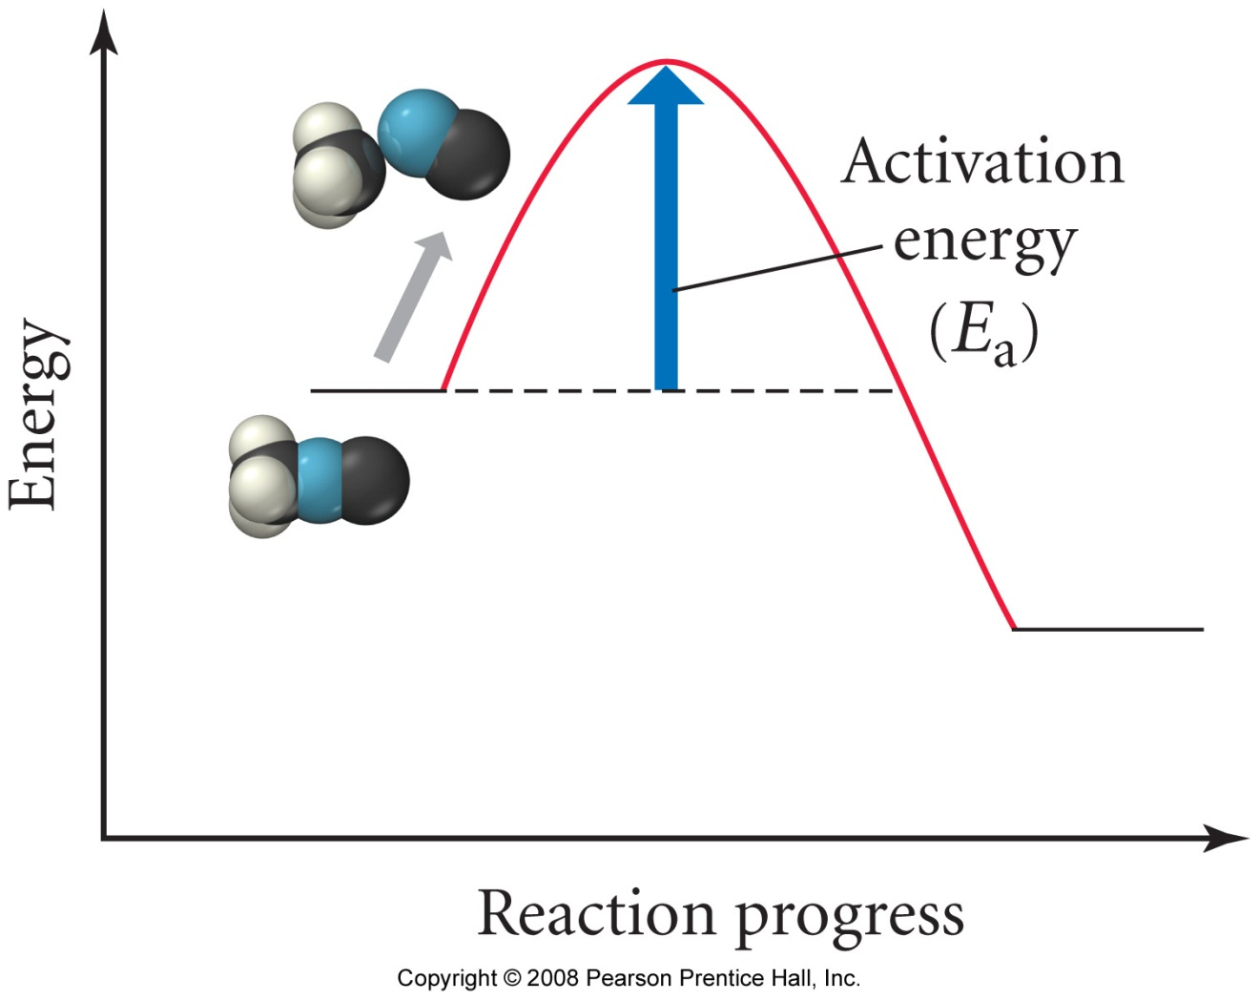

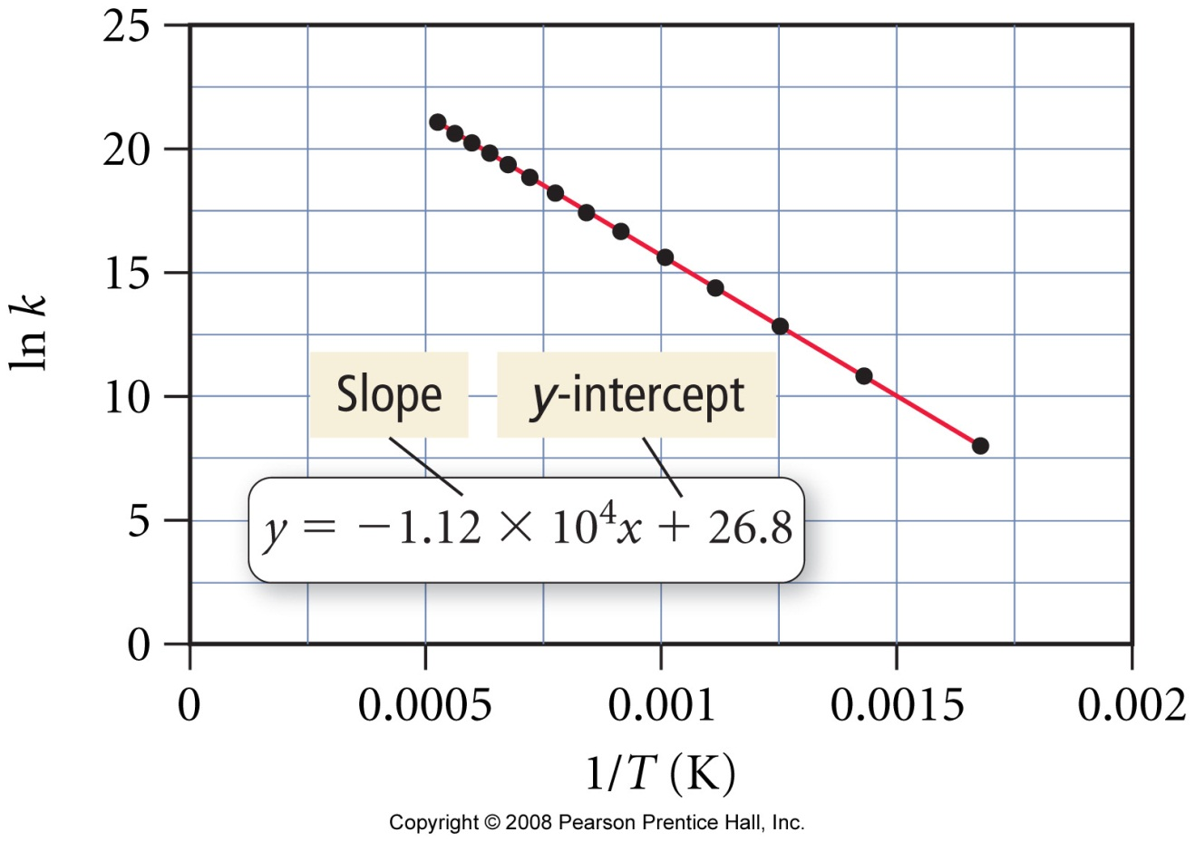

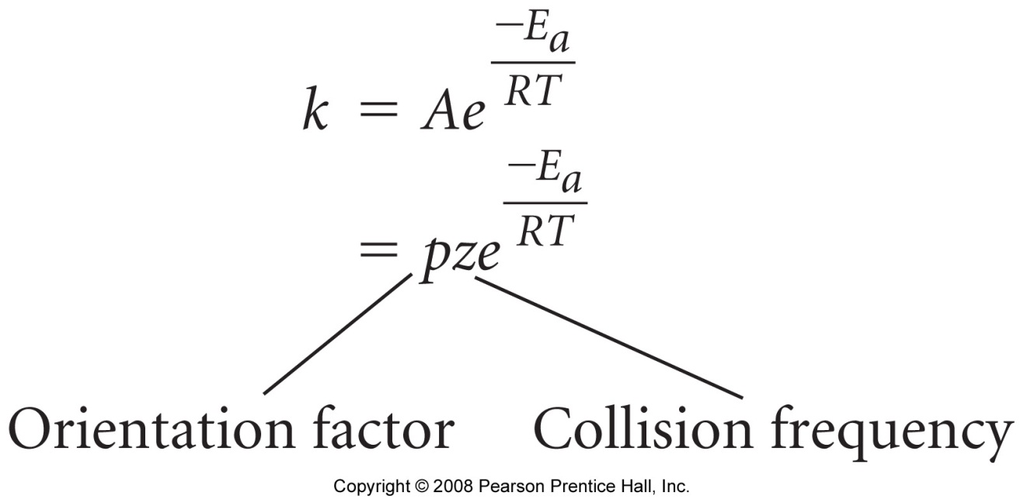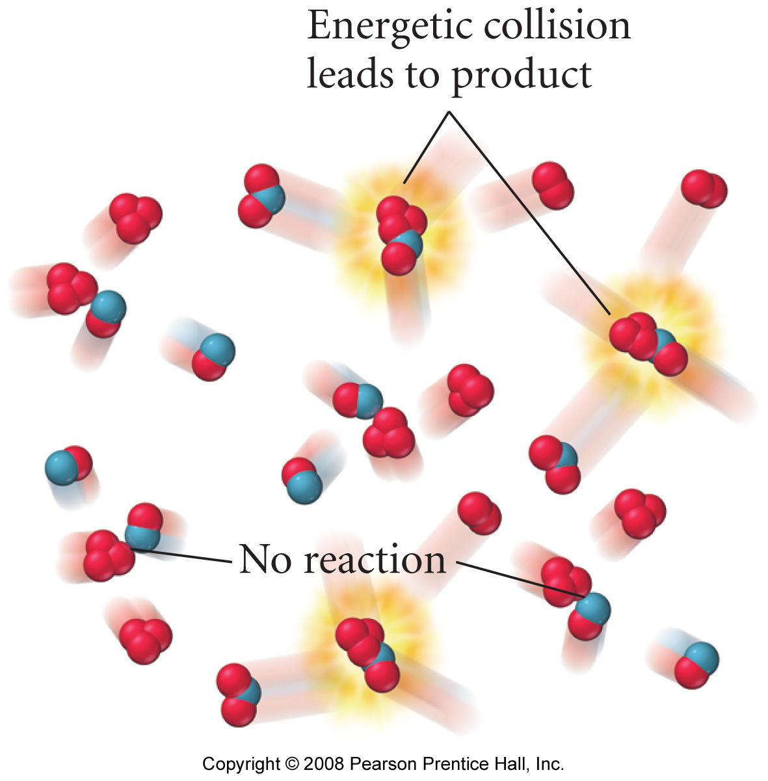

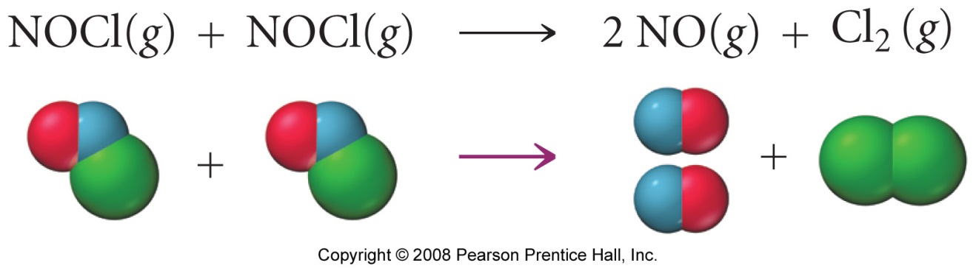

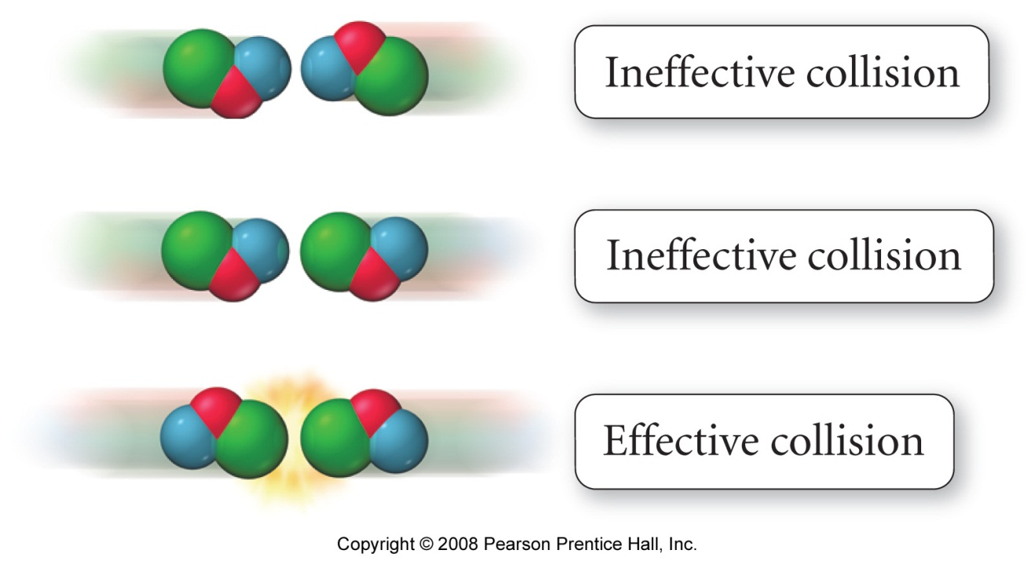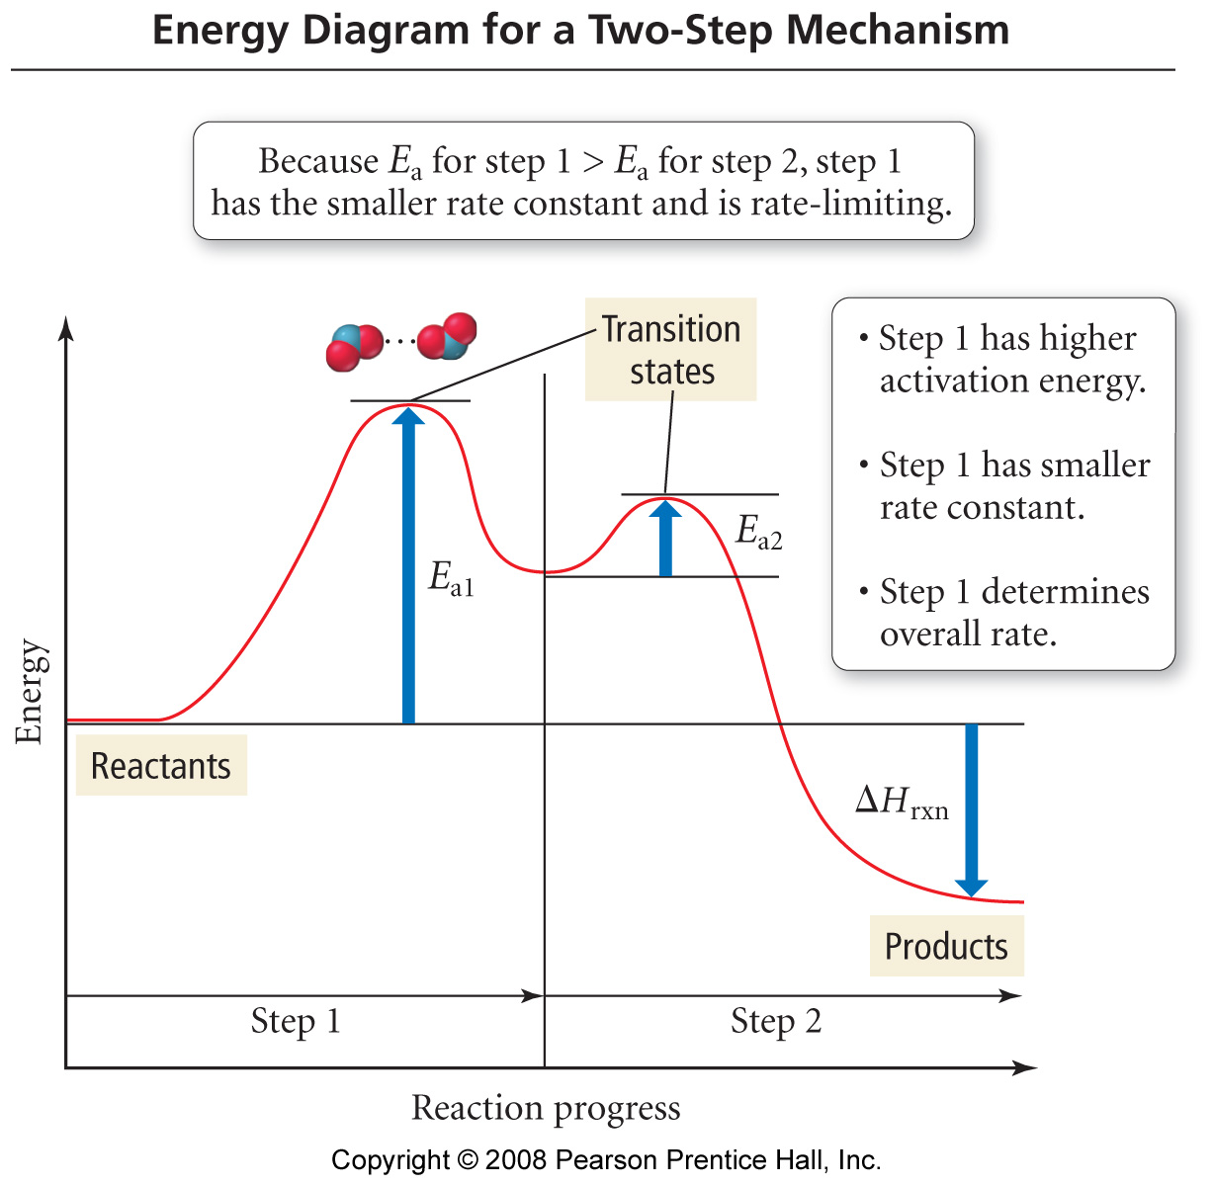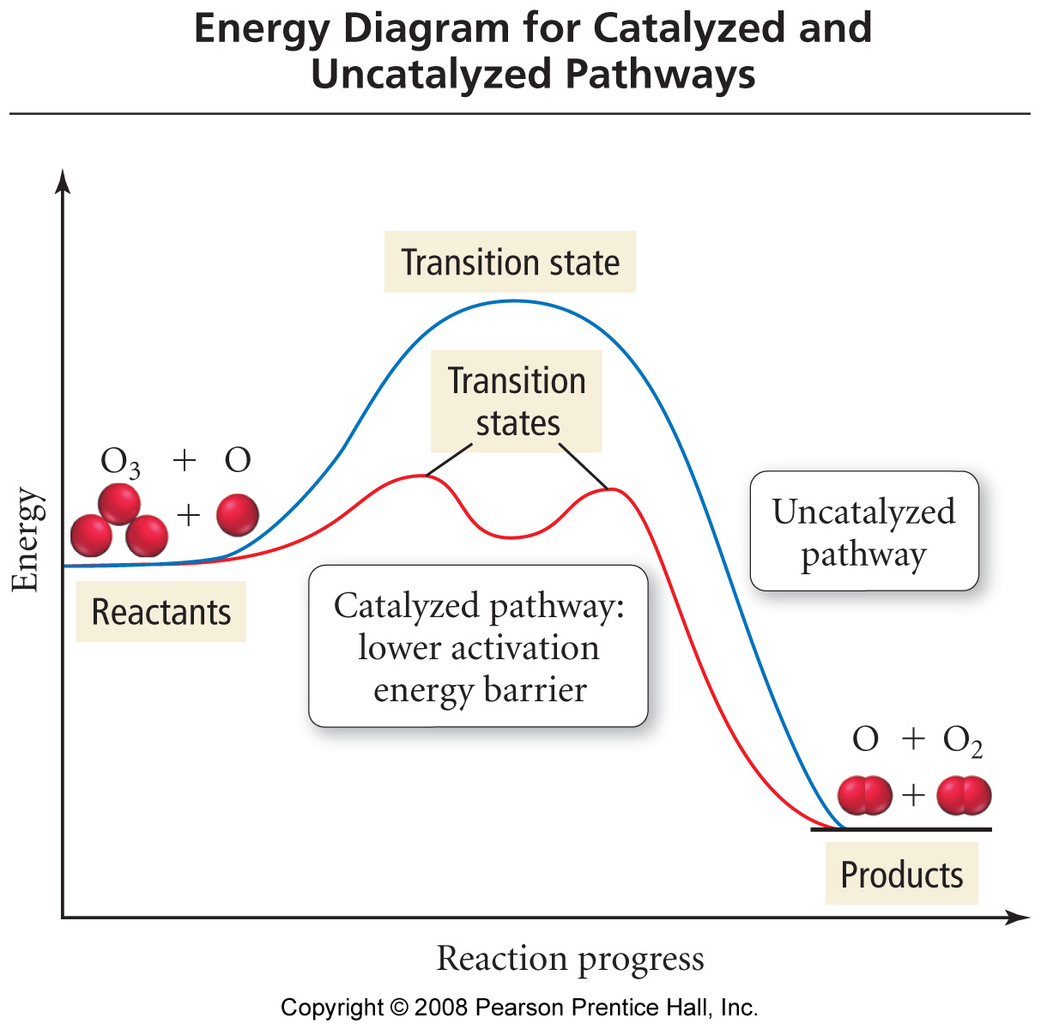

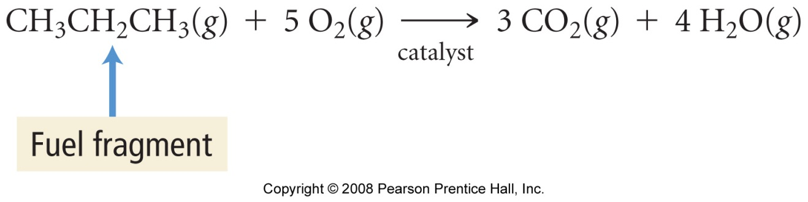
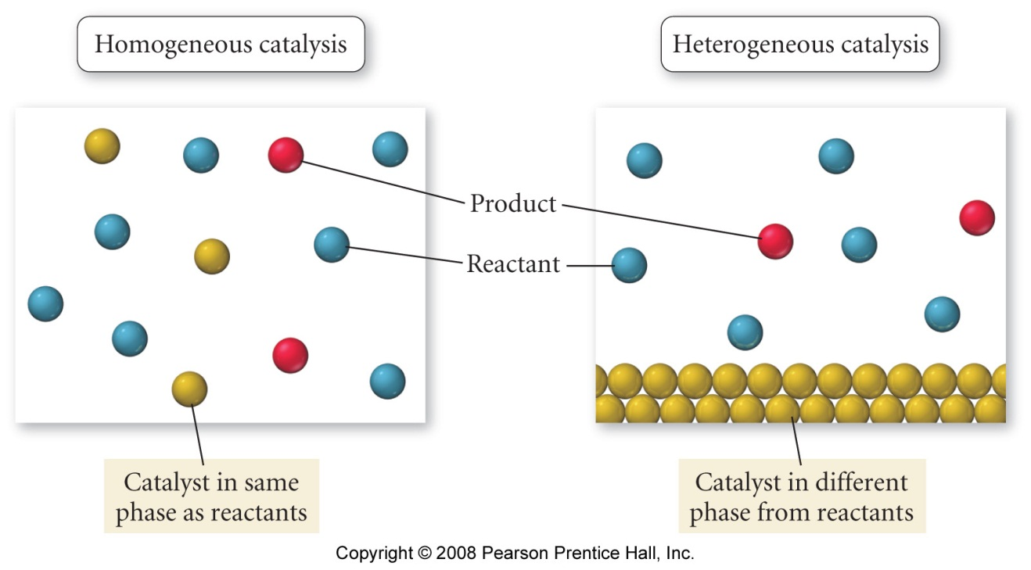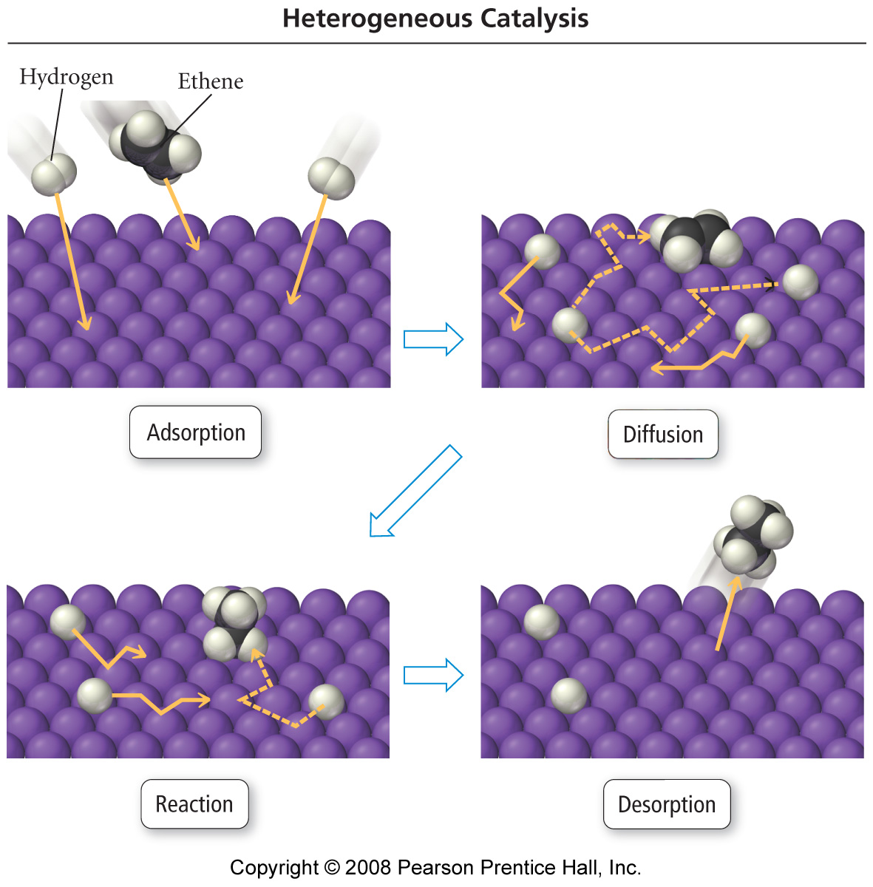

Chemical Equilibria 1

Reading: | Ch 14 sections 1 - 5 | Homework: | Chapter 14: 21*, 23, 25, 35*, 37, 39*
* = ‘important’ homework question

Background: Expressing Equilibria

Discussion: What is a dynamic chemical equilibrium?

Analogy: the Vancouver shoe sale

8:59 am: Before reaction starts

9:01 am: Reaction starts

9:10 am: Dynamic equilibrium established

Product(s) and reactant(s) have fixed molar ratios at equilibrium. Therefore:

Forward rate of reaction ≡ Reverse rate of reaction for a system at equilibrium

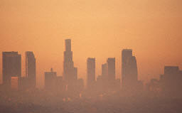 | Example: The Equilibrium between N₂O₄ (g) and the ‘smog gas’ NO₂ (g) - see slide.

Equilibrium Position

Discussion: Based on the slide (as well as the above picture of the LA skyline), would you say that the equilibrium between N₂O₄ (g) and NO₂ (g) favors reactants or products at room temperature? Why?

N₂O₄ (g) ⇔ 2 NO₂ (g)

The position (or condition) of a chemical equilibrium is expressed as a ratio of product(s) : reactant(s). This ratio is reported as a single quantity K, the equilibrium constant.
Simply:
K | = | [Product(s)]
 |  | [Reactant(s)]

Typically: | K > 1 for equilibria that favor product(s)
 | K < 1 for equilibria that favor reactant(s)

Quantitative Determination of the Equilibrium Constant, K

Task: Based on the basic definition of K, discussed above, estimate* the value of K for the N₂O₄ (g) ⇔ 2 NO₂ (g) equilibrium via inspection of the supplied slide. What about the shoe store?

A chemical equilibrium and its respective equilibrium expression are quantitatively related via the following generic expression:

For: aA + bB ⇔ cC + dD

K | = | [C]^{c}[D]^{d}
 |  | [A]ª[B]^{b}

Important: The concentration of each reactant and product in a chemical equilibrium is raised to the power of its respective stoichiometic constant (balancing number), as found in the appropriate balanced chemical equation.

Task: Use the preceding math in conjunction with the slide to determine* a more accurate value of K for the N₂O₄ (g) ⇔ 2 NO₂ (g) equilibrium.

Note: For gas phase reactions, [conc] ∝ p. Therefore, partial pressures (e.g. p_{NO2} ) may be used in place of [conc] expressions for gas phase processes. See appendix for more examples.

Task: Write an expression for K, involving partial pressures, for:

N₂O₄ (g) ⇔ 2 NO₂ (g)

Note: It is possible to mix ‘n match [conc] and p units in a single equilibrium expression – this is an example of a heterogeneous equilibrium

Pure solids and/or liquids do NOT have a defined concentrations or partial pressures, so do NOT appear in equilibrium expressions

Example: Write an equilibrium expression for:

CaCO₃(s) + 2 HCl (g) ⇔ CaCl₂ (s) + H₂O (l) + CO₂ (g)

Example: A mixture of H₂ (g) and N₂ (g) was allowed to come to equilibrium at 472 ºC:

N₂ (g) + 3 H₂ (g) ⇔ 2 NH₃ (g)

Find K for this system, assuming the partial pressures or each reactant were found to be p_{N2} = 2.46 atm, p_{H2} = 7.38 atm, and be p_{NH3} = 0.166 atm respectively.

If K is known for a chemical process, then the [conc] and/or partial pressures of aqueous and/or gas phase species, respectively, involved in a chemical process may be determined.

Example: At 21.8ºC, K for the following equilibrium is known to be
7.0 x 10⁻².
NH₄HS (s) ⇔ NH₃ (g) + H₂S (g)

Calculate the equilibrium partial pressures of NH₃ (g) and H₂S (g) if a solid sample of NH₄HS is placed in a closed vessel and allowed to decompose until equilibrium is attained. Is this a hetero- or homogeneous equilibrium? See appendix for another example.

The Feasibility of a Reaction – what does the value of K really mean?

Discussion: If K is very large, do reactants or products dominate at equilibrium? If K is very small, do reactants or products dominate at equilibrium? Hint: Recall the basic definition of K.

If K is large, the equilibrium is said to lie to the right.

If K is small, the equilibrium is said to lie to the left.

Extreme Cases – ‘complete’ and ‘incomplete’ reactions

If K ≥ 10⁶, a reaction is said to be ‘complete’

If K ≤ 10⁻⁶, a reaction is said to be ‘incomplete’

Discussion: Given the above information, is there such a thing as an entirely complete or incomplete chemical reaction??

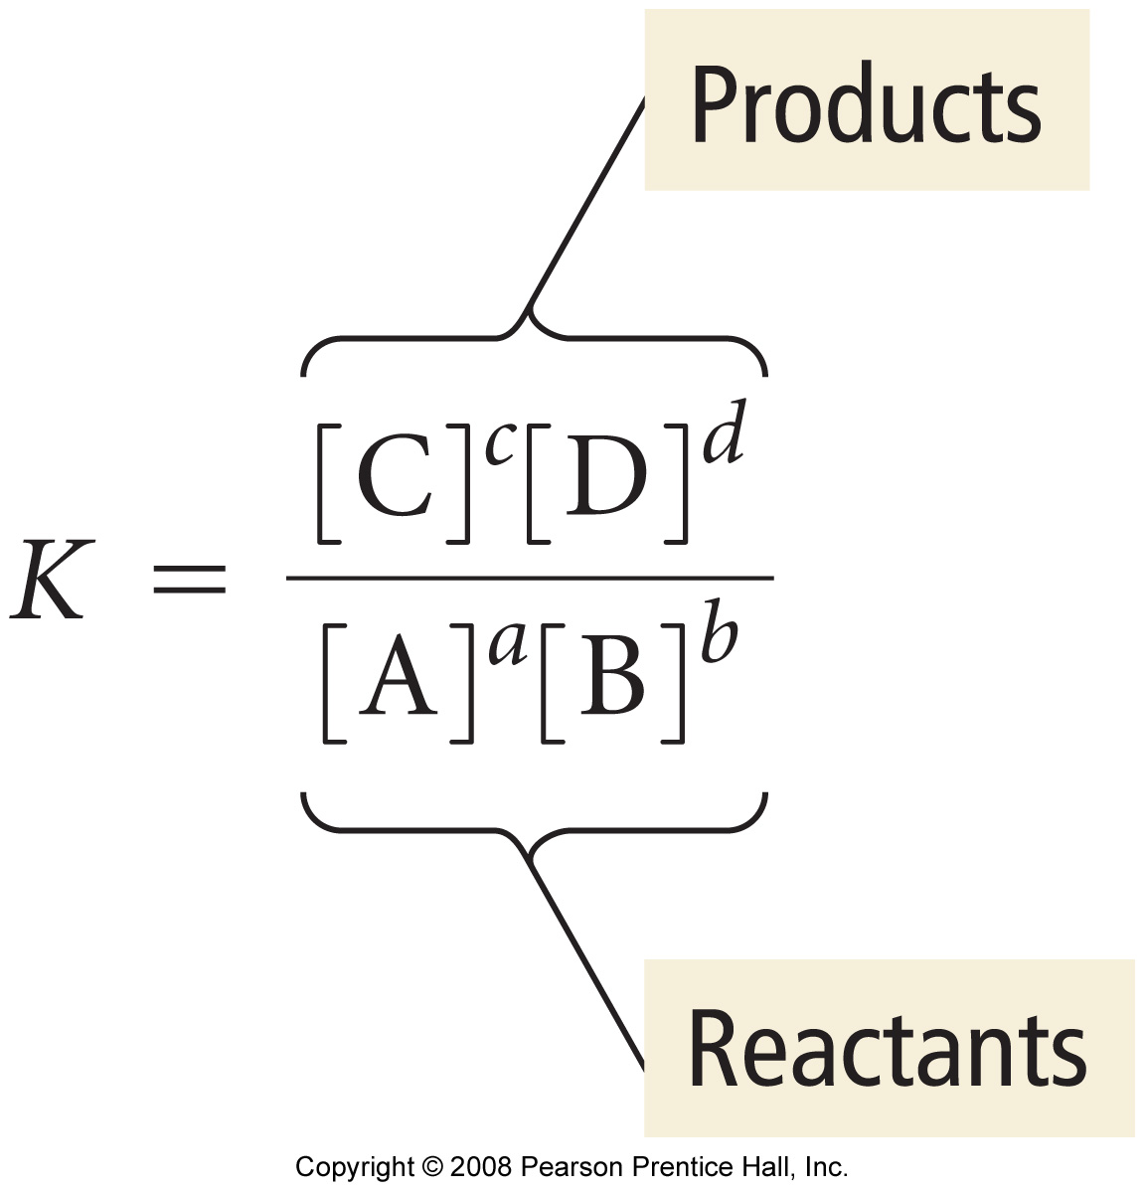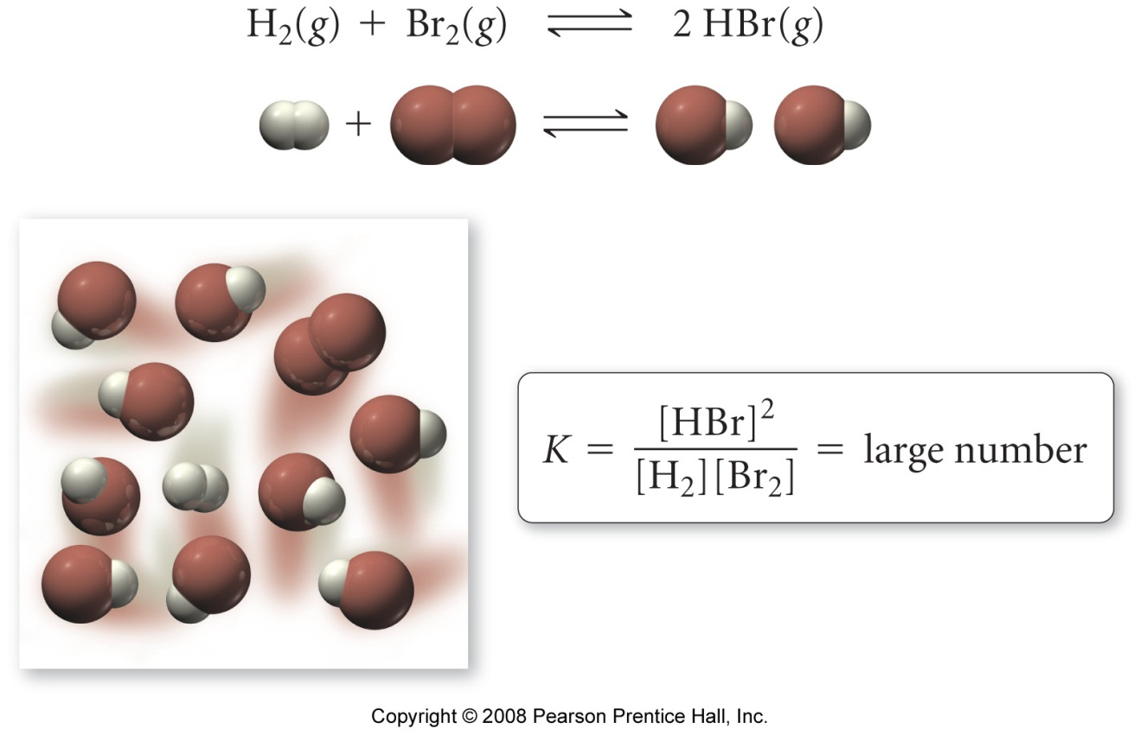

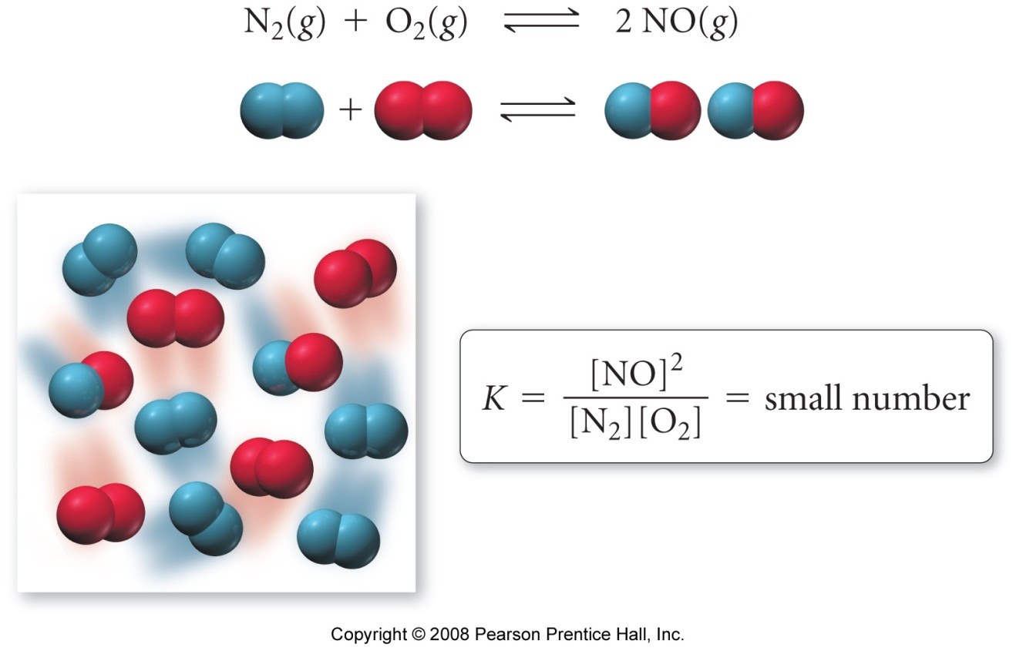

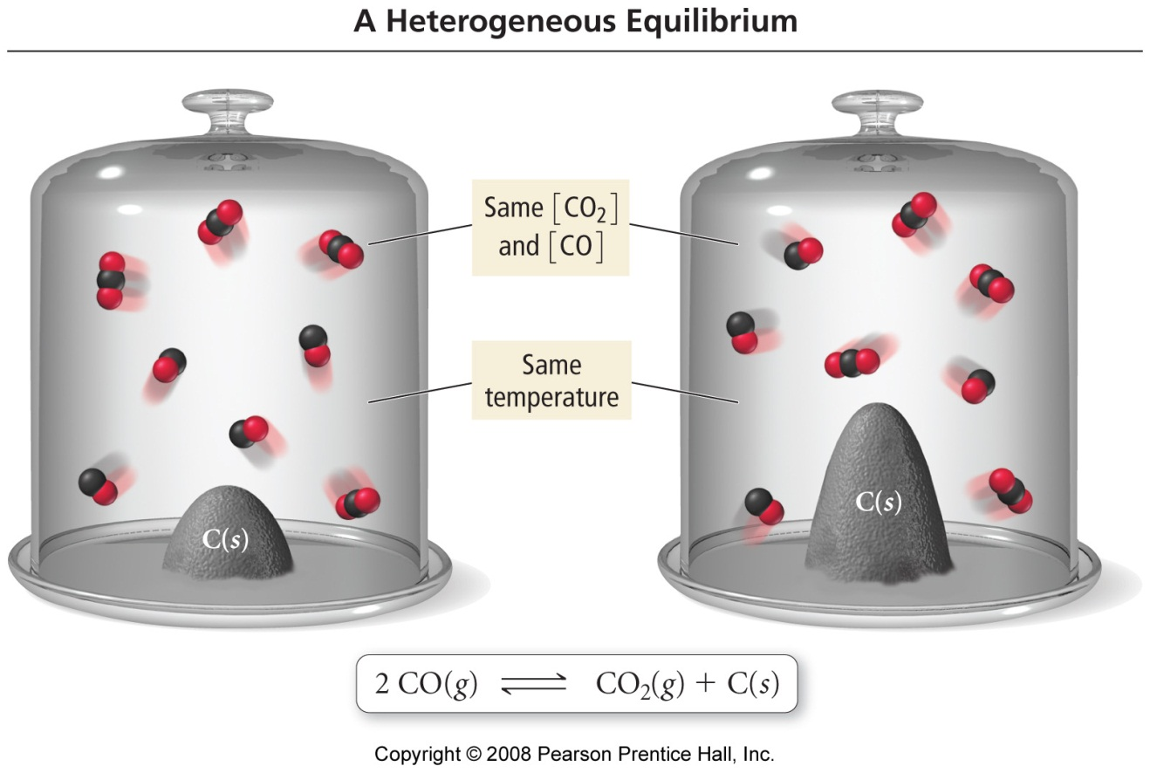

Chemical Equilibria 2

Reading: | Ch 14 sections 6 - 9 | Homework: | Chapter 14: 27*, 29*, 31, 33, 41, 43, 45, 51*, 55, 61*, 63, 67*, 69*
* = ‘important’ homework question

Review

A chemical equilibrium and its respective equilibrium expression are quantitatively related via the following generic expression:

For: aA + bB ⇔ cC + dD

K | = | [C]^{c}[D]^{d}
 |  | [A]ª[B]^{b}

If K is large, the equilibrium is said to lie to the right.

If K is small, the equilibrium is said to lie to the left.

Task: Analyze and discuss the following rate plots for chemical processes that attain measurable equilibria. Which equilibrium lies to the right, to the left?

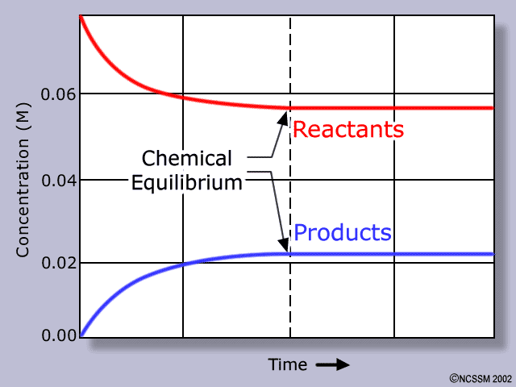 | 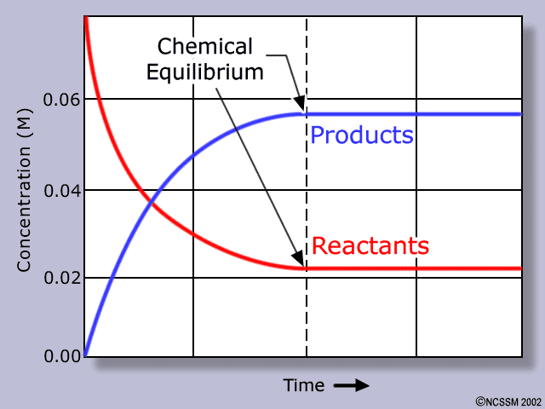

Since the value of K is fixed for a specific temperature and pressure, the ratio of products to reactants is also fixed. Therefore:

A reaction mixture will approach the equilibrium position from either the reactants side (reactants in XS, forward reaction) or the products side (products in XS, reverse reaction). See slide and appendix table.

Notes

Reverse Reactions

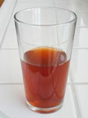 | Analogy Is the glass half full or half empty? There are two ways of looking at equilibrium too – either from the point of view of the formation of product(s) from reactants (L→R) or the formation of reactants from products (L←R).  Question: How are these two processes related?

For the Generic Equilibrium:

A ⇔ B | K_{for} | = | [B] |  | Derivation
 |  |  | [A]
 | K_{rev} | = | [A]
 |  |  | [B]

Example:

HF (aq) ⇔ H⁺ (aq) + F⁻ (aq) ; K = 6.4 x 10⁻⁴

What is K_{rev}?

Do you think HF (aq) is a strong acid? Why?

More Equilibrium Math

If an equilibrium expression is multiplied by a constant value, its ‘new’ eq^{m} constant is the original value of K raised to the multiplying power

Example: Given:

HF (aq) ⇔ H⁺ (aq) + F⁻ (aq) ; K = 6.4 x 10⁻⁴

What is K for:

1. 2 HF (aq) ⇔ 2 H⁺ (aq) + 2 F⁻ (aq) ; K =

2. ½ HF (aq) ⇔ ½ H⁺ (aq) + ½ F⁻ (aq) ; K =

The eq^{m} constant for a net reaction made up from two or more steps is the product of the steps individual eq^{m} constants

i.e: “Add reactions, multiply Ks”

Worked Example: Given:

 | 2HF (aq) | ⇔ | 2H⁺ (aq) | + | 2F⁻ (aq) | ; K₁ = 4.6 x 10⁻⁷
and
 | 2 H⁺ (aq) | + | C₂O₄ ²⁻(aq) | ⇔ | H₂C₂O₄ (aq) | ; K₂ = 2.6 x 10⁵

What is K for: 2HF (aq) + C₂O₄ ²⁻(aq) ⇔ 2F⁻ (aq) + H₂C₂O₄ (aq)

Always add equations and multiply Ks first - just to see what you get

Task: What is K for: CO (g) + 2 H₂S (g) ⇔ CS₂ (g) + H₂O(g) + H₂ (g)

Given: CO (g) + 3 H₂ (g) ⇔ CH₄ (g) + H₂O (g) ; K₁ = 3.92
CH₄ (g) + 2 H₂S (g) ⇔ CS₂ (g) + 4 H₂ (g) ; K₂ = 3.3 x10⁴

The Equilibrium Constant K_{p}

For gas phase reactions it is easier to measure partial pressures of reactants and products. This will yield an equilibrium constant in terms of partial pressures only, K_{p}

K_{p} is related to the ‘regular’ equilibrium constant, K_{c}, (used for expressing molar concs. of reactants and products) by:

K_{p} = K_{c}(RT)^{Δn}

Where: | R = molar gas constant (careful with units) = | or
 | T = Temp. in Kelvin
 | Δn = Σ (coeff gas products) - Σ(coeff gas reactants)

Math:

Example: What is K_{p} for: PCl₅ (g) ⇔ PCl₃ (g) + Cl₂ (g) at 191ºC, given K_{c} = 3.26 x10⁻²

The Reaction Quotient, Q_{c}

“An expression that has the same form as the eq^{m} constant (K_{c}), except that the conc values are not necessarily those at equilibrium”

For: aA + bB ⇔ cC + dD

Q | = | [C]^{c}[D]^{d}
 |  | [A]ª[B]^{b}

Given the [conc] of all reactant(s) and product(s) under non-eq^{m} conditions, the direction of the reaction proceeds in order to establish eq^{m} can be found

Discussion: What does it really mean, in terms of the [reactants] and [products], when Q_{c} > K_{c}?

When Q_{c} > K_{c}, reaction moves to ___________________
When Q_{c} < K_{c}, reaction moves to ___________________

When Q_{c} = K_{c}, reaction is ___________________

See appendix
Worked Example: A 10.0 L vessel contains 0.0015 mol. CO₂ (g) and 0.100 mol. CO (g). If:

CO₂ (g) + C (s) ⇔ 2 CO (g) ; K_{c} = 1.17

What will happen to the concentrations of the gasses present if a small amount of C (s) is added to the vessel?

Initial [CO₂] =

Initial [CO] =

Q_{c} =

Q_{c} K_{c}, therefore:

Task: A 50.0 L vessel contains 1.00 mol. N₂ (g), 3.00 mol. H₂ (g) and 0.500 mol. NH₃ (g). If:

N₂ (g) + 3 H₂ (g) ⇔ 2 NH₃ (g) ; K_{c} = 0.5 under rxn. conditions

Will more or less NH₃ (g) be present when the system attains equilibrium?

ANS = Less
Le Châtelier’s Principle

When a system in eq^{m} is disturbed by a change in [conc], temperature or pressure, the eq^{m} will shift to compensate for this change

“You push me, I push back” - John Rambo, noted physical chemist

Discussion:

For: | A ⇔ B | K | = | [B] | (A constant)
 |  |  |  | [A]

What, then, must happen if [B] is reduced by removing this chemical from the reaction mixture?

Answer:

1. Altering Concentration - Removing Products and/or Adding Reactants

For: N₂ (g) + 3 H₂ (g) ⇔ 2 NH₃ (g)

What will happen to the position of the equilibrium if:

A. Some NH₃ (g) is removed from the reaction vessel (its partial pressure is reduced)

B. N₂ (g) and/or H₂ (g) is added to the reaction vessel

C. Some N₂ (g) is added to the reaction vessel (see slide)
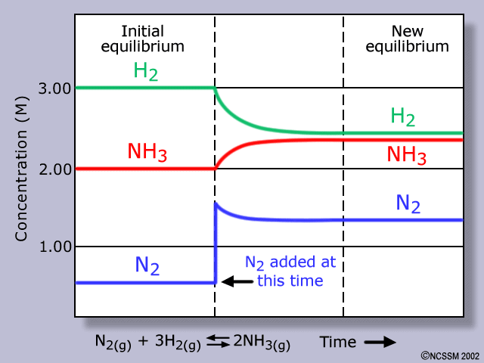

Task: Predict the direction of reaction for:

CaCO₃ (s) ⇔ CaO (s) + CO₂ (g)

If the amount (pressure) of CO₂ (g) is increased

If the amount of CaCO₃ (s) is doubled

2. Changing Pressure and /or Temperature

Discussion: What exerts more pressure in a fixed volume container – 2 moles of gas or 4 moles of gas?

When an equilibrium involving gasses is stressed by altering the pressure, the equilibrium will shift to either increase (p↑) or decrease (p↓) the number of gasses species present

Thus:

When the pressure is increased, the system will remove this stress by _______________ the moles of gaseous species present at equilibrium

When the pressure is decreased, the system will remove this stress by _______________ the moles of gaseous species present at equilibrium

Example: Consider the equilibrium:

CO (g) + 3 H₂ (g) ⇔ CH₄ (g) + H₂O (g)

What would happen to the rxn. mixture if the vessel were compressed? (See below fig. for a microscopic view of what happens)

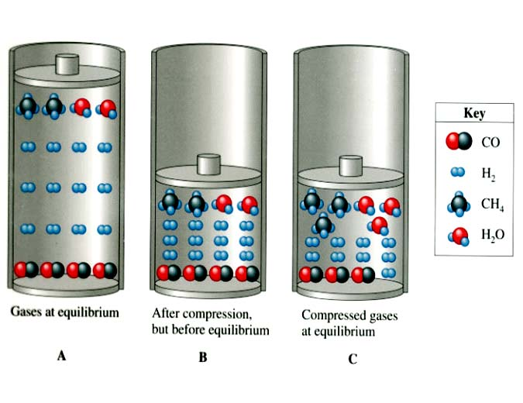

What would happen if the volume of the reaction vessel were doubled?

Examples: Can the amount of product(s) in the following reactions be increased by
increasing the pressure inside the reaction vessel?
a. CO₂ (g) + H₂ (g) ⇔ CO (g) + H₂O(g)

b. 4 CuO (s) ⇔ 2 Cu₂O (s) + O₂ (g)

c. 2 SO₂ (g) + O₂ (g) ⇔ 2 SO₃ (g)

Temperature Effects

Aside: Recall from the ‘Thermo’ section of Chem. 101:

Discussion: what is an exothermic reaction, what is an endothermic reaction? Hint: think of the roots –(ex, en)

EXOthermic:

ENDOthermic:

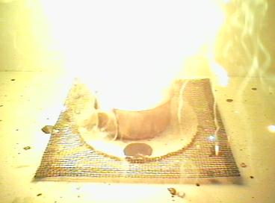 | Fact: The vast majority of all known reactions are exothermic (heat is evolved). For example, all combustion reactions give out heat.

Type of reaction | Observation | Write heat where? | Sign of ΔH (enthalpy)
Exothermic |  |  | -VE
Endothermic |  |  | +VE

The amount of heat evolved (exothermic, -ve ΔH) or absorbed (endothermic, +ve ΔH) during a chemical process is expressed in the form of a thermochemical equation – like a regular balanced equation, but with the numerical value of ΔH included

Write ‘heat’ as a product (on the right) for exothermic reactions (vice versa for endo) – Le Châtelier’s Principle can then be applied with regard to heating or cooling the reaction vessel

Example: Consider the following thermochemical process:

CO (g) + 3 H₂ (g) ⇔ CH₄ (g) + H₂O (g) ; ΔH = -206.2 kJ/mol

What happens to the position of the equilibrium when the reaction vessel is:

- Heated up:

- Cooled down:

Another example: Is a high or low temperature favorable for the formation of CO (g) in the following process? Hint: Remember the previous trick.

CO₂ (g) + C (s) ⇔ 2 CO (g) ; ΔH = +172 kJ/mol

Choosing Optimal Reaction Conditions based on Le Châtelier’s Principle

Chemists typically want to maximize the formation of products from a chemical reaction. Therefore, choosing the ‘right’ conditions of P and T (according to Le Châtelier) will allow for the maximum possible yield of product(s)

Example: What conditions of temperature and pressure would maximize the formation of ammonia (NH₃) via the Haber process?

N₂ (g) + 3 H₂ (g) ⇔ 2 NH₃ (g) ; ΔH = -91.8 kJ/mol

Temperature: | Increase temperature of vessel | OR | Decrease temperature of vessel
Pressure: | Increase pressure on vessel | OR | Decrease pressure on vessel

See appendix for figures
Another Example: What conditions of temperature and pressure would maximize the formation of CO (g) for:

2 CO₂ (g) ⇔ 2 CO (g) + O₂ (g) ; ΔH = +556 kJ/mol

Discussion: What happens to the rate of any exothermic reaction when it is ‘optimized’ according to Le Châtelier’s Principle?

The Great Cosmic Joke – Kinetics v Equilibrium

Increasing the temperature of a reaction increases the rate at which reactants form. However, most reactions are exothermic, so the equilibrium is shifted in favor of reactant and higher temps. IE

You can either make less ‘stuff’ more quickly (high temp.) or more ‘stuff’ over a longer period of time (low temp) – you just can’t win!

Wrap up: Intro to the ICE method (will be covered in more detail in acid/base equilibria)

Worked Example (Lab question 4): The air pollutant NO (g) is produced in automobile engines from the high temperature reaction below. If the initial concentrations of N₂ (g) and O₂ (g) are both 1.40 M, what is the concentration of each reactant and product at equilibrium. K = 0.0017 at 2300 K.

N₂ (g) + O₂ (g) ⇔ 2 NO (g)

“Equilibrium”

The following question was taken from a previous 102 quiz:

Question 1 (6 points): Write equilibrium (K) expressions for the following:

- MgCO₃(s) ↔ MgO (s) + CO₂ (g)

- N₂ (g) + O₂ (g) ↔ 2NO (g)

- Sn(s) + 2H⁺ (aq) ↔ Sn²⁺ (aq) + H₂ (g)

Question 2 (5 points): The following equilibrium has a value of K_{p} = 0.556 at 700 K:

2SO₂(g) + O₂ (g) ↔ 2SO₃(g)

If the partial pressures of SO₂(g) and O₂ (g) at equilibrium are 0.175 atm and 0.856 atm, respectively, what is the equilibrium partial pressure of SO₃(g)?
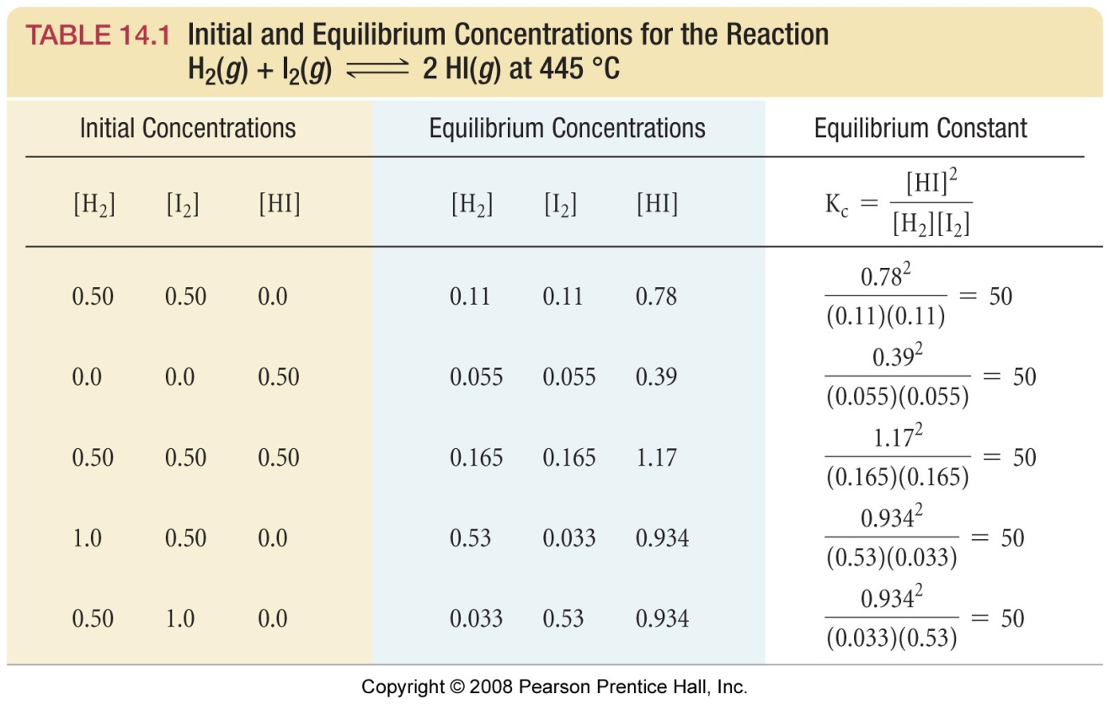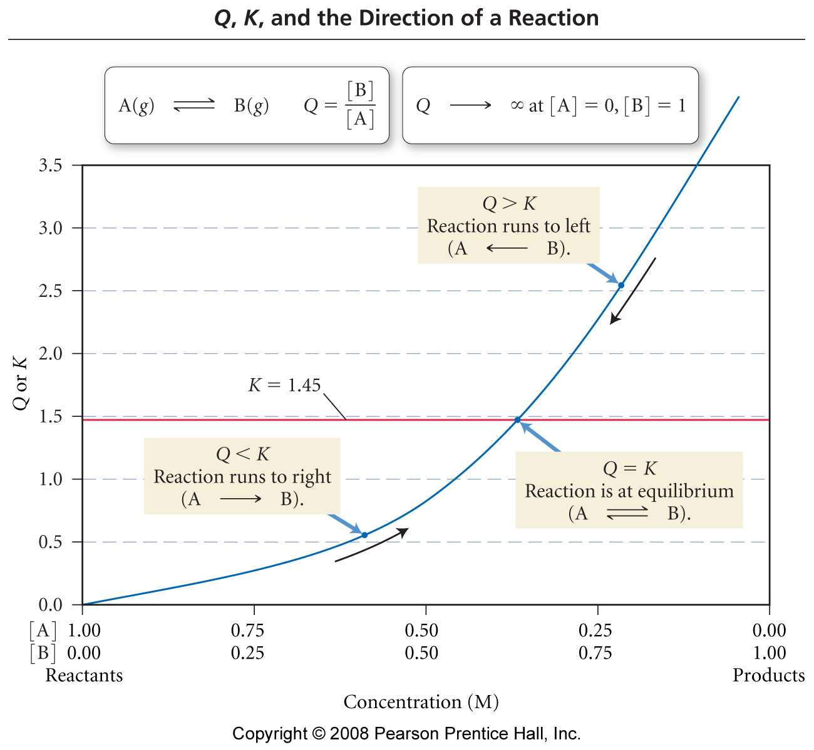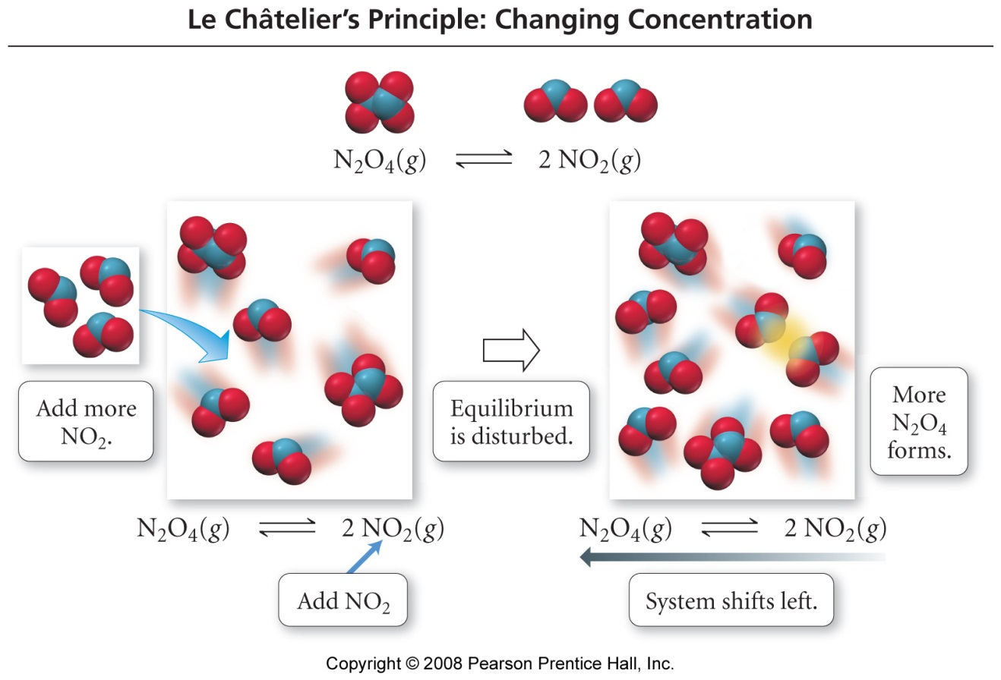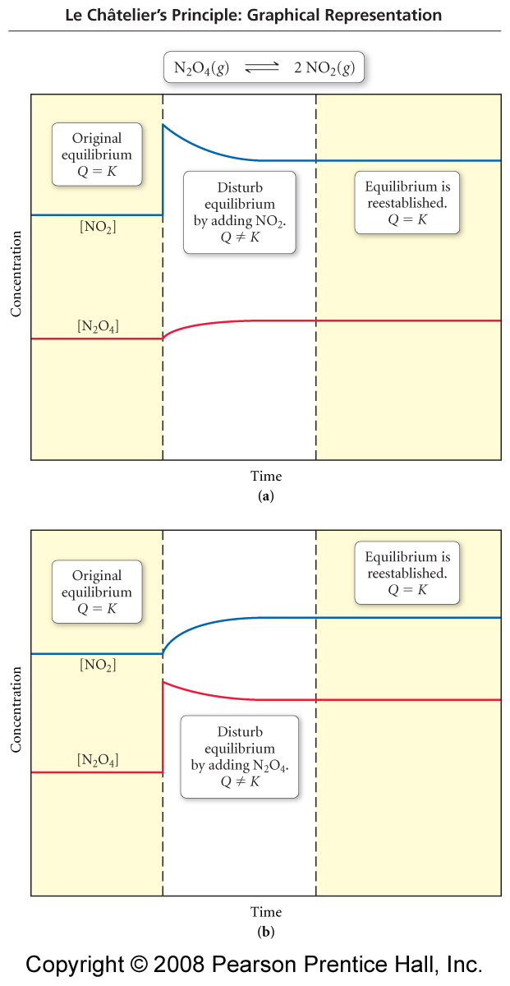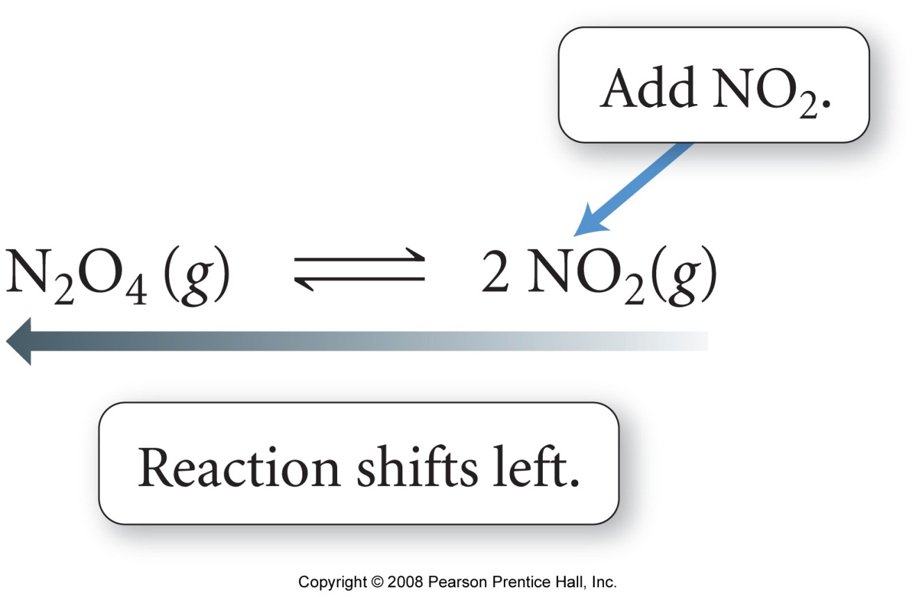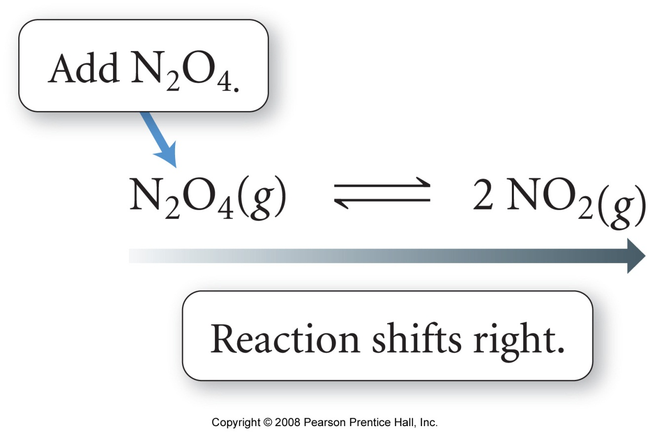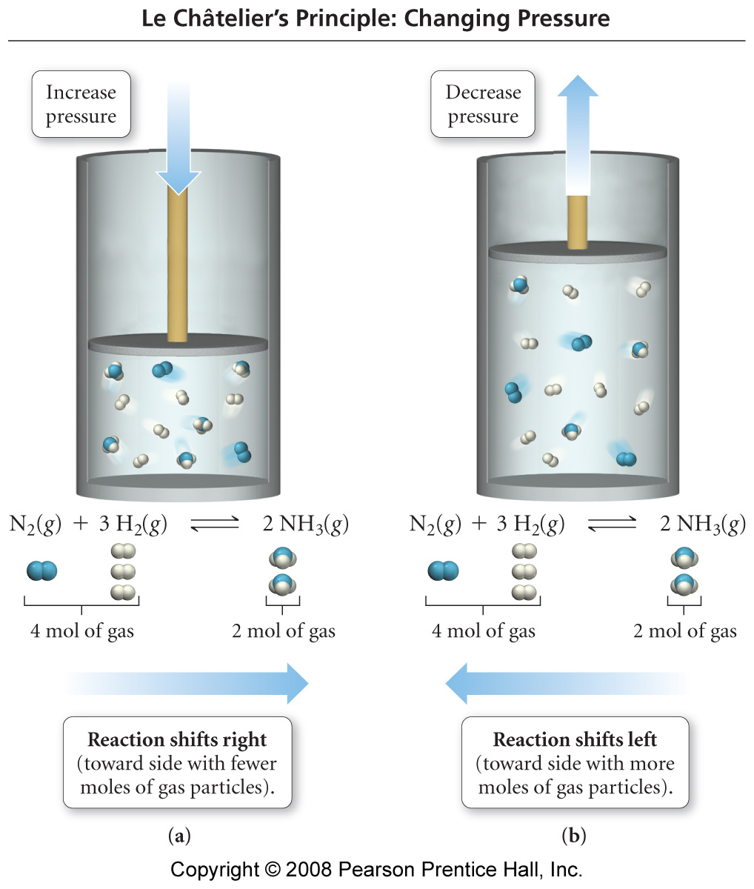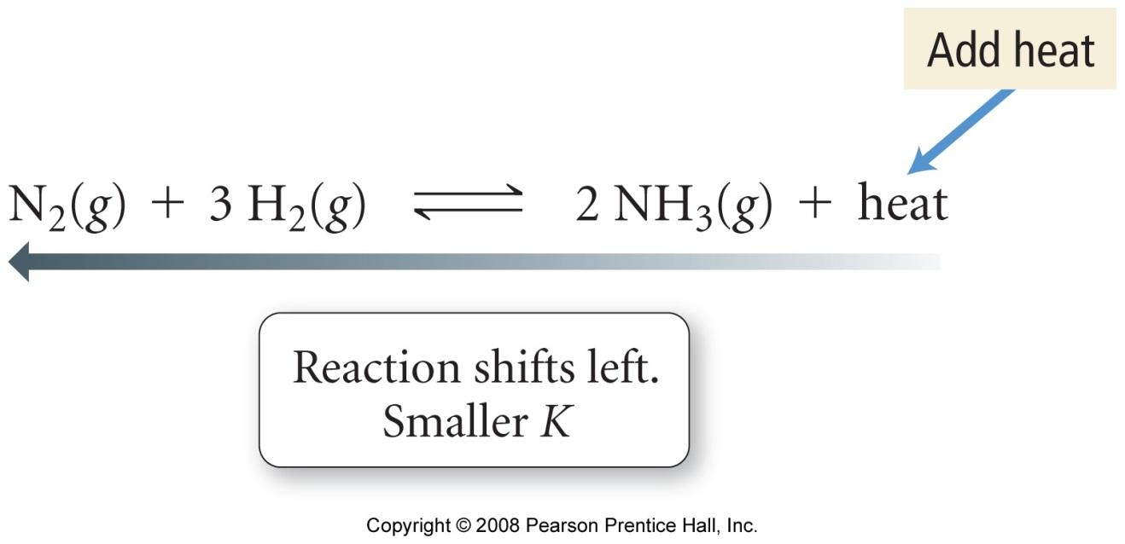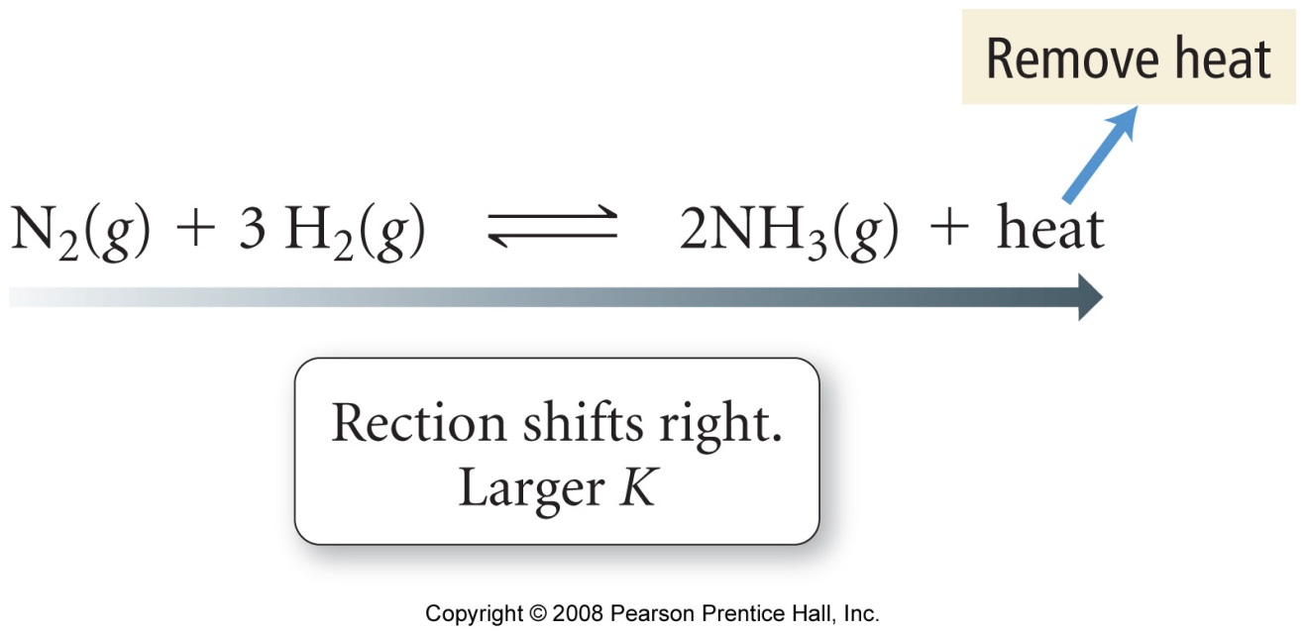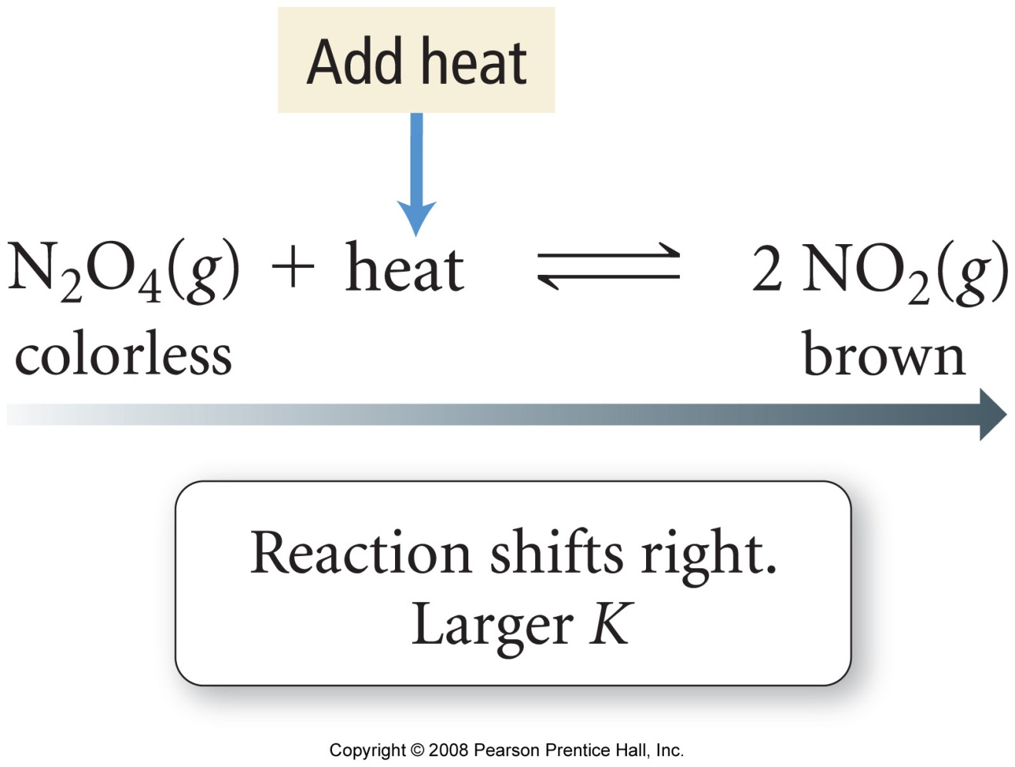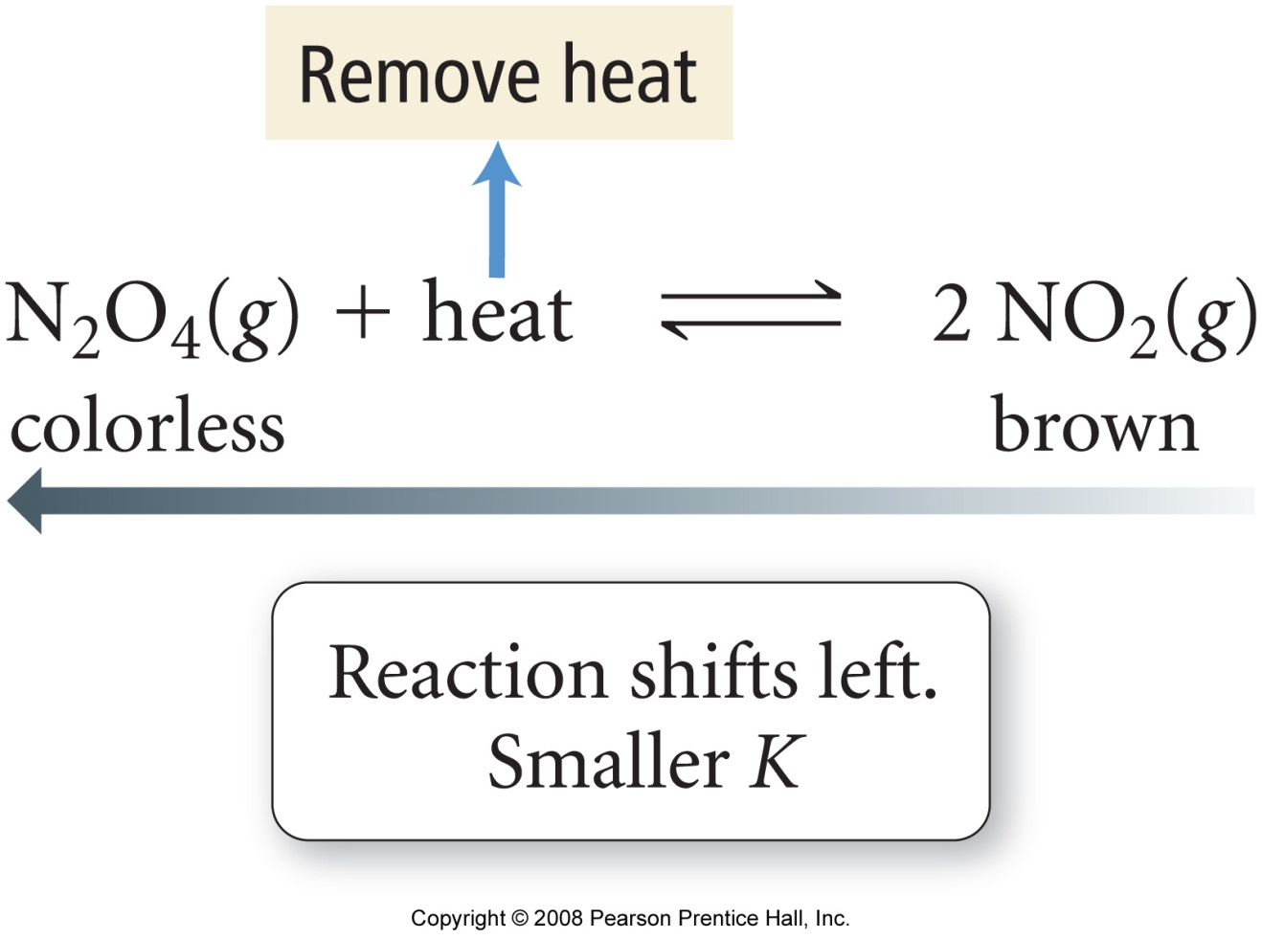
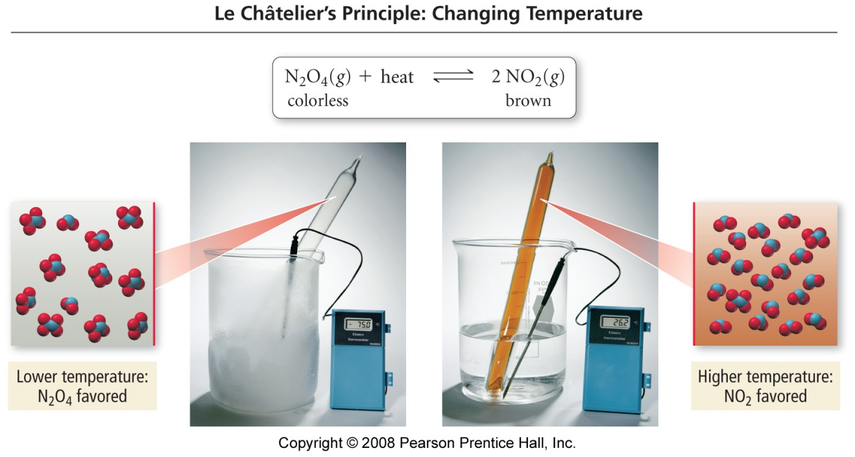

Acid - Base Equilibria 1

Reading: | Ch 15 sections 1 – 7 | Homework: | Chapter 15: 33, 35, 39, 45, 47, 49*, 51, 53, 55, 57, 79*, 81
* = ‘important’ homework question

 | 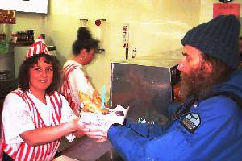 | Background and Discussion: What is an acid? What is a base? Give some common examples.

There are three models used to describe acid and base behavior: Arrhenius, Brønsted – Lowery, and Lewis
Note: Lewis Acids and Bases: will be discussed later in the course

Arrhenius Acids and Bases:

Arrhenius Acid: “A substance when dissolved in water increases the [H⁺]” - this is a generic definition, true for all three models

Example:

Arrhenius Base:

Example:

Brønsted – Lowery Acids and Bases: - the proton transfer model

‘Naked’ H⁺ (aq) ions do not really exist (even though we often write them in chemical equations). H⁺ ions ‘piggyback’ on H₂O molecules – the resulting H₃O⁺ (aq) (hydronium) ion is what is actually responsible for acidic behavior

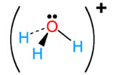 |  |  | Even though we write H⁺ (aq) in chemical equations, it is always assumed that this species is actually H₃O⁺ (aq)
Molecular representation of the hydronium ion

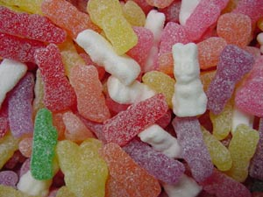 | Aside: Can a completely ‘dry’ acid cause a chemical burn (like HCl(g)) or just taste acidic (like vinegar)?  Hint: think about sour candies – what is the ‘sharp’ tasting powdered coating made of?

The Brønsted – Lowery Proton Transfer model

Recall: In the Brønsted – Lowery model:

B-L Acids are identified as substances that transfer proton(s) to other substances

B-L Bases are identified as substances that accept proton(s) from other substances

Example: HCl (aq) as a Brønsted – Lowery acid

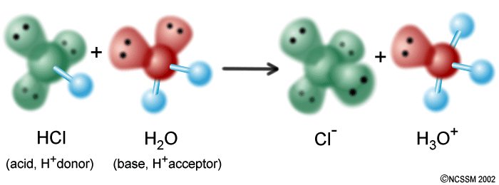

Task: Identify the B-L acids and B-L bases in the following reactions:

NH₄⁺ (aq) + CN⁻ (aq) → HCN (aq) + NH₃ (aq)

HSO₄⁻ (aq) + HCO₃⁻ (aq) → SO₄²⁻ (aq) + H₂CO₃ (aq)

NH₃ (aq) + H₂O (l) → NH₄⁺ (aq) + OH⁻ (aq)

Conjugate Acid – Base Pairs

In an acid base equilibrium, the reacting acid most protonate (by definition) a base. The (now) de-protonated acid is now known as a conjugate base and appears on the products side of the equation.

Similarly, the reactant base that accepts proton(s) becomes a conjugate acid on the reactants side of the equation.

Generic Example:

HX (aq) | + | H₂O (l) | ⇔ | X⁻ (aq) | + | H₃O⁺ (aq)
Acid |  | Base |  | Conjugate base |  | Conjugate acid

Forward reaction: HX (aq) and X⁻ (aq) are an acid / conjugate base pair

H₂O (l) and H₃O⁺ (aq) are a base / conjugate acid pair

Conjugate acids and bases are so named because they act as acids and bases, respectively, for the reverse reaction

Example:
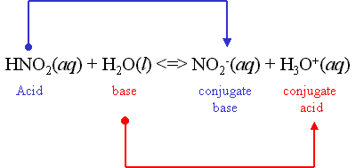

Task: Identify the acid / conjugate base and base / conjugate acid pair for above REVERSE reaction

Workshop: Complete the following assignments:

- Identify acid / conjugate base and base / conjugate acid pairs for the following forward reactions:

HNO₃ (aq) + H₂O (l) ⇔ NO₃⁻ (aq) + H₃O⁺ (aq)

NH₃ (aq) + H₂O (l) ⇔ NH₄⁺ (aq) + OH⁻ (aq)

- What are the conjugate bases of:

H₂PO₄⁻

H₂S

H₂SO₃

HCO₃⁻

- What are the conjugate acids of:

H₂PO₄⁻

SO₄²⁻

CN⁻

HCO₃⁻

Amphoteric Behavior

Question: Did you notice anything ‘interesting’ with regarding the behavior of the poly-protic acids in the previous examples?

Observation:

Answer: Dihydrogen phosphate is amphoteric:

Amphoteric: “capable as behaving as either an acid or a base”

Tasks:

- Write and equation for the reaction of H₂PO₄⁻ with water in which it acts as an acid

- Write and equation for the reaction of H₂PO₄⁻ with water in which it acts as a base

- Write a single equilibrium equation that represents what happens when dihydrogen phosphate is dissolved in water

The Relative Strengths of Acids and Bases

Back to the fish ‘n chips: Why can 0.1 M acetic acid (vinegar) be sprinkled on fish ‘n chips, while it is unadvised to sprinkle 0.1 M HCl on this Scottish staple?

Strong (mineral) acids, such as HCl, dissociate completely in water:

Weak (organic) acids undergo partial dissociation in water (much more on this later):

Microscopic View

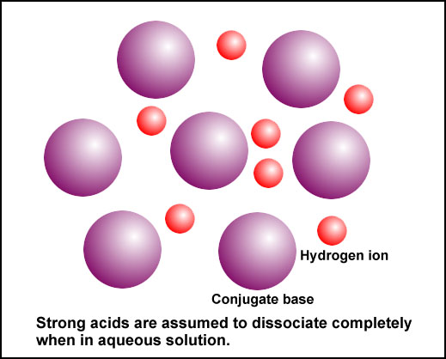 | 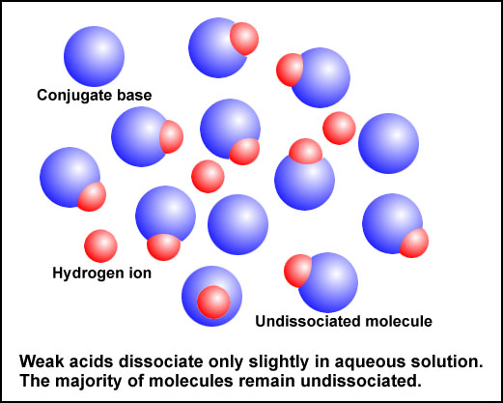
HCl (aq) – 100% dissociation | HA (weak acid) ~ 10% dissociation

Observations from the slide – Conjugate Acid and Base Pairs

1.

2.

3.

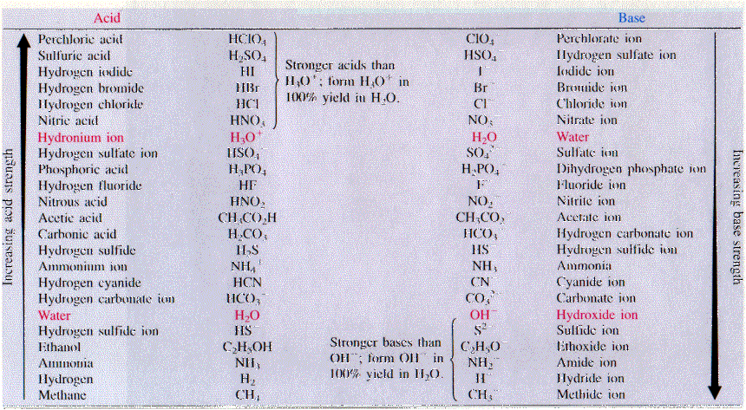

Task: Use the slide/handout to predict if the following equilibria lie to the left or to the right:

Recall that protonation favors transfer from stronger acid (or weaker base) to stronger base (or weaker acid)

1. PO₄³⁻ + H₂O (l) ⇔ HPO₄²⁻ + ⁻OH (aq)

2. NH₄⁺ (aq) + OH⁻ (aq) ⇔ NH₃ (aq) + H₂O (l)

The Autoionization of Water

Water is ‘special’ – it dissociates to simultaneously give both H₃O⁺ (aq) and ⁻OH (aq) ions (autoionization):
2 H₂O (l) ⇔ H₃O⁺ (aq) + ⁻OH (aq)

Task: Write an equilibrium (K) expression for the autoionization of water

Derivation of K_{w} and Other Useful Math

The value of K_{w} is constant for ANY aqueous solution, regardless of how much acid or base is added from external sources. I.E., for any aqueous solution:

K_{w} = 1.0 x 10⁻¹⁴ = [H⁺][⁻OH] @ 25ºC

Applications of K_{w} - pH, pOH and pK_{w}

Discussion Questions:

- If 1.0 x 10⁻¹⁴ = [H⁺][⁻OH], what is the concentration of both H⁺ (aq) and OH⁻ (aq) in any neutral solution. Hint: What must always true in terms of the concentrations of [H⁺] and [⁻OH] for any neutral solution?

- What is pH, what is it a measure of? What is the relationship between pH and [H⁺] for a neutral solution?

p is simply a mathematical function that means: “take the
-log₁₀ of the quantity of interest (such as [H⁺])”

Further expressions:

pOH =

pK_{w} =

There is a synergic relationship between pH and pOH (or [H⁺] and [⁻OH]) for any solution. I.E., as one rises ↑, one falls ↓:

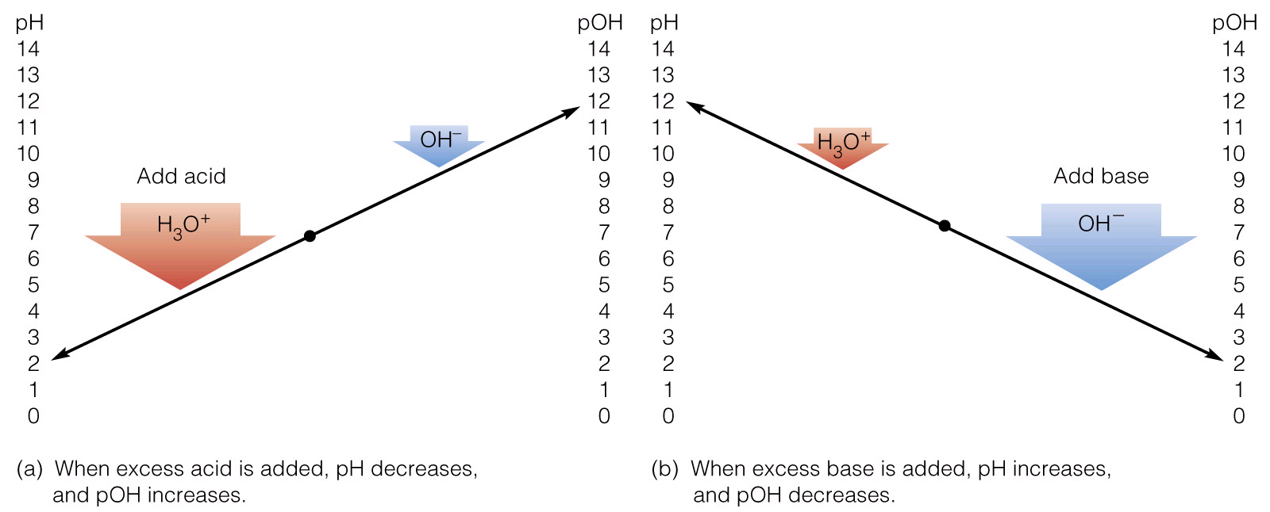

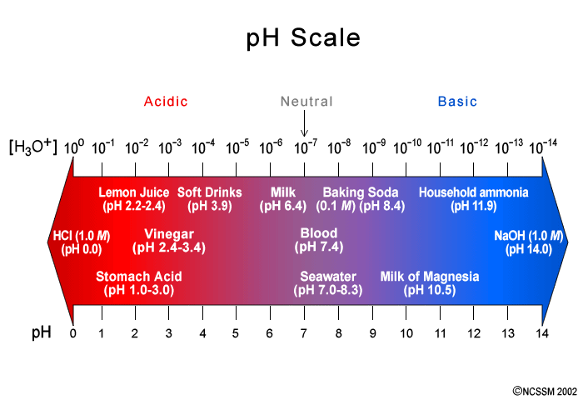

See the additional slide also

Questions: Determine the pH and pOH of the following strong acid and strong base solutions (assume 100% dissociation in each case):

0.055 M HCl (aq) | 0.008 M NaOH (aq)
0.055 M H₂SO₄ (aq) | 0.008 M Ca(OH)₂ (aq)

Workshop: Work in small groups to solve the following problems:

Calculate pH, pOH and [⁻OH] for each of the following solutions. State if each solution is acidic, basic or neutral:

- [H⁺] = 0.0041 M

- [H⁺] = 3.5 x10⁻⁹ M

- A solution where [H⁺] is 10 times greater than [⁻OH]

- If you finish the above, try some homework problems

Acid – Base Indicators

Recall your Lab: Acid base indicators are simply chemicals that undergo a color change when exposed to a specific [H⁺] or [⁻OH].

Thus, acid-base indicators work over a specific pH range. Indicators are selected based on their observed colors over specific / desired pH ranges

Table of common Indicators

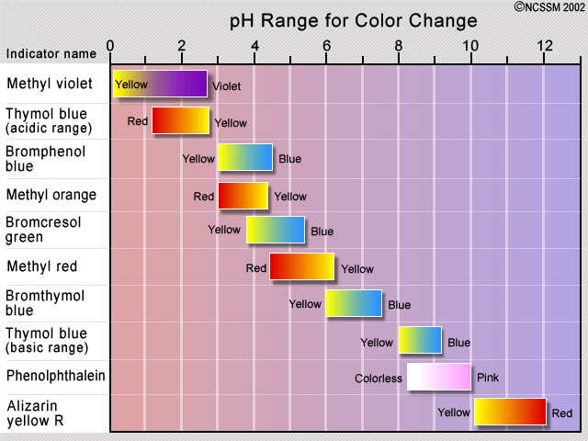

Questions: Which indicator would be best for detecting a titration endpoint that occurs at pH 4.0? What color change would be observed if the acidic sample was titrated with NaOH (aq)?

Why is indicator choice less important for a strong acid / strong base titration??

Appendix
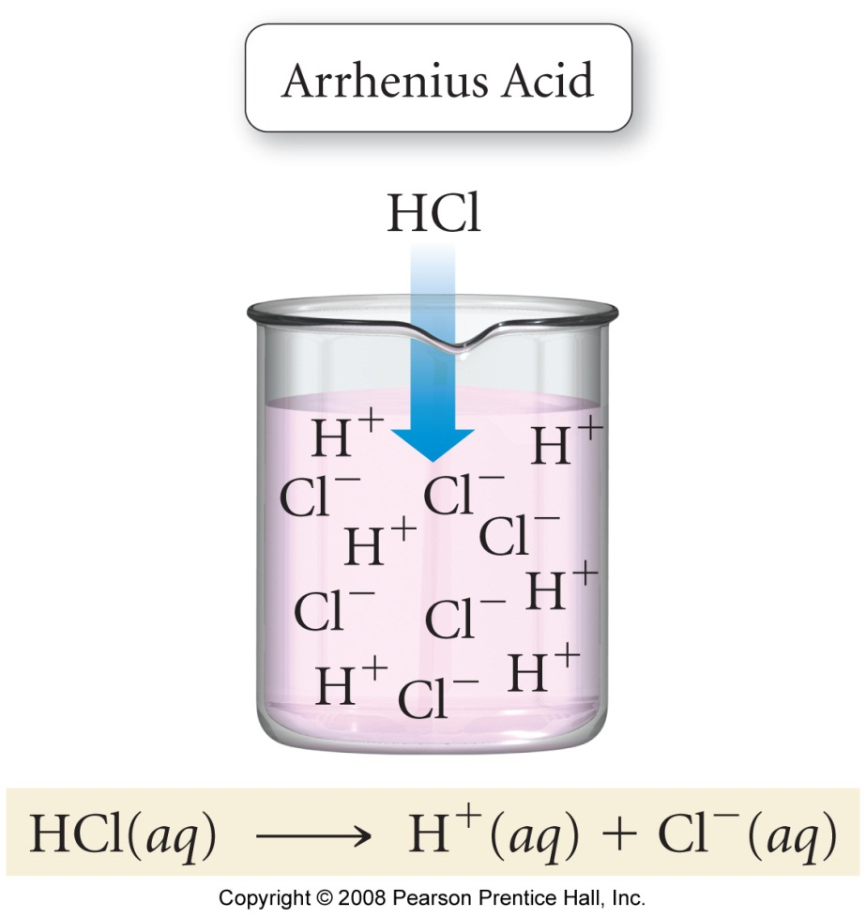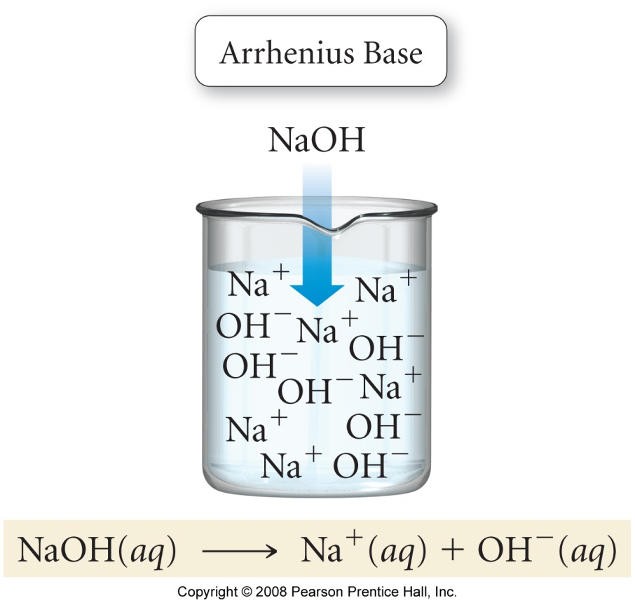

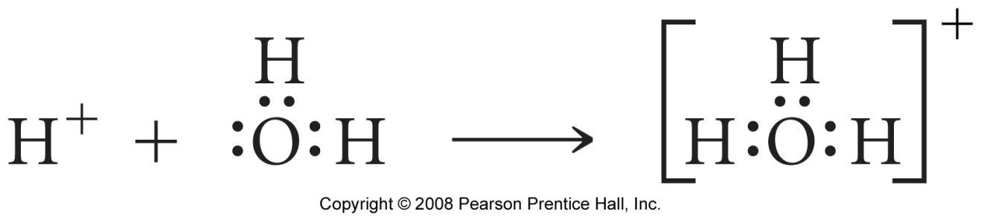

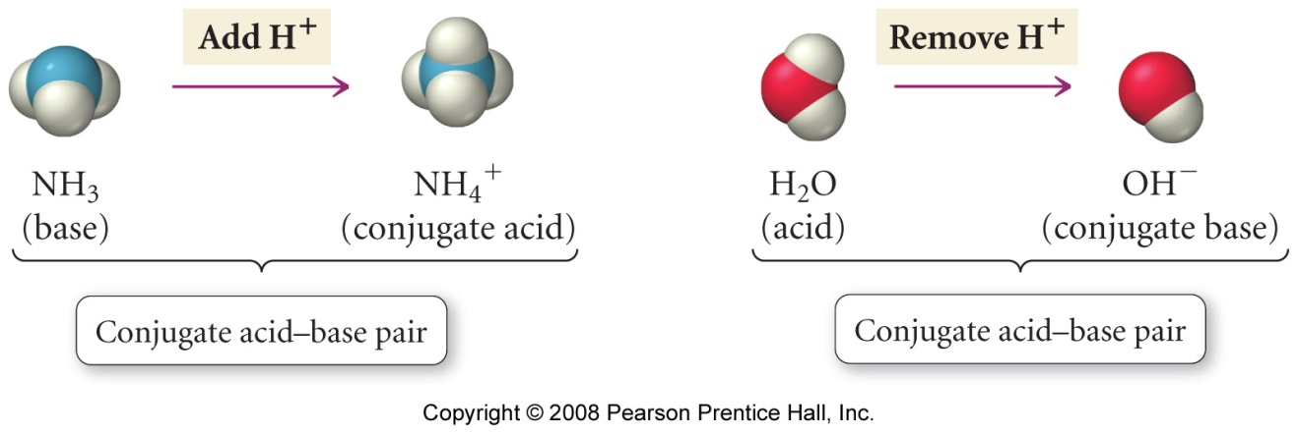
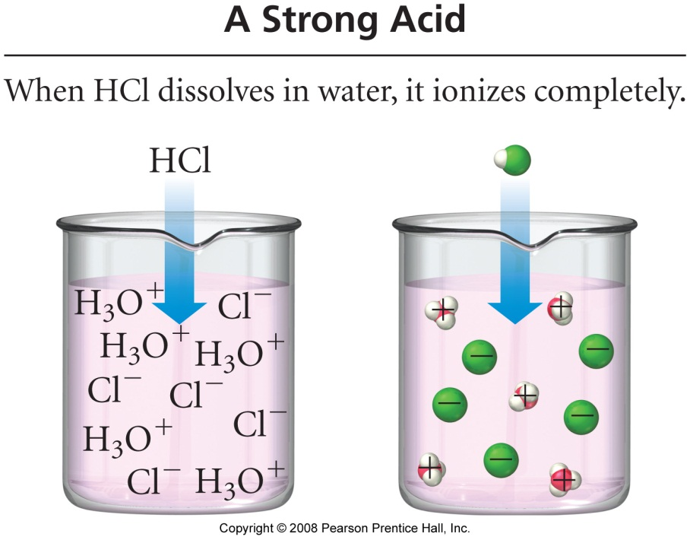

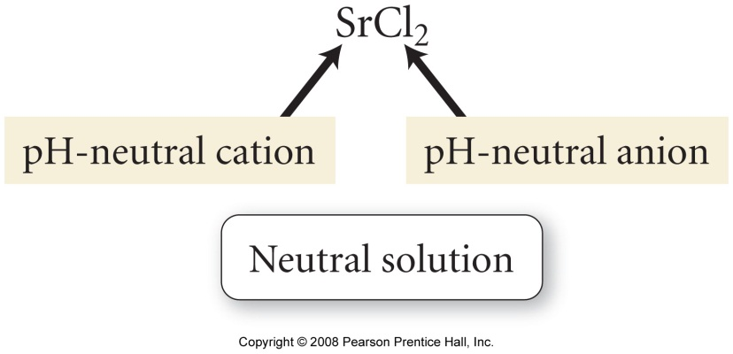

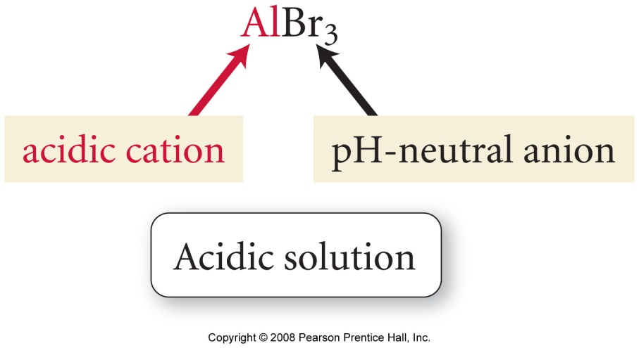

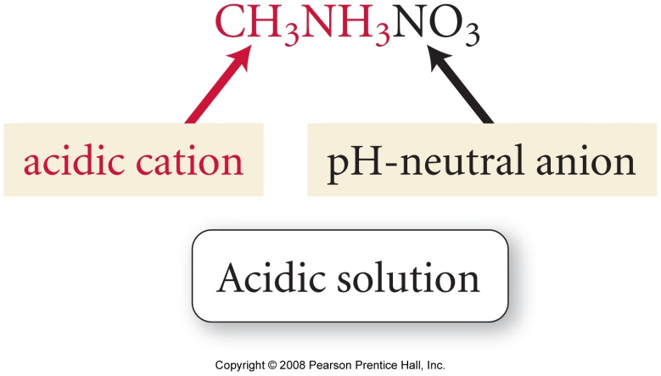
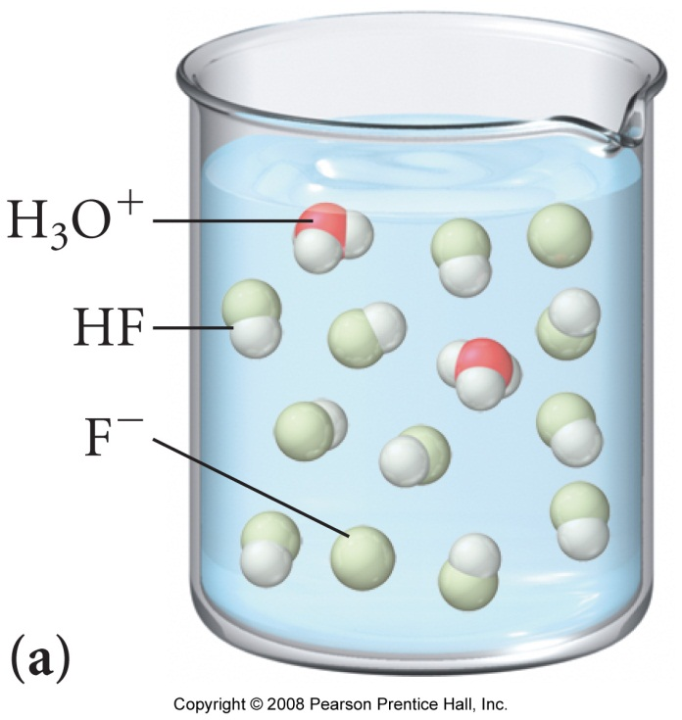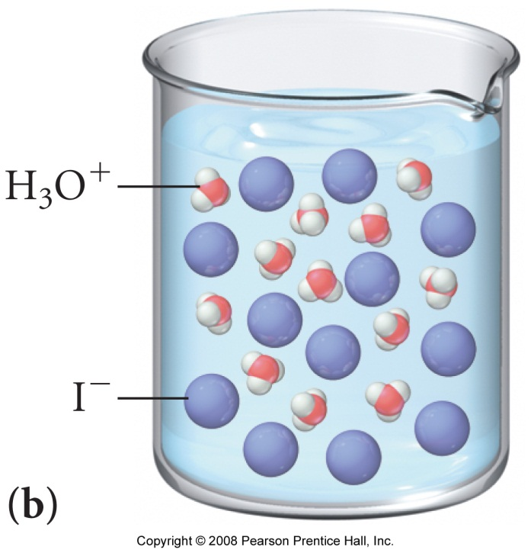
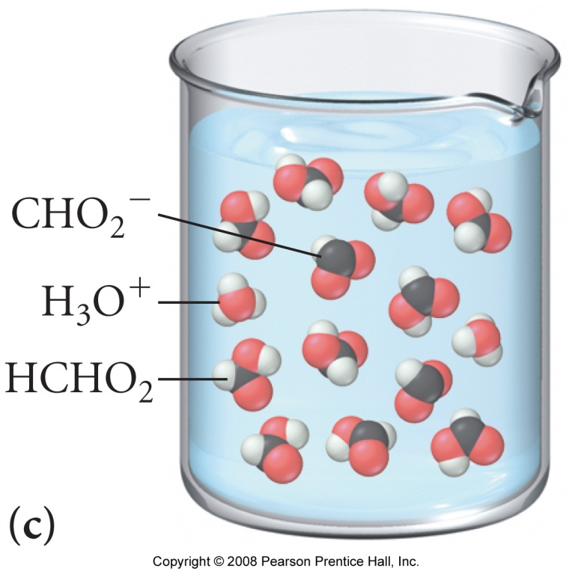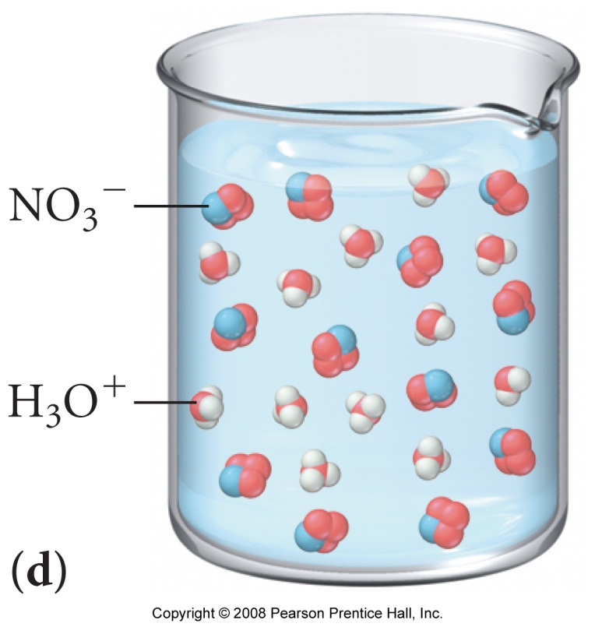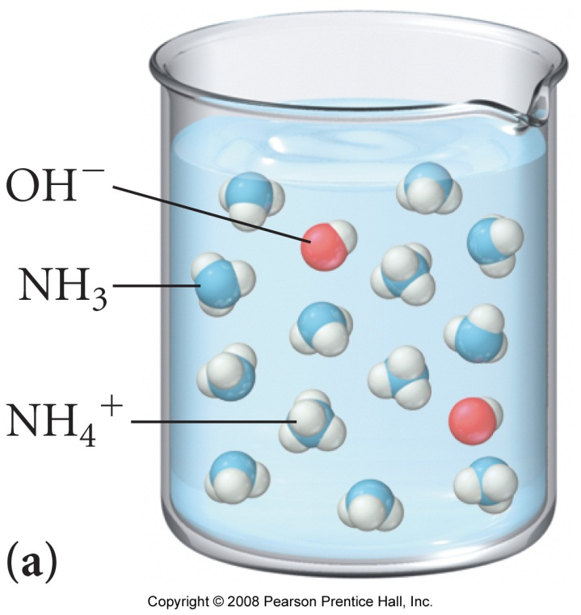

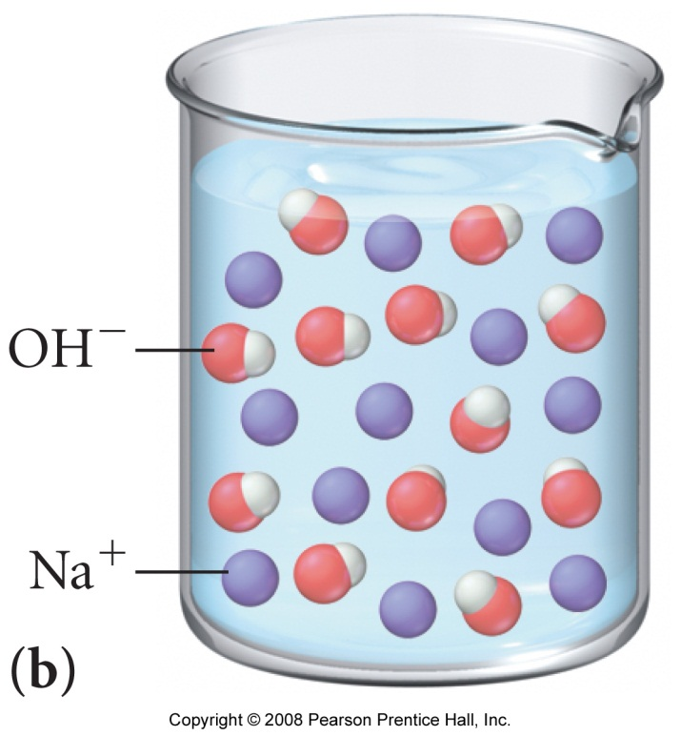
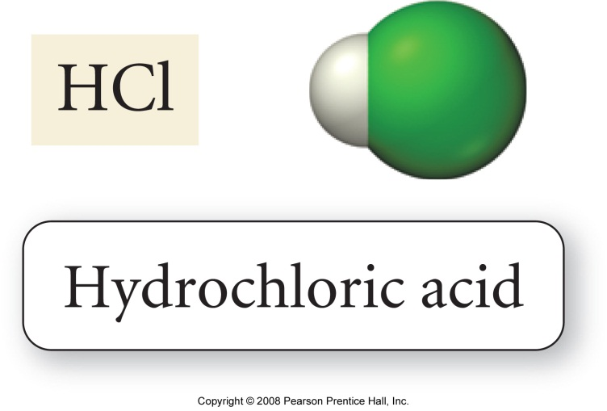

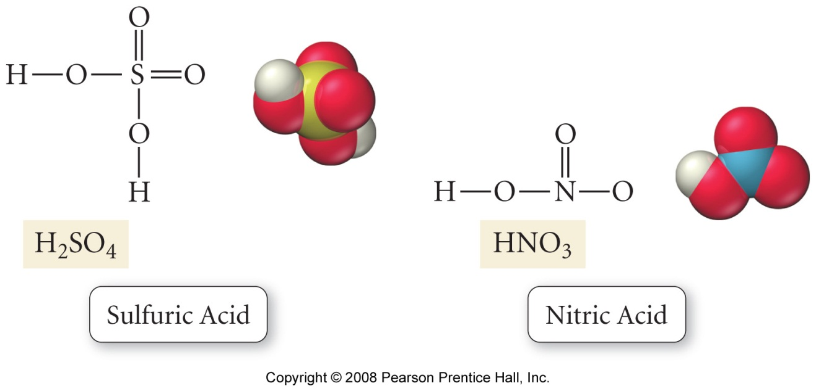
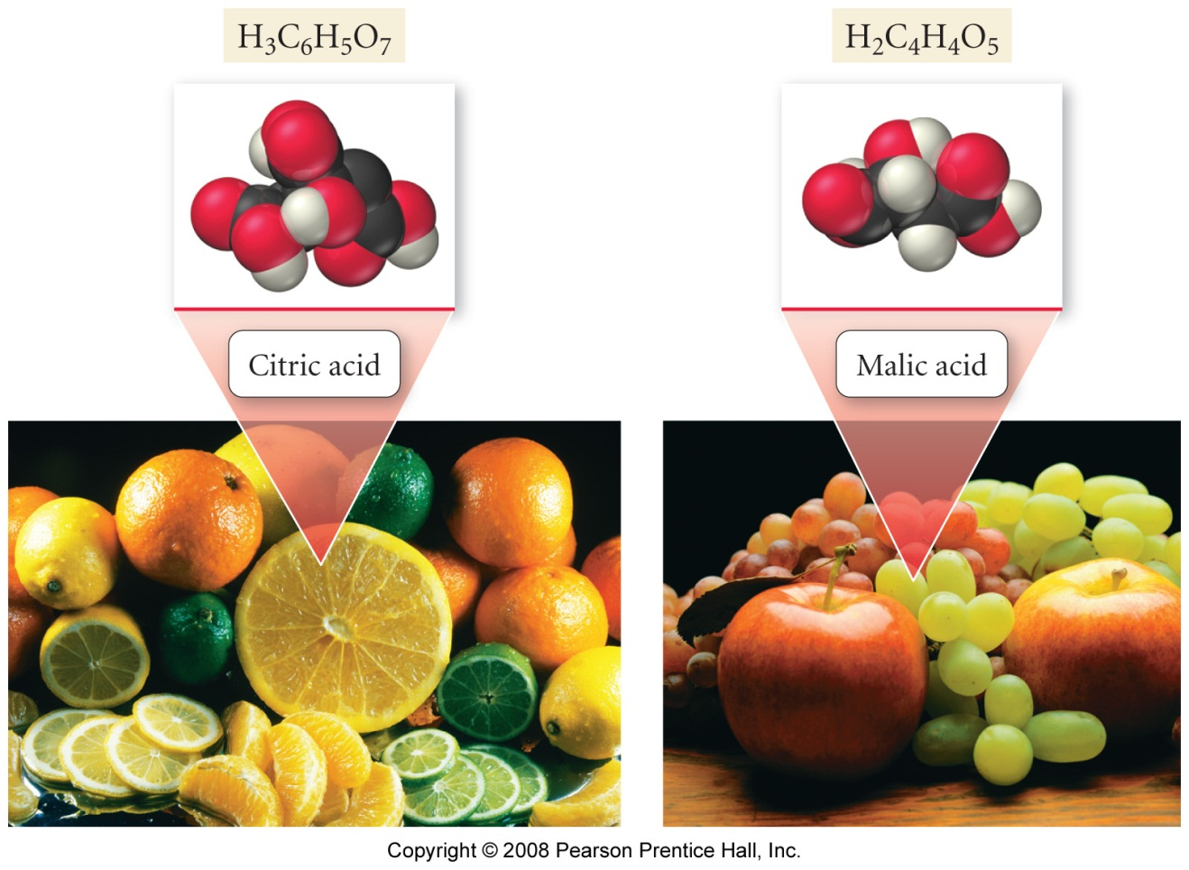

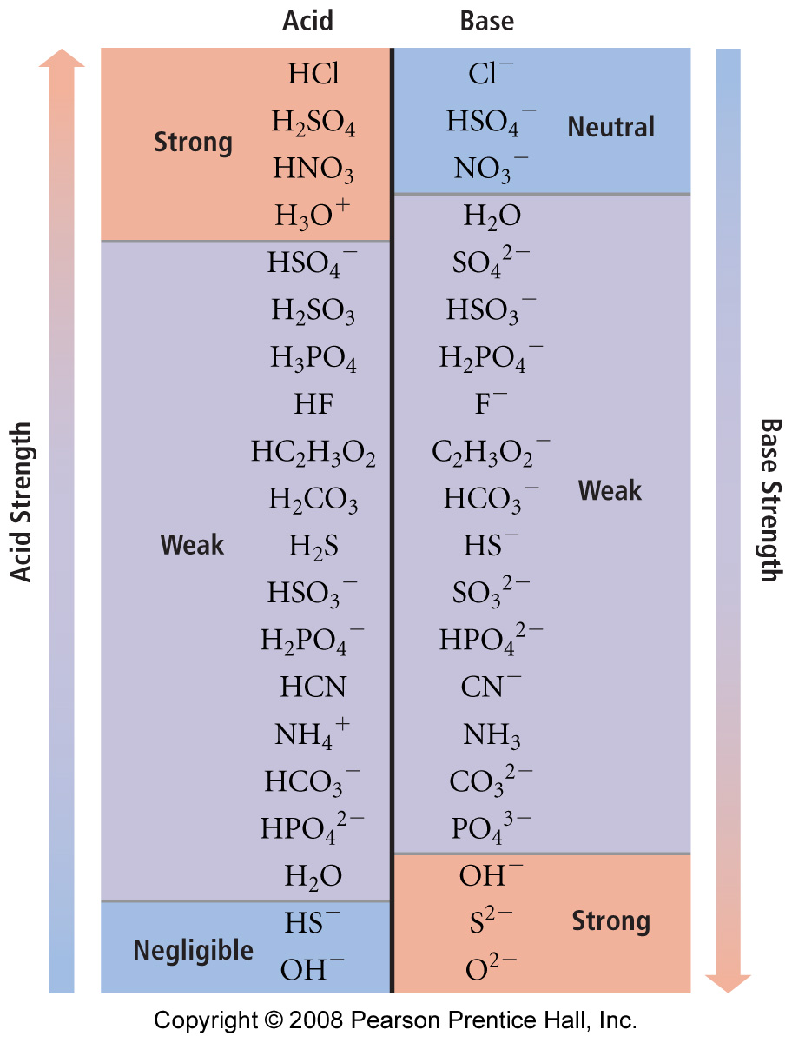

Acid - Base Equilibria 2

Reading: | Ch 15 sections 8 – 12 | Homework: | Chapter 15: 41, 57, 61*, 63, 65*, 67*, 73*, 85, 87*, 89, 91
* = ‘important’ homework question

Weak Acids

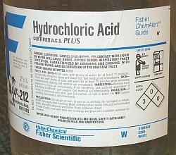 | 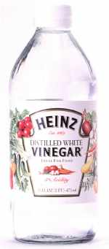 | Review / Discussion: What is ‘stronger’ – HCl (aq) or vinegar (acetic acid)? What are the differences?

Strong (mineral) acids, such as HCl, dissociate completely in water:

Weak (organic) acids undergo partial dissociation in water (much more on this later):

Because any weak acid and its respective dissociation products (H⁺ and conjugate base) are in equilibrium, ‘equilibrium math’ can be used to define K

Task: Determine an equilibrium expression (K) for the generic weak acid equilibrium:

HA (aq) | + | H₂O (l) | ⇔ | H₃O⁺ (aq) | + | A⁻ (aq)
Weak Acid |  | Water |  | Hydronium ion |  | Conjugate Base

Note: Since, in this case, K pertains to the dissociation of a weak acid only, it is called the acid dissociation constant and assigned a suitable subscript:
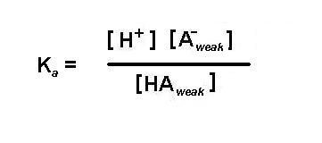
Discussion: Will strong acids (like HCl) have large or small values for K_{a}? Will weak acids (like acetic acid) have large or small values for K_{a}?

Task: Complete the following table:

Acid | Type | Reaction with water | K_{a}
HCl | strong | HCl (aq) → H⁺ (aq) + Cl⁻ (aq) | ‘∞’
HNO₃

HF |  |  | 6.8 x10⁻⁴
HC₂H₃O₂  (acetic) |  |  | 1.8 x10⁻⁴
HCN |  |  | 4.9 x10⁻¹⁰

Discussion: Of all the weak acids listed above, which is the ‘strongest’, weakest? Why?

The Relationship Between K_{a} and pH

Overview: Since any weak acid is in equilibrium, a modified I.C.E. method can be used to determine either pH or K_{a}

Vanilla I.C.E., noted chemical philosopher

Worked Example: A sample of 0.10 M formic acid (HCHO₂) has a pH of 2.38. Determine K_{a} for formic acid and the % to which formic acid is dissociated.

Plan:

- Find [H⁺]

- Set up and solve an I.C.E. table in order to find the equilibrium concentrations of HA, H⁺, A⁻. ‘Insert and evaluate’ to find K_{a}

- Find % dissociation

Using K_{a} to find pH (the ‘reverse’ problem)

Question: What is the pH of 0.2 M HCN (aq) (K_{a} = 4.9 x10⁻¹⁰)

Plan:

Execution:

IMPORTANT: The weak acid approximation: when K_{a} ≤ 10⁻³

[HA] – [H⁺] ≈ [HA]

This greatly simplifies the I.C.E. method, which is usually not undertaken unless the above is true (would otherwise require a quadratic equation to be solved)

Group work: Skip ahead to the end of this handout and work through the first two practice exam problems

Weak Bases

Weak base problems are very similar to the I.C.E. weak acid examples, except that [OH⁻] and pOH (rather than [H⁺] and pH) are found initially

Generic Equilibrium:

B (aq) | + | H₂O (l) | ⇔ | HB(aq) | + | OH⁻ (aq)
Weak base |  | Water |  | Conjugate Acid |  | Hydroxide ion

For ammonia dissolved in water:

NH₃ (aq) + H₂O (l) → NH₄⁺ (aq) + OH⁻ (aq)

Task: Determine K for the above ammonia equilibrium

Note: Since, in this case, K pertains to the dissociation of a weak base only, it is called the base dissociation constant and assigned a suitable subscript:

Task: Complete the following table:

Base | Type | Reaction with water | K_{a}
NaOH | strong | NaOH (aq) → Na⁺ (aq) + OH⁻ (aq) | ‘∞’
KOH

NH₃ |  |  | 1.8 x10⁻⁵
HS⁻ |  |  | 1.8 x10⁻⁷
CO₃²⁻ |  |  | 1.8 x10⁻⁴

Discussion: Of all the weak bases listed above, which is the ‘strongest’, weakest? Why?

Example: Find [OH⁻] and pH for 0.15 M NH₃ solution (K_{b} = 1.8 x10⁻⁵)

Plan:

Recall that [OH-] and pOH can be found initially, then pH can be determined via:
pH + pOH = 14

Execution:

Group Task: An NH₃ (aq) solution has a pH of 10.50. What is [NH₃] in this solution?

The Relationship between K_{a} and K_{b}

Recall: All weak acids and bases are in equilibrium with their respective conjugates. Each will also have an equilibrium (K) expression, e.g.:

NH₄⁺ (aq) → H⁺ (aq) + NH₃ (aq); K_{a} =

NH₃ (aq) + H₂O (l) → NH₄⁺ (aq) + OH⁻ (aq); K_{b} =

‘Equilibrium constant math’ can be applied to the above pair of equations.

Task: Add the above equations and find an expression for K in terms of K_{a} and K_{b}. Do you notice something familiar?

For any weak acid or weak base:

K_{a}K_{b} = K_{w} = 1 x 10⁻¹⁴ = [H⁺][OH⁻]

Also, since K_{a}K_{b} = K_{w}:

pK_{a} + pK_{b} = pK_{w}

Quick Question: What is K_{a} for NH₃ (aq)?

Group work: Skip ahead to the last page of this handout and work through the practice exam problem ‘Weak Base’
“What’s the pH?”

Question 2 (25 points): Calculate the pH of each of the following solutions:

- 0.015 M HCl (aq) (assume complete dissociation)

- 0.015 M H₂SO₄ (aq) (assume complete dissociation)

- 0.015 M NaOH (aq) (assume complete dissociation)

- 0.015 M HC₂H₃O₂ (aq), K_{a} = 1.8 x 10⁻⁵
“Weak Acid”

Question 3 (25 points): A 0.200 M solution of a weak acid HA (aq) is 9.4 % ionized (dissociated) at equilibrium. Use this information to calculate [H⁺], [HA] and K_{a} for HA.

“Weak Base”

Codeine (C₁₈H₂₁NO₃) is a weak organic base. A 5.0 x 10⁻³ M solution of codeine has a pH of 9.95.

Question 4a (20 points): Calculate K_{b} for codeine.

Question 4b (5 points): Calculate pK_{a} for codeine.

Appendix:

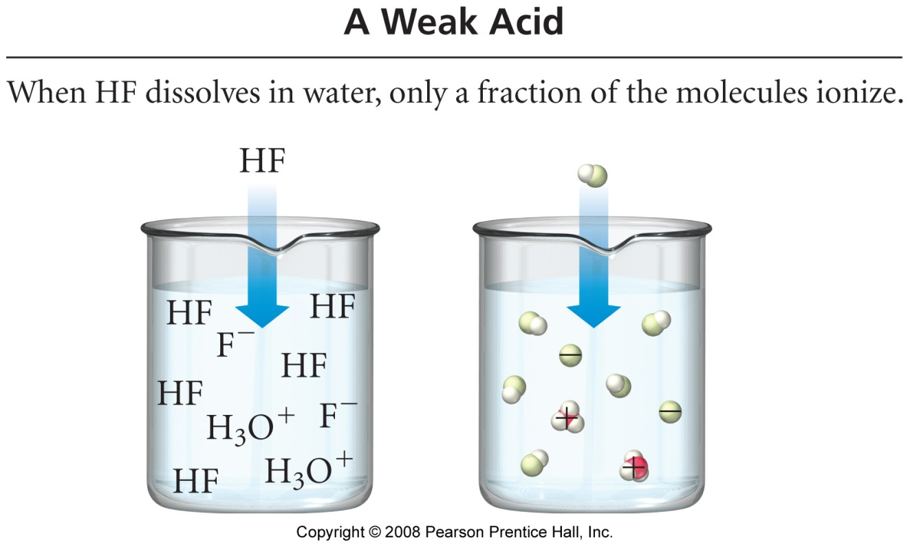

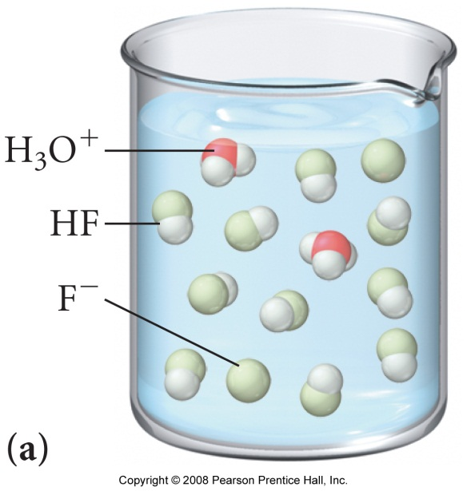 | 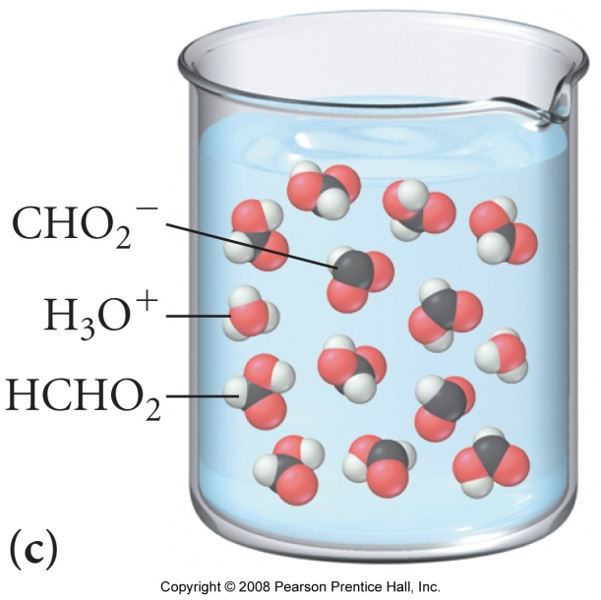

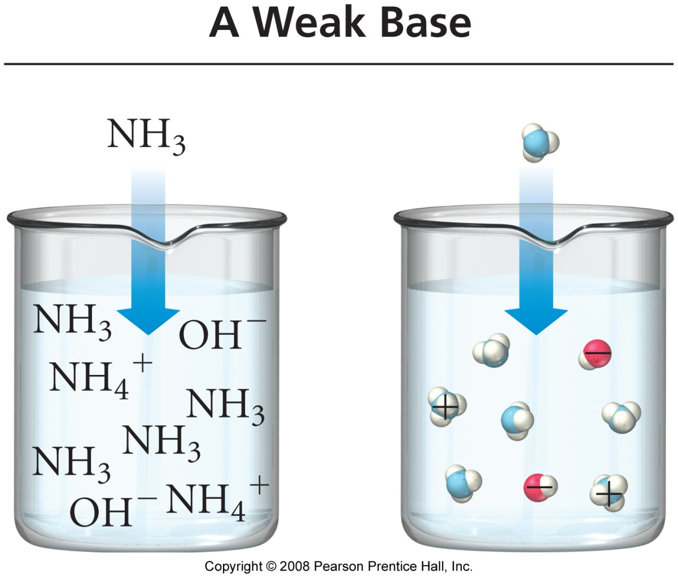

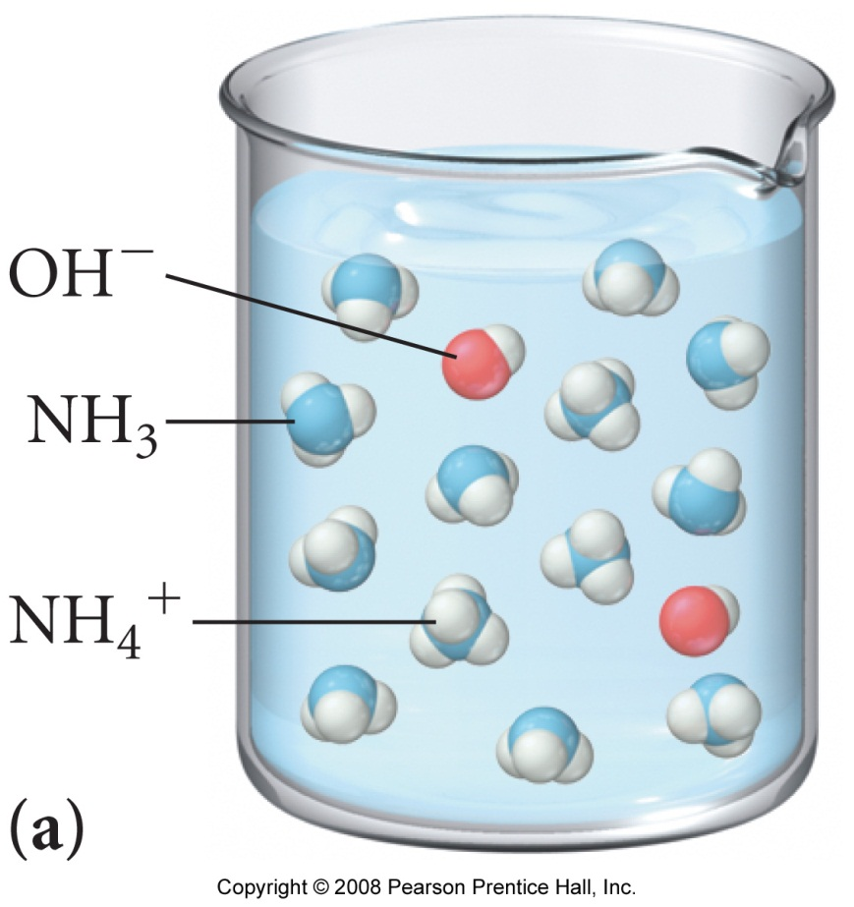
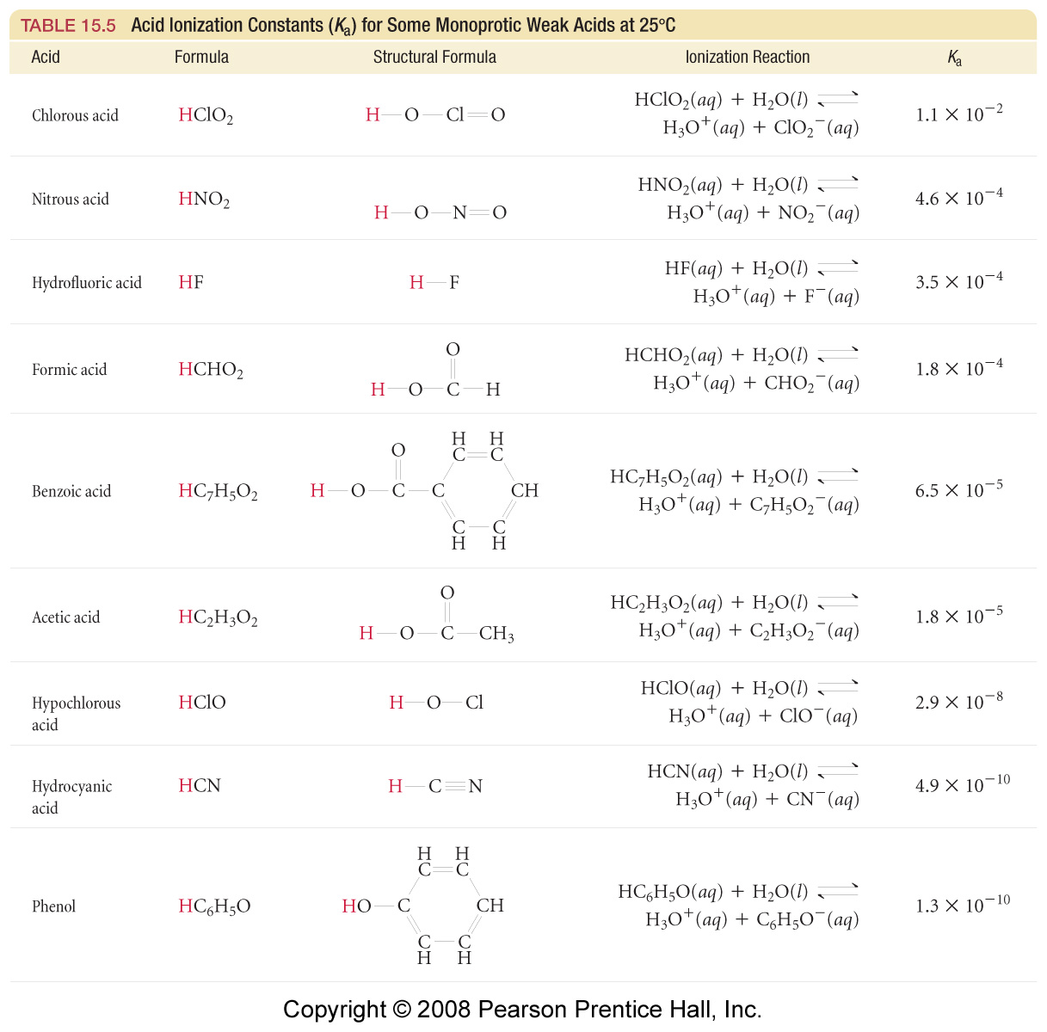
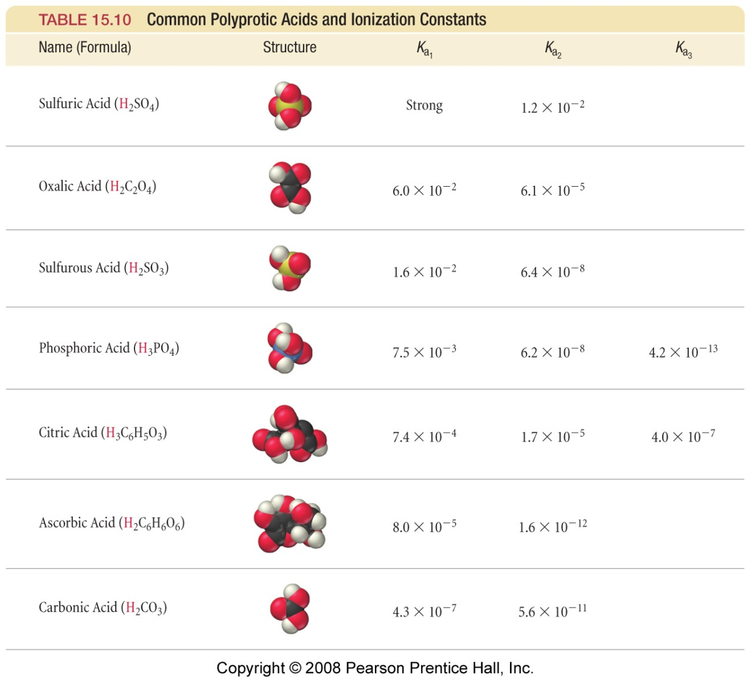

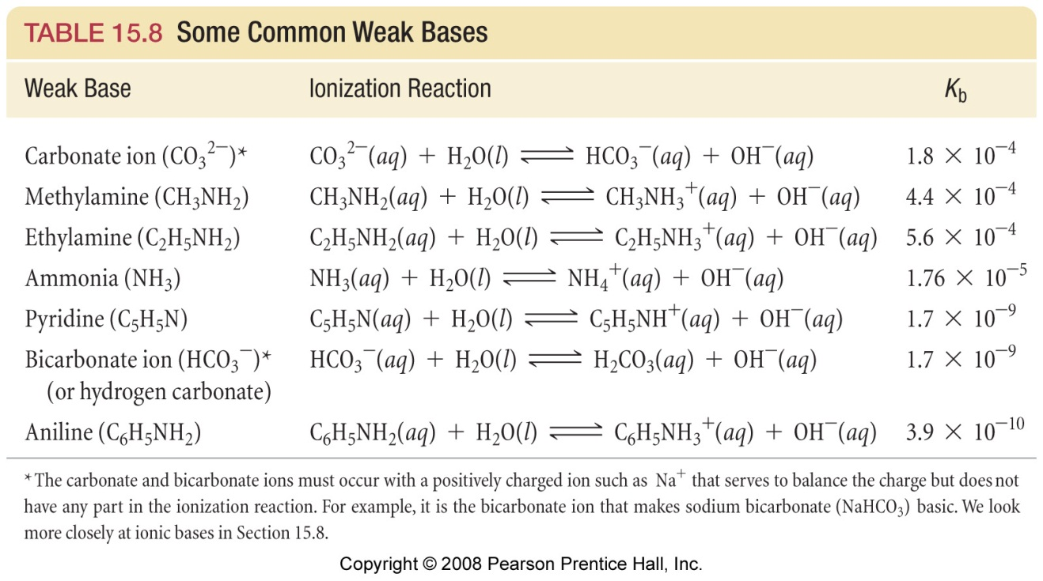

Acid - Base Equilibria 3

Reading: | Ch 15 sections 8 – 9  Ch 16 sections 1 – 7 | Homework: | Chapter 15: 97, 103, 107,  Chapter 16: 29*, 33*, 35, 37*, 39*, 41, 43*, 49, 55, 57, 61, 65, 81, 85*, 87*, 89*, 93, 95*, 101, 103
* = ‘important’ homework question

Additional Aspects of Acid-Base Equilibrium

Salts and Polyprotic Acids

Discussion: What happens, on a molecular level, when sodium acetate (or any salt of a weak acid and a strong base) is dissolved in water?

Equation 1:

Would you expect the resulting solution to be acidic, basic or neutral? What’s the trick??
(K_{a} HC₂H₃O₂ = 1.8 x 10⁻⁵).

Equation 2:

Task: Calculate the pH of a solution made by dissolving 10.0 grams of NaC₂H₃O₂ (s) in water, making the final solution volume equal 1.0 L

Discussion: What is the difference between a monoprotic and a polyprotic acid? Give an example of each.

Recall your lab: Polyprotic acids are amphoteric, so will have several equivalence points when titrated - each acidic proton is either removed (NaOH titration of the acid form) or added (HCl titration of the base form).

Each deprotonation step will have a specific K_{a} (or pK_{a}) value associated with it (see slide / handout)

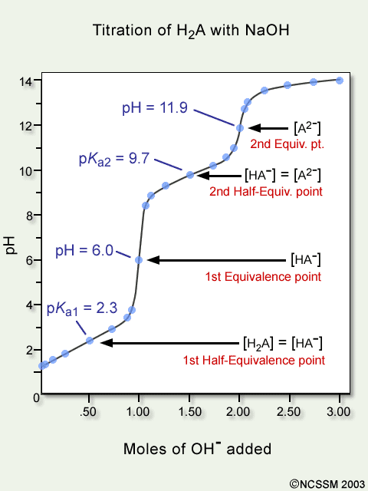 | Equivalence Point 1  H₂A ⇔ H⁺ + HA⁻  pK_{a1} = 2.3  K_{a1} = ________________  Equivalence Point 2  HA⁻ ⇔ H⁺ + A⁻  pK_{a2} = 9.7  K_{a2} = ________________  Note: Titration plots can be used to determine K_{a} values – this will be covered in more detail below.

Generic titration plot for a diprotic acid (H₂A) with a strong base

Questions: Which indicators would be best for detecting the two titration endpoints, observed for H₂A (above), when this diprotic acid is titrated with NaOH (aq)? What color changes would be observed?

The common Ion effect

Consider the following equilibrium for acetic acid:

HC₂H₃O₂ (aq) ⇔ H⁺ (aq) + C₂H₃O₂⁻ (aq)

Discussion: according to Le Châtelier’s Principle, what would happen to the position of the above equilibrium if a large amount of C₂H₃O₂⁻ (aq) (from, for example, NaC₂H₃O₂) were added?

Your description:

(an unnecessarily wordy) Dictionary Description

The extent of ionization of a weak electrolyte is decreased by adding a strong electrolyte (such as a salt) that has a common ion with the weak electrolyte in solution

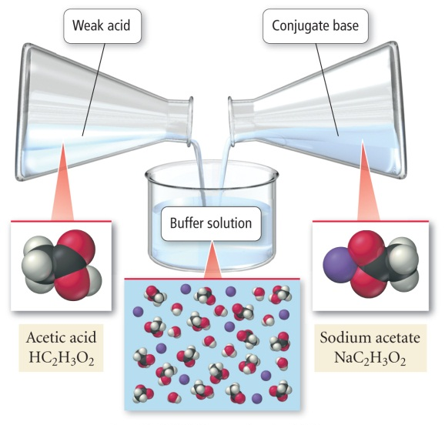 | Worked Example: What is the pH of a solution made by adding 0.125 mol. of HC₂H₃O₂ and 0.075 mol. of NaC₂H₃O₂ to enough water to make a 1.0 L solution? K_{a} acetic acid = 1.8 x10⁻⁵  Use the standard I.C.E. method for weak acids, BUT include the (now non-zero)  initial concentration of the conjugate base introduced via dissolving it’s salt.

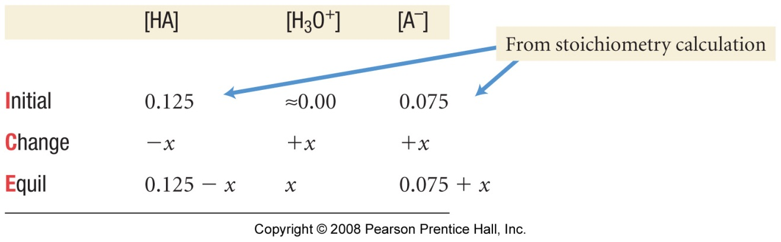

ANS =

Task: Calculate [F⁻] and pH of a solution that is simultaneously 0.20M in HF (aq) and 0.10 M in HCl (aq). K_{a} for HF = 6.8 x10⁻⁴

ANS: [F⁻] = 1.4 x10⁻³ M
pH = 1.0

Comment:

Buffered Solutions

Buffered solutions (buffers) are weak acid / base conjugate pairs that resist drastic changes in pH upon addition of strong acids or bases from external sources.

This is simply a specific application of the common ion effect – the common ion introduced from an external source is always either H⁺(aq) (from a strong acid) or OH⁻(aq) (from a strong base)

Discussion / Background: consider the following generic weak acid /conjugate base equilibrium (see appendix):

HA (aq) ⇔ H⁺ (aq) + A⁻ (aq)

According to Le Châtelier’s Principle, what would happen to the position of the above equilibrium if:

- A large amount of H⁺ (aq) from an external source (such as a strong acid like HCl (aq)) were added?

Equation:

- A large amount of OH⁻ (aq) from an external source (such as a strong base like NaOH (aq)) were added?

Equation:

Buffering capacity and Buffer pH

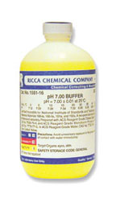 | A buffer will resist changes in pH (i.e. increases in either [H⁺] or [OH⁻]) by ‘reacting away’ these chemical species.  The buffering capacity of the buffer is determined by the relative concentrations of the weak acid (HA) and conjugate base (A⁻) at equilibrium. For example, a buffer with HA: A⁻ in a 10:1 ratio will be able to ‘react away’ x10 more OH⁻ than can H⁺ before the buffer becomes exhausted.  The chemical makeup of the buffer (i.e. K_{a} or K_{b} for the weak acid/base system) determines the ‘natural’ pH the buffer. Buffers of virtually any pH between ~2 and 13 can be constructed.

Titration curves for non-buffered and buffered systems (see appendix)

Titration of a strong acid with NaOH (non-buffered) | Titration of a weak acid /conjugate base buffer with NaOH

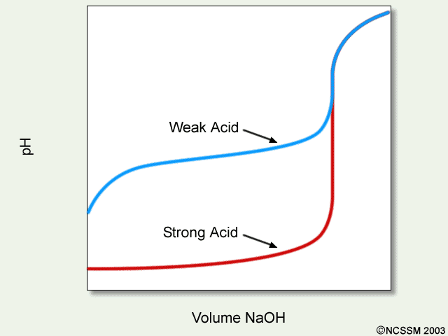 | Diagram illustrating the ‘buffer region’ for a weak acid undergoing titration with NaOH (aq).  Recall:  HA + OH⁻ → A⁻ + H₂O  Equivalence is reached when moles HA present = moles OH added. Before equivalence, the ‘natural’ pH of the buffer is maintained
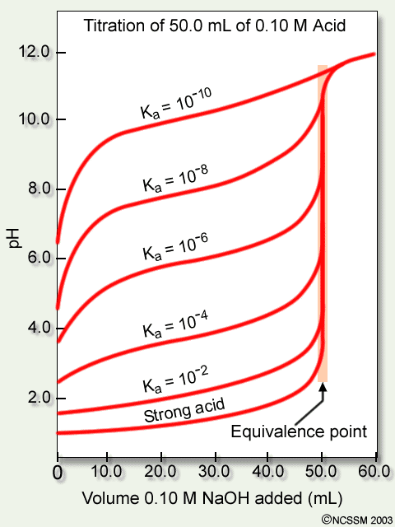 | Diagram illustrating the ‘buffer region’ for weak acids of specific Ka values undergoing titration with NaOH (aq).  Discussion: What do you notice with regard to the relationship between K_{a} and the ‘natural’ pH of the buffer?  Note: The mathematical relationship between pH and K_{a} is discussed further below

Because buffers are essentially just either a weak acid or a weak base and their respective conjugate in equilibrium, a standard ‘common ion’ I.C.E. approach can be used to find the ‘natural’ pH of a buffer (recall the HC₂H₃O₂ / NaC₂H₃O₂ system discussed previously).

Example (group work): What is the pH of a buffer that is 0.12 M in lactic acid (HC₃H₅O₃) and 0.10M in sodium lactate? K_{a} = 1.4 x10⁻⁴.

The Verve had a good handle on weak acid / base equilibria. Kind of…. | Drugs are typically either weak acids or weak bases (more on this later), so their pH - which relates to solubility, and ultimately if the drug should be taken orally or intravenously – is of great interest to MCAT and PCAT examiners!  Problem: Do you think ‘they’ intend for you to employ a time consuming modified I.C.E. methodology on the ‘CAT’ test?  Answer:  Solution: There is a quicker and much more convenient method to find the pH of a buffer solution: the Henderson –Hasselbalch equation.

Derivation of the Henderson –Hasselbalch equation

Since, for any weak acid conjugate base buffer:
Then:

Henderson –Hasselbalch equation

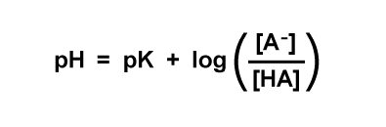
Task: Assume you are taking the PCAT or MCAT- use the H-H equation to quickly answer the previous lactic acid buffer question:

What is the pH of a buffer that is 0.12 M in lactic acid (HC₃H₅O₃) and 0.10M in sodium lactate? K_{a} = 1.4 x10⁻⁴.

Discussion: When you perform a titration, what is true in terms of the moles of acid and base present at equivalence? What then must be true at half- equivalence?

What happens to the H-H equation at half-equivalence for the titration of a weak acid with NaOH? (i.e. when moles HA unreacted = moles A⁻ formed)?

pH = pK_{a} for a buffer at half- equivalence (i.e. when [HA] = [A⁻])

(see titration cure examples, above (H₂A), and in Appendix)
Mr. Buffer’s buffer (buffers in the body)

Blood has a regulated (buffered) pH of 7.4. The buffer responsible for maintaining the pH of blood is the carbonic acid / hydrogen carbonate system – i.e. the same one studied in your recent lab:

H₂CO₃(aq) ⇔ H⁺ (aq) + HCO₃⁻(aq)

Group work: If H₂CO₃(aq) has a concentration of 0.0012 M in human blood, what is [HCO₃⁻] in blood? Is blood better at resisting changes in [H⁺] or [OH⁻]? K_{a} = 4.3 x10⁻⁷

Lewis acids/bases and more about Drugs

The Lewis lone–pair transfer model

In the Lewis model:

Lewis Acids are identified as lone pair electron acceptors

Lewis Bases are identified as lone pair electron donors

Just like proton transfer, but viewed in terms of what the proton ‘sticks to’

Example: NH₃ (aq) as Lewis base

Question: Why worry about Lewis base behavior, when it is essentially just B-L theory from a different point of view?

Answer: Most ‘interesting’ drugs (be they legal or illegal) are Lewis bases – they contain N: group(s) (just like ammonia).

Problem: Most ‘free bases’ (where have you heard that term before?) are volatile and not too soluble in water – not good candidates for turning into oral (or other) medication.

Solution: Turn ‘free bases’ into acids salts – acid salts are soluble and non-volatile, so have long shelf lives and can be taken orally.
Generic example of forming the acid salt of a ‘free base’

D: + HCl (aq) → [D: H]⁺[Cl]⁻

A great many drugs, both legal and illegal, are manufactured and sold as the acid or other salts

Levitra (vardenafil HCl):
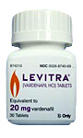

‘Crack’ (cocaine sodium hydrogen carbonate):

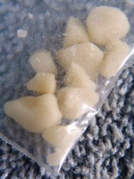

Social commentary: I don’t want to go off on a rant here, but…

Solubility Equilibria

Background: What is a saturated solution?

Official definition: A solution in which undissolved solute and dissolved solute are present in equilibrium

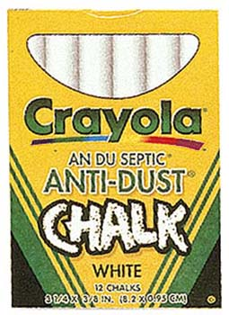 | Most apparently insoluble solids (such as chalk, for example) are sparingly soluble – they dissolve to a tiny degree:  CaCO₃ (s) ⇔ Ca²⁺ (aq) + CO₃²⁻ (aq)

Task: Derive a simple ‘products over reactants’ expression for the above equilibrium featuring solid chalk (calcium carbonate) and it’s dissolved ions. What ‘cancels’?

Any sparingly soluble salt (ionic compound) will have a related solubility product (K_{sp}) expression. K_{sp} values are known for most compounds at 25ºC. For chalk (calcium carbonate):

K_{sp} = [Ca²⁺][CO₃²⁻] = 4.5 x 10⁻⁹

Note: Since the ionic materials we are dealing with are sparingly soluble, their K_{sp} values are necessarily very low

Compound | K_{sp} | Compound | K_{sp}
BaSO₄ | 5.0 x10⁻⁹ | CaF₂ | 3.9 x10⁻¹¹
Ag₂SO₄ | 1.5 x10⁻⁵ | AgCl | 1.8 x10⁻¹⁰
See the Appendix for a more complete list

Task: Write solubility product expressions for the following equilibria

- Dissolution of barium sulfate

- Dissolution of calcium fluoride

- Dissolution of silver sulfate

As with all other equilibria, the concentration of a reactant is raised to the power of its stoichiometic coefficient in the expression

Solubility and K_{sp}

Group work: You drop a stick of chalk into some pure water. What will the concentration of the Ca²⁺ (aq) ions be in the resulting saturated solution after the solid and its aqueous ions have attained equilibrium? Hint: Use the K_{sp} expression

Harder example: A saturated solution of magnesium hydroxide has a pH of 10.17. Find K_{sp} for Mg(OH)₂. See appendix for equation.

Solubility

The solubility (s) of any sparingly soluble salt (ionic compound) is expressed in terms of the solvated metal cation

For the dissolution of AgCl:

AgCl (s) ⇔ Ag⁺ (aq) + Cl⁻ (aq)

solubility (s) = [Ag⁺] (which also = [Cl⁻] in this example)

Task: Derive an expression for s in terms of K_{sp}, given that, for silver chloride:

K_{sp} = [Ag⁺][ Cl⁻]

Group Task: Determine K_{sp} and solubility (s) expressions for the following equilibrium:

CaF₂ (s) ⇔ Ca²⁺ (aq) + 2F⁻ (aq)

Worked (quantitative) Example: What is the solubility of calcium fluoride in g/L? K_{sp} = 3.9 x10⁻¹¹

Plan:

Note: Solubilities (especially in the biochemical and medical fields) are often quoted in g/L or mg/mL
K_{sp} and the Common Ion Effect

Recall: According to Le Châtelier’s Principle, increasing the concentration of a dissolved reactant or product in equilibrium will cause the equilibrium to shift in order to remove that material. The same is true for K_{sp} equilibria

Worked Example: Calculate the molar solubility (s, in mol/L) of CaF₂ in a solution that is 0.010M in Ca(NO₃)₂ (aq)

Plan: set up a modified I.C.E. grid, then insert and evaluate in the K_{sp} expression.

Notice that any compound that undergoes partial dissociation (weak acids, weak bases, buffers, and now sparingly soluble salts) can be modeled using the I.C.E. method coupled with the appropriate equilibrium expression – it’s just a case of same math, different application….

Discussion / Observation: As the infamous serial killer Jeffery Dahmer would have told you, the easiest way to get sparingly soluble salts (like calcium phosphate (bone)) into solution is to dissolve them in an acid.

Jeffery obviously paid attention in Gen. Chem., as this is a standard lab ‘trick’:

Example: Consider the dissolution equilibrium of the sparingly soluble salt material magnesium carbonate:

MgCO₃ (s) ⇔ Mg²⁺ (aq) + CO₃²⁻ (aq)

If HCl (aq) is used as a solvent, then:

HCl (aq) → H⁺ (aq) + Cl⁻ (aq) (complete dissociation)

Now, the H⁺ ions will enter into equilibrium with the carbonate anion, which is the conjugate base of the weak acid HCO₃⁻:

H⁺ (aq) + CO₃²⁻ (aq) ⇔ HCO₃⁻ (aq)

Question: What happens to the original magnesium carbonate equilibrium when carbonate ions are removed in this way? What will happen to the value of [Mg²⁺] (s) and the amount of sold magnesium carbonate present?

“Common Ion”

Question 2 (25 points): A solution contains 2.5 x 10⁻⁴ M Ag⁺(aq) and 1.7 x 10⁻³ M Pb²⁺(aq).

- If NaI (aq) is added, will AgI (K_{sp} = 8.3 x 10⁻¹⁷) or PbI₂ (K_{sp} = 7.9 x 10⁻⁹) precipitate first?

- Specify the concentration of I⁻ (aq) needed to begin precipitation of the material you determined would precipitate first in part A.

Appendix:

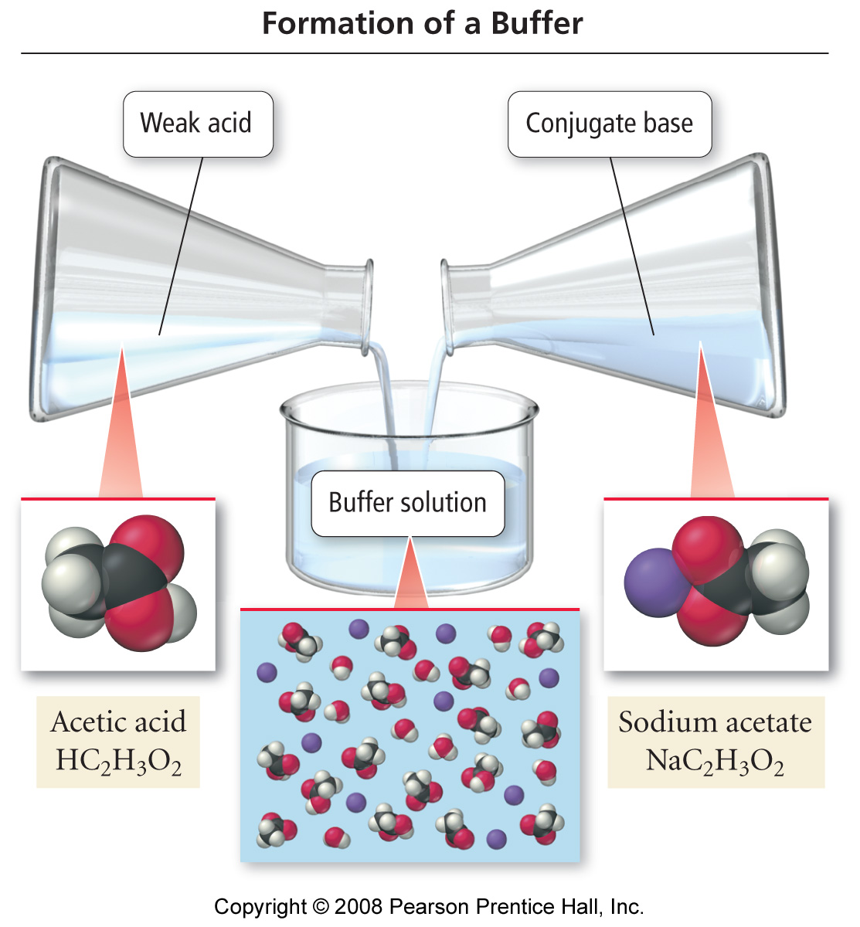

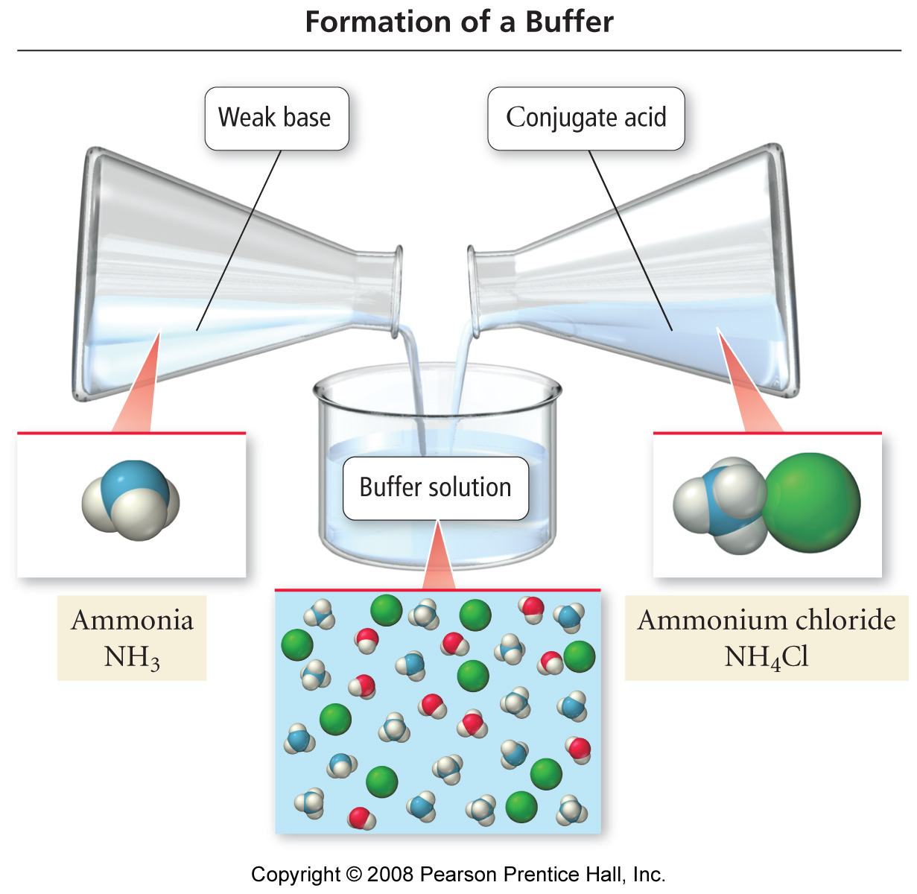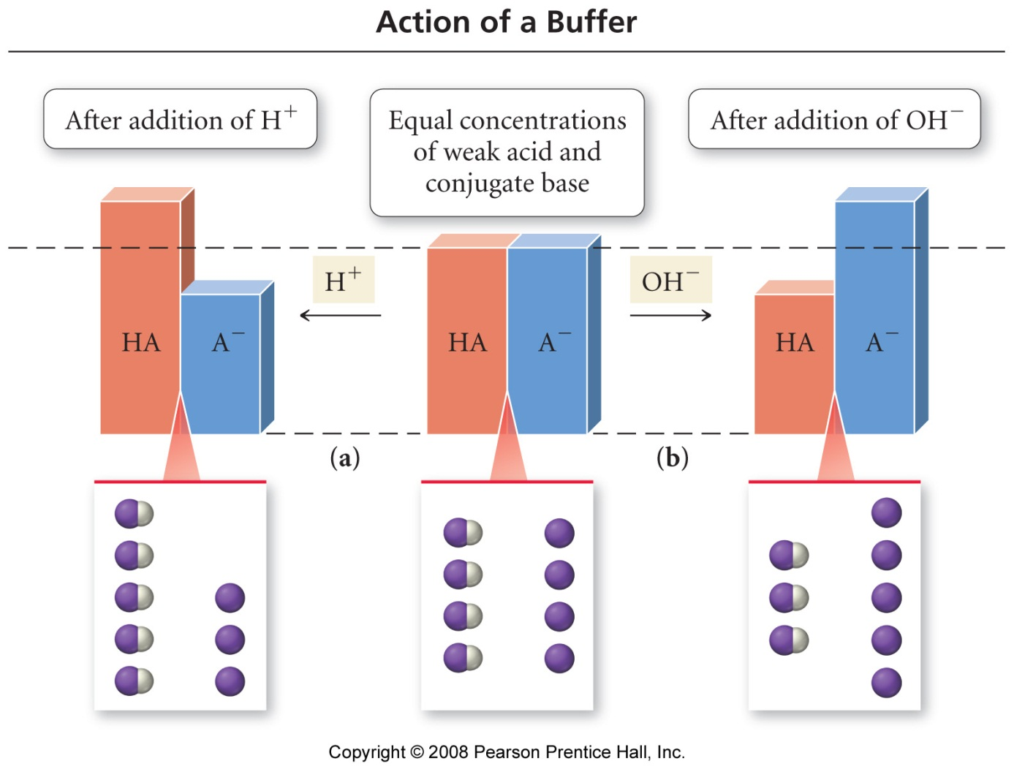

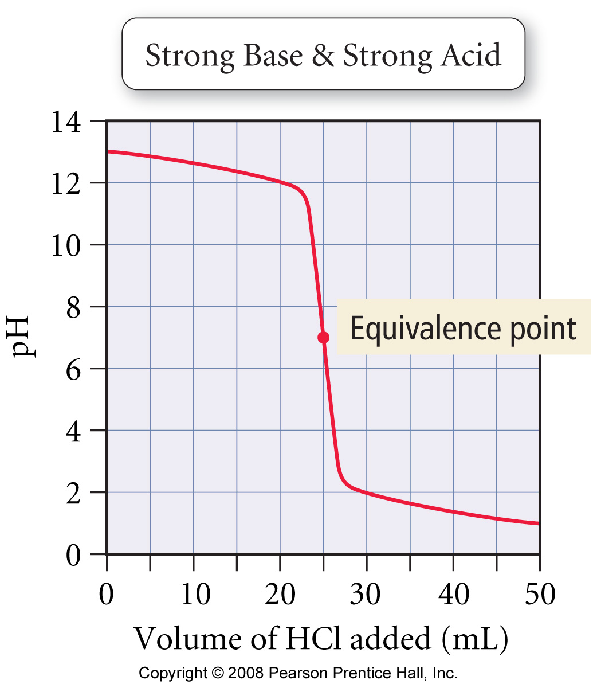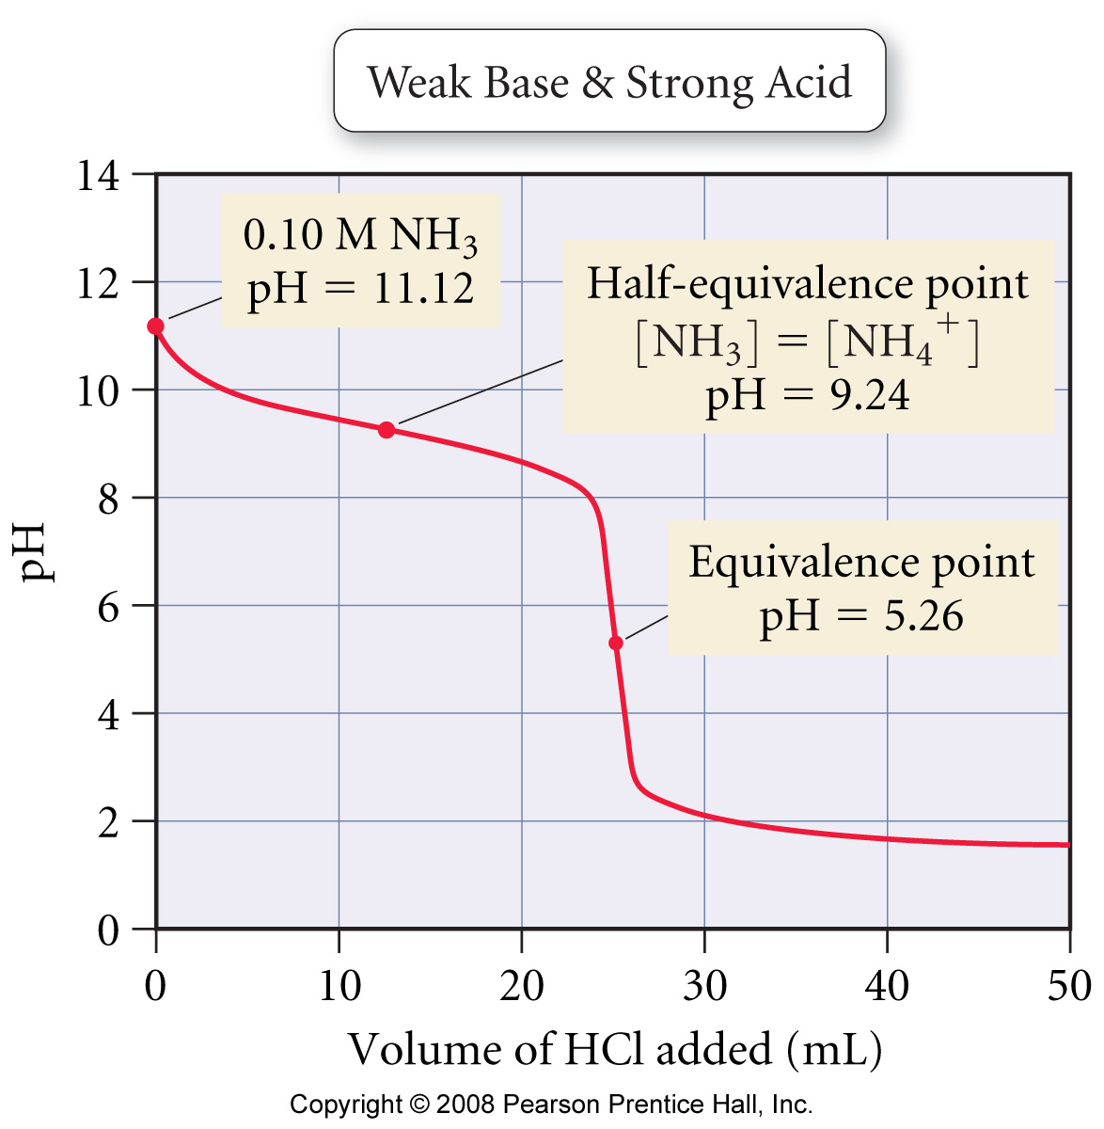
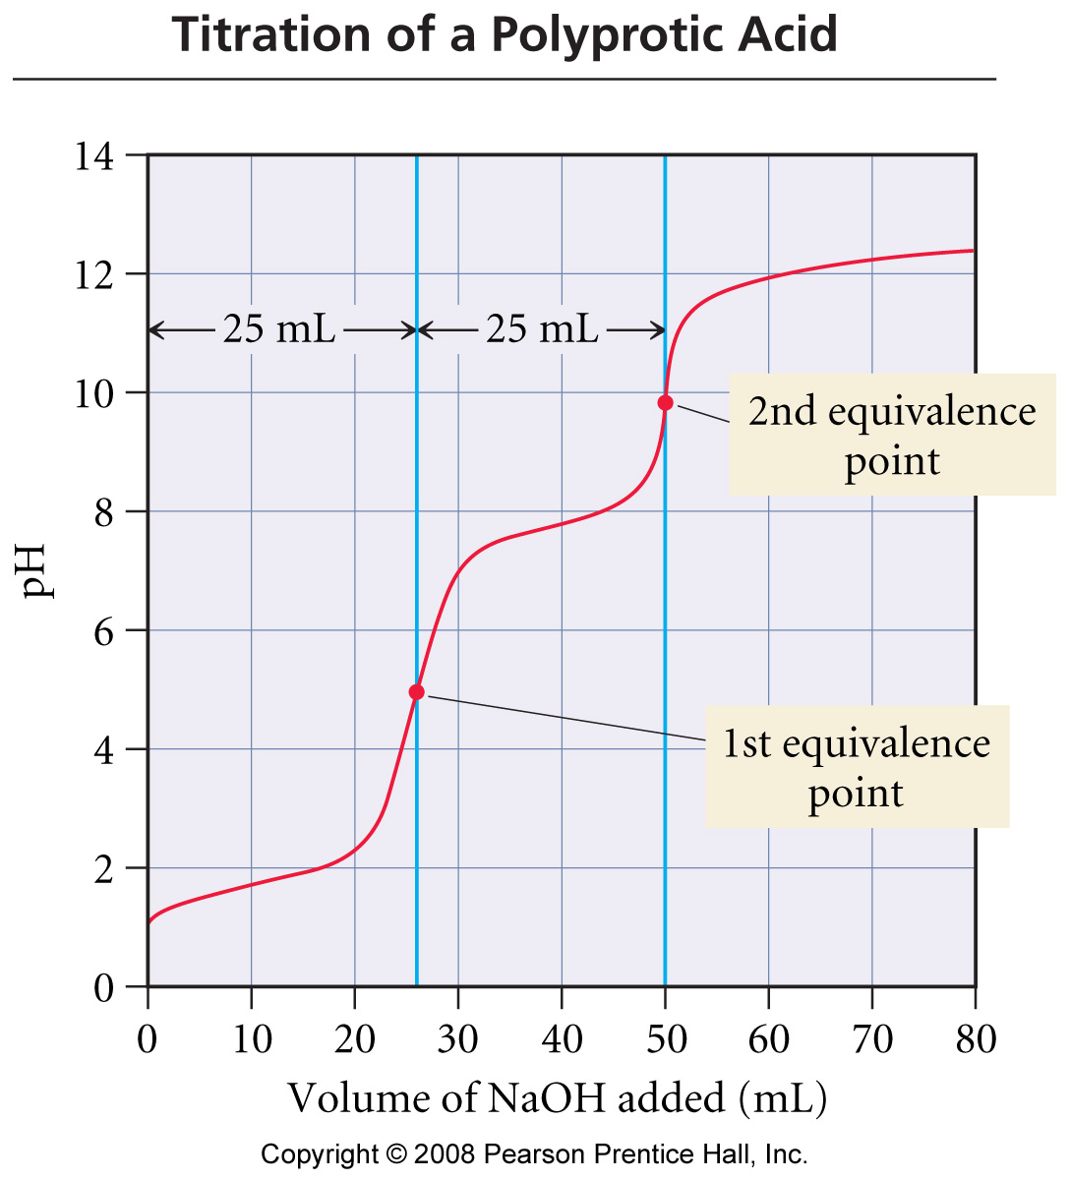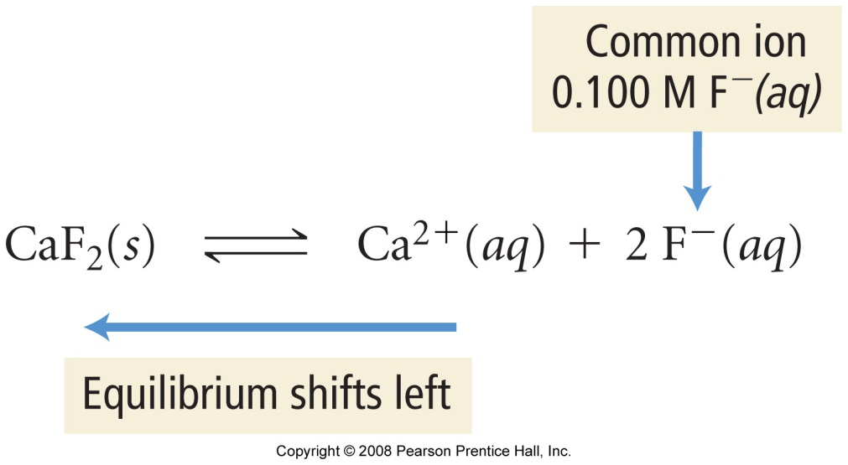

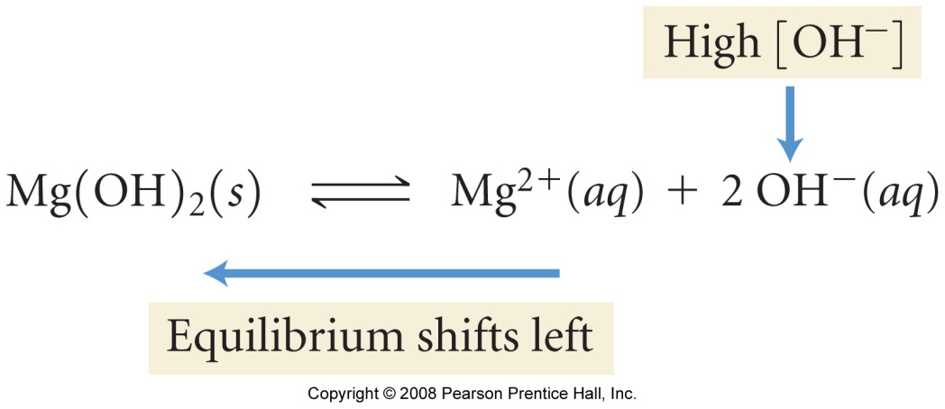

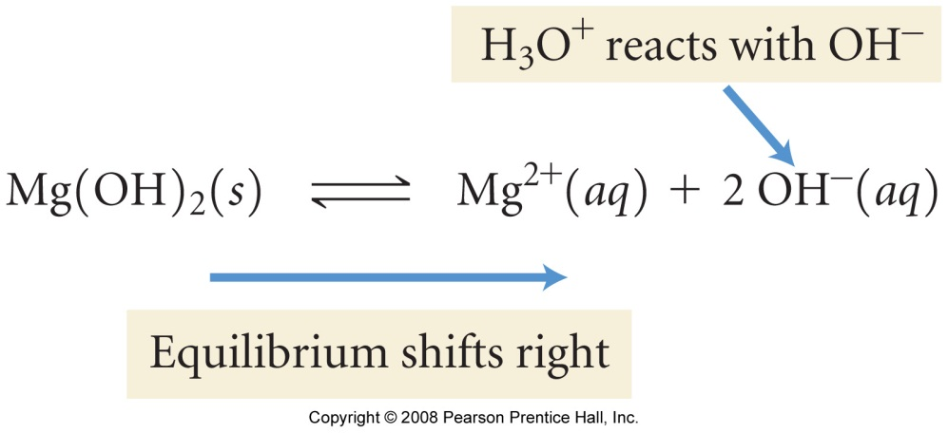

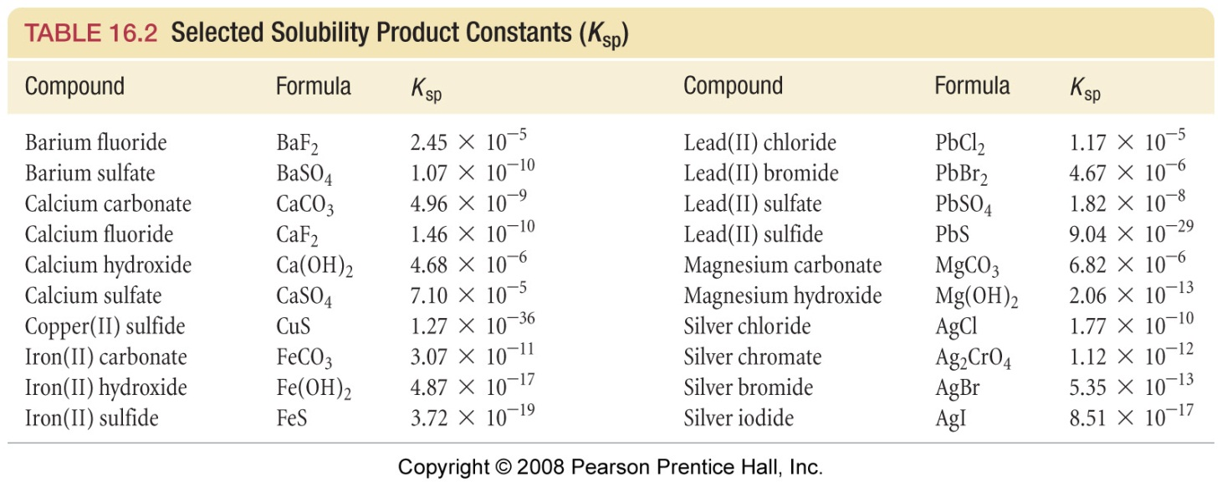

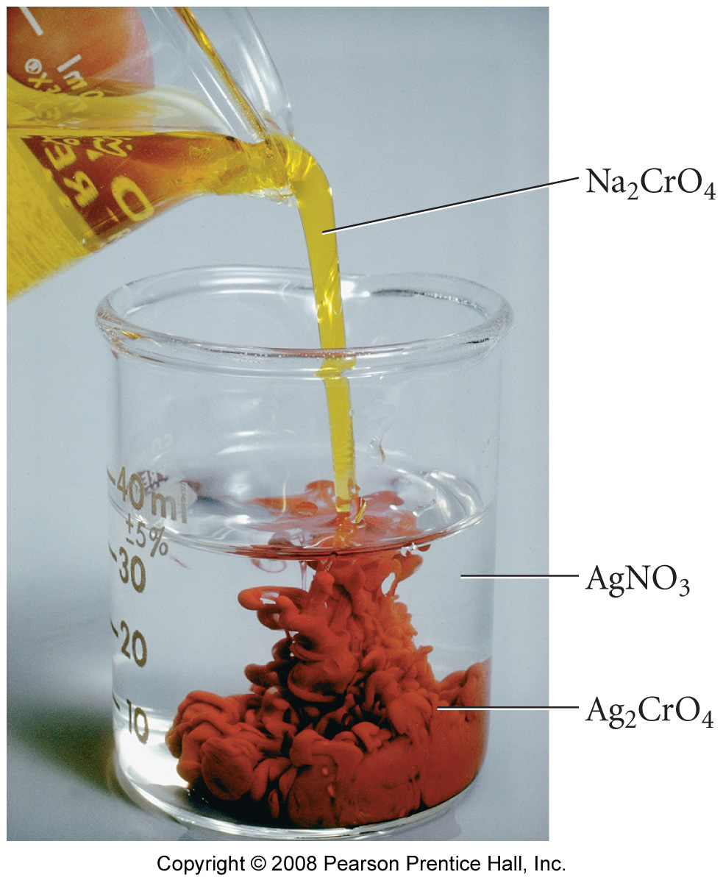

Chemical Thermodynamics

Reading: | Ch 17, sections 1 – 9 | Homework: | Chapter 17: 27, 31, 37*, 39*, 41*, 43, 47, 49, 51*, 55, 57*, 59, 63, 71
* = ‘important’ homework question

The Second Law of Thermodynamics - ENTROPY

Key Idea and Definitions

The ENTROPY (note spelling), S, of the Universe increases (ΔS = +ve) for a spontaneous process.

Discussion: What is a spontaneous process? ‘Being spontaneous’ is a somewhat accurate analogy…

“We don’t like the idea of an increasingly disordered universe”

Entropy (S): A measure of the amount of disorder in a system, Symbol S.

Discussion: What is disorder? Example, which has a higher degree of disorder (entropy) - a rack of pool balls before or after a break off??

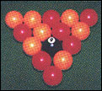 | 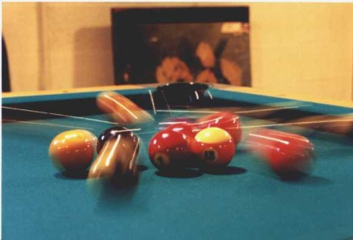
Before  Entropy: | After  Entropy:

⇒ ΔS = S_{(final)} – S_{(initial)} =

Examples: Based on Entropy arguments alone, would you expect the following processes to be spontaneous (i.e. experience an increase in entropy upon completion)? Briefly explain.

1. H₂CO₃ (aq) → H₂O (l) + CO₂ (g)

Observation

2. The air drying of washing up or clothes on a washing line

H₂O (l) → H₂O (g)

Observation

“The 2nd law will take care of it”…

3. NaCl (s) → NaCl (aq)

Observation (see more detailed figure below)

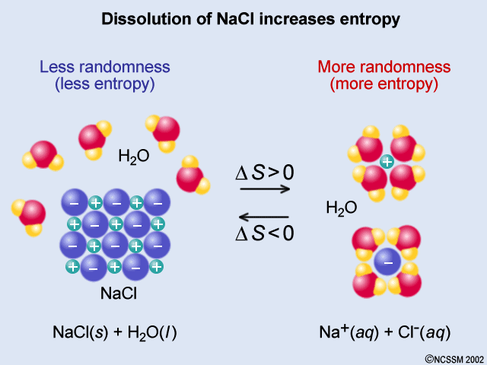

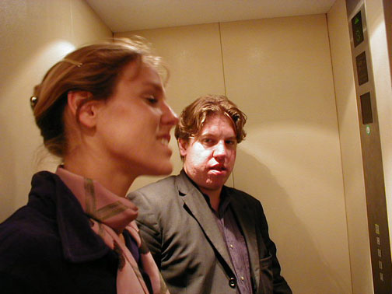 | 4. The diffusion of any gas  Observation

Task: List at least three entropy driven processes (see appendix for examples)

Just like with Enthalpy (H), each material has an inherent amount of entropy. All S values are measured in J/mol K and are always positive. The magnitude of S indicates the relative amount of disorder for the material.

Standard Entropy values can be used (in a similar way to ΔH_{f} values) to find ΔS for any reaction. See Appendix.

Example: Calculate ΔS for the following reaction:

CCl₄ (l) → CCl₄ (g) ; ΔS = _____________

Given: CCl₄ (g), S = 309.4 J/molK
CCl₄ (l), S = 214.4 J/molK

What conclusion can you make regarding the evaporation of CCl₄ (l)?
Math considerations – the second law of thermodynamics

Entropy is temperature dependant – the hotter a material is the more entropy it has (standard entropies form Appendix C are calculated at 25ºC, 1.00 atm). This fact is conveyed in the formal mathematical description of the 2nd law:
S = | q_{rev}
 | T

For chemical systems that do not do ‘PV’ work, ΔH = q (first law), therefore:

S = | ΔH
 | T

Wrap up Discussion: If all spontaneous processes result in an increase in entropy, how can processes that result in a decrease in entropy (such as the freezing of water) for a material ever occur??

Gibbs Free Energy

Gibbs free energy (ΔG) for a reaction relates ΔH and ΔS for that reaction.

Simply, the mathematical sign of ΔG, determined via the Gibbs equation, determines if a reaction will ever work (is spontaneous); will never work (in non-spontaneous) or at equilibrium.

Spontaneous: ΔG < 0 | Non-spontaneous: ΔG > 0 | Equilibrium: ΔG = 0

Gibbs Free Energy Equation:

ΔG = ΔH - T ΔS

The sign of ΔG (and, therefore, if a reaction is spontaneous) depends on the signs of ΔH and ΔS. See appendix.

Task: Complete the following table / determine the sign of ΔG

ΔH | ΔS | ΔG | spontaneous
-ve | -ve
-ve | +ve
+ve | -ve
+ve | +ve

As with ΔH and ΔS, ΔG is a state function.

ΔG values follow the same ‘state function’ math rules as the ΔH and ΔS, so can be determined from these quantities. Slides

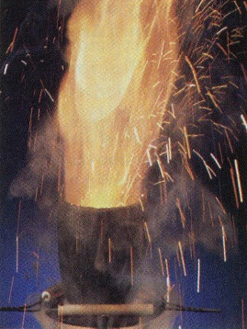 | ‘Huge’ worked Example: The thermite reaction is used to weld railway tracks:  Fe₂O₃ (s) + 2 Al (s) → 2 Fe (s) + Al₂O₃ (s)  Based on the below data, determine if this reaction is spontaneous at 25ºC and quote the value of ΔG in kJ/mol

Given:

ΔH_{f} Fe₂O₃ (s) = - 822.16 kJ/mol | S Fe₂O₃ (s) = +89.96 J/molK
ΔH_{f} Al₂O₃ (s) = - 1669.9 kJ/mol | S Al₂O₃ (s) =+51.00 J/molK
 | S Fe (s) = +27.15 J/molK
 | S Al (s) = +25.32 J/molK

Plan: Find ΔH, ΔS, and then find ΔG

Free Energy and Equilibrium

Recall: For and equilibrium, ΔG = 0. In terms of the equilibrium constant K and other variables

ΔG = -RT lnK

Where: K = equilibrium constant (no units)
ΔG = Gibbs Free energy (kJ/mol)

R = 8.314 J/molK
T = temperature in Kelvin

Task: Rearrange the above equation to find an expression for K in terms of ΔG

Group activity: Use the standard ΔG values in appendicies to find K at 25ºC for:

N₂ (g) + 3 H₂ (g) → 2 NH₃ (g)

Plan: Find ΔG, find K

“Gibbs”

Question 1 (25 points): Using the thermodynamic information given in the data sheet, calculate ΔGº for the following reaction:

Fe₂O₃ _{(s)} + 6 HCl _{(g)} → 2 FeCl₃ _{(s)} + 3 H₂O _{(g)}

Appendix
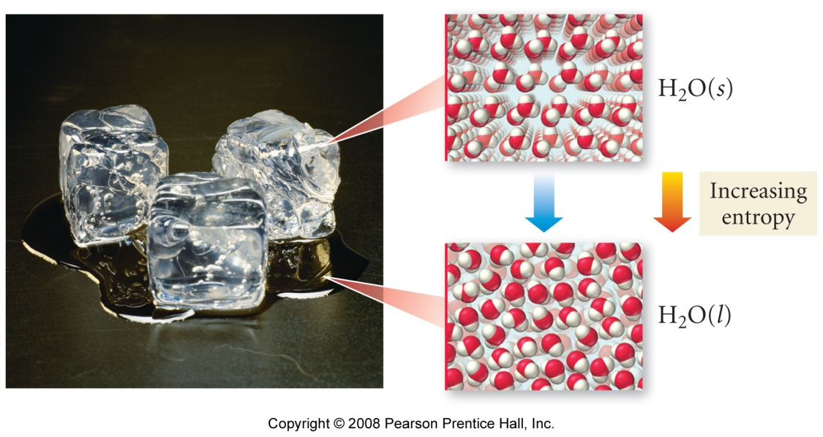

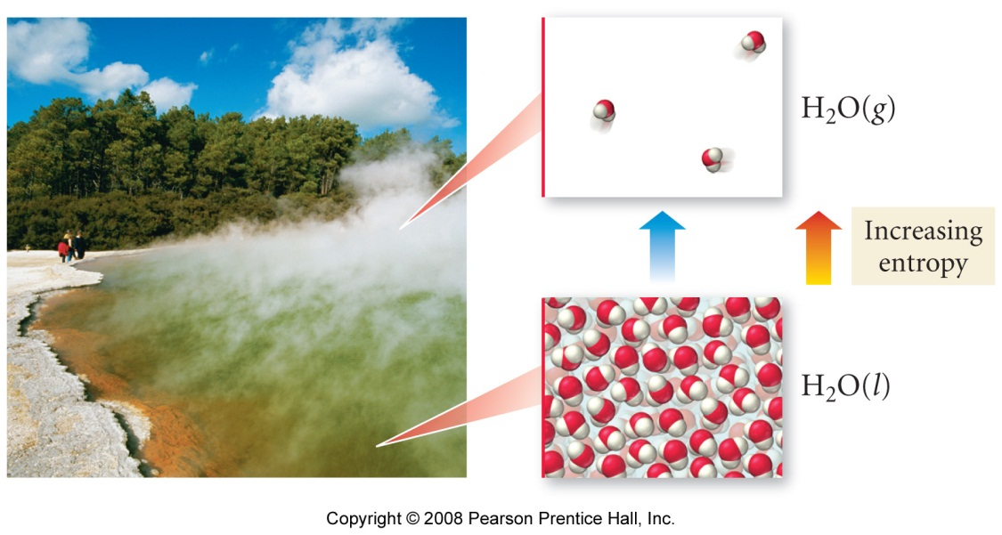

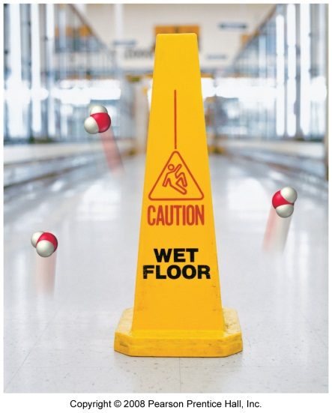
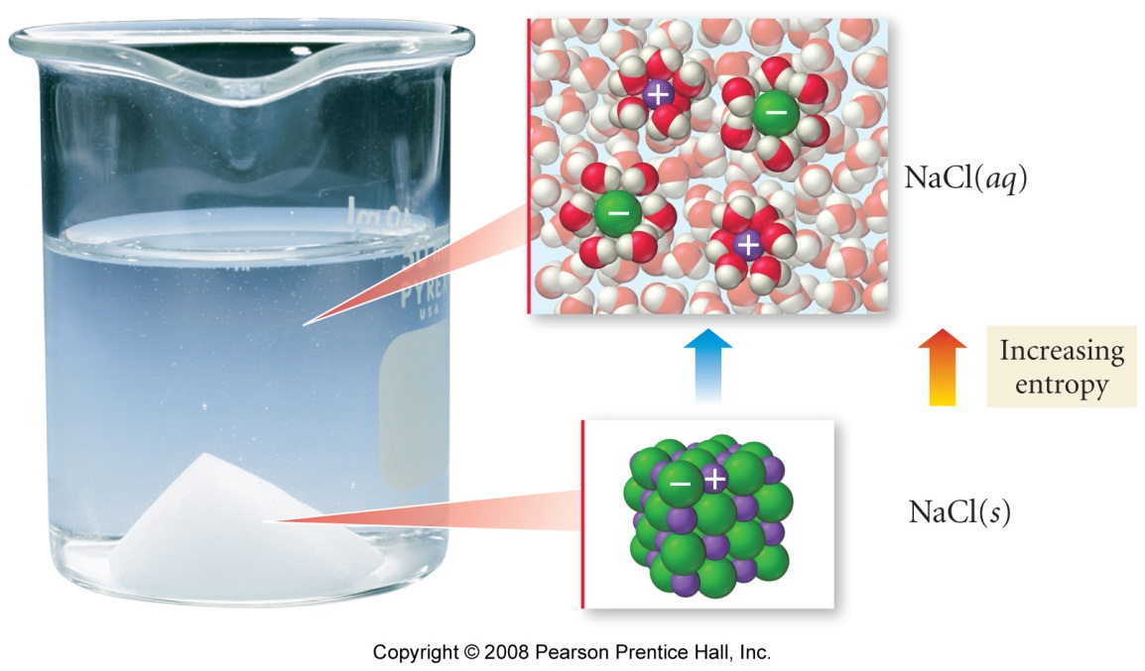

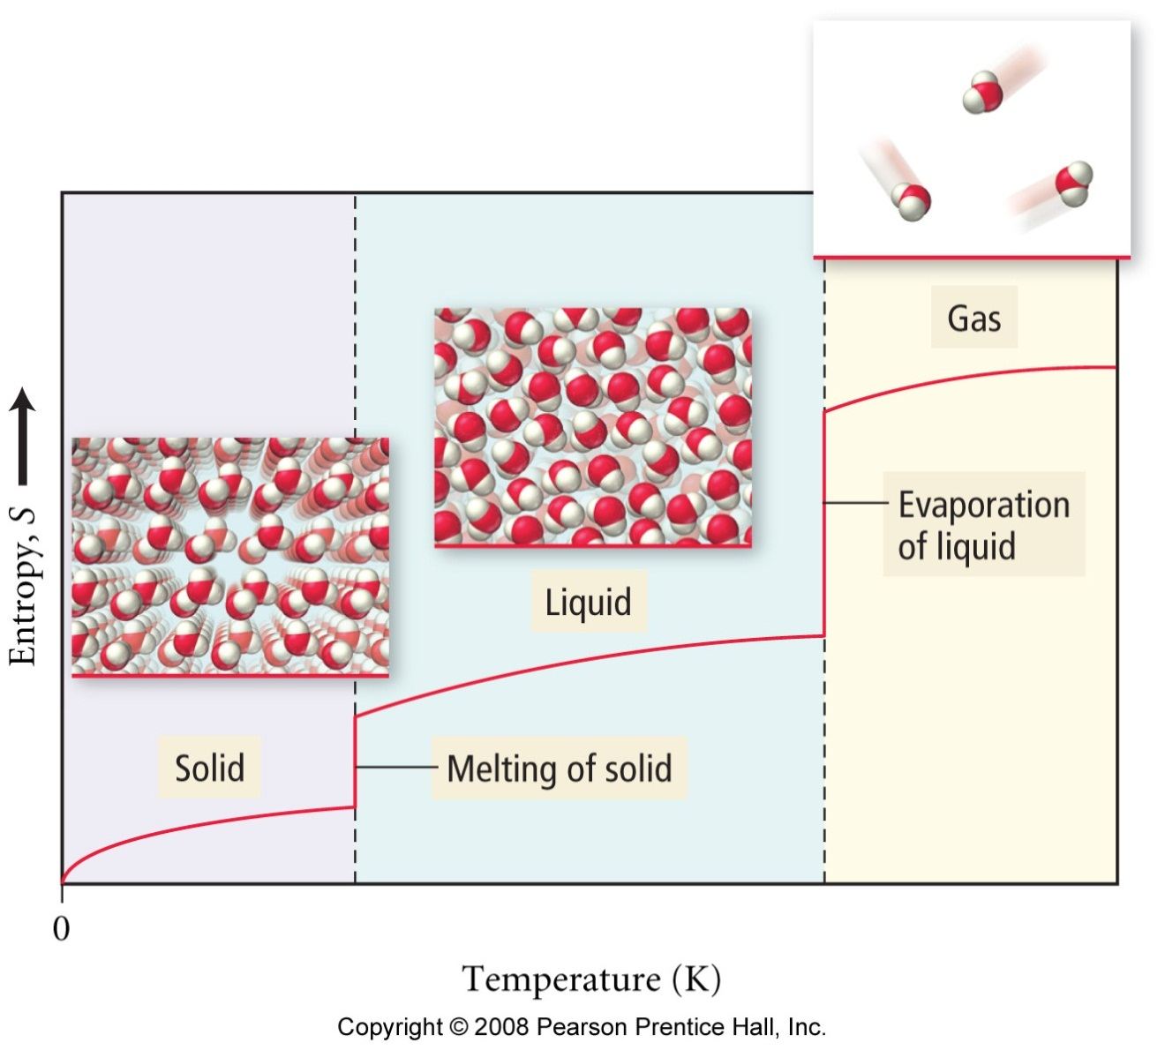

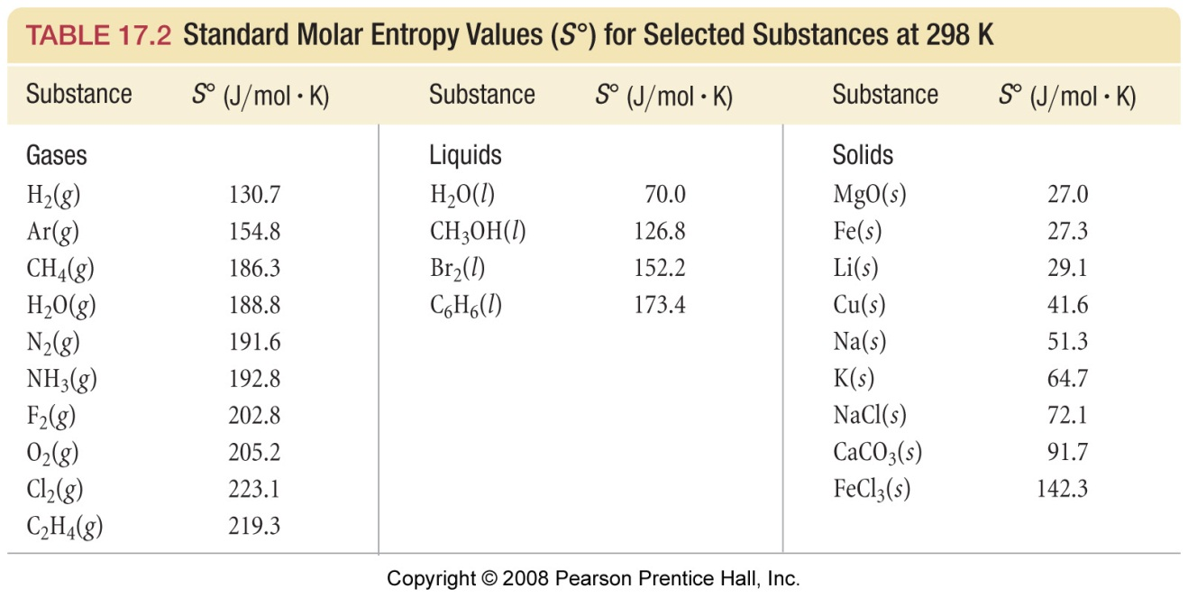

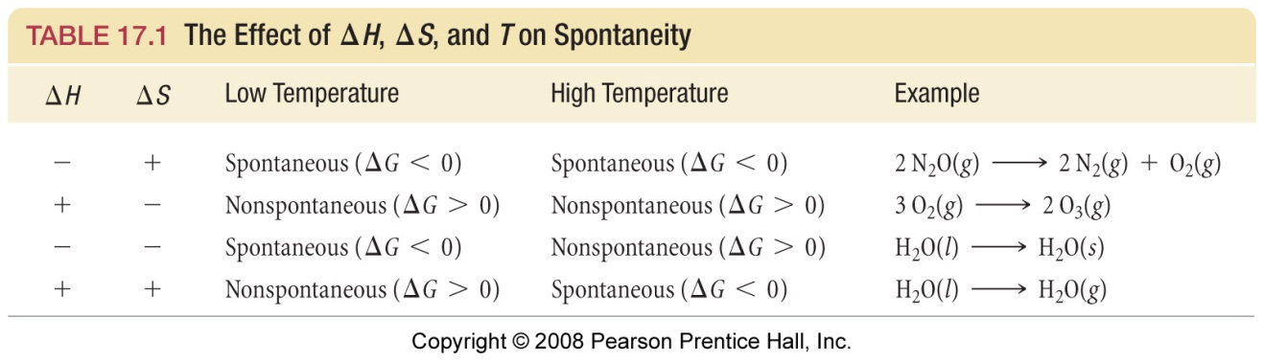

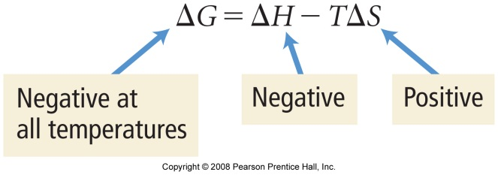 | 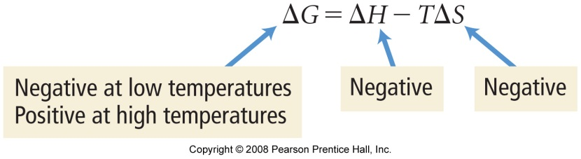
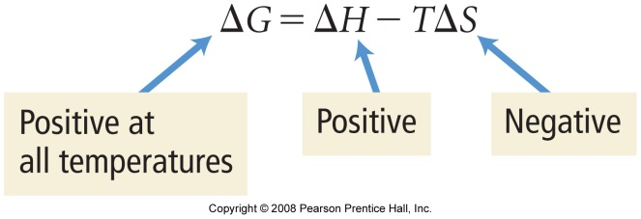 | 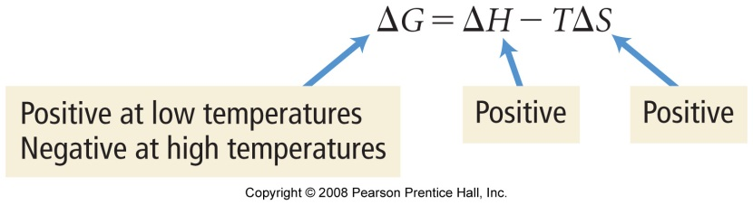

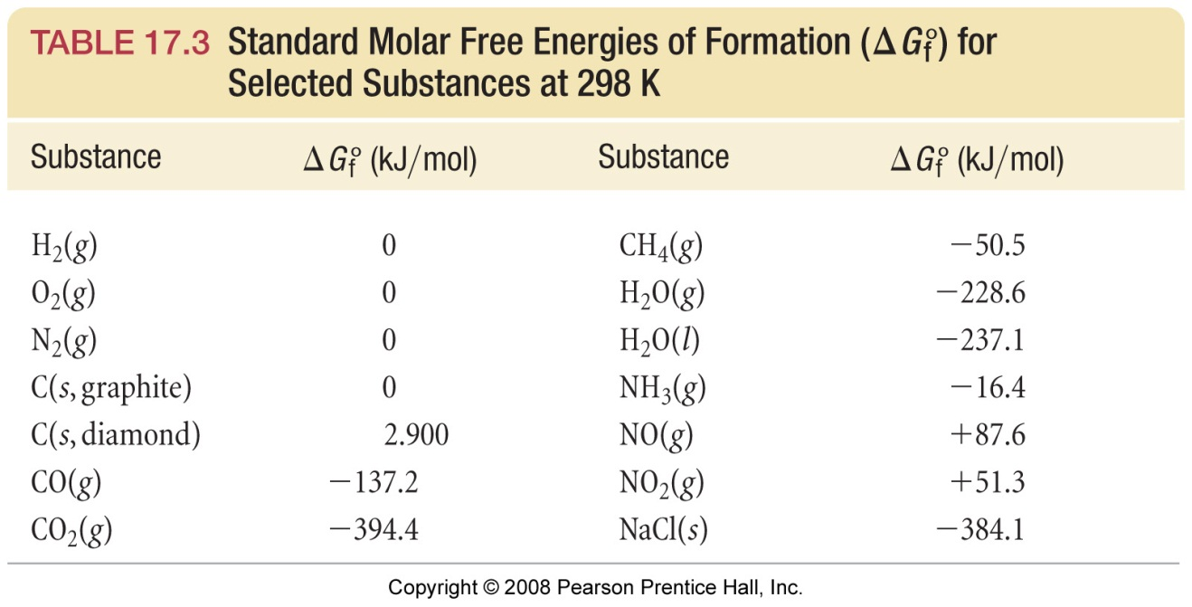

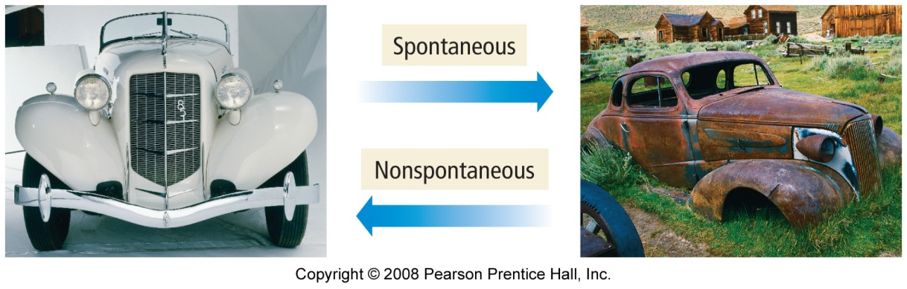
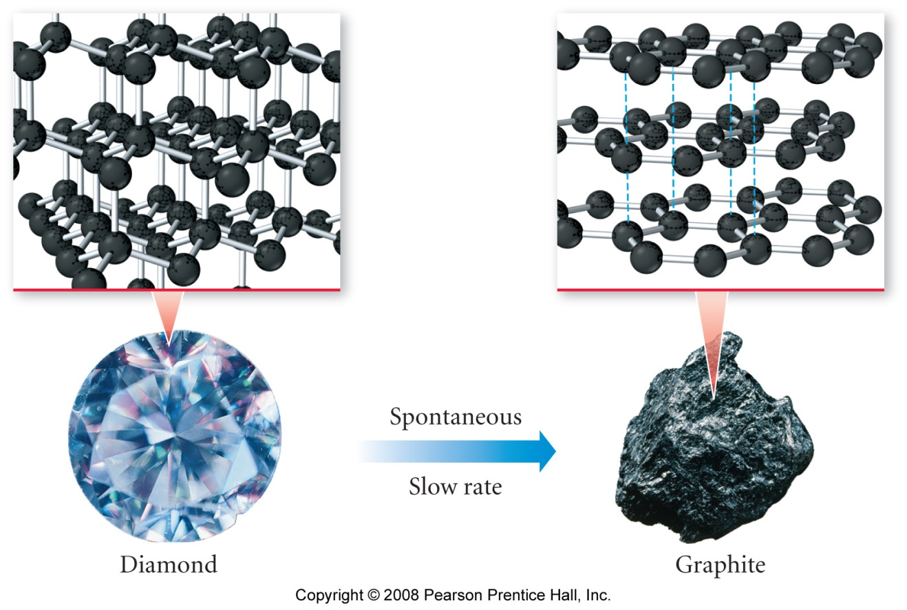
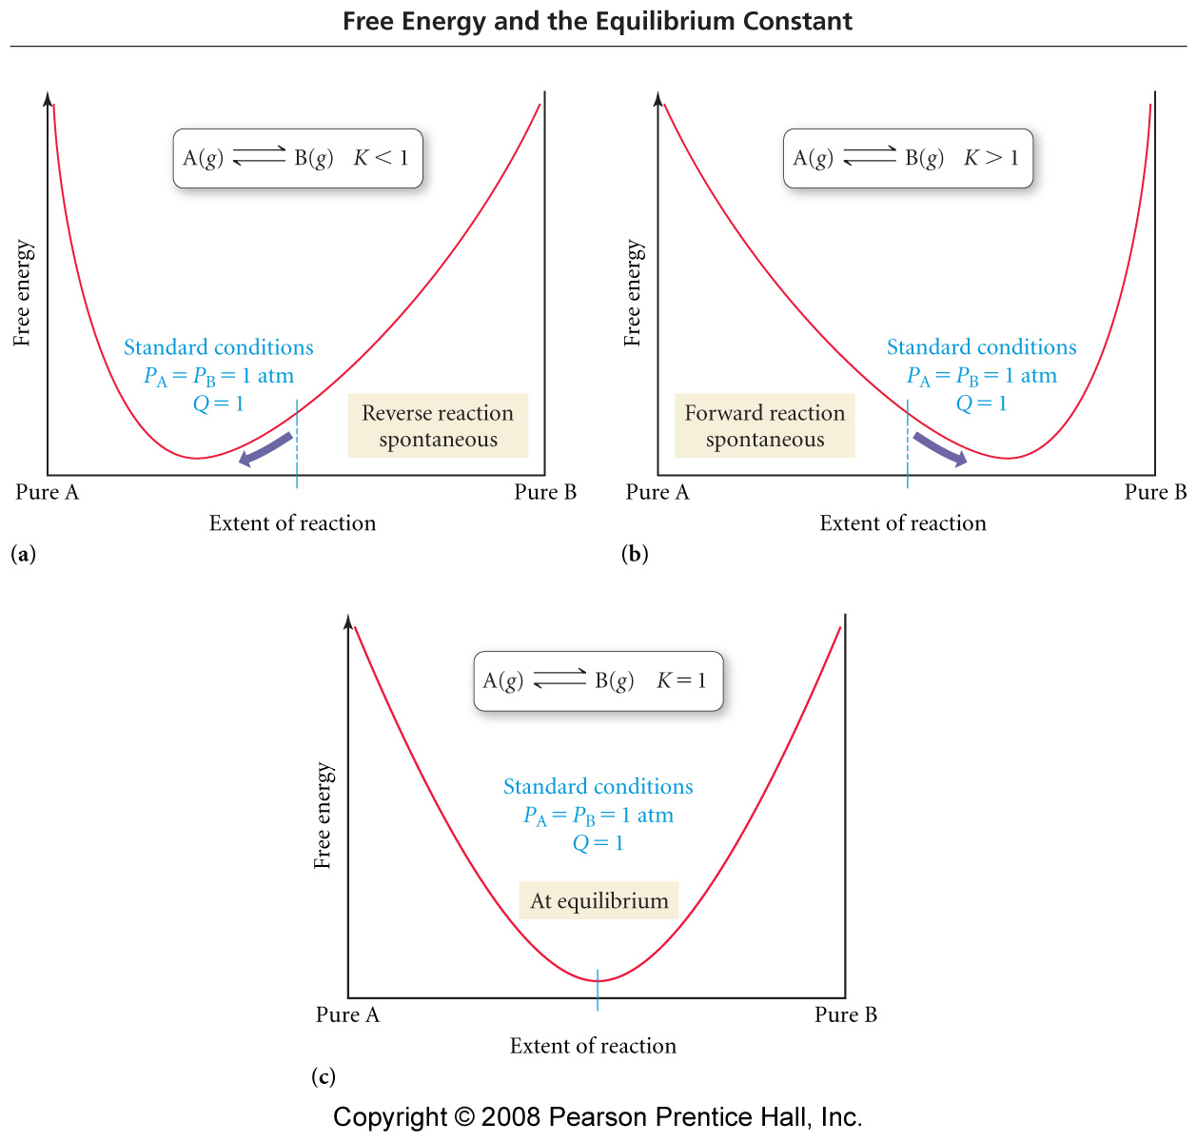

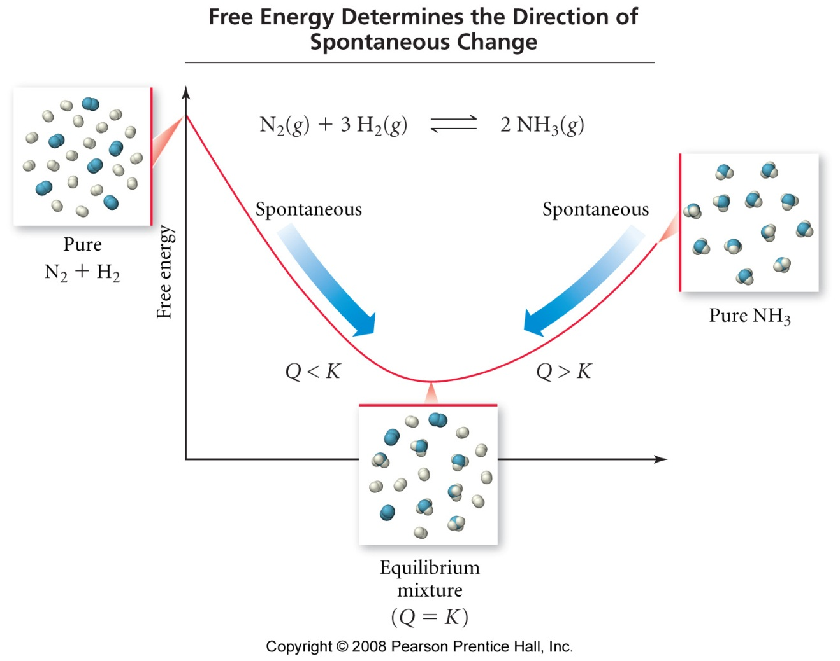

Electrochemistry

Reading: | Ch 18, sections 1 – 9 | Homework: | Chapter 18: 37, 39*, 43, 45*, 47, 53, 55, 61, 63, 65*, 67, 69, 73, 77
* = ‘important’ homework question

Review of REDOX Reactions

Background

‘REDOX’ reactions are chemical processes in which REDuction and OXidation simultaneously occur

Oxidation Is Loss of electrons. An element or compound that loses electron(s) during a chemical process is said to be OXIDIZED

Reduction Is Gain of electrons. An element or compound that gains electron(s) during a chemical process is said to be REDUCED

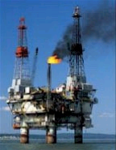 | TRICK: Remembering the difference between oxidation and reduction is easy, just remember….  OIL RIG of electrons  Oxidation Is Loss, Reduction Is Gain of electrons

Example of a Simple REDOX reaction:

Na + Cl → NaCl

Discussion: Which chemical species has lost electrons during this process (i.e. been oxidized)? Which has gained electrons (been reduced)? How can you figure this out?

An overall REDOX equation is the sum of two half equations – one for oxidation, one for reduction

Oxidation ½ Eqn. | Na → Na⁺ + 1 e⁻
Reduction ½ Eqn. | 1 e⁻ + Cl → Cl⁻ | +

Summary: All REDOX equations are balanced by combining their two respective ½ equations, just like in the above example. We will learn how to perform this task for more complex reactions in the following pages

Oxidation Numbers

Oxidation Number or Oxidation State – the ‘charge’ on an atom in a substance as if it were a monatomic ion

A change in oxidation state during a chemical process indicates that a specie has either been oxidized (number goes up), or reduced (number goes down). Recall the previous NaCl example.

Rules for assigning oxidation numbers

1. For materials that form atomic ions, the oxidation state is the same as the ‘regular’ ionic charge

Task: State the oxidation state of the following:

Na in NaCl |  |  | Cl in AlCl₃
Mg in MgCl₂ |  |  | Fe in Fe₂O₃
Since you know the charge of a great many atomic ions, you also know their oxidation states, i.e.:
Group I = I (Li⁺, Na⁺…)  Group II = II (Mg²⁺, Ca²⁺…) | Group VII = -I (F⁻, Cl⁻…)  Group VI = -II (O²⁻, S²⁻…)
Note: Oxidation states / numbers are expressed with Roman Numerals (this differentiates them from ‘pure’ ionic charges)

2. For ANY elemental atom, its oxidation state is ZERO. Why?

E.g. Elemental chlorine, Cl₂

Cl ― Cl

Any atom bonded to other identical atom(s) must have an oxidation state (oxidation number) of ZERO
ALL ELEMENTS must by definition posses zero oxidation states

Examples: Any diatomic element (O₂, F₂), any metallic element (Pb(s), Al(s)) etc.

3. All other atoms’ oxidation states must be determined mathematically using the ‘Sum of Oxidation States’ Rule:

For molecules: The sum of the molecule’s component atoms individual oxidation numbers = ZERO

Example: Nitric acid, HNO₃

For polyatomic ions (‘charged molecules’): The sum of the polyatomic ion’s component atoms individual oxidation numbers = overall ionic charge

Example: The nitrate ion, NO₃⁻

Exceptions:

- Oxygen always has a -II oxidation state, except when bonded to either fluorine or itself. Why? Hint: Think of the periodic trend in electronegativity (slide, appendix).

Examples:

H₂O₂ | OF₂

- F always has a –I oxidation state, except when bonded to itself. Other Halogens (Cl, Br, I) are also –I, except when bonded to F or O. Why?

Examples:

ClO₂ | ClO₃⁻

More Examples: Calculate the oxidation state of:

S in SO₃ | Xe in XeF₆
S in SO₄²⁻ | Cr in CrO₄⁻
Na in NaH (Hint: think electronegativity) | N in Mg₃N₂

Balancing ‘harder’ REDOX reactions

Worked example

Balance the following REDOX process:

MnO₄⁻ (aq) + C₂O₄²⁻ (aq) → Mn²⁺ (aq) + CO₂ (g)

Question: Why cant we just balance these equations ‘normally’

Answer:

Step 1: Split the overall reaction into a pair of ½ equations and balance atoms OTHER THAN H and O.
Trick: assign oxidation numbers to the original unbalanced equation in order to see which species were oxidized and reduced.

__ MnO₄⁻ (aq) → __ Mn²⁺ (aq) (reduction)

__ C₂O₄²⁻ (aq) → __ CO₂ (g) (oxidation)

Step 2: Balance the amount of O (oxygen atoms) in each ½ equation by adding H₂O (l) where necessary.
Step 3: Balance the amount of H (hydrogen atoms) in each ½ equation by adding H⁺ (aq) where necessary.

Step 4: Balance the NET charges on both sides of each ½ equation by adding e⁻ (electrons) where necessary.

Trick: Electrons have a -1 charge, so add them to the more positive side of each ½ equation until the charge on both sides IS THE SAME

Step 5: Equalize the amount of e⁻ in each ½ equation by multiplying through by the appropriate LCF.

Recall: REDOX reactions are really electron exchange reactions. By completing this step you ensure that an equal number of e⁻ are transferred (lost and gained respectively) during the two ½ equations. This is the goal of the procedure(!)

Step 6: Add the two ½ equations, cancel any similar terms. Ensure that the conservation of mass law (same # and type of atoms b.s.) is obeyed

Background: ALL batteries utilize REDOX processes, with the electrons transferred between each ½ reaction being passed through a circuit in order to provide electrical power. Your cell phone most likely uses a ‘NiCad’ (Nickel/Cadmium) battery – take a look!

Task: Balance the following ‘NiCad battery’ REDOX reaction:

Cd (s) + NiO₂ (s) → Cd(OH)₂ (s) + Ni(OH)₂ (s)

Trick: Write the initial pair of ½ equations ONCE, but leave space for each balancing step

The Reactivity Series

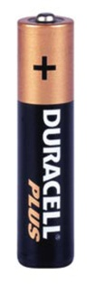 | Background: For batteries featuring similar ½ reactions (such as in the Cu-Zn battery), it is often difficult to know which metal undergoes oxidation and which reduction  This information is contained within the Reactivity Series

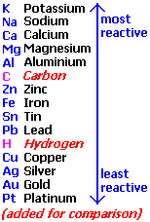 | The MOST reactive metals are those which LOSE electrons (i.e. become oxidized) the most easily. These (e.g. K) are at the TOP of the reactivity series  Discussion: Which of the following is the correct REDOX reaction for the Cu-Zn battery? See slide / handout.  Cu + Zn(NO₃)₂(aq) → Zn + Cu(NO₃)₂(aq)  or  Zn + Cu(NO₃)₂(aq) → Cu + Zn(NO₃)₂(aq)

Task: Write a REDOX reaction for the Ag(s) / Ag(NO₃)(aq) : Cu(s) / Cu(NO₃)₂(aq) battery. Hint: Decide on two ½ reactions, then follow ‘the rules’.

Quantitative Electrochemistry – Cell EMF

The reactivity series can be quantified using standard reduction potentials. Note: reduction potentials (reduction) are listed in revere order to the reactivity (oxidation) series.

A standard reduction potential is the voltage of the respective half-cell reaction’s reduction process compared to that of the 2H⁺(aq) / H₂ (g) half-cell (0.00 V)

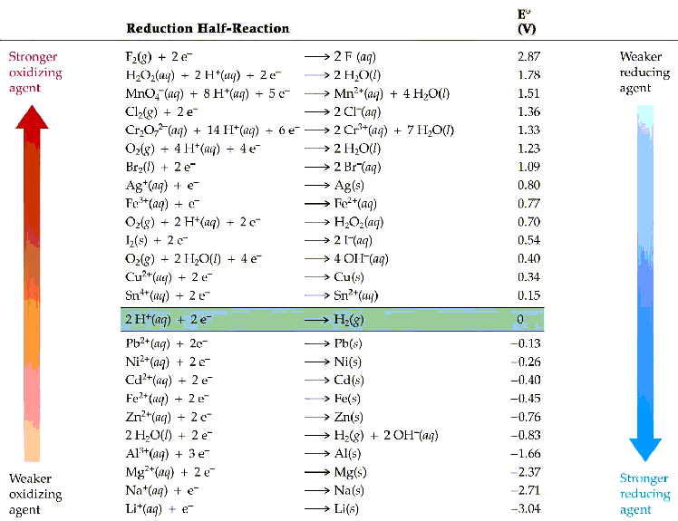

Recall your lab – the EMF (voltage or potential difference) of an electrochemical cell (voltaic cell or battery) is simply the DIFFERENCE (potential difference, get it!?) in the two half cell reduction potentials.

Task: Determine the magnitude of the voltage for a Cu-Zn battery
Problem: Working out the magnitude of a battery’s EMF is straight forward, but determining if this voltage difference is ‘positive’ or ‘negative’ requires further consideration.

Recall the complication of having to ‘reverse the leads’ in your lab – this was the manifestation of this issue in practice.

Quantitative analysis of the ‘Duracell’ reaction

1. Recall: Since zinc is higher in the reactivity series that copper it will be oxidized, while copper ions are reduced:

Zn + Cu²⁺ → Cu + Zn²⁺(aq)

2. Using a ‘number line’ approach, we know that the absolute EMF of this cell (from above) is 0.34 V + 0.76V = 1.1 V

3. Electrochemical conventions must now be used to determine which half –cell makes up the anode and which the cathode of the cell. This will determine the sign (+ or -) of the cell voltage.

Remember that Oxidation occurs at the Anode (-ve electrode) and Reduction at the Cathode (+ve electrode)

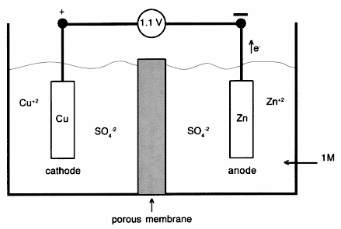
Now, we must use the following equation to find both the magnitude and sign of the cell EMF (must remember):

Eº_{cell} = Eº_{red} (cathode) – Eº_{red} (anode)

Where: Eº_{cell} = cell EMF, with correct sign
Eº_{red} (cathode) = standard reduction potential of the reduction
process (at the cathode)
Eº_{red} (anode) = standard reduction potential of the oxidation
process (at the anode)

Determine which half-cells make up the anode and cathode, respectively.

Recall, Oxidation at the Anode – the half-cell highest in the reactivity series (lowest in the reduction potential table) will be the anode.

‘Insert and evaluate’ in the above equation, once anode and cathode reduction potentials have been assigned.

For the Zn-Cu battery:

Oxidation: Zn(s) → Zn²⁺(aq) Eº_{red} = -0.76 V

Reduction: Cu²⁺(aq) → Cu(s) Eº_{red} = +0.34 V

Since Eº_{cell} = Eº_{red} (cathode) – Eº_{red} (anode):

Eº_{cell} = (+0.34 V) – (-0.76V) = +1.10 V

Note: The Zn-Cu battery has a positive sign for Eº_{cell} - this is only true (for any voltaic cell) if the anode and cathode are correctly assigned.

Group Task: Determine the magnitude and sign of the EMF for the following voltaic cells, constructed from the half-cells shown (also see appendix E or slide for standard potentials)

1. | 2 H⁺ (aq) + 2e → H₂ (g) Eº_{red} = 0.00 V (anode)  Cu²⁺(aq) + 2e → Cu(s) Eº_{red} = +0.34 V (cathode)
2. | H₂ (g) + F₂(g) → 2H⁺ (aq) + 2 F⁻ (aq)
3. | 3 Fe²⁺ (aq) → Fe (s) + 2Fe³⁺ (aq) (disproportionation reaction)

EMF and Gibbs Free Energy

Clearly, voltaic cells feature spontaneous processes – the electrons transferred between the two half-cells do so upon demand in order to power your I-pod, CD player etc. This relationship is directly proportional in terms of EMF and ΔG:

ΔG ∝ E

The quantitative version of the above relationship is:

ΔGº = -nFEº

Where: ΔGº = standard Gibbs free energy of the REDOX process

n = number of electrons transferred in the redox process (from
the balanced REDOX equation)

F = The Faraday constant (the charge of 1 mole of electrons), where 1 F = 96,500 Coulombs/mole

Eº = standard cell potential of the REDOX process

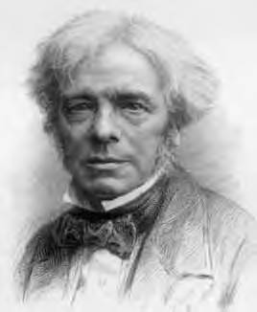
Micheal Farady – Scientific idol of Margaret Thatcher, ex Prime Minister of Great Britain |  | Margaret Thatcher – the only British Prime Minister to hold a bachelors degree in chemistry. ‘Maggie’ also shares a birthday with Dr. Mills (err, scary!)
Task: Determine ΔGº for:

3 Fe²⁺ (aq) → Fe (s) + 2Fe³⁺ (aq)

Is this process spontaneous?

Cell EMF Under Non-Standard Conditions

Discussion: The voltage of an AA Duracell Zn-Cu battery is 1.5 V, whereas the standard electrode potential for this pair of half-cells is only 1.1 V. Why is this?

The Nernst Equation relates the EMF of a cell to that at under standard conditions (Eº_{cell}) and Q, (the reaction quotient). Recall from the equilibria topic that Q = [products]/[reactants].

Nernst Equation:

ΔG = ΔGº + RT lnQ or | E = E_{o} | -RT | lnQ
 |  | nF

Since ΔG = 0 at equilibrium (or E_{cell} = zero when the battery goes ‘flat’, i.e. at equilibrium*:

ΔG = -RTlnK

*This new equation will allow for evaluation of K (equilibrium constant) for any Redox process at any temperature.

Group Task: Use your new equation to answer the following question: What is the value of the equilibrium constant, K, for the following REDOX process? See Appendix E of your notes for standard reduction potentials.

Fe (s) + Ni²⁺ (aq) → Fe²⁺ (aq) + Ni (s)

Appendix:

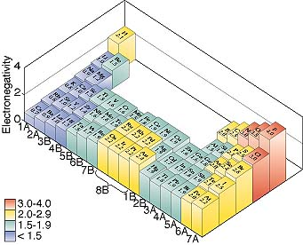

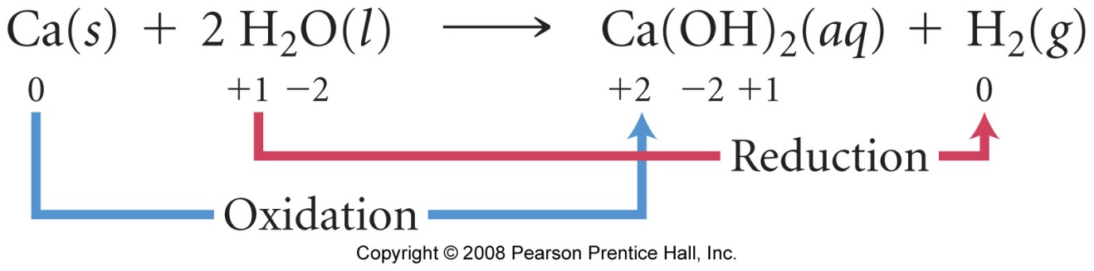

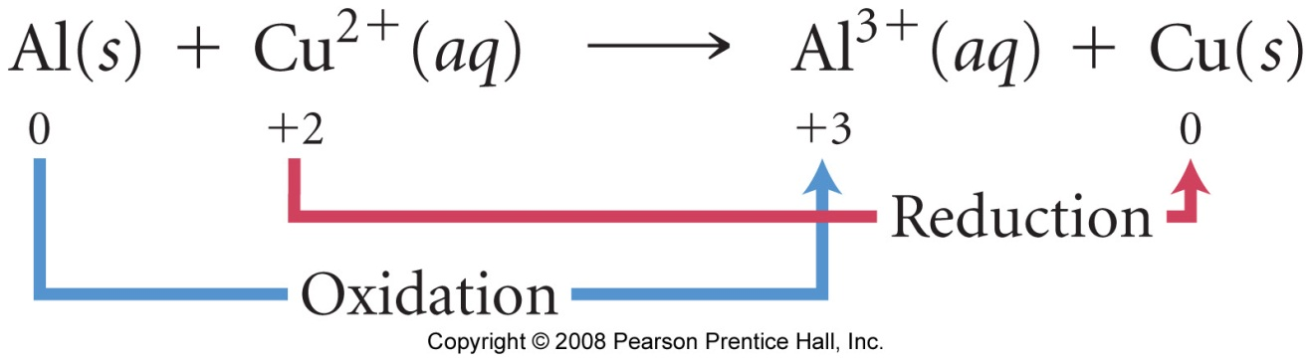

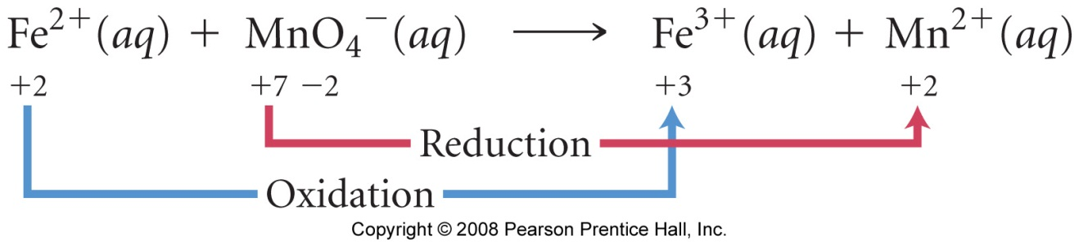

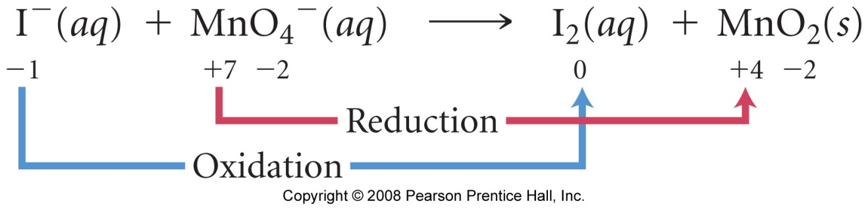

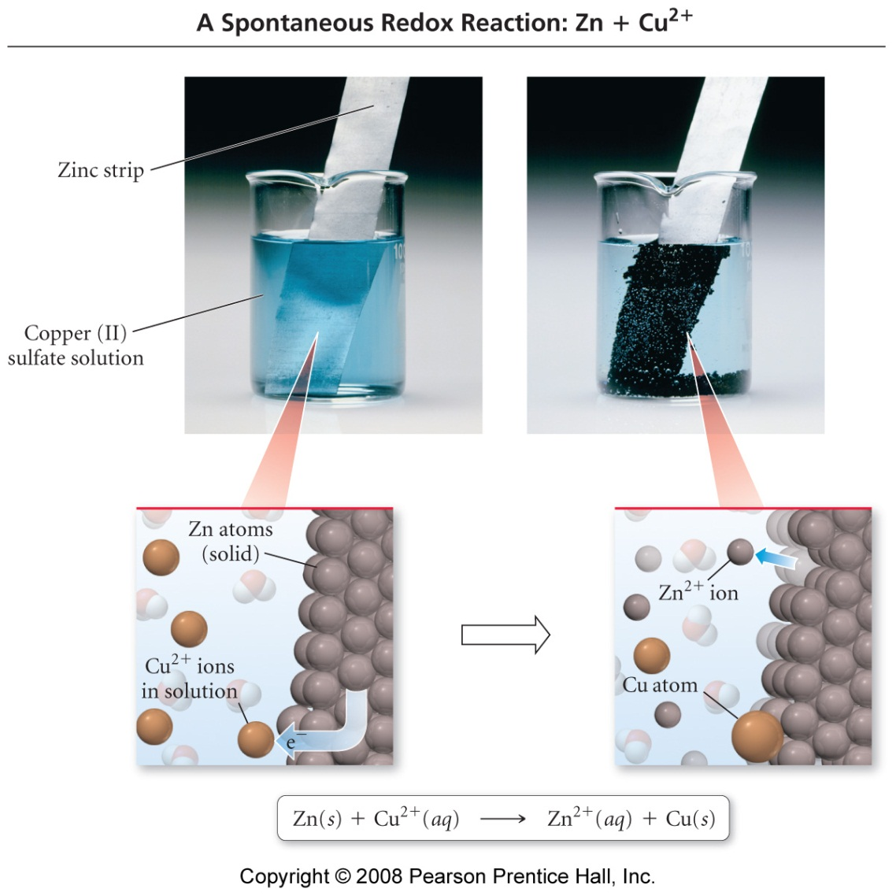
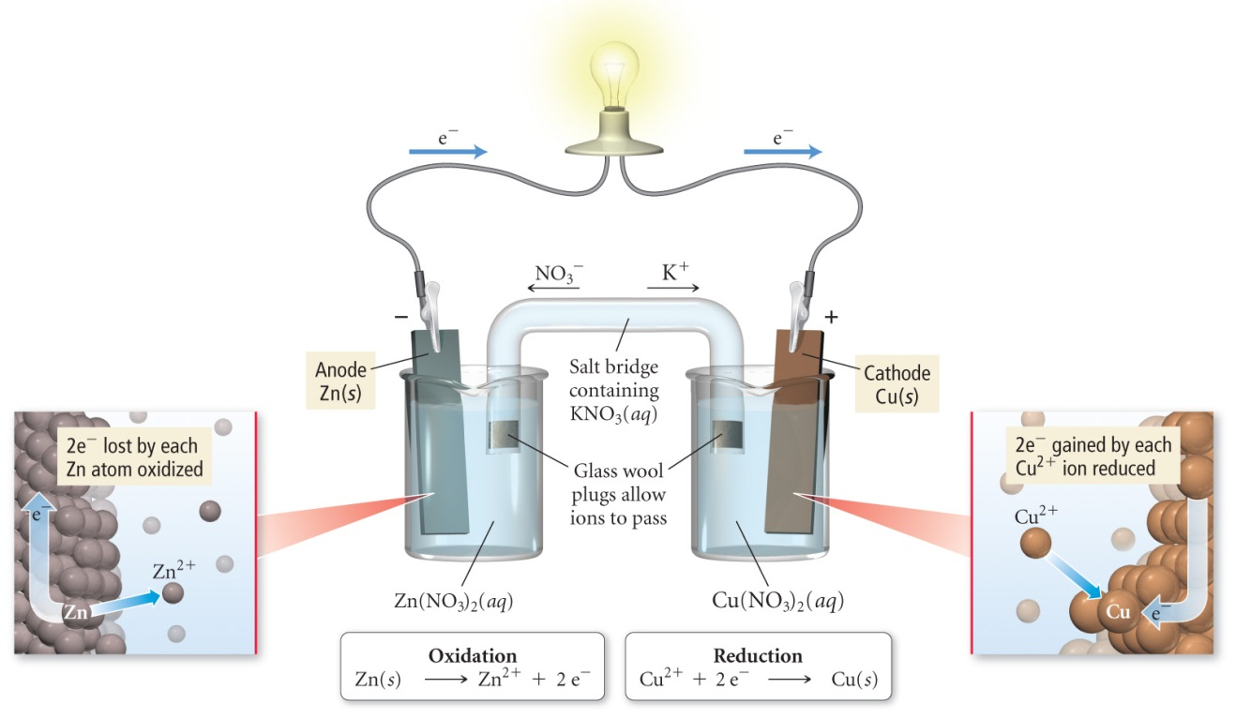
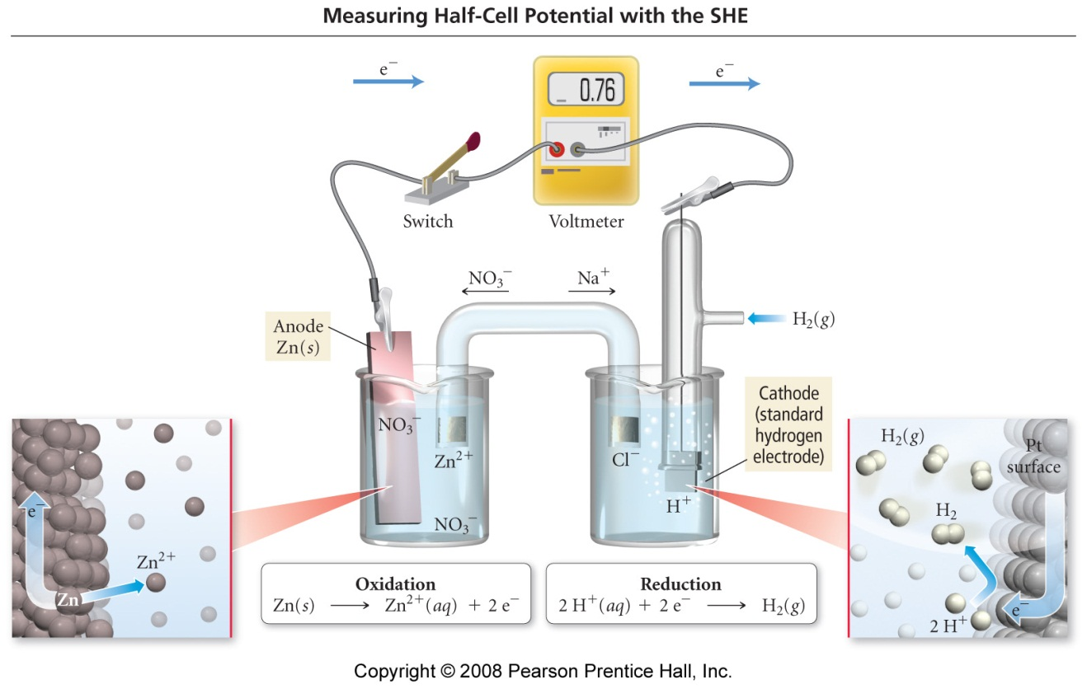

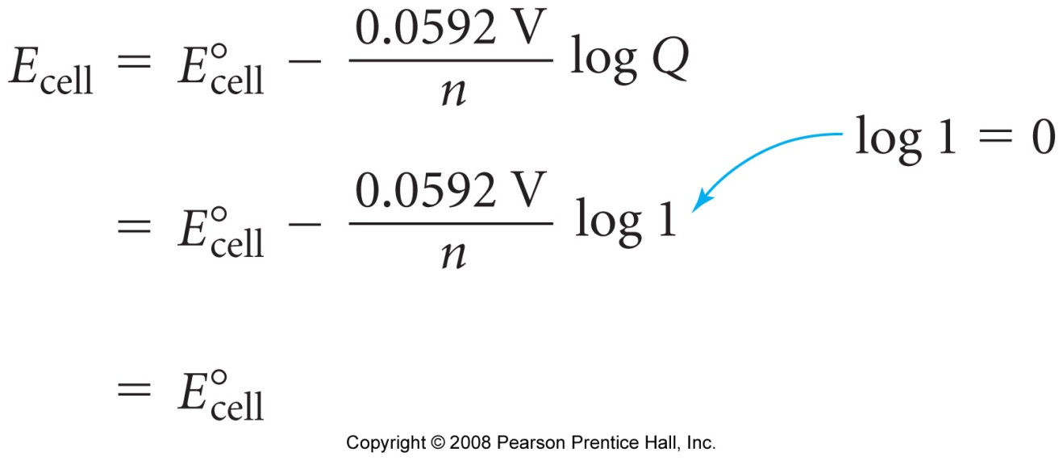

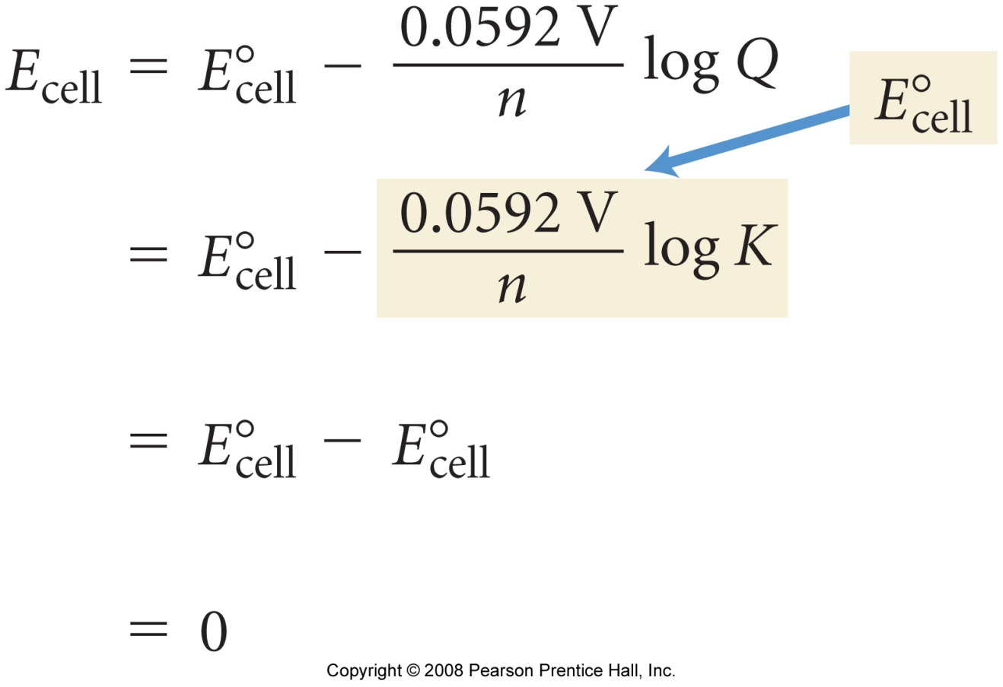

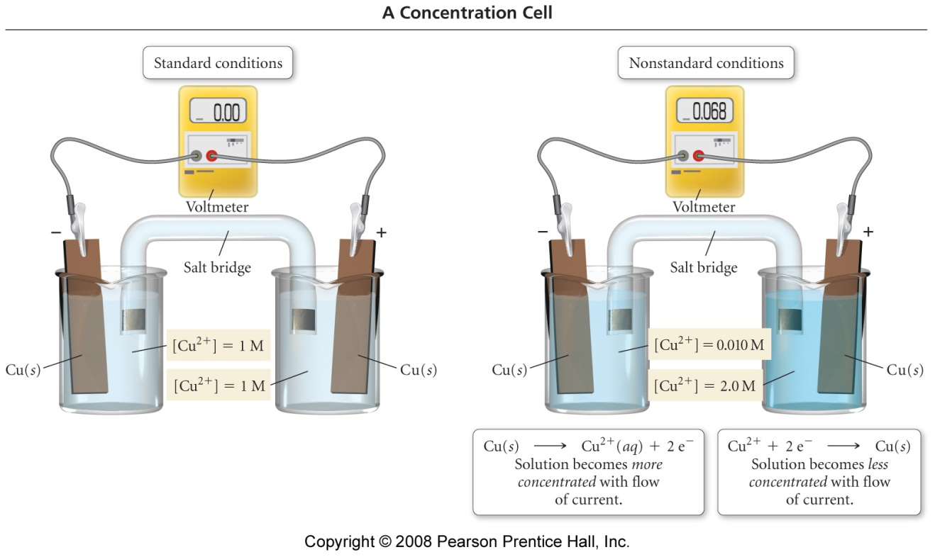
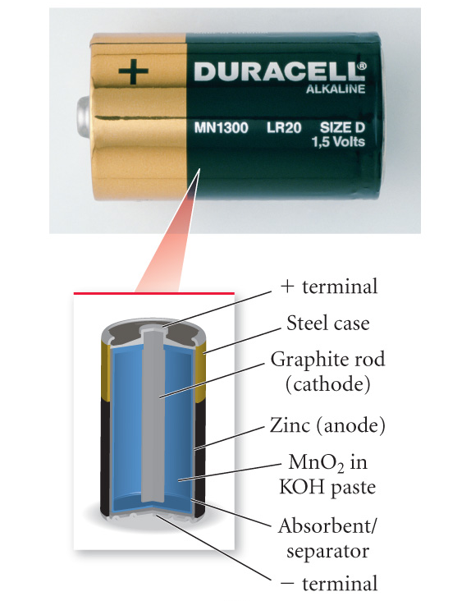

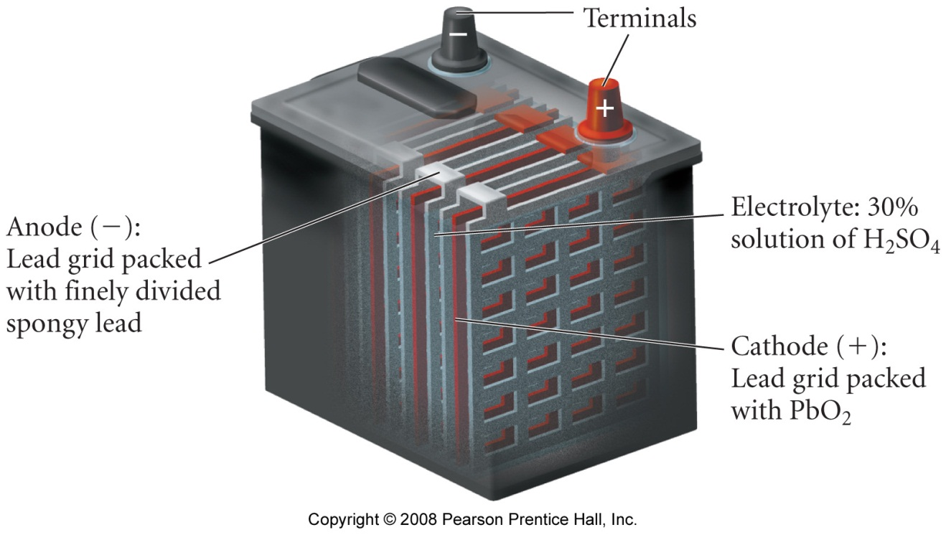

Nuclear Chemistry

Reading: | Ch 19, sections 1 – 12 | Homework: | Chapter 19: 31*, 33*, 35, 45, 47*, 49*, 53, 55, 59*, 61, 63, 65, 67, 69*, 71*
* = ‘important’ homework question

Radioactivity

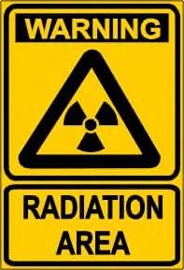 | Discussion: What kinds of nuclear radiation are there? What are the origins of each type of radiation?

Types of radiation (see appendix)*

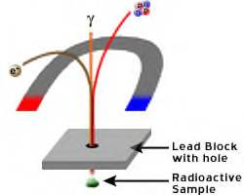 | Alpha particles are helium nuclei (2 p, 2 n):
 | Beta particles are speedy electrons:
 | Gamma radiation is a high-energy photon:

Name | Symbol | Charge | Penetration Limit
alpha () particles | 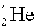 or 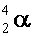 | +2 | skin, thin metal foil
beta () particles | 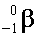 or 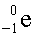 | -1 | thicker foil, plastic
gamma () rays |  | 0 | lead, concrete

Overview

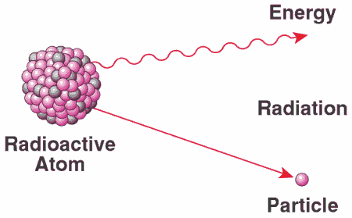 | ‘Heavy’ nuclei are unstable; they undergo nuclear decay via either alpha, beta and/or gamma emission to form lighter, more stable nuclei.  Iron has the most stable nucleus (ever wondered why the Earth and many other planets have iron cores?).

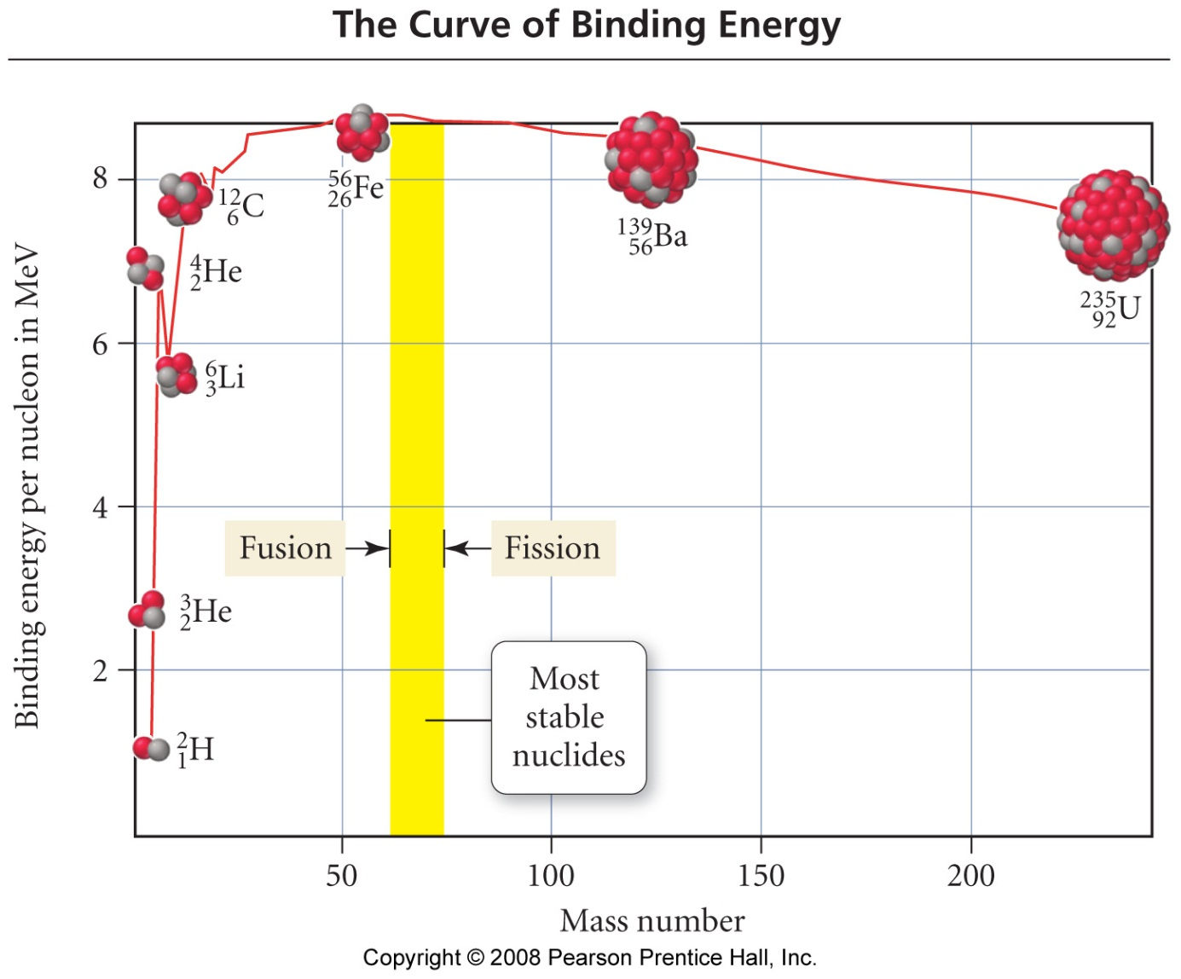

Strong v weak nuclear force - it’s magnets with velcro (more later!)
Writing radioactive decay equations

Recall writing complete atomic symbols from CHM 101. Writing nuclear decay equations is just accounting for changes in atomic number (Z) and atomic mass (A) in such symbols

Worked Example: Write reaction for the α-particle decay of Pu-240.

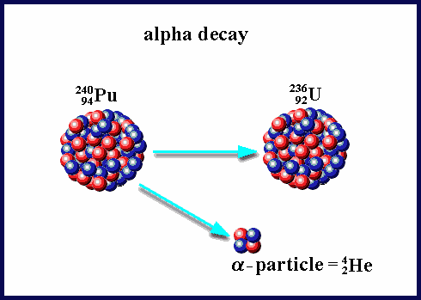 | 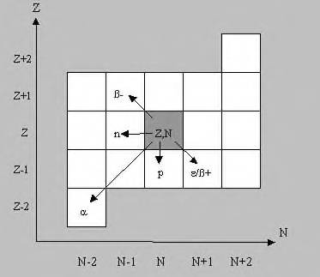
α-particle decay of Pu-240 | Variation in Z and #N for various types of nuclear decay

Task: Write nuclear decay equations for the following processes:

- The β decay of I-131

- The α decay of U-238 (see appendix)

Nuclear Transmutations

Similar math (with regard to balancing mass and atomic numbers) can be used for writing nuclear transmutation equations

Worked example: Write an equation for the capture of a neutron (cosmic ray) by N-14

Task: Write nuclear transmutation equations for the following processes:

- Fe-58 undergoing neutron capture

- See Example question 19.2 (a – c), page 870, of your text

Radioactive Decay

All radioactive decay processes are 1st order in terms of their kinetics. Thus, familiar relationships from the ‘Kinetics’ topic can be employed directly. Remember the basic ‘half-life trick’ for simpler questions

Worked Example: It takes 5.2 minutes for a 1.000 g sample of Fr-210 to decay to 0.250 g. What is the half-life of Fr-210?

Task: How much time is required for a 5.75 mg of Cr-51 to decay to 1.50 mg if its half-life is 27.8 days?

Nuclear Binding Energy

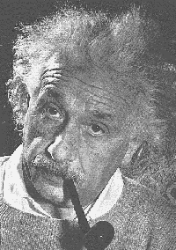  It’s a little more complicated than that…. | Discussion: What Holds a nucleus together? Shouldn’t it fly apart – after all, protons must repel one another, right?  Remember: Strong v weak nuclear force - it’s magnets with velcro!  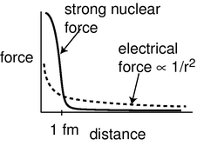

Einstein showed that mass and energy are convertible. The relationship is:
E = mc² or ΔE = Δmc²
The energy, or ‘glue’, that holds a nucleus’ otherwise repulsive nuclear particles together appears as a mass defect
Where: | mass proton = 1.00728 amu
 | mass neutron = 1.00866 amu
 | 1 amu = 1.66053873 x10⁻²⁴g
 | c = 3.0 x10⁸ m/s

Mass Defect: the difference in mass between an atomic nucleus and the sum of its individual component particles.

To work out mass defect problems, the mass of the nucleus must be compared to the sum of the masses of its component neutrons and protons.

The mass difference, stated in the form of energy (from E = mc²), is the binding energy of the nucleus.

Worked example: Calculate the binding energy per nucleon for C-12 (nuclear mass = 11.996708 amu)

Task: Calculate the binding energy per nucleon for Cl-37 (nuclear mass = 36.956576 amu)

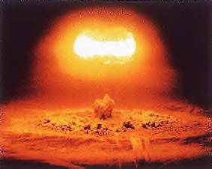 | Nuclear Fission and Fusion  Recall the graph of nuclear stability – Fe-56 has the most binding energy per nucleon, so is the most stable of all nuclei. Thus, ALL heavier nuclei may undergo fission, while all lighter nuclei may undergo fusion to form more stable products. Hey, universe, there’s a lot of iron in your distant future!?  Vast amounts of energy are liberated during fission (nuclear weapons, U-235) or fusion (the sun, H → He) reactions. The origin of this energy is the mass deficit (Δm) between products and reactants in each respective process.
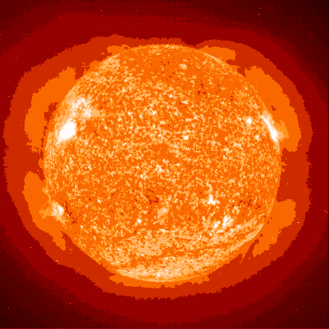

Fission and Fusion processes

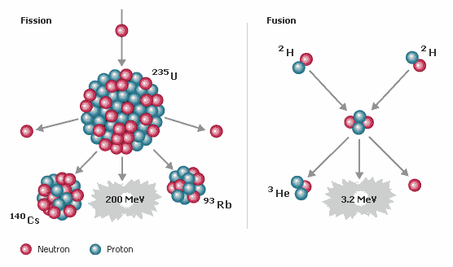

Group Wrap Up: Try question 19.7 from your text

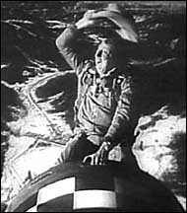

Appendix:

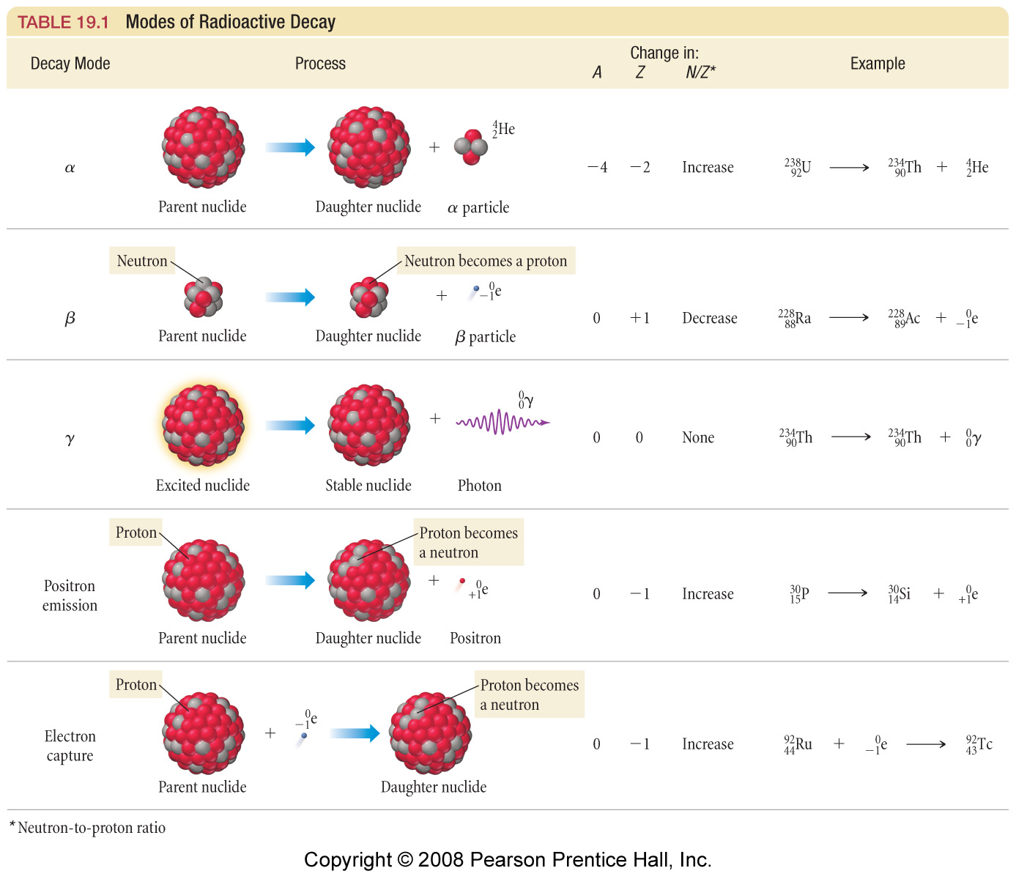
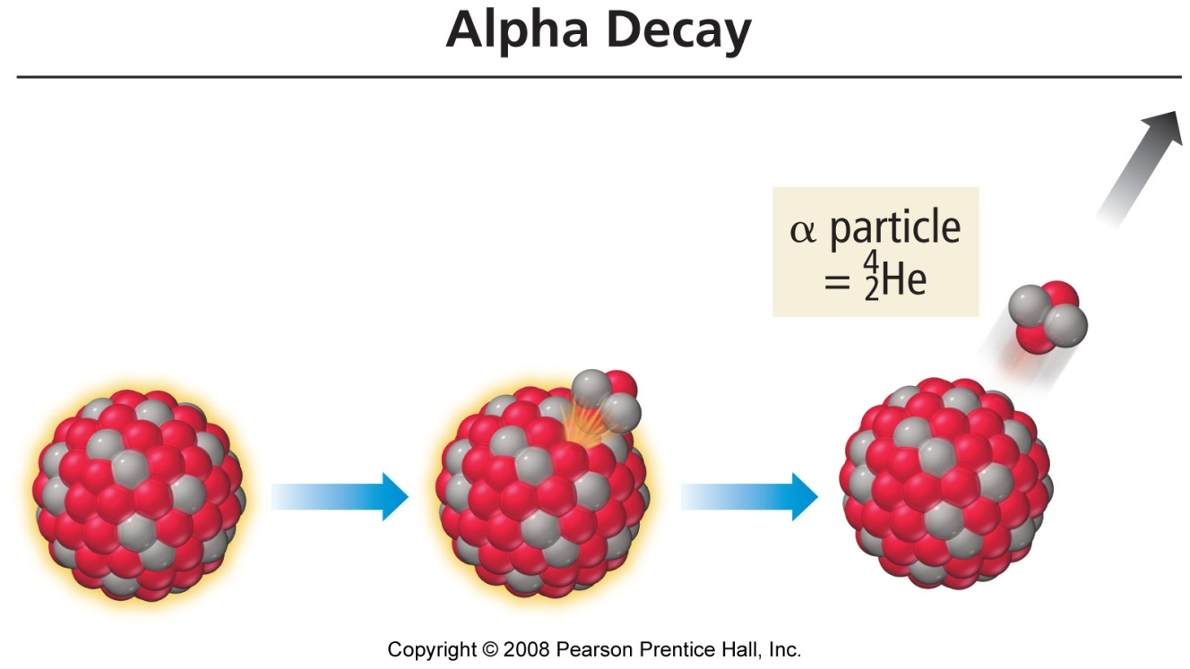

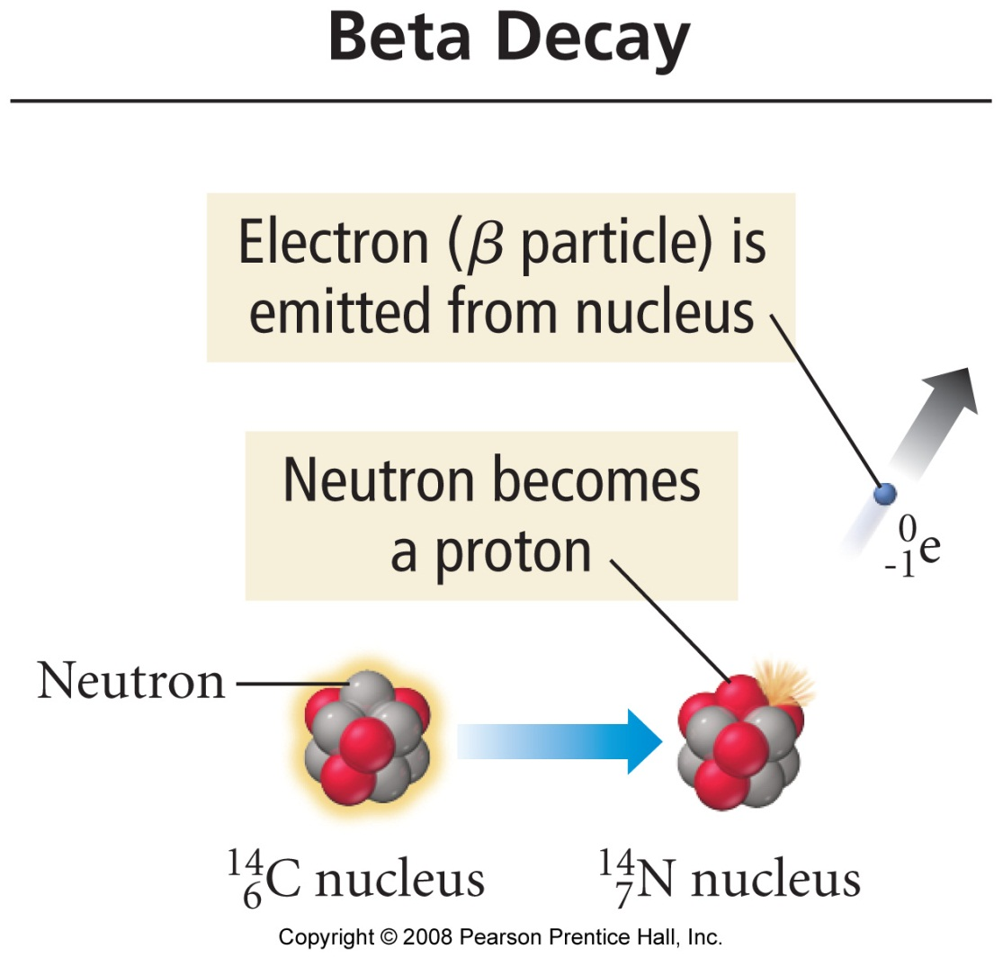
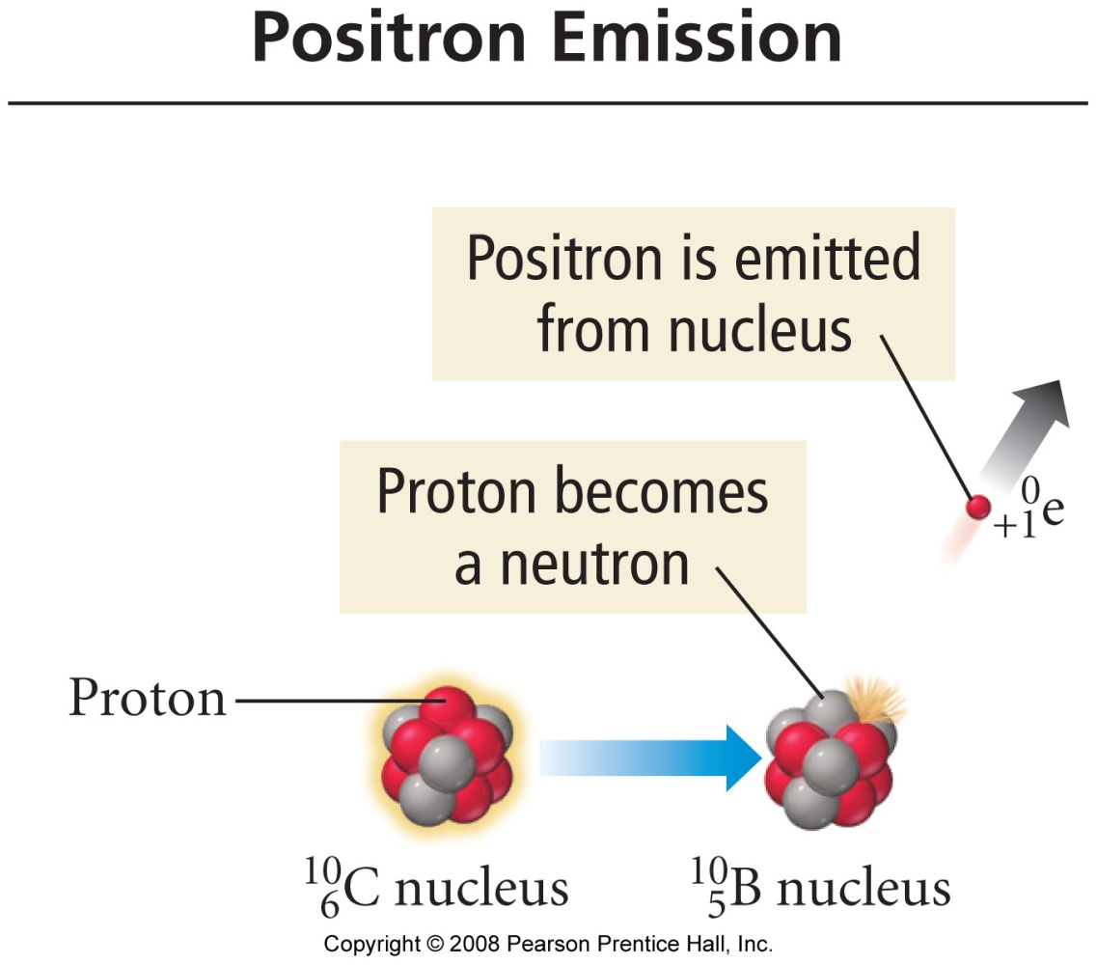

PET Scan
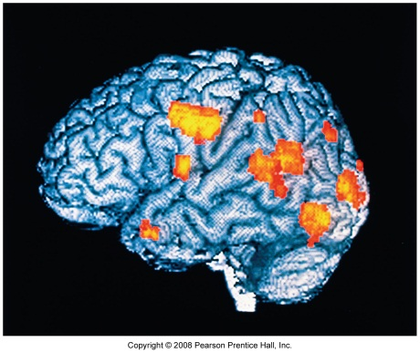 | 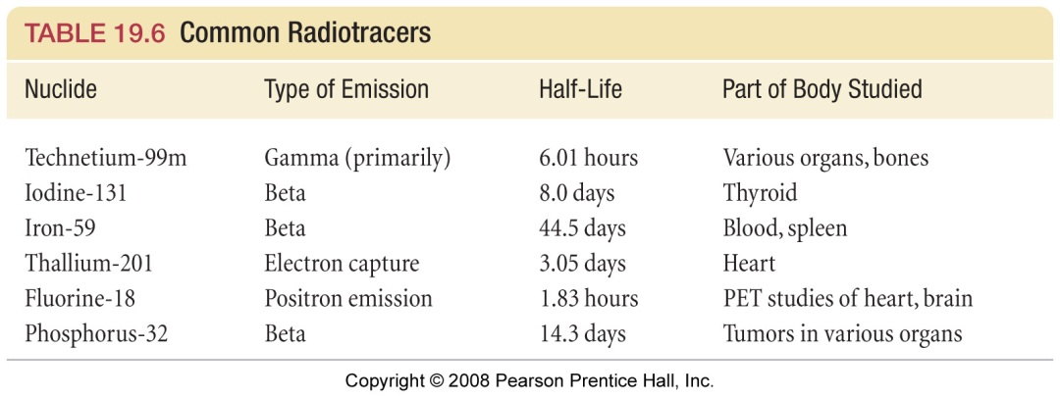

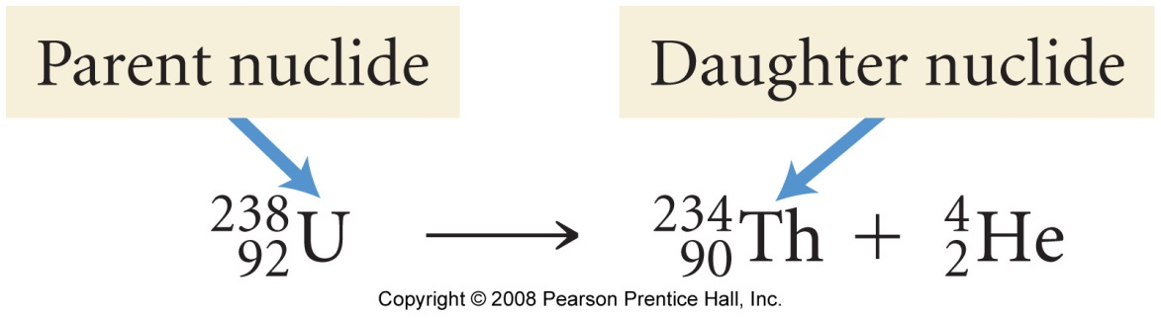

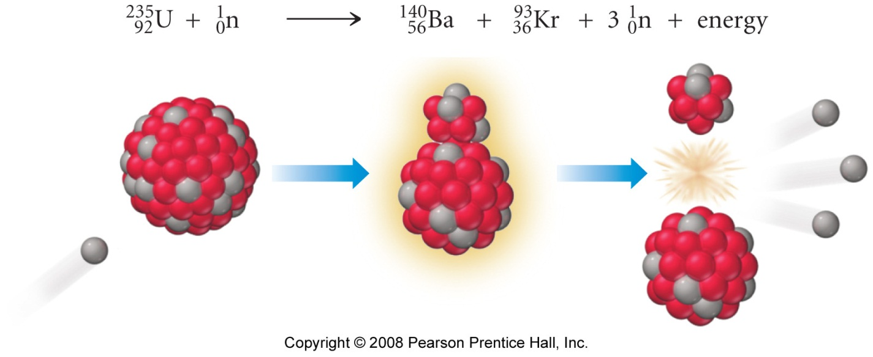

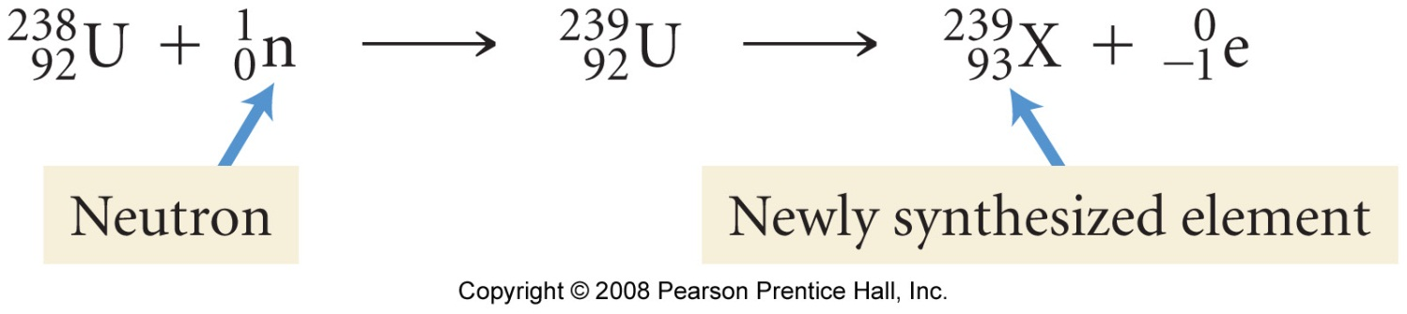

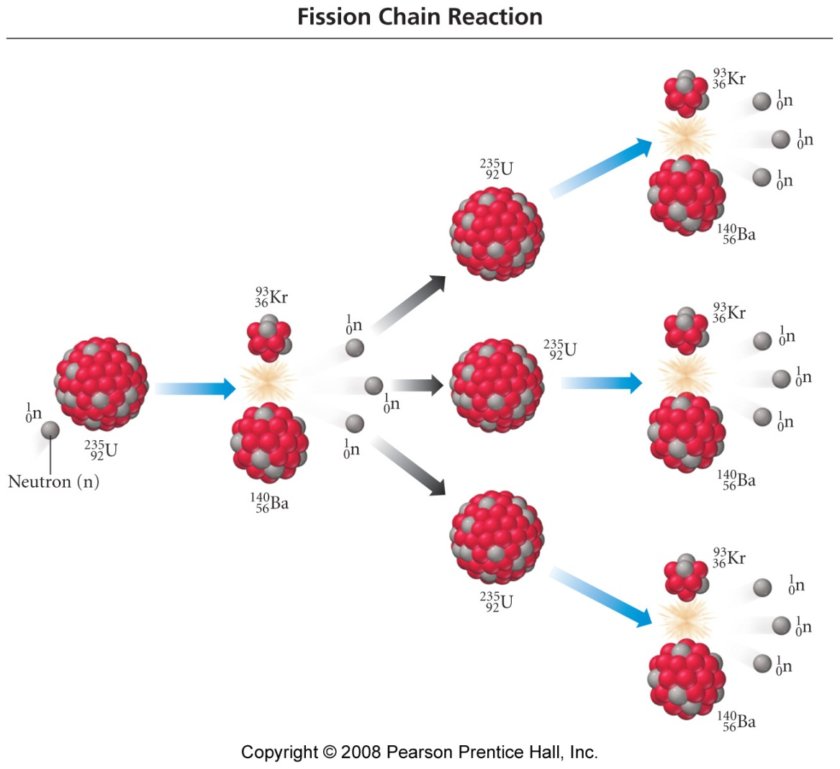

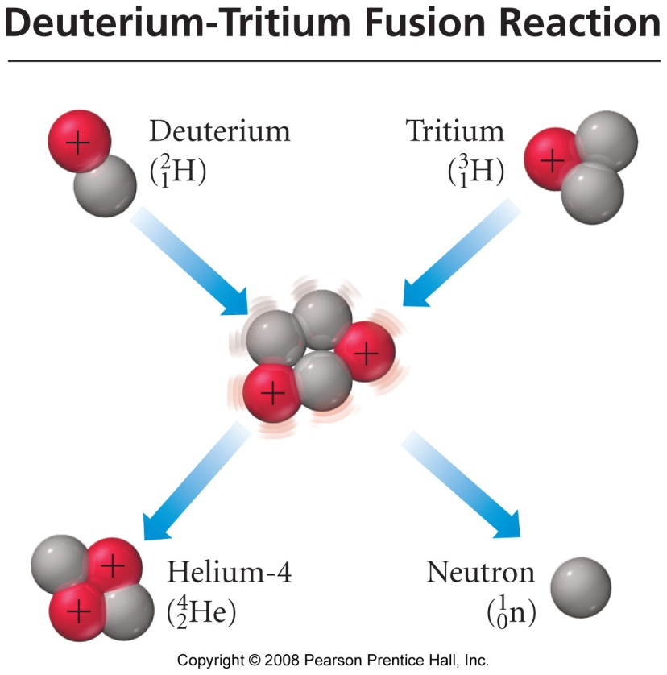

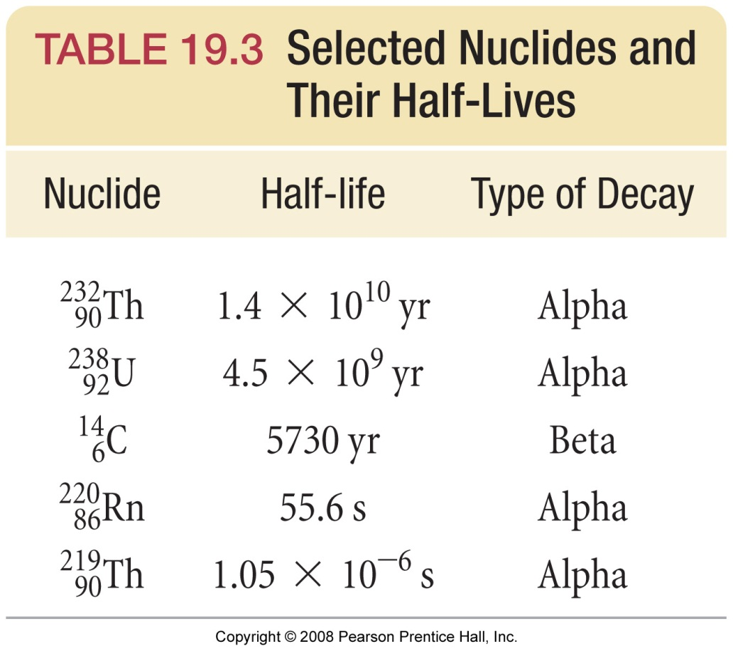

Final Exam Review

Information

Your ACS standardized final exam is a comprehensive, 70 question multiple choice (a – d) test featuring material from BOTH the CHM 101 and 102 syllabi. Questions are graded as either correct or incorrect. No points are subtracted for wrong guesses. There are two versions of the test, so your neighbors will have a different version of the test.
I normalize your final exam score out of 70 to a score out of 150. This score out of 150 is included in your final course total.

Tips

A great way to ensure a good grade on your final exam is to practice ACS style questions*. To help you with this, a pair of ACS study guides has been put on reserve in the library. Additionally, if you are going to take the MCAT or PCAT etc., the ACS guide is makes for an excellent resource for these tests' respective chemistry sections. If you wish to purchase a copy ($12 ea.) log on to: http://www3.uwm.edu/dept/chemexams/guides/details_guides.cfm?ID=162
*Ask me to remind you of the ‘BB’ story

Due to the number of questions set and the time allowed, most of the multiple choice questions you will meet on the final may be considered to be ‘lite’ versions of my midterm and quiz questions. The following tips will help you record a better score on your final:

- The test is cumulative, so review everything we have covered since the beginning for the course, as well as the CHM 101 materials.

- Review all the topics, but concentrate on topics you have had difficulty with. Since the questions are not ‘super hard’, this will increase your number of correct answers. Do not fall in to the trap of studying what you are good at (you’ll get those questions right regardless, most likely), so preferentially study what you are ‘bad’ at.

- Try to answer the questions in order when using a scantron sheet. It is better to guess a wrong answer (and then come back to it) than risk systematically filling out ovals ‘a line out’.

- Work out the answers on the scratch paper provided, then check the possible answers provided. This will cut down on ‘red herring’ type errors (see below)

- Watch out for obvious ‘red herrings’, as illustrated by the following example. MOST questions DO NOT have a red herring, but a reasonable fraction do:

Example: CO is the formula for:

a. | copper | c. | cobalt
b. | carbon monoxide | d. | Monocarbon monoxide

Sample Final Exam Questions (CHM 101 syllabus)

1. In all neutral atoms, there are equal numbers of:

a. | electrons and protons | c. | electrons and neutrons
b. | protons and neutrons | d. | electrons and positrons

2. Which pair of particles has the same number of electrons?

a. | F⁻, Mg²⁺ | c. | P³⁻, Al³⁺
b. | Ne, Ar | d. | Br⁻, Se

3. What is the mass percent of oxygen in Ca(NO₃)₂?

a. | 29.3 % | c. | 58.5 %
b. | 47.1 % | d. | 94.1%

4. A 24.0 g sample of carbon contains how many atoms:

a. | 6.02 x10²³ | c. | 3.01 x10²³
b. | 1.20 x10²⁴ | d. | 2.04 x10²⁴

5. When 1.187 g of a metallic oxide is reduced with excess hydrogen, 1.054 g of the metal is produced. What is the metallic oxide?

a. | Ag₂O | c. | K₂O
b. | Cu₂O | d. | Tl₂O

6. A single molecule of a certain compound has a mass of 3.4 x10⁻²² g. Which value comes closest to the mass of a mole of this compound?

a. | 50 g | c. | 150 g
b. | 100 g | d. | 200 g

7. The electronic configuration for the Ca atom is:

a. | 1s²2s²2p⁶3s²3p⁶4s²3d² | c. | 1s²2s²2p⁶3s²3p⁶4s²
b. | 1s²2s²2p⁶3s² | d. | 1s²2s²2p⁶3s²3p⁶4s²3d¹⁰4p²

8. Two moles of any gas will occupy what volume at STP?

a. | 22.4 L | c. | 4.48 L
b. | 11.2 L | d. | 44.8 L

Answers:
1. | a. | 5. | b.
2. | a. | 6. | d.
3. | c. | 7. | c.
4. | b. | 8. | d.

Sample Final Exam Questions (CHM 102 syllabus)

1. When a material in the liquid state is vaporized and then condensed to a liquid, the steps in the process are, respectively:

a. | ΔT₂ = 4 ΔT₁ | c. | ΔT₂ = 0.5 ΔT₁
b. | ΔT₂ = 2 ΔT₁ | d. | ΔT₂ = ΔT₁

2. Calculate ΔHº for the chemical reaction:

Cl₂ (g) + F₂ (g) → 2ClF (g)

Given the bond enthalpies: F-F = 159 kJ/mol
Cl-Cl = 243 kJ/mol
Cl-F = 255 kJ/mol

a. | -147 kJ | c. | +171 kJ
b. | -108 kJ | d. | +912 kJ

3. The standard enthalpy of formation ΔHº_{f} for NO₂ is the enthalpy change for which reaction?

a. | N (g) + 2O (g) → NO₂ (g) | c. | ½ N₂ (g) + O₂ (g) → NO₂ (g)
b. | ½ N₂O₄ (g) → NO₂ (g) | d. | NO (g) + ½O₂ (g) → NO₂ (g)

4. In a bomb calorimeter, reactions are carried out at:

a. | constant pressure | c. | constant volume
b. | 1 atm and 25ºC | d. | 1 atm and 0ºC

5. Calculate ΔHº for the chemical reaction:

3H₂ (g) + O₃ (g) → 3H₂O (l)

Given the ΔHº_{rxn} enthalpies: H₂ (g) + ½O₂ (g) → H₂O (l) = -286 kJ/mol
3O₂ (g) → 2O₃ (g) = +271 kJ/mol

a. | -15 kJ | c. | -722 kJ
b. | -558 kJ | d. | -994 kJ

6. The gas phase reaction A₂ + B₂ → 2 AB proceeds by bimolecular collisions between A₂ and B₂ molecules. If the concentrations of both A₂ and B₂ are doubled, the reaction rate will change by a factor of:

a. | ½ | c. | 2
b. | √2 | d. | 4

7. Under certain conditions, the average rate of appearance of ozone gas in the reaction

3O₂ (g) → 2O₃ (g)

is 1.2 x10⁻³ atm.s⁻¹. What is the average rate for the disappearance of O₂ (g)?

a. | 8.0 x 10⁻⁴ atm.s⁻¹ | c. | 1.8 x 10⁻³ atm.s⁻¹
b. | 1.2 x 10⁻³ atm.s⁻¹ | d. | 5.3 x 10⁻³ atm.s⁻¹

8. A plot of reactant concentration as a function of time gives a straight line. What is the order of reaction for this reactant?

a. | zero | c. | second
b. | first | d. | third

9. Carbon monoxide gas reacts with hydrogen gas at elevated temperatures to form methanol, according to the equation:

CO (g) + 2H₂ (g) ⇔ CH₃OH (g)

When 0.40 mol of CO and 0.30 mol of H₂ are allowed to reach equilibrium in a 1.0 L container, 0.060 mol of CH₃OH (g) is formed. What is the value of K_{c}?

a. | 0.50 | c. | 1.7
b. | 0.98 | d. | 5.4

10. Which factors will affect both the position of the equilibrium and the value of the equilibrium constant for this reaction:

N₂ (g) + 3H₂ (g) ⇔ 2NH₃ (g); ΔH = -92 kJ

a. | Increasing the volume of the container | c. | Removing ammonia gas
b. | Adding more N₂ gas | d. | Lowering the temperature

11. In a 0.050 M solution of weak monoprotic acid, [H⁺] = 1.8 x 10⁻³ M. What is K_{a}?

a. | 3.6 x 10⁻² | c. | 6.7 x 10⁻⁵
b. | 9.0 x 10⁻⁵ | d. | 1.6 x 10⁻⁷

12. What is the value of the equilibrium constant K, for a reaction in which ΔGº = -5.20 kJ at 50 ºC?

a. | 0.144 | c. | 6.93
b. | 0.287 | d. | 86.4
Answers:
1. | d. | 7. | c.
2. | b. | 8. | a.
3. | c. | 9. | d.
4. | c. | 10. | d.
5. | d. | 11. | c.
6. | d. | 12. | c.

Post-Final Wrap Up

General chemistry final exams are graded immediately after they have been completed by the students. The final exam scores (out of 150), as well as overall course scores and letter grades, will be available from 10:00 am on Thursday of exam week. Students can check their scores by sending Dr. Mills an e-mail request at any time before noon on Thursday of exam week. In order to ensure confidentiality, students requesting such feedback must include the following code word(s) within their e-mail requests:

So Close, Yet so Far?

Unfortunately, it is sometimes the case that students find themselves just a few points below the C/D (50%) cut-off line after the completion of all course materials. In order for such students to achieve a passing ‘C’ grades, an optional 25 pt. extra credit assignment may be completed. Students may only complete this assignment if they are in good academic standing (no more than one missed quiz, exam or lab) and contact Dr. Mills, via e-mail with a grade request, no later than noon on Thursday of exam week. Such students’ final scores must have fallen no more than 25 points below the C/D cut-off in order for them to be eligible to take the assignment.

Dr. Mills will supply qualifying students with a copy of the extra credit assignment, as an e-mail attachment, via return e-mail. The hard deadline for completing this assignment is 10:00 am on Friday of exam week – no exceptions.

Name: __________________

Instructor: Mills

Chemistry 102: 1st Practice Examination

Answer all five questions. Each question is worth 30 points. Please ensure you have all five pages of questions, as well as a formula sheet and a copy of the periodic table, before starting.

Show all work

Question | Score
1

2

3

4

5

Total

“Expressing reaction rates”

The reaction between hydrogen and nitrogen to form ammonia is known as the Haber process:

N₂ (g) + 3H₂ (g) → 2NH₃ (g)

Question 1a (5 points each): Express the rate of the above reaction in terms of changes in [N₂] with time, [H₂] with time, and [NH₃] with time.

Question 1b (15 points): When [H₂] is decreasing at 0.175 molL⁻¹s⁻¹, at what rate is [NH₃] increasing?

“Initial rates”

Question 2 (30 points): Consider the generic reaction:

A + B + C → D

Assuming the above reaction was analyzed using the initial rate method at 25ºC, use the data below to determine:

- The order of reaction with respect to each reactant and the overall order of the reaction. Summarize your findings in the form of a complete rate equation.
- The value of k at this temperature.
- What is the rate of reaction when the concentrations of each reactant is 0.50 M,

Experiment | Initial concentrations (molL⁻¹) |  |  | Initial rate
 | A | B | C | (molL⁻¹s⁻¹)
1 | 0.10 | 0.10 | 0.50 | 1.5 x 10⁻⁶
2 | 0.20 | 0.10 | 0.50 | 3.0 x 10⁻⁶
3 | 0.10 | 0.20 | 0.50 | 6.0 x 10⁻⁶
4 | 0.10 | 0.10 | 1.00 | 1.5 x 10⁻⁶

“Half - life”

Question 3a (15 points): The decomposition of N₂O₅ (g) is a first order process:

2N₂O₅ (g) → 4NO₂ (g) + O₂ (g)

The concentration of N₂O₅ (g) may be monitored with time using a simple diode colorimeter. If, during such an experiment, k is determined to be 5.2 x 10⁻⁴ s⁻¹, then what is the half-life of the reaction measured in minutes?

Question 3b (15 points): If, in the above experiment, an absorbance of 0.84 is recorded immediately prior to the commencement of N₂O₅ (g) decomposition (i.e. at t = 0), then what absorbance value will be recorded record after exactly one half-life has passed? Recall that Abs ∝ [N₂O₅]

For the above reaction, what Abs value would be detected by the colorimeter after exactly three half-lives had passed?

“Arrhenius”

Question 4 (30 points): The activation energy for a certain reaction is 65.7 kJ/mol. How many times faster will the reaction occur at 50ºC than 0ºC?

“Bloody Solution”
Question 5 (30 points): Calculate the osmotic pressure of a solution containing 20.5 mg of hemoglobin in 15.0 mL of solution at 25ºC. The molar mass of hemoglobin is 6.5 x10⁴ g/mol.

Data sheet

Molar volume: V_{m} = 22.41 L.mol⁻¹ at STP (0.00ºC, 1.00 atm) | Daltons law of partial pressures:  P_{Tot} = P_{a} + P_{b} + P_{c} ….
Ideal gas law: PV= nRT | Beer's law  A = log(I_{o}/I) = εbc
Combined gas law: P₁V₁/T₁ = P₂V₂/T₂ | R = 0.0821 L atm mol⁻¹ K⁻¹  = 8.315 Jmol⁻¹K⁻¹
Boyle's Law: P ∝ 1/V (at fixed T and n) | d = m/v
Charles's Law: P ∝ T (at fixed V and n) | 1.00 atm = 760 mmHg = 101.5 kPa
Avagadro's Law: V = nV_{m} | ρH₂O = 1.00 gmL⁻¹
1st order rate equations  ln([A]_{t} /[A]_{o}) = -kt  t_{1/2} = 0.693/k | 2nd order rate equations  1/[A]_{t} = kt + 1/[A]_{o}  t_{1/2} = 1/ k[A]_{o}
Osmotic pressure: Π= MRT | Arrhenius equation  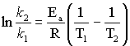

Substance | Specific heat (Jg^{-1o}C⁻¹) |  | Substance | ΔHº_{f} (kJmol⁻¹)
Water, H₂O (l) | 4.18 |  | H₂O (g) | -241.8
Iron, Fe | 0.450 |  | H₂O (l) | -285.8
steel | 0.455 |  | CH₄ (g) | -74.9
Graphite, C | 0.711 |  | NH₃ (g) | -45.9
 |  |  | HCN (g) | 135

Name: __________________

Instructor: Mills

Chemistry 102: 2nd Practice Examination

Answer all five questions. Each question is worth 30 points. Please ensure you have all five pages of questions, as well as a formula sheet and a copy of the periodic table, before starting.

Show all work

Question | Score
1

2

3

4

5

Total

“Gibbs”

Question 1 (30 points): Using the thermodynamic information given in the data sheet, calculate ΔGº for the following reaction:

Fe₂O₃ _{(s)} + 6 HCl _{(g)} → 2 FeCl₃ _{(s)} + 3 H₂O _{(g)}

“What’s the pH?”

Question 2 (30 points): Calculate the pH of each of the following solutions:

- 0.015 M HCl (aq) (assume complete dissociation)

- 0.015 M H₂SO₄ (aq) (assume complete dissociation)

- 0.015 M NaOH (aq) (assume complete dissociation)

- 0.015 M HC₂H₃O₂ (aq), K_{a} = 1.8 x 10⁻⁵
“Weak Acid”

Question 3 (30 points): A 0.200 M solution of a weak acid HA (aq) is 9.4 % ionized (dissociated) at equilibrium. Use this information to calculate [H⁺], [HA] and K_{a} for HA.

“Weak Base”

Codeine (C₁₈H₂₁NO₃) is a weak organic base. A 5.0 x 10⁻³ M solution of codeine has a pH of 9.95.

Question 4a (30 points): Calculate K_{b} for codeine.

Question 4b (5 points): Calculate pK_{b} for codeine.

“Common Ion”

Question 5 (30 points): A solution contains 2.5 x 10⁻⁴ M Ag⁺(aq) and 1.7 x 10⁻³ M Pb²⁺(aq).

- If NaI (aq) is added, will AgI (K_{sp} = 8.3 x 10⁻¹⁷) or PbI₂ (K_{sp} = 7.9 x 10⁻⁹) precipitate first?

- Specify the concentration of I⁻ (aq) needed to begin precipitation of the material you determined would precipitate first in part A.

“REDOX”

Question 5a (10 points): State the oxidation state of the specified atom in each of the chemical species listed below:

Cr in Cr₂O₇²⁻ | I in IO₃⁻

Question5b (20 points): Balance the following REDOX reaction. Assume acidic conditions.

Cr₂O₇²⁻_{(aq)} + I⁻_{(aq)} → Cr³⁺_{(aq)} + IO₃⁻_{(aq)}

Data sheet

Molar volume: V_{m} = 22.41 L.mol⁻¹ at STP (0.00ºC, 1.00 atm) | Daltons law of partial pressures:  P_{Tot} = P_{a} + P_{b} + P_{c} ….
Ideal gas law: PV= nRT | Beer's law  A = log(I_{o}/I) = εbc
Combined gas law: P₁V₁/T₁ = P₂V₂/T₂ | R = 0.0821 L atm mol⁻¹ K⁻¹  = 8.315 Jmol⁻¹K⁻¹
Boyle's Law: P ∝ 1/V (at fixed T and n) | d = m/v
Charles's Law: P ∝ T (at fixed V and n) | 1.00 atm = 760 mmHg = 101.5 kPa
Avagadro's Law: V = nV_{m} | ρH₂O = 1.00 gmL⁻¹
1st order rate equations  ln([A]_{t} /[A]_{o}) = -kt  t_{1/2} = 0.693/k | 2nd order rate equations  1/[A]_{t} = kt + 1/[A]_{o}  t_{1/2} = 1/ k[A]_{o}
Arrhenius equation  ln(k₂/k₁) = E_{a}(1/T₁-1/T₂) / R | Equilibrium constants: K_{p} = K_{c}(RT)^{Δn}
K_{w} = [H⁺][⁻OH] = 1 x10⁻¹⁴ | pH = -log [H⁺]
pH + pOH = 14 | K_{a}K_{b} = K_{w}
ΔG = ΔH - TΔS | ΔH_{rxn} = ΔH_{f} (products) - ΔH_{f} (reactants)

Substance | Sº (Jmol⁻¹K⁻¹) |  | Substance | ΔHº_{f} (kJmol⁻¹)
H₂O (g) | 188.83 |  | H₂O (g) | - 241.8
Fe₂O₃ (s) | 89.96 |  | Fe₂O₃ (s) | - 822.16
FeCl₃ (s) | 142.3 |  | FeCl₃ (s) | - 400.0
HCl (g) | 186.69 |  | HCl (g) | - 92.30

Notes

