Chemical Kinetics 3

Reading: | Ch 13 sections 5-7 | Homework: | Chapter 13: 57*, 59*, 61*, 63*, 65*, 69, 73, 75 Excel assignment*  (see assignments for link)
* = ‘important’ homework question

Temperature and Rate – Transition State Theory and the Arrhenius
Equation

Background: Recall that the number of ‘fruitful’ collisions per unit time among the reactant(s) determine the overall rate of reaction.

Discussion: What factors determine if a single collision will be fruitful?

1.
2.
3.

 | The above are the three basic assumptions of collision theory

Collision Theory

For a reaction to occur, the reactant molecules must collide with energy greater than some minimum value (E_{a}) and have the correct spatial orientation. E_{a} is the activation energy.

Recap: At a defined temperature, a reaction rate is described by the rate equation:

Generically: | aA + bB → cC + dD | Rate = k[A]^{m}[B]^{n}
Observation: Rates of reaction typically increase substantially for a relatively small elevation of temperature.

Discussion: How does increasing temperature effect the rate equation?

(see slide of k v temp)

The makeup of k

The three collision theory variables (energy of reactants, frequency of collisions and orientation of reactants), when combined, give rise to the rate constant k. Clearly, the value of k varies with temperature(!)

Mathematically:

k = Zpf | where: | k = rate constant
k = Zpf |  | Z = frequency of collisions
k = Zpf |  | p = fraction of molecules with correct orientation
k = Zpf |  | f = fraction of molecules with E_{a} or greater
Discussion: To what extent are Z, p and f affected by temperature?

Collision Frequency (Z) – recall Chemical Kinetics 1

KE = ½ mv² = kT (k is the Boltzmann constant). i.e. Temp ∝ v²

Reactant Orientation (p)

Random (see slide) – temp has NO effect, some fixed fraction of reactant(s) will have the correct orientation

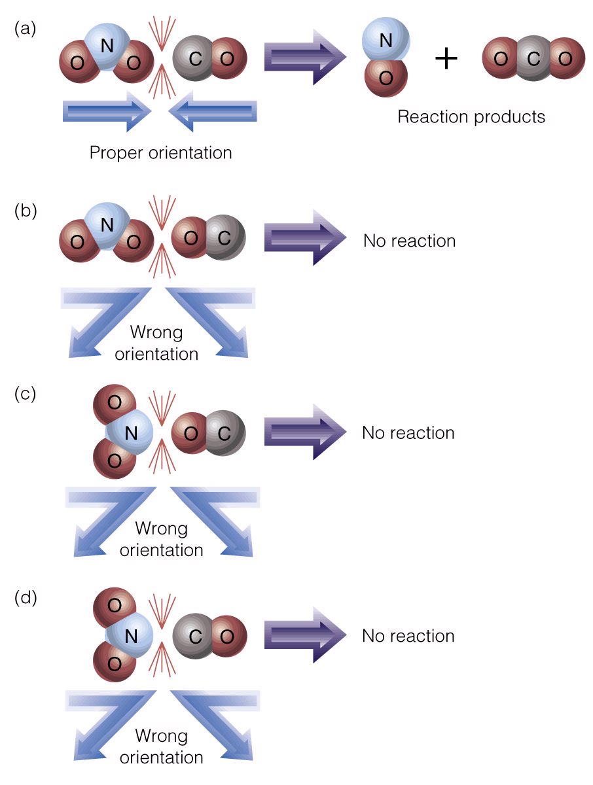 | Transition State Theory  Only reactants colliding with the correct orientation (a) may give rise to an activated complex, or transition state species  The reactants must also have greater than a minimum amount of ‘collision energy’ (E_{a}, see next) in order to form an activated complex (see additional slide).  We will return to this topic later in the handout
Fraction of molecules with E_{a} or greater (f)

 | Q: Do all molecules of a compound have the same speed at, say, room temperature?  A:

The distribution of molecular speeds - the Boltzmann distribution
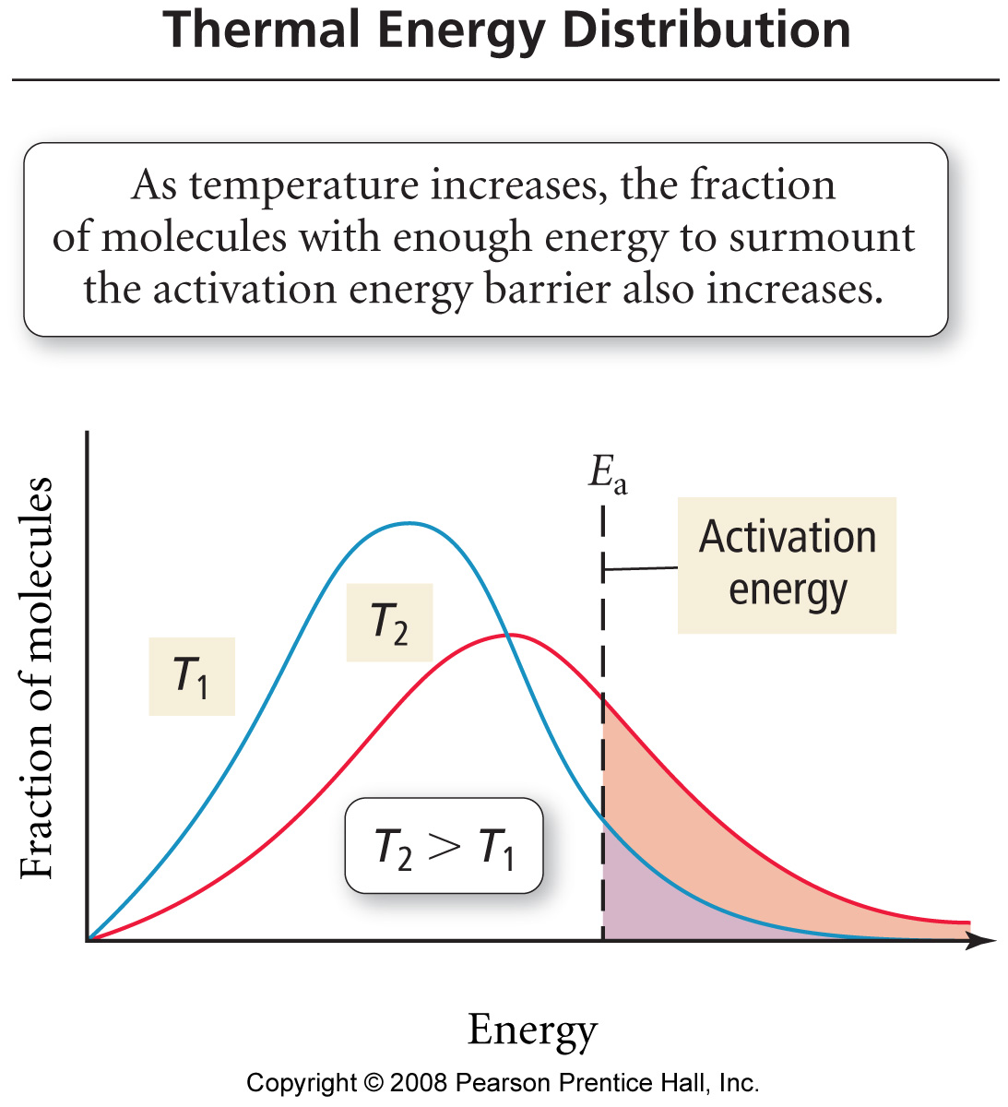

Features

Due to the line shape of the Boltzmann distribution, the fraction of molecules with E_{a} or greater has an exponential relationship with temperature:

Since the fraction of molecules with the correct orientation (p) is fixed and the frequency of collisions (Z) does not vary significantly for a small change in temperature, these two variables are combined into a single constant called the ‘frequency factor’ (A):

The Arrhenius Equation

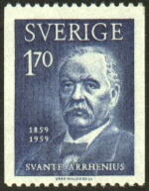 | The Arrhenius Equation combines the above variables and, so, relates k to activation energy and temperature for any reaction  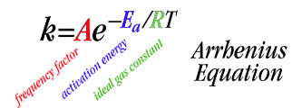

We will return to the Arrhenius equation soon, but first, more on transition state theory and activated complexes….

Definition of an Activated Complex

An unstable grouping of atoms, formed during a fruitful collision, that breaks apart to form reaction product(s)

A short lived activated complex (transition state) is formed during a fruitful collision

The activated complex, once formed, quickly decomposes to give reaction products

The energy needed to form an activated complex is equal to or greater than the respective reaction’s activation energy (E_{a})

“If you think about it, reactions are really all about making activated complexes”

Example: The isomerization of methylisonitrile (see slide and appendix)

CH₃NC (g) → [activated complex ]‡ → CH₃CN (g)

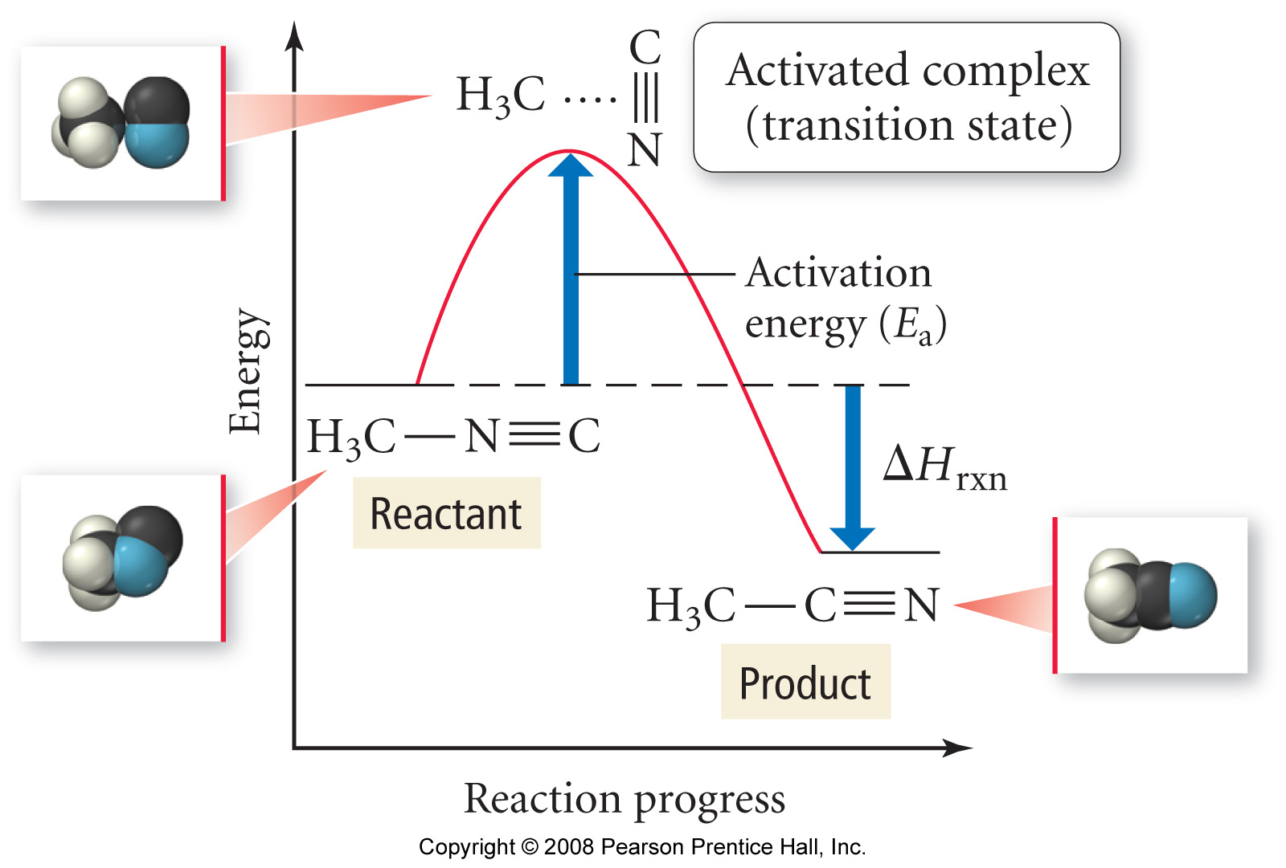 | 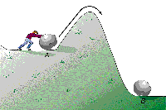
Reaction Pathway (coordinate) diagram | Analogy

“Activation energy gets you over the ‘hump’ needed to start a reaction” - think about this in terms of why you have to strike a match or spark your stove.

A reaction cannot proceed unless the reactants have achieved or surpassed the necessary activation energy (E_{a}) for the chemical process

OK, back to the Arrhenius Equation….

A LINEAR version of the Arrhenius Equation, in terms of k and T, is required to determine the activation energy (E_{a}) for a chemical process.

Derivation: The two linear forms of the Arrhenius equation

Interpretation

ln k | = | -Ea | 1 | + | ln A | OR | ln k₂ | - | ln k₁ | = | -Ea | ⎧1 | - | 1 ⎫
 |  | R | T |  |  |  |  |  |  |  | R | ⎩T₂ |  | T₁⎭
y | = | m | x | + | b |  | (y₂ | - | y₁) | = | m | (x₂ | - | x₁)

A plot of ln k v 1/T (for k determined at different temperatures) for any chemical process will yield a LINEAR plot with slope equal to -E_{a}/R. OR
Two points from the Arrhenius data (ln k₁, 1/T₁) and (ln k₂, 1/T₂) may be used to find E_{a} mathematically

Generic Arrhenius Plot of ln k v 1/T

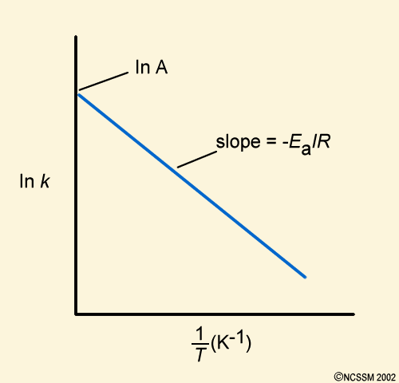

The following data was determined:

Experiment | k | T (K)
1. | 1.05 x10⁻³ | 759
2. | 2.14 x 10⁻² | 836

Questions: What is E_{a}? What is k at 865 K?

Discussion: How would you solve these problems (there are two general methods)?

Plan and execution:

 | “Standard question”  The following question is a great example of the type asked on standardized tests like the MCAT etc. Again, as is often the case, once you know the trick they are easy….

The rate of a particular reaction is quadrupled when the temperature was increased from 55ºC → 60ºC. What is E_{a} for this process?

Work in groups of 3 or 4 – try to figure out the ‘trick’

Reaction Mechanisms

Definition of Reaction Mechanism: A combination of elementary steps resulting in the formation of product(s) from reactant(s)

Example: The following reaction has a single, bimolecular, elementary step:

NO (g) + O₃ (g) → [NOO₃] ‡ → NO₂ (g) + O₂ (g)

bimolecular – involves the collision of two reactant molecules (NO and O₃)

elementary step – ONE collision or other molecular scale event

molecularity – the number of molecules involved in an elementary step

Note: Reactions can also feature unimolecular (e.g. isomerization of methylisonitrile, any nuclear decay) or (rarely, why?) termolecular elementary steps.

Elementary Steps and their rate laws (fill in the blanks)

Molecularity | Elementary Step | Rate Law
Unimolecular | A → products | Rate = k[A]¹
Bimolecular | A + A → products | Rate = k[A]²
Bimolecular | A + B → products | Rate = k[A]¹[B]¹
Termolecular | A + A + A → products | Rate = k[A]³
Termolecular | A + A + B → products | Rate =
Termolecular | A + B + C → products | Rate =

Discussion: For the above reactions, which feature single elementary steps, do you see any correlation between the molecularity and the overall order in each case?

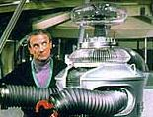 | DANGER! DANGER! WILL ROBINSON…  DO NOT assume molecularity (stoichiometry) and reaction order are numerically identical for all reactions. This IS true for elementary steps, but not for multi-step reactions (discussed below).  Recall from Chemical Kinetics 2 that orders of reaction must be determined from initial rate (experimental) data

Multiple Step Reactions

Most reactions feature two or more elementary steps – these are called multi-step reactions

The mechanism (and balanced chemical equation) for a multi-step reaction is the sum of its individual elementary steps.

Example: The formation of NO and CO₂ from NO₂ and CO

Elementary step 1: NO₂ + NO₂ → NO₃ + NO (slow)

Elementary step 2: NO₃ + CO → NO₂ + CO₂ (fast)

Combine steps: | NO₂ + NO₂ + NO₃ + CO → NO₃ + NO + NO₂ + CO₂

What’s that itch??

Net Reaction:

 | The overall rate of a multi-step reaction is limited by its slowest single elementary step (the rate limiting step) – this fact was utilized in your recent clock reaction lab. How?  Analogy: A production line is only as fast as its slowest person – “quit showing off Frank, these pies need to go in the oven!”

Catalysis

 | Background: As we saw in Chemical Kinetics 1, a catalyst speeds up the rate of reaction without being consumed in the process. We discovered that, in part, this is due to the catalyst (be it homogeneous or heterogeneous) increasing the local reactant concentration. However, this is only part of the story - what’s really going on behind the curtain?
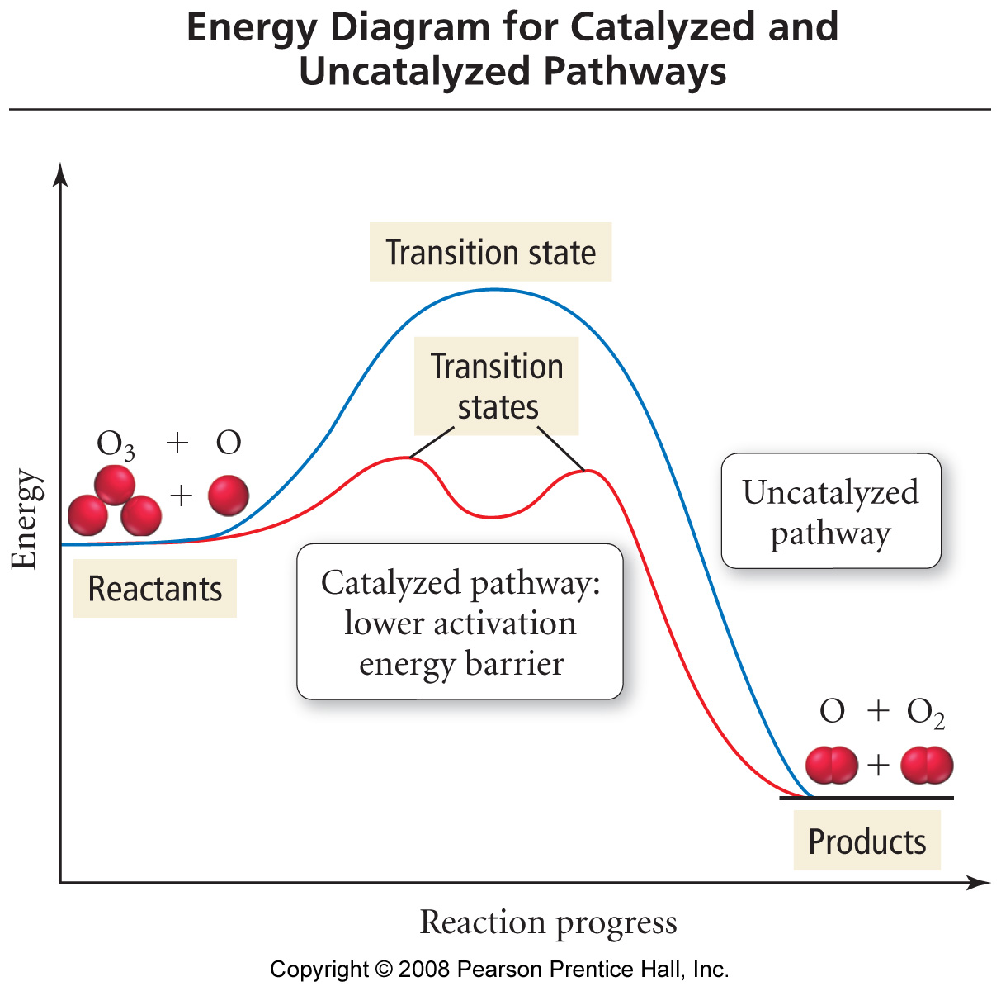

A catalyst provides an alternate reaction pathway, which, in turn, consists of two or more elementary steps.

While the total activation energies for the uncatalyzed and catalyzed pathways are the same, that of the catalyzed process is made up from the sum of each elementary step’s activation energies.

A greater fraction of molecules (recall the Boltzmann distribution) will have kinetic energy greater than, or equal to, that of the largest E_{a} for the catalyzed reaction’s elementary steps

Case study: The conversion of NO₂ (g)→ N₂ (g) + O₂ (g) by your car’s catalytic converter

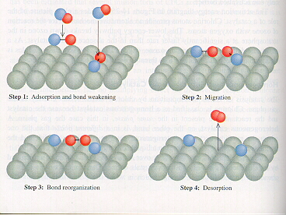 | The (catalyzed) reaction is now composed of four(+) individual processes, each with its own E_{a}, that occur at the catalyst surface:  a. NO₂ (g) → NO₂ (ads)  b. 2 NO₂ (ads) → O₂(ads) + 2 N (ads)  c. O₂ (ads) → O₂(g)  d. 2 N (ads) → N₂(ads) (not shown)  e. N₂ (ads) → N₂(g) (not shown)  The sum of these reactions E_{a}s equals that of the uncatalyzed reaction

Homogeneous Catalysis

 | Homogeneous catalysts ‘do the same job’ as heterogeneous catalysts, but are in the same phase as the reactants – typically in solution.  Examples of homogeneous catalysts include aqueous ions, such as H⁺, or aqueous transition metal complexes, such as TiCl₄.

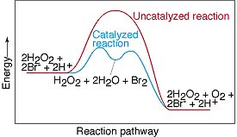

“Arrhenius”

The following question was taken from your 2nd practice midterm:

Question 1 (25 points): The activation energy for a certain reaction is 65.7 kJ/mol. How many times faster will the reaction occur at 50ºC than 0ºC?

Appendix



