Properties of Solutions

Reading: | Ch 11, section 8  Ch 12, sections 1-8 | Homework: | Chapter 11: 85*, 87  Chapter 12: 29, 33, 35, 41, 51*, 53, 55, 63*, 65, 67*, 69, 71, 75*, 79*, 81
* = ‘important’ homework question

Types of Solutions and Solubility

Discussion: What very ‘general’ kinds of solutes can you dissolve in a solvent (say water) to make a solution? Provide examples.

__________ + water | __________ + water | __________ + water

Quick aside: What happens when one solution is mixed with another, or a solution is mixed with more additional solvent?

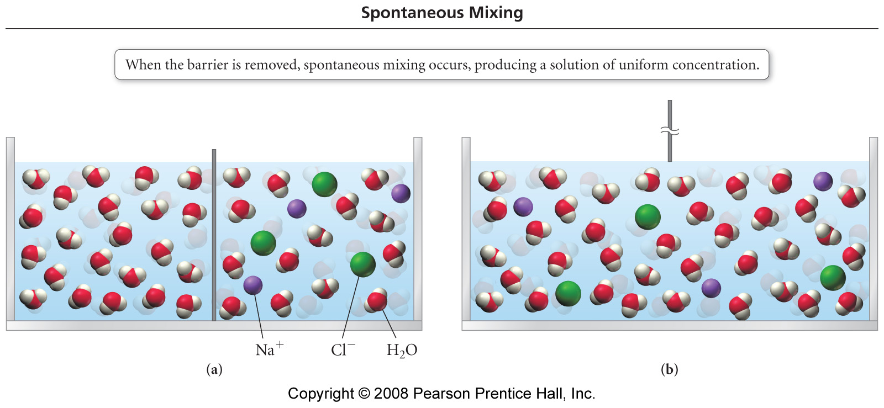

Why do the solutions mix, what’s the ‘pay off’?

 | On a molecular level the final solution is more ‘randomized’ (has more ENTROPY*). Chemical systems that possess a higher degree of entropy are more thermodynamically stable. ‘Nature likes stable’!
*More on Entropy in Chemical Thermodynamics

OK, back to it….

 | Based on your current knowledge (recall the intermolecular forces work from CHM 101), simply explain why certain classes of compounds will or will not dissolve in water.  Hint: ‘like dissolves in like’ - old chemistry saying*

*Recall the ‘ions’ slide, plus basic details on solutions (see Appendix).

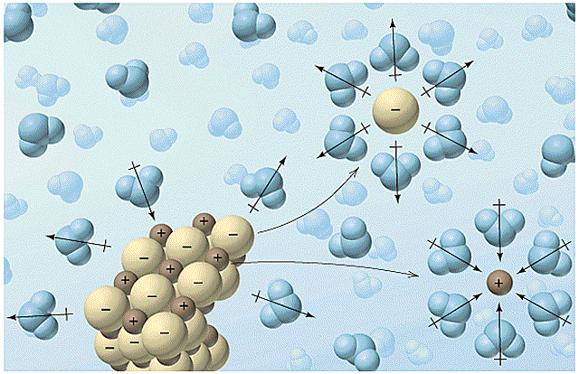
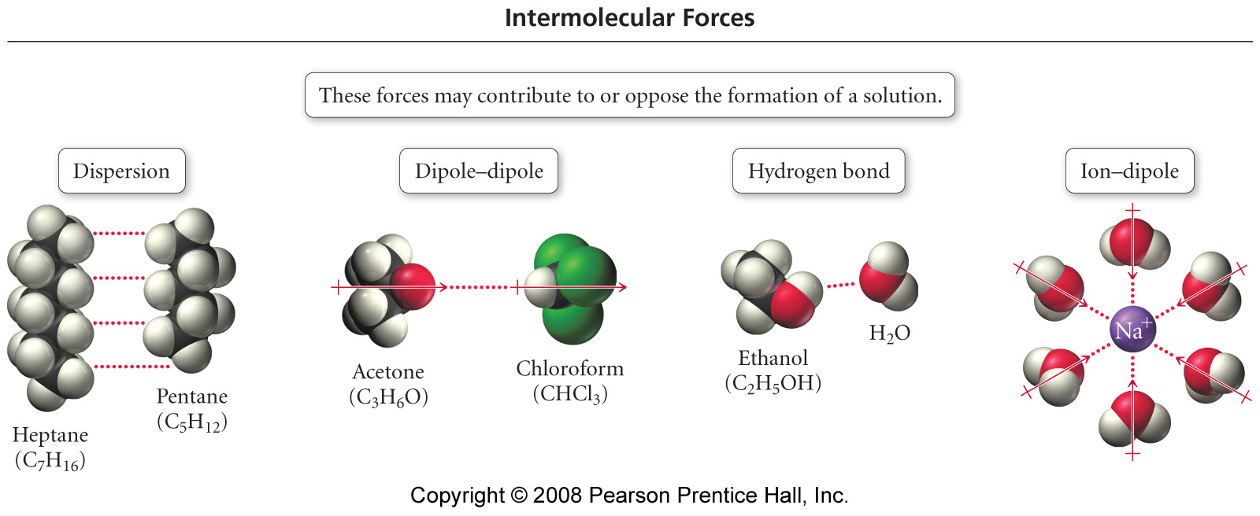

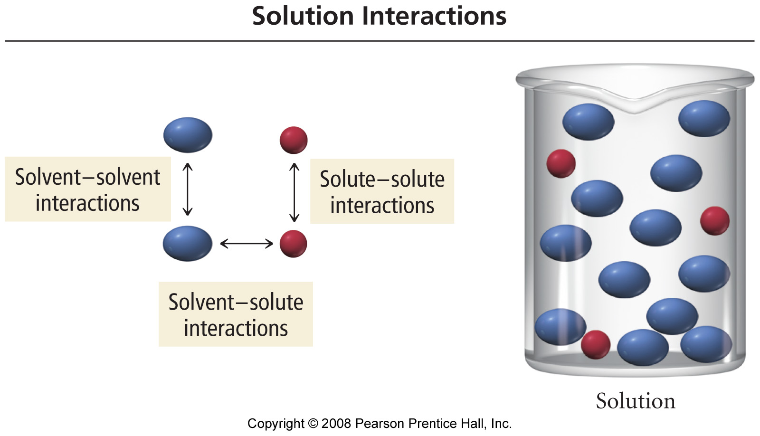

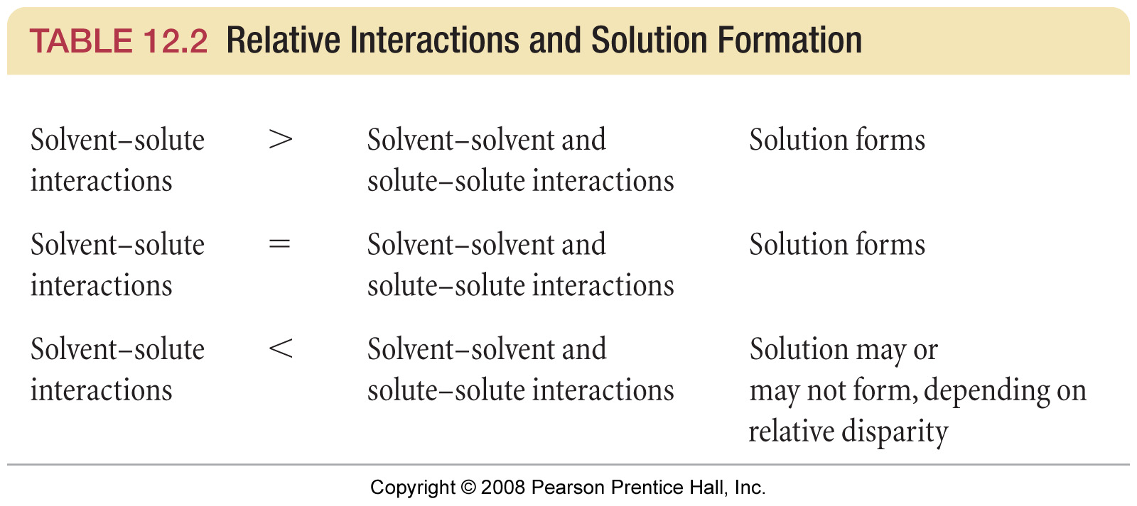
Task: predict whether the following pairs of compounds are soluble, insoluble, miscible or immiscible. What’s the difference??

Mixture | Details
Salt (NaCl) with water
Sugar with water
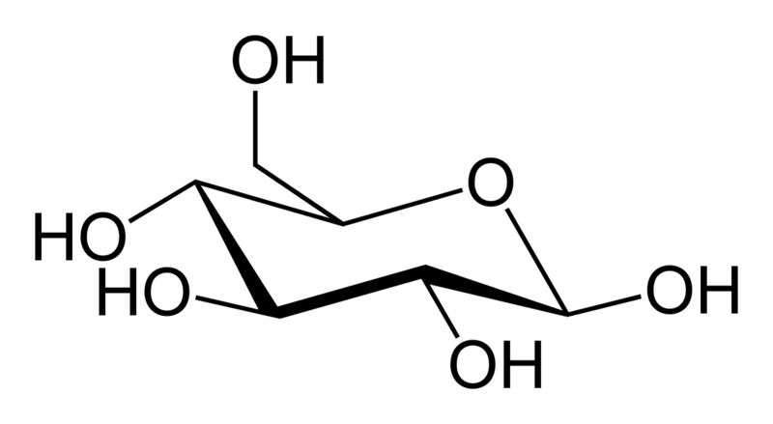
Sugar with hexane
Hexane with water
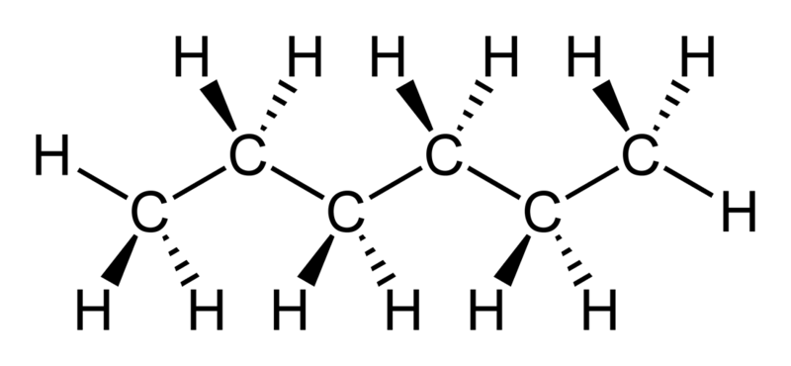
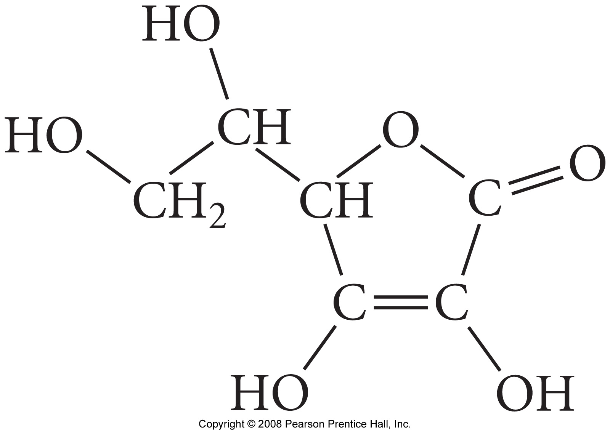
Vitamin C with water
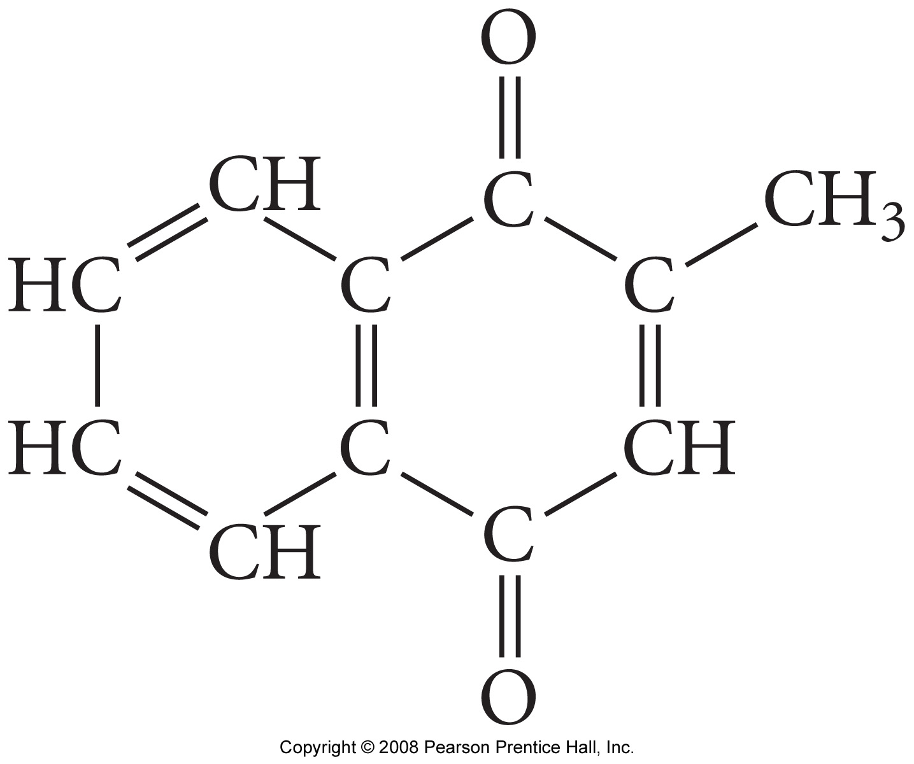
Vitamin K₃ with water

Summary: Recall that ‘Nature likes stable’! Or, in other words, the ‘winner’ (in terms of the relative strengths of respective intermolecular force combinations) typically determines whether the solute /solvent pair are soluble or insoluble.

Solution Energetics

Recall from the CHM 101 Thermochemistry material that a difference in stored chemical potential energy (∆H) – i.e. the change in the amount of energy stored within chemical bonds when reactants → products in a reaction is either released (exothermic) or absorbed (endothermic) as an equivalent amount of heat energy (q). This leads to the First law of thermodynamics:

-∆H = +q (exothermic reaction)

 | A similar approach can be applied to the formation of solutions, and (similarly) be represented in terms of familiar enthalpy (Hess’ Law) relationships and diagrams

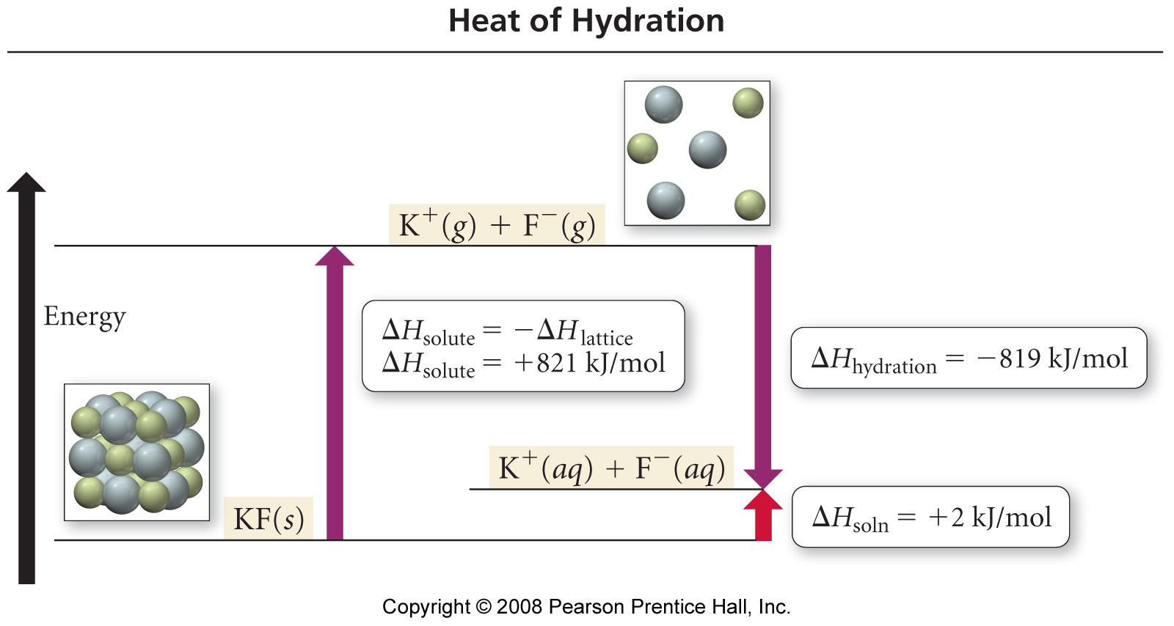
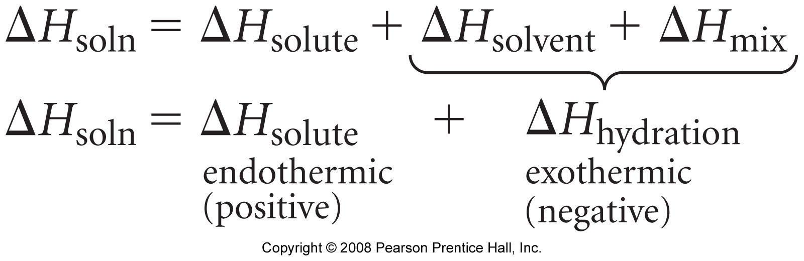

Task: Prove it to yourself; calculate ∆H_{soln} using the ∆H_{solute} and ∆H_{hydration} values listed above.
Factors Affecting Solubility

Or, in other words, stuff you already know from everyday observation……

Temperature

How are the solubility of solids and gasses typically affected by an increase in temperature?

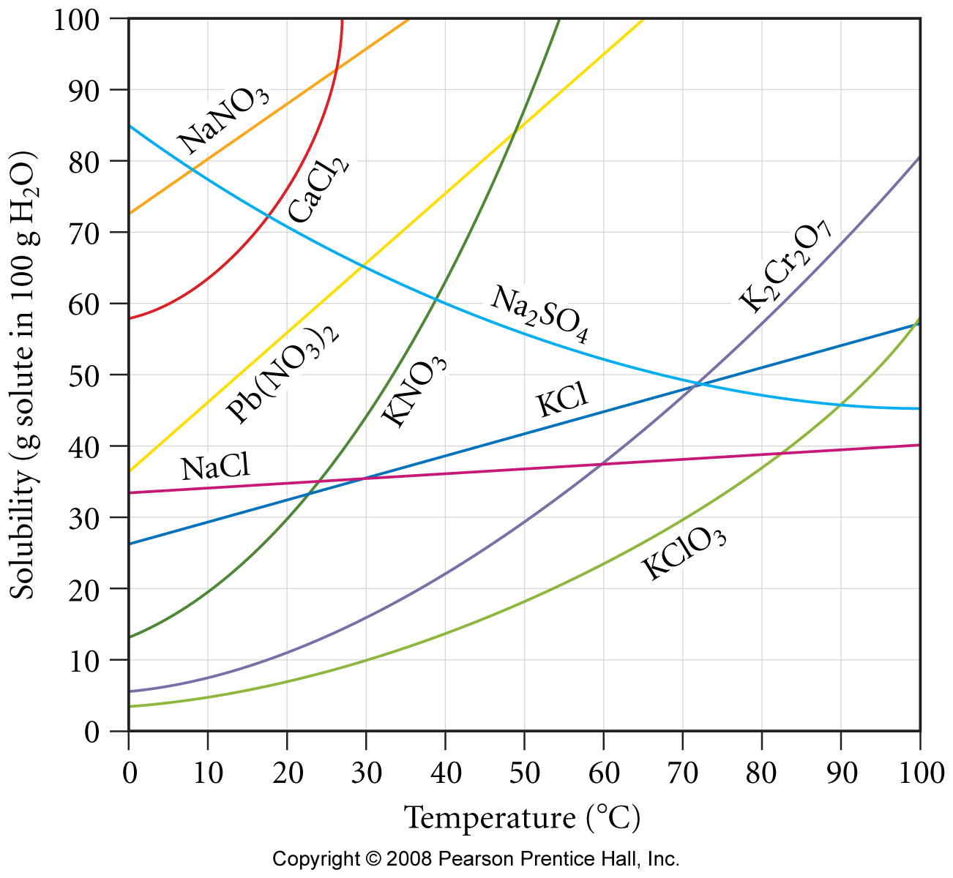 | Solids:

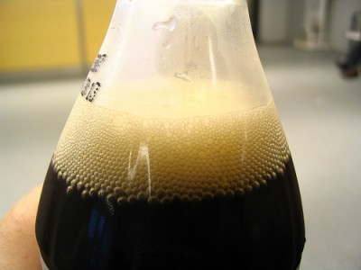 |   Gasses:

Pressure

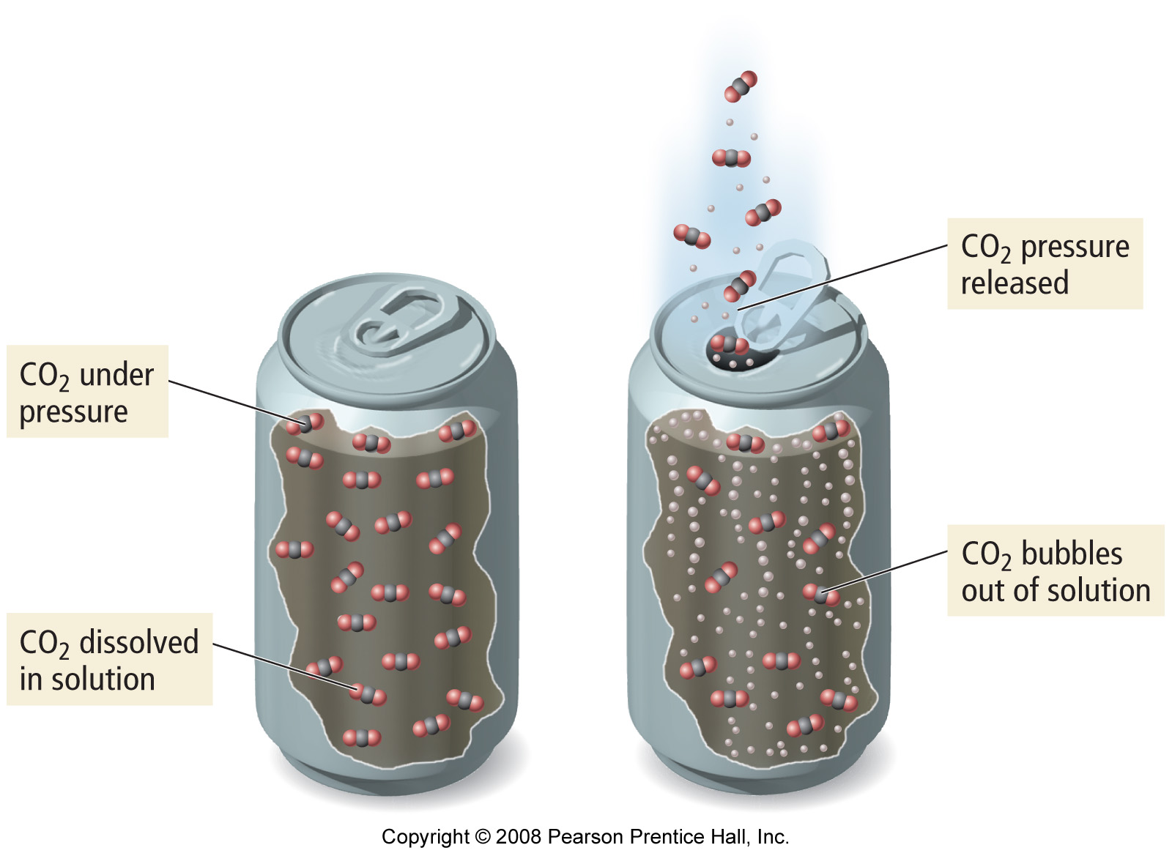 | 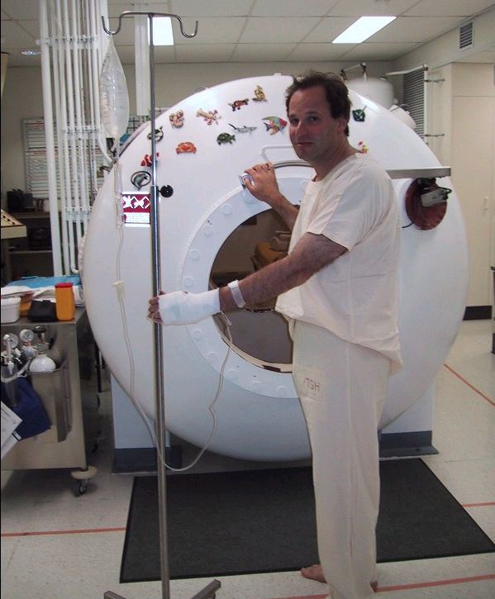 | How is the solubility of a gas affected by an increase or decrease in pressure?

Expressing Solution Concentration

Overview: There are four ways of expressing the concentration or ‘strength’ of a solution – Molarity (M, mols/L), % mass, ppm (parts per million) and Molality (mols/kg). It is important to know how to determine and convert between these concentration types.

Familiar Units – Molarity and % mass

1. Molarity:

Molarity* (M) = number moles of solute per Liter of solution
* The Molarity (mol/L conc.) is most often printed on lab reagent solution bottles, e.g. 9.0 M H₂SO₄ (aq)

i.e. Molarity = | Moles Solute | Units: mol/L or just M
 | Liters Solution

Example: What is the concentration (molarity, M) of a solution made by dissolving 25 g of NaCl in water and making the final volume of the solution equal to 750 mL?

2. % Mass

% Mass = | Mass Solute | x 100 % (units of %)
 | Mass Solution

Example: What is the % mass concentration of an NaCl in a solution made by dissolving 25 g of NaCl in water and making the final volume of the solution equal to 750 mL? Assume the final solution has a density of 1.15 g/mL

New Units – ppm and Molality

Discussion: Why learn these new unit types? What are they used for?

3. ppm (parts per million)

The ppm unit is simply a mass ratio: ‘grams per million grams’, i.e. there is a ‘difference factor’ of 10⁶ between mass solute and mass solution. A better way to express this would be mg solute per kg solution

Parts per million = ppm = mg solute per kg of solution

i.e. ppm = | mg solute | Units: ppm or mg/kg
 | kg solution

Regular molarity (mol/L) concs can be easily converted to ppm if the density of the solution is known. Recall that mass = density x volume

Example: What is the ppm concentration of NaCl in a solution made by dissolving 25 g of NaCl in water and making the final volume of the solution equal to 750 mL? Assume the final solution has a density of 1.15 g/mL

- Find mass solution

- Divide mass of solute (in mg) by mass solution (in kg)

4. Molality:

m = Molality = number moles of solute per kg of solvent

i.e. molality = | Moles Solute | Units: mol/kg or m
 | kg solvent

Example: What is the molality of an HCl solution that is 36% by mass?

When presented with a % mass concentration, assume that you have 100 g of this solution. The % mass of solute is than the same numerical value as the mass (in g) of solute in the solution

Mass solute =

Mass SOLVENT =

Molality of solution

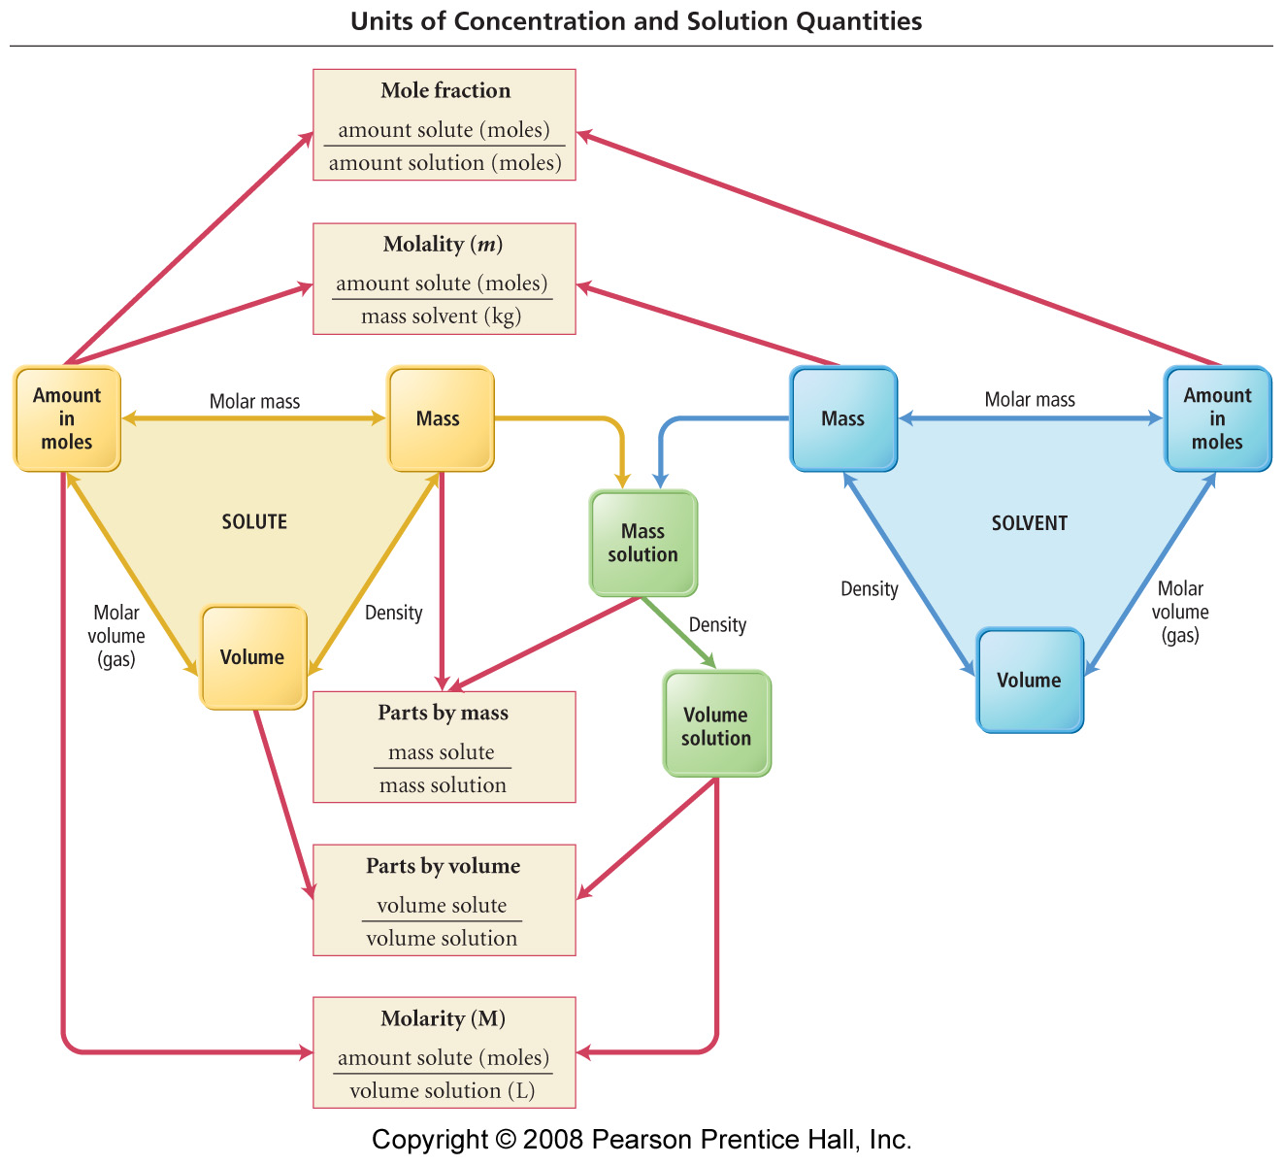

Colligative Properties

Definition: A property of a solution that only depends on the number of particles dissolved in solution (i.e. concentration), not the type of particle or their respective chemistries (ions, molecules etc.)
Application 1: Boiling Point Elevation / Freezing Point Depression

Discussion: Why is salt added to pasta water, why is salt spread on the roads in winter?

The change in bpt. or fpt. (ΔT) of a solution is proportional to its molality. Bpt. elevation and fpt. depression are colloidal properties – they depend only on the number (molality) of solute particles disrupting intermolecular forces between the solvent molecules. It is the solvent’s bpt or fpt that is affected.

Equations

Bpt. Elevation  ΔT = K_{b} m |  | Fpt. Depression  ΔT = K_{f} m

Where: | ΔT = change in bpt. or fpt. of the solution compared to the pure solvent
 | K_{b} = boiling point elevation constant for the solvent
 | K_{f} = freezing point depression constant for the solvent
 | m = molality of the solution

Water is the most common solvent. Its cryoscopic constants are:

 | K_{b} (H₂O) = 0.51 ºC/m |  |  | K_{f} (H₂O) = 1.86 ºC/m
 |  | Because a difference in either bpt. or fpt (ΔT) is determined, either ºC or K can be used to measure temperature.

 | Example: Calculate the fpt. of a 30 % by mass ethylene glycol (C₂H₆O₂) solution (this is what you probably have in your car, or perhaps in your wine rack)

Ionic Solutes

Unlike molecular solutes (like ethylene glycol), ionic solutes dissociate into more than one solvated particle when dissolved.

Eg: NaCl(s) → Na⁺ (aq) + Cl⁻ (aq) (x2 as many ions in solution)

The higher concentration of solvated particles (ions) in solution must be accounted for in elevation / depression problems

Example: What is the boiling point of a solution that has a 2.5 m NaCl conc? What about 2.5 m CaCl₂ (sold as ‘Quick Melt’)

Recall: Phase Diagrams

A Phase Diagram relates the physical state (s, l, g) of a material to pressure and temperature conditions.

Generic Phase Diagram (see appendix)
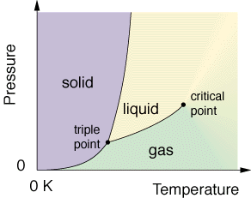

Features of the Graph

Boiling point (l ↔ g) | Triple point
Freezing point (s ↔ l) | Critical point
Sublimation Point (s ↔ g)

Discussion: How would the phase diagram of water be affected if some NaCl was dissolved in the water being studied? Hint: Think about the effects of bpt. and fpt. changes.

Phase Diagrams for an NaCl (aq) solution (see appendix)

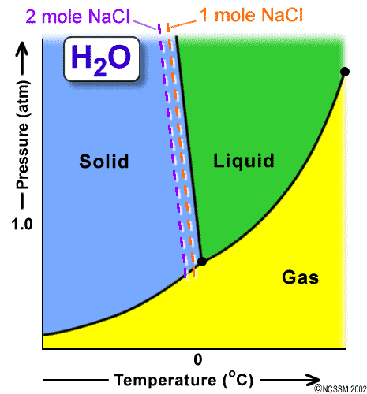 | 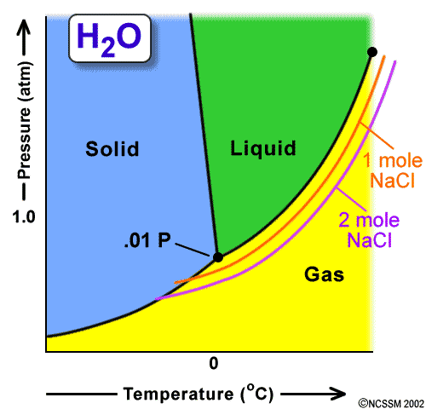

Application 2: Vapor Pressure Lowering

Vapor Pressure = pressure of a gas ‘above’ a liquid when the two are in dynamic equilibrium*
*more on this in the Equilibrium packet, also recall Ch.11.

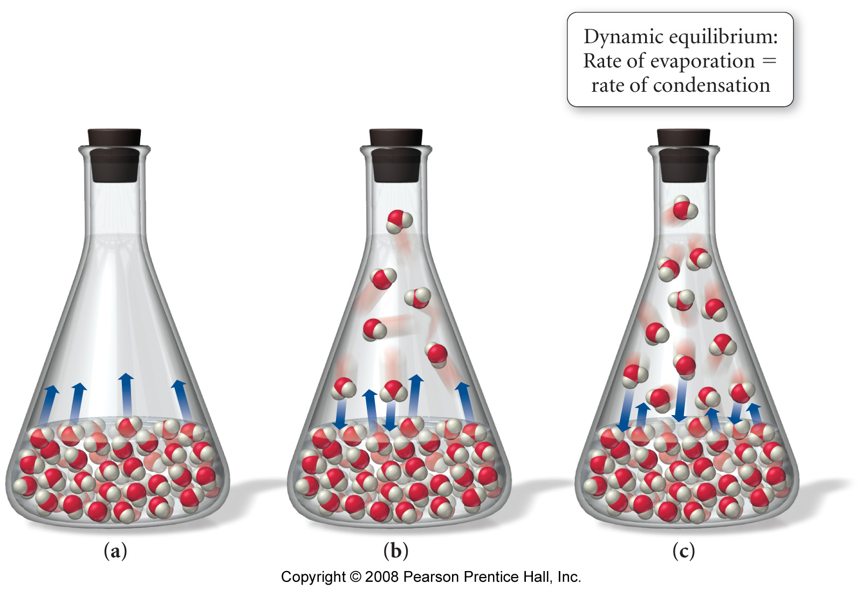 | 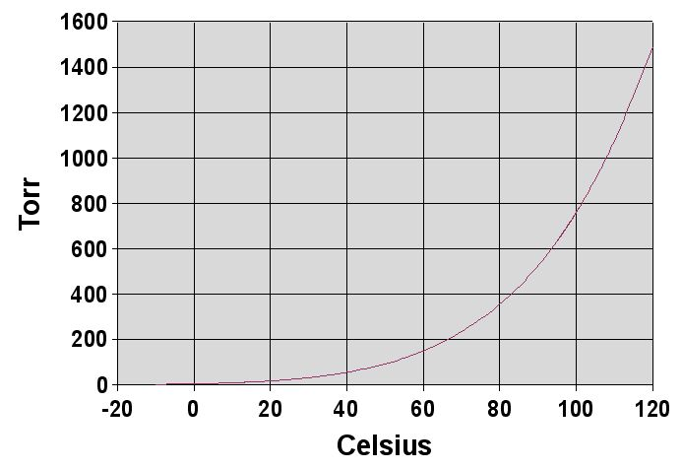

Think of vapor pressure like humidity – there is always a fixed amount (partial pressure) of gaseous material ‘above’ any liquid (in a closed container) at a specific temp – recall the CHM 101 ‘humidity’ plot… What is the vapor pressure of water at 100ºC?

 | Think about it. Does the vapor pressure / equilibrium idea help to explain why clothes on a washing line dry faster on warm and windy days??

Raoult’s Law Definition: (Recall partial pressure work from CHM 101)

- Volatile solutes (e.g. ethanol, benzene)

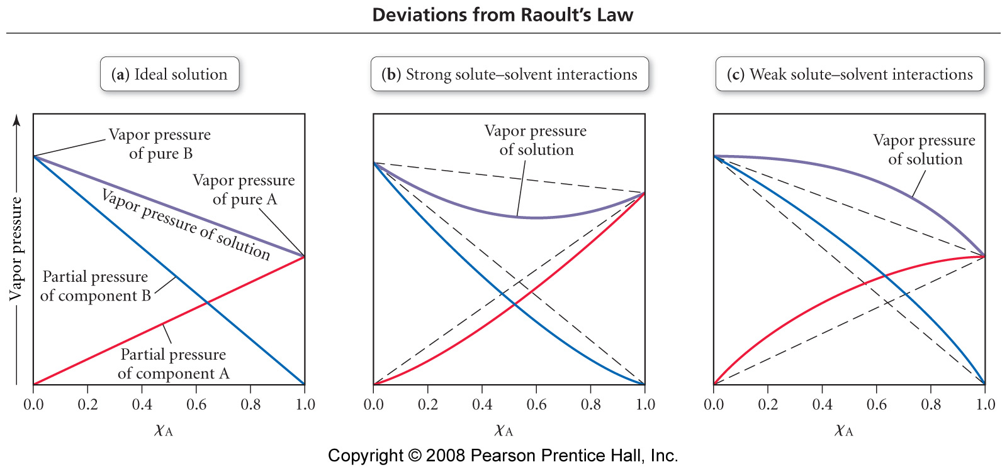 | ‘Using words’  1.  2.
‘Using math’  1. | 2.

Worked Example (HWK 12.73): A solution contains 50.0 g heptane (C₇H₁₆) and 50.0 g of octane (C₈H₁₈) at 25ºC. The vapor pressures of pure heptane and pure octane at 25ºC are 45.8 Torr and 10.9 Torr, respectively. Assuming ideal behavior, calculate:

- The vapor pressure of each of the solution components in the mixture

- The total pressure above the solution

- The composition of the vapor in mass percent

Recall that p ∝ n, and then let 1 mole. = 1 torr

- Why is the composition of the vapor different than that of the solution

Deviating from Raoult’s Law

Solutions do not necessarily follow IDEAL (i.e. pure solute or solvent) behavior with regard to their Vapor Pressure v Composition plots – this is called deviating from Raoult’s Law.

Discussion: What microscopic events would cause a deviation from Raoult’s Law, i.e. the vapor pressure for the solution to become greater or less than the partial pressure contributions expected from its pure components?

Positive Deviation | Negative Deviation
Ans: | Ans:

Summary

- Non-Volatile solutes (e.g. sucrose, table salt)

Since non-volatile solutes will not generate a respective vapor above the mixture, only the solvent (now with a reduce mole fraction) will generate a slightly reduced, (compared to its pure state) vapor pressure.

Worked Example: Calculate the vapor pressure at 25ºC of a solution containing 95.5 g sucrose (C₁₂H₂₂O₁₁) and 300.0 mL water. The vapor pressure water at 25ºC is 23.8 Torr, assume density H₂O = 1.00 g/mL

Plan:

Execute:

Task: Calculate the vapor pressure at 25ºC of a solution containing 55.3 g ethylene glycol (C₂H₆O₂) and 285.2 mL water. The vapor pressure water at 25ºC is 23.8 Torr, assume density H₂O = 1.00 g/mL.

Recall that for ionic solutions, the concentration of colloidal particles in solution is ‘multiplied out’ by the number of ions of the formula unit. Be sure to remember this when answering questions pertaining to ionic solutes.

e.g. Since NaCl(s) → Na⁺(aq) + Cl⁻(aq) ( i ≈ 2), the effective concentration of particles in 0.20 M NaCl (aq) is…

 | 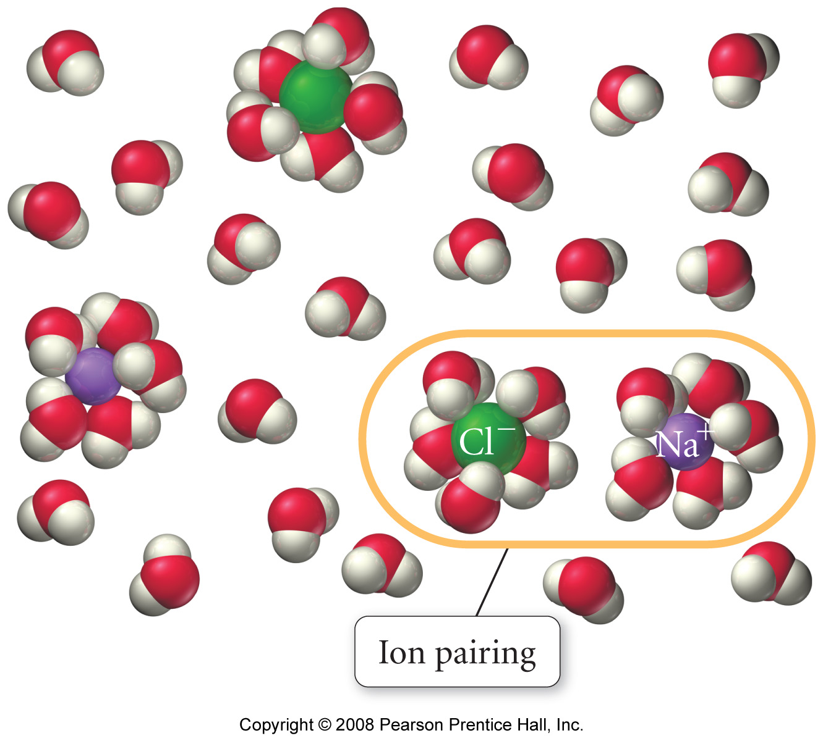 | *see appendix for measured i values

Application 3: Osmotic Pressure

 |  | Discussion: Please explain the joke / observation that: “I’m learning through osmosis”  Scientific hint: recall the earlier discussion about mixing solutions

Observation: ‘Seawater and Hangovers’

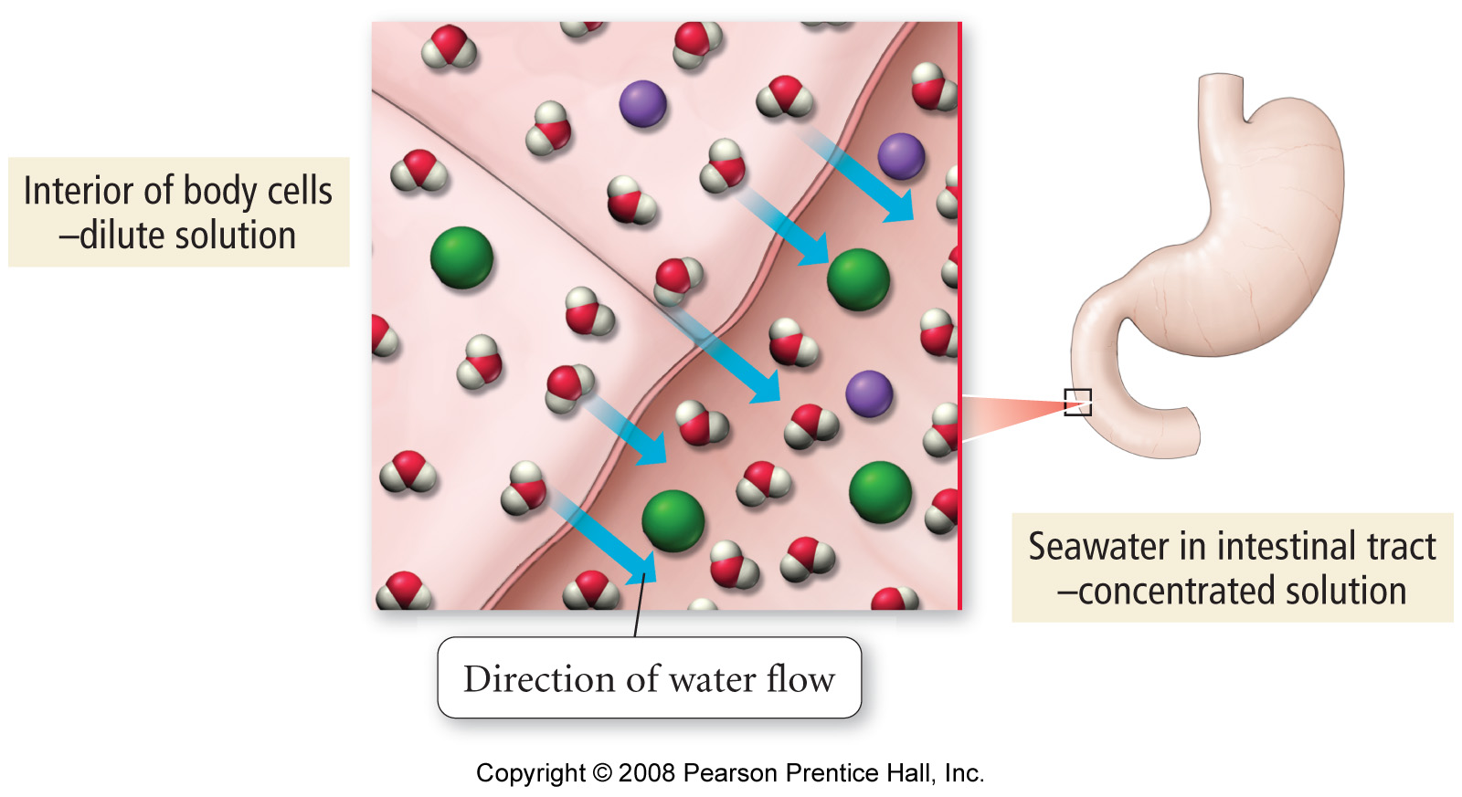

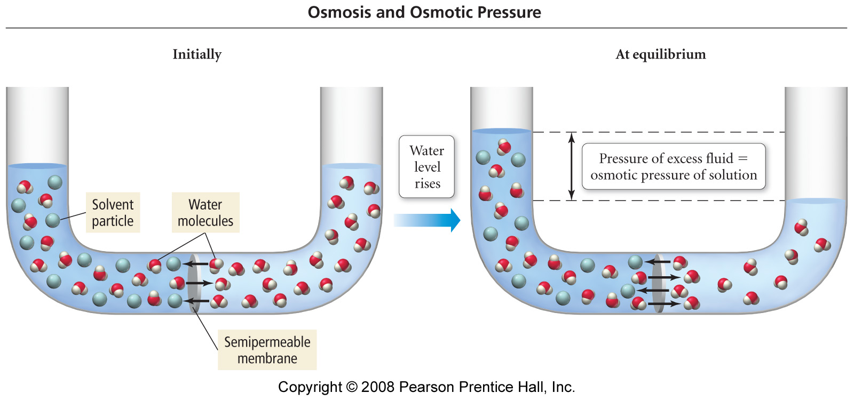
Osmotic Pressure Math

Π = iMRT

Where: | Π = osmotic pressure
 | i = number of ions per formula unit (ionic solutes only)
 | M = Molarity (mol/L)
 | R= gas constant (0.0821 Latm/mol K)
 | T= temp in K

Worked Example: The osmotic pressure of a solution containing 5.87 mg of an unknown protein (per 10.0 mL of solution) was 2.45 Torr at 25ºC. Find the molar mass of the protein.

Extra credit (2 points): Type a brief (less than 100 words) report detailing how reverse osmosis works. Include at least one diagram.

 | ““Bloody Solution”  The following question was taken from your 1st practice midterm:

Question 5 (30 points): Calculate the osmotic pressure of a solution containing 20.5 mg of hemoglobin in 15.0 mL of solution at 25ºC. The molar mass of hemoglobin is 6.5 x10⁴ g/mol.

Appendix

Chem. 101 Review Material: Strong, Weak and Non-Electrolytic solutions
Strong Electrolytes: Salts

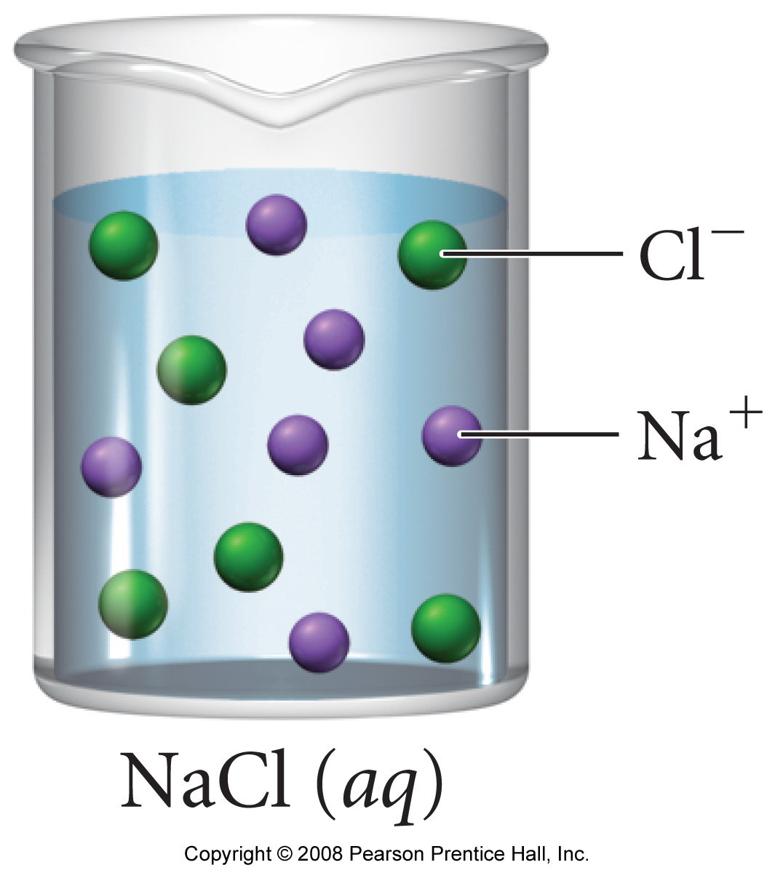 | Strong electrolytes are formed from the dissolution of SALTS (e.g. NaCl), which typically undergo complete (100%) dissociation
  Strong electrolytes contain very large numbers of dissociated ions when dissolved

Weak Electrolytes: Molecular acids

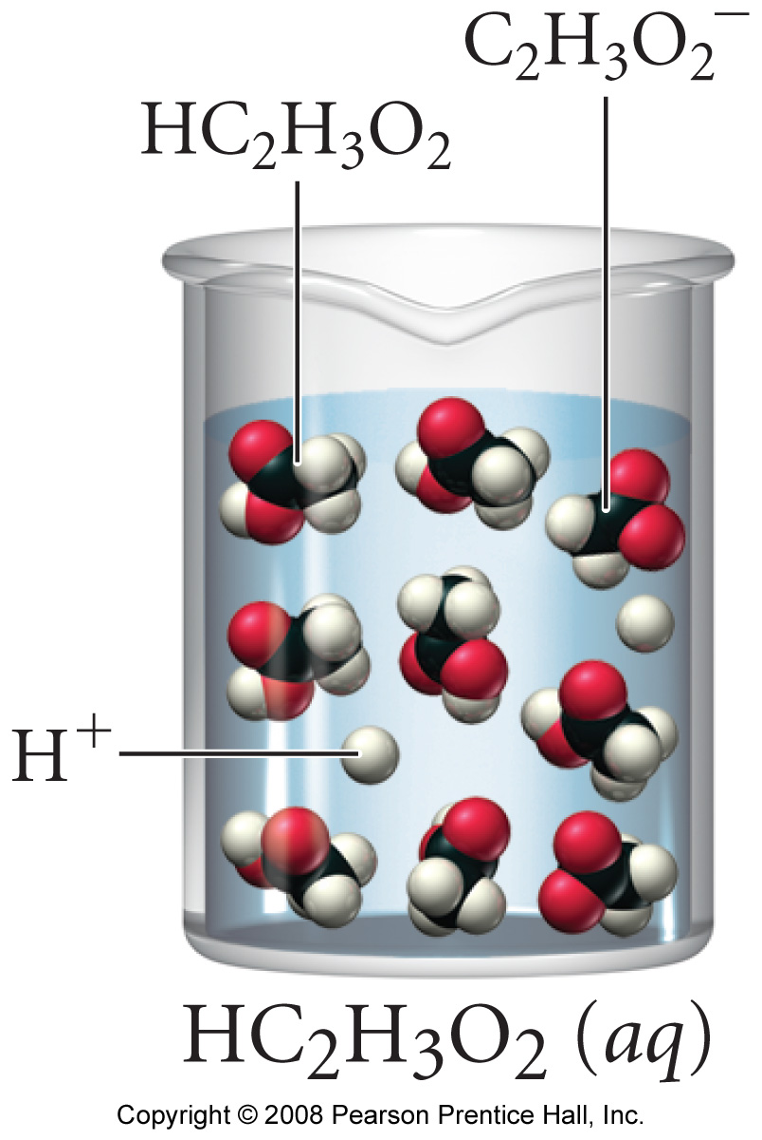 | Weak electrolytes are formed from the dissolution of MOLECULAR ACIDS (generic formula HA, e.g. H(C₂H₃O₂) or HCl), which typically undergo partial (<100%) dissociation
  Weak electrolytes contain ‘smaller’ numbers of dissociated ions when dissolved

Non Electrolytes: Molecular Materials

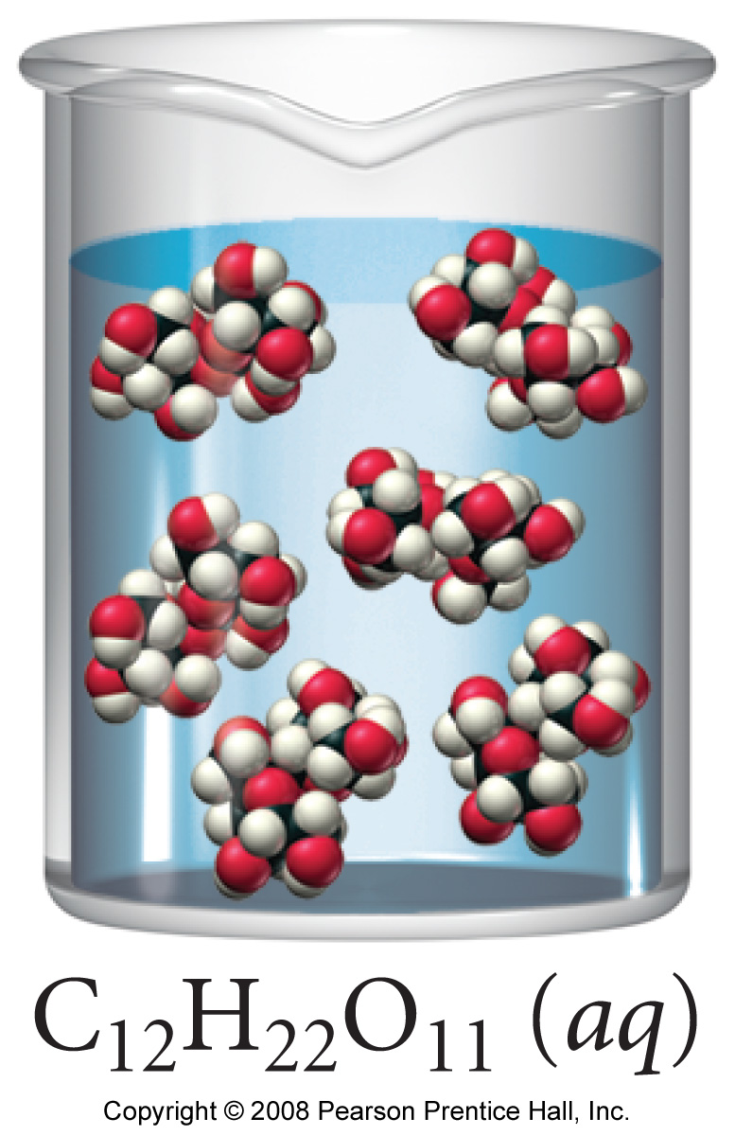 | ⇒ Since non-electrolytes do NOT contain ions they must be MOLECULAR. As it cannot dissociate, molecular material remains INTACT when it dissolves (see below comparison)
  Non-electrolytes contain NO dissociated ions when dissolved, so CANNOT conduct electricity.

Comparison of (a) ionic and (b) molecular dissolution processes
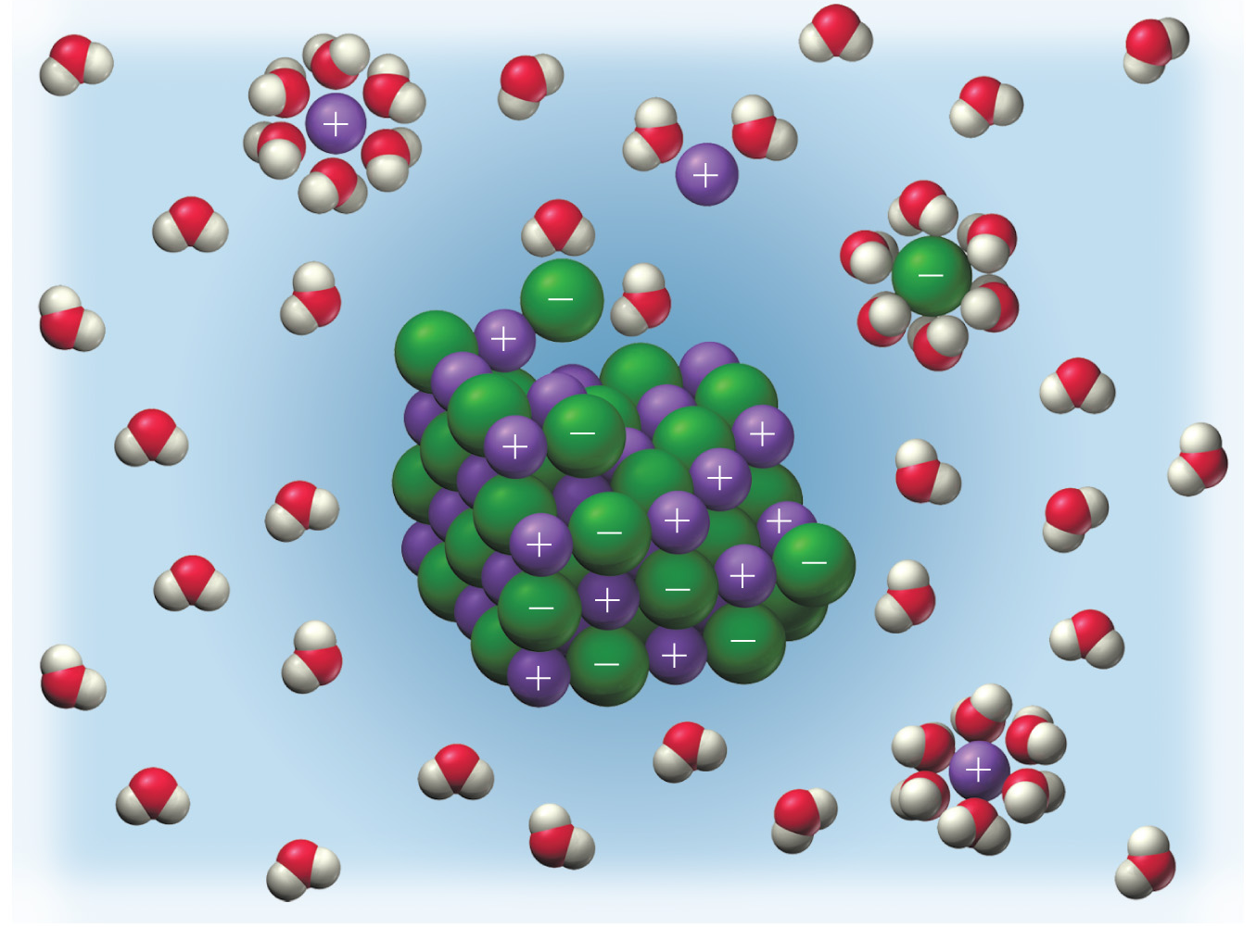 | 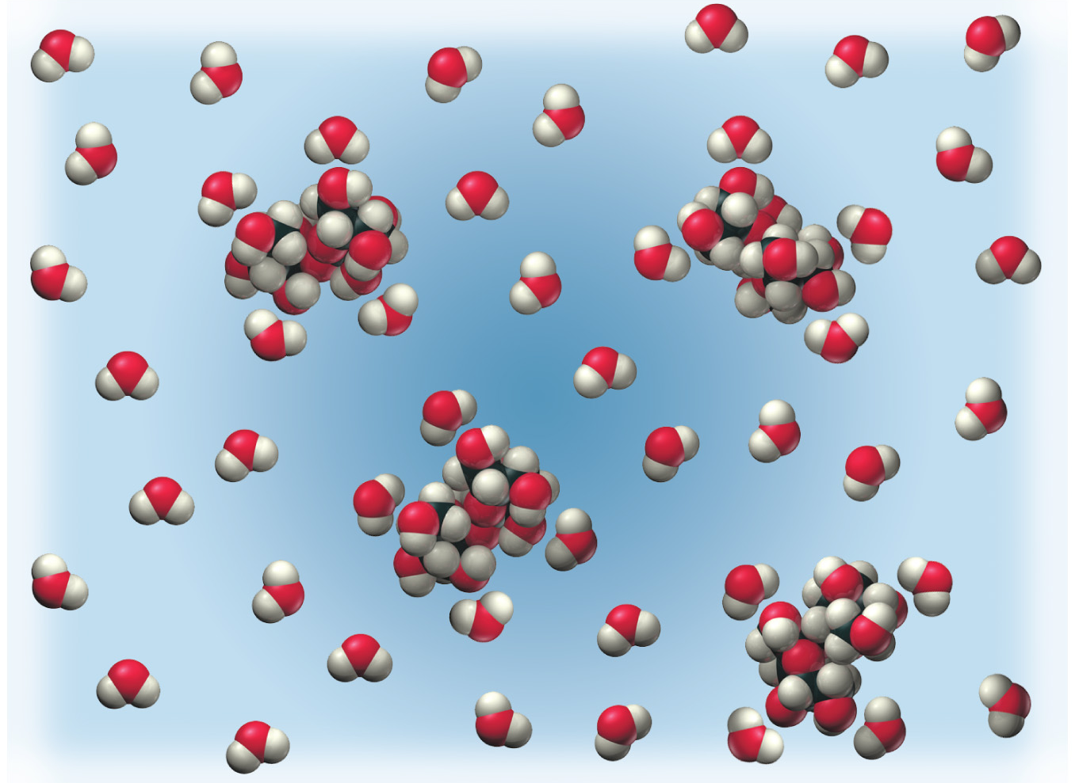
NaCl(aq) | ‘Sugar’ (C₁₂H₂₂O₁₁ (aq))



