Chemical Composition

Reading: | Ch 8 sections 1 - 9  Ch 9 sections 1 - 6 | Homework: | 8.2 questions 6, 8  8.3 questions 10*, 12, 14, 20*,22*  8.4 questions 28*, 30, 32*, 34, 38, 40*  8.5 questions 30, 32*, 34*, 36, 40*  8.6 questions 46, 50,  8.8 questions 58*, 60*, 78*, 80  9.3 questions 20, 22*, 24, 26*, 30*, 32*  9.5 questions 42, 46, 56
* = ‘important’ homework question

Solve the following everyday questions using ‘supermarket’, or (better still) ‘conversion factor’, math:

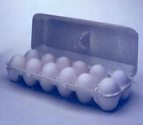 | Question: If a dozen eggs weigh 1.50 pounds, then how many dozen eggs weigh 30.0 pounds?

Question: How many single eggs are there in 30.0 pounds of eggs?

 | Solving chemistry problems that involve converting between numbers of molecules and gram weights uses EXACTLY the same concepts as the above egg problem.  Pounds of eggs ↔ Dozens of eggs ↔ Number of eggs
The Mole

 | Just like the dozen, the MOLE is just a number that represents a bigger number. Since atoms and/or molecules are very small (i.e. to see a collection of atoms, say in your hand, you need a lot of them), the mole is a VERY large number :  1 dozen = 12 things (eggs) 1 mole = 6.02 x 10²³ things (atoms)

Task: To get an idea about how many atoms there are in a mole of atoms, write 6.02 x 10²³ as a regular number:

1 mole = _____________________________________________________

Note: The mole is sometimes called Avogadro’s number (N_{A}), so:

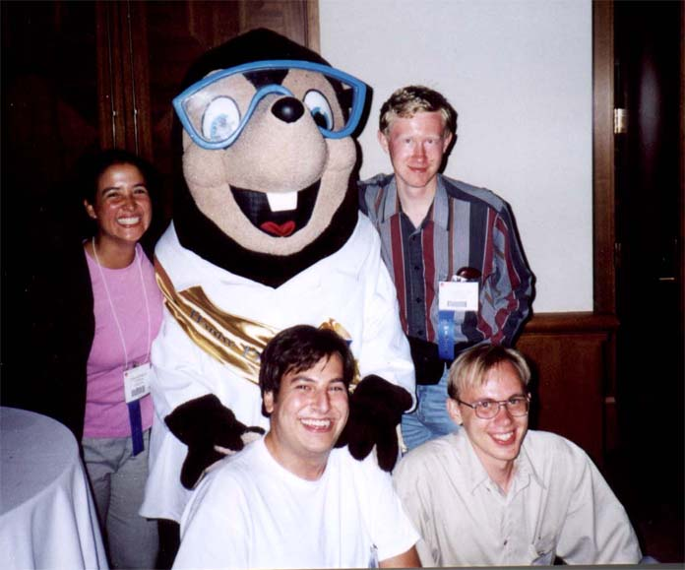 | 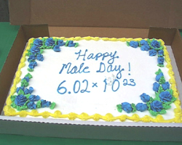 | 1 mole = N_{A} = 6.02 x10²³ things

Nerd stuff: When do you think some chemists celebrate mole day?

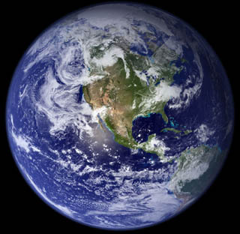 | Question: If the population of the world is 5.7 billion (5.7 x 10⁹) people, how many moles of people is this? Hint: this is a conversion problem.

Discussion: Why is the mole (N_{A} = 6.02 x10²³) such a ‘strange’ number? Why not just 1 x 10²⁰ or something?

&
Task: Use the periodic table and the previous information to determine the following quantities:

Convert between grams, moles and number of atoms SEPARATELY using atomic mass values (Periodic table) and Avogadro’s number respectively.

Grams ↔ Moles ↔ Number of atoms

- The mass of 2.0 moles of carbon atoms

- The number of moles of carbon atoms in 6.0 g of C

- The number of gold atoms in 2.0 moles of Au

- The number of moles of lead (Pb) atoms in 35.5 grams of lead.

- The number of Pb atoms in 35.5 grams of lead

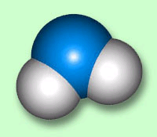 | Question: What is the mass in amu of 1 molecule of water (H₂O).What is the mass of one mole of water molecules in grams?

Recall that a molecule is the ‘sum of its parts’ (atoms). Thus, simply add the masses of all the atoms in a molecule to find the molecule’s FW in amu, OR the mass of 1 mole of molecules (MOLAR MASS, M) in grams. THIS IS THE POWER OF THE MOLE(!)

Note: The units of Molar mass (M) are grams/mole (i.e. the number of grams in 1 mole of material).

Task: Calculate the Molar masses (M) of the following compounds:

Carbon dioxide:

Diphosphorous pentoxide:

Calcium chloride:

Just like with atomic masses, Molar masses can be used to convert between grams, moles and number of molecules.

Grams ↔ Moles ↔ Number of molecules

Worked Example: How many molecules of sugar (C₆H₁₂O₆) are there in a 2.15 gram packet of sugar?

Plan: Write down what you are given and what you can immediately figure out:

Mass sugar = 2.15 g

M C₆H₁₂O₆ = 6C + 12 H + 6 O
= 6(12.011 g/mol) + 12(1.01g/mol) + 6(16.00 g/mol)
= 180.2 g/mol

Use the conversion factor of 1 mol C₆H₁₂O₆ = 180.2 g to find # moles sugar in 2.15 g of sugar:

2.15 g x | 1mol | = 0.0119 mols
 | 180.2 g

Use the conversion factor of 1 mol = 6.02 x 10²³ molecules to find # molecules of sugar in 0.0119 mols. (2.15 g) of sugar:

0.0119 mol x | 6.02 x 10²³ molecules | = 7.16 x10²¹ molecules
 | 1 mol

Remember: You CANNOT convert directly from grams to number of molecules. i.e. YOU MUST ALWAYS GO THROUGH MOLES:

Grams ↔ Moles ↔ Number of molecules

Things to remember:

Key relationships:

FW = sum of all atomic masses in a SINGLE molecular formula
(amu/molecule)

M = sum of all atomic masses in any SINGLE molecular or ionic
formula (grams/mole)

M = | number grams material
M = | number moles of material

1 mole = 6.02 x10²³ particles

FW and M have identical numerical values but DIFFERENT units

You can write a conversion pyramid showing the relationship between M, g and mols!

The relationship between M, #grams and #moles is THE most frequently used equations in chemistry? Why?

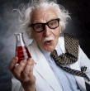 | Answer:

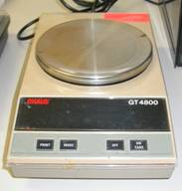 | Observation(!):

Task: Determine the following quantities:

- The number of moles of oxygen molecules in 5.0 g of oxygen gas

- The weight in grams of 2.5 moles of P₂O₅ (s)

- The number of water molecules in 330 grams of pure water

- The mass in grams of 5.0 x 10²⁴ molecules of CO₂ (g)

The Molar Volume

One mole of ANY gas occupies 22.4 Liters at STP (standard temperature and pressure, 0ºC, 1 atm.). This has two significant consequences:

1 mole = 22.4 L at STP for ANY gas

Gas Volume ↔ Moles ↔ Number of particles

Task: Use the above information to determine the number of atoms of He (g) in a party balloon of volume 35.6 L (assume STP).

 | 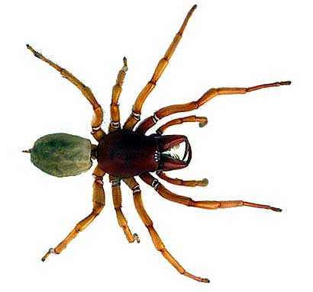 | Let’s start the spider……

Applications

A. Determining Empirical and Molecular Formulas

Recall the definitions of molecular formula and empirical formula:

Molecular Formula: the actual number and type of atoms in a compound, e.g. hydrogen peroxide = H₂O₂

Empirical Formula: the lowest whole number ratio of each type of atom in a compound e.g. hydrogen peroxide = HO

Task: Complete the following table

Name | Molecular formula | Empirical formula
Dinitrogen tetroxide

Benzene | C₆H₆
Butane | C₄H₁₀
Tetraphosphorous decoxide | P₄O₁₀

Note: Empirical formulas most often pertain to molecular / covalent compounds, as ionic compounds’ formulas are typically in their lowest ratio to begin with (i.e. a sample of NaCl (s) contains many more than two ions!)
Worked Example: A 1.271 g sample of Al(s) was allowed to react with chlorine. The mass of aluminum chloride produced was 6.280 g. Determine the empirical formula of aluminum chloride.

Recall that the Empirical formula is the lowest whole number ratio of each type of atom in a compound ⇒ find the moles of each type of atom and then find their ratio.

Step 1. Write an unbalanced chemical equation (do not assume balancing numbers or formulas for these problems). Find the mass of the missing reactant by applying the conservation of mass law.

Al + Cl → Al_{x}Cl_{y}

1.271 g 6.280 g

Step 2. Find the moles of each reactant using the atomic masses from the periodic table.

Moles Al =

Moles Cl =

Step 3. Substitute the # moles determined for each type of atom in the product’s empirical formula.

Al Cl

Step 4. Find the lowest whole number ratio of each type of atom in the empirical formula. This is the final answer.

Al Cl

Finding the molecular formula from the empirical formula

Recall that the molecular formula is some whole number of times larger than the empirical formula (e.g. H₂O₂ compared to HO (x2)).

⇒ the molecular formula will be ‘heavier’ than the empirical
formula by the same factor (x2)

Task: Work out the molecular masses of H₂O₂ and HO. What is their ratio?

M _{H2O2} = |  | M _{HO} =

Ratio =

Find the ratio of the molecular formula to the empirical formula – this information tells you how much ‘bigger’ the molecular formula is than the empirical formula.

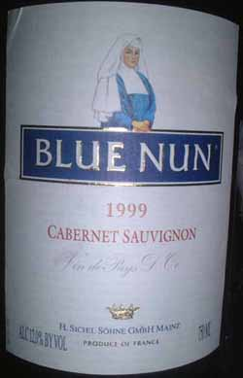 | Worked Example: Ethylene glycol contains 38.7 % C, 9.7 % H and 51.6 % O. Calculate the empirical and molecular formula of ethylene glycol given its molar mass = 60 g/mol (60 amu/molecule)

When given the % by mass values of each atom in a compound assume a 100 g sample – the % and g values are then the same.

B. ‘Slides and Ladders’ – finding theoretical yield and % yield

Important Definitions:

Theoretical Yield: The amount of product, in grams, expected (calculated) for a reaction.

Actual Yield: The amount of product, in grams, recovered (weighed) for a reaction.

% Yield : | % Yield = | Actual Yield | x 100%
 |  | Theoretical Yield

Discussion: Are theoretical and actual yields ever the same (i.e. does % yield = 100%) in practice? What factors influence the % yield?

Finding the Theoretical Yield using ‘Slides and Ladders’

 | Worked Example: If 5.00 g of Propane (C₃H₈(l)) is combusted in excess oxygen gas, what mass of water is expected to be formed? What mass and volume of CO₂ (g) (at STP) would you expect to collect?

Step 1. Write a balanced Chemical Equation and

[over]
Step 2. Set up g, M and mole ‘ladder’ grid

Step 3. Fill in the ladder grid with as much information as possible – this is typically supplied gram weights and molar mass data.

Step 4. Convert g → moles by ‘climbing’ down ladder(s) (g / M = moles).

Remember: Molar masses are calculated for ONE molecular formula only. I.E. ignore any balancing numbers when figuring out M values

Step 5. Convert moles reactant → moles product(s) by comparing balancing numbers and ‘sliding’ across.

Step 6. Convert moles product(s) → grams product(s) by ‘climbing’ up ladder(s) (moles x M = grams).

Note: moles of gas can be converted to Liters of gas using:

1 mole any gas = 22.4 L at STP

Group Tasks: Determine the following quantities

- What mass of dissolved HCl is needed to completely react 5.00g of CaCO₃(s), according to the following unbalanced reaction? What volume of CO₂(g) is generated at STP?

CaCO₃(s) + __ HCl(aq) → CaCl₂(aq) + CO₂(g) + H₂O(l)

- What mass of magnesium oxide is recovered when 1.56 g of Mg(s) is burnt in air to give MgO(s)? What volume of oxygen gas is consumed during this process (assume STP).

- A student recovers 1.59 g of CaCO₃ (s) from an experiment when they should have produced 2.32 g. What is the student’s % yield for their reaction?

- Task: Complete your lab assignment (Precipitating Calcium Phosphate), if you have not already done so
C. ‘Slides and Ladders’ – Limiting reactant problems

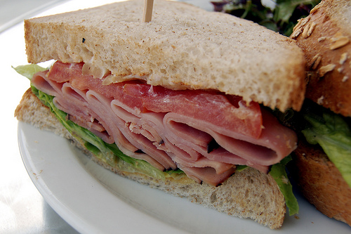 | Analogy: Suppose you are making ham sandwiches. Each sandwich is made from 1 piece of ham and 2 pieces of bread:  i.e.: 1 ham + 2 bread → 1 sandwich

Questions:

How many sandwiches can you make from 5 pieces of ham and 18 slices of bread?

Which ingredient is there too much of (excess, ‘XS’)?

Which ingredient is there too little of (limiting)?

Which ingredient ultimately determines how many sandwiches can be made? Why?

How much of the XS ingredient remains unused?

Similarly…

Recall: Reactants ALWAYS combine in the ratio defined by their respective balancing numbers:

1 AgNO₃(aq) + 1 NaCl(aq) → 1 AgCl(s) + 1 NaNO₃(aq)

i.e. 1 mole of AgNO₃(aq) will react exactly with 1 mole of NaCl(aq)

Problem: It is VERY difficult to add exactly the right ratio of reactants in the lab ⇒

There will be too much of one reactant (the excess (XS) reactant)

There will be too little of one reactant (the limiting reactant)

Discussion questions: If 10 moles of AgNO₃(aq) is added to 15 moles of NaCl(aq), then:

- Which reactant is INXS?

- Which reactant is limiting?

- How many moles of AgCl(s) would be formed?

- How many moles of NaCl(aq) would remain unreacted?

Compare the ‘Ideal’ (from the balanced equation) and the ‘Real’ (given) ratio of reactants to determine which is the limiting reactant (AgNO₃(aq))

Since the LIMITING reactant will run out first, it determines the amount of product that can be formed (as well as the amount of XS reactant that is left behind)

Questions: Work out the mass of each product formed in the following reactions, assuming 10.0 grams of each reactant are initially mixed together.

Use a regular slides and ladders approach, but ‘slide’ across (to find moles of product) using the molar ratio determined by the limiting reactant.

Use conversions factors to find out the number of moles required to react with one of the reactants in ‘NON 1:1 problems’

- AgNO₃(aq) + NaCl(aq) → AgCl(s) + NaNO₃(aq)

- CaCO₃(s) + __ HCl(aq) → CaCl₂(aq) + CO₂(g) + H₂O(l)

D. Concentration of Solutions

Discussion: When you finish this class chances are good you’ll head out to a local bar for a well deserved ‘adult beverage’. Assuming the bar you visit is running a special where you can buy a pint of beer or a pint of wine for the same price, which do you choose and why?

Answer:

Concentration = Molarity (M) = number moles of solute per Liter
of solution

i.e. Molarity = | Moles Solute | Units: mol/L or just M
 | Liters Solution

Where:

SOLUTION = SOLUTE + SOLVENT

Example:

PEPSI =

Task: Think up two more examples illustrating the components of a solution.
Question and Demo: What is the concentration of a solution made by dissolving 2.845 g of sugar (C₆H₁₂O₆) in water and making the final volume up to 150 mL?

Remember that Moles, Concentration and Volume are all related for a solution. Sketch a ‘triangle’ to help you solve concentration problems.

Question: What mass of NaCl is contained within 0.50 L of a 6.0 M NaCl(aq) solution?

Since CV = moles for any solution, concentration (C) and solution volume (V) terms can also be used in ‘slides and ladders’ problems featuring solutions.

Example: What mass of CaCO₃(s) would be completely reacted with 100 mL of 2.0 M HCl? What volume of CO₂ (g) would be collected at STP?

CaCO₃(s) + 2 HCl(aq) → CaCl₂(aq) + CO₂(g) + H₂O(l)
g | C
M | V
mol | mol

The Importance of the mole
Most of the equations we have met in this handout feature # moles as a variable. Thus, moles can in many ways be considered the chemists’ link between macro and micro scale quantities.

Task: Write down as many equations you can featuring the mole. Use this information to construct a flow chart illustrating how all these conversions ‘go through’ moles

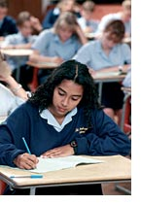 | “Slides and Ladders”  The following question was taken from your 3rd practice midterm:

Question 1 (25 points): For the following unbalanced chemical reaction, determine the quantities listed below (Hint: balance the reaction first):

Fe(s) + O₂(g) → Fe₂O₃(s)

- The mass of iron (III) oxide produced when 2.56 g of solid iron is burnt in excess oxygen gas:

- The number of oxygen molecules consumed in part (a)

Extra Credit: State to which one of the five general classes of reaction the above processes belongs.

