Chemical Foundations – Part 1

Reading: | Ch 4 sections 1 - 7 | Homework: | 4.1, question 4  4.2, questions 8, 10  4.5, question 22  4.6 questions 24, 26, 28  4.7 questions 30, 34, 36*, 38*, 40 (optional)
* = ‘important’ homework question

Atoms and Isotopes

Discussion: In the preceding sections we took a brief look at different types of matter (i.e. elements, compounds and mixtures). These materials are made from smaller matter still – name as many of these fundamental ‘building blocks’ of matter as you can:

Question: How are these fundamental ‘building blocks’ of matter related?

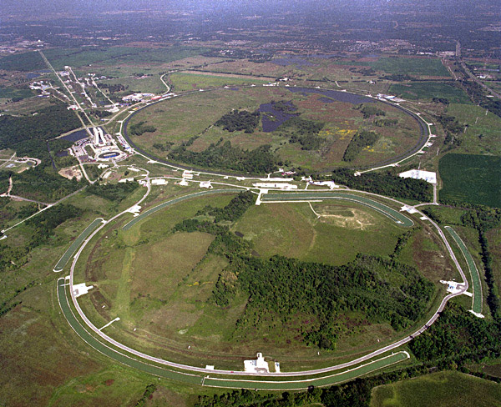 | 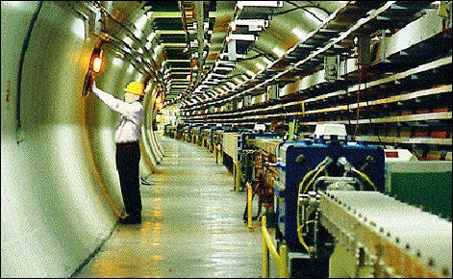 | Fermi Lab, located in West Chicago, IL, is the world’s largest ‘atom smasher*’. Fermi is where scientists perform experiments in an attempt to understand the origins of the universe

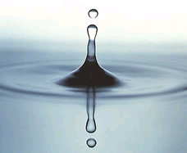 | Example: Water
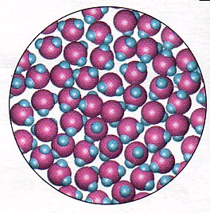 | Example: Water

Structure of the Atom

Fact: Atoms are the smallest type of stable matter, they are typically spherical and have diameters of ~ 0.18 – 0.60 nanometers.

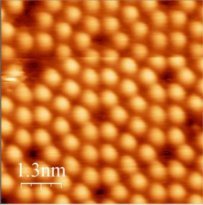 | Shown on the left is an STM image of a silicon chip’s (Si (s)) surface. Note that it has a repeating ‘giant’ structure.  Question: Based on the scale, what is the approximate width of a silicon atom in nm?  Answer:
Ask me about an extra credit assignment

Questions:

- What is at the center of an atom? What is this small central region of an atom called?

- What two different types of subatomic particle are found inside the nucleus? (subatomic means ‘smaller than’ atomic)

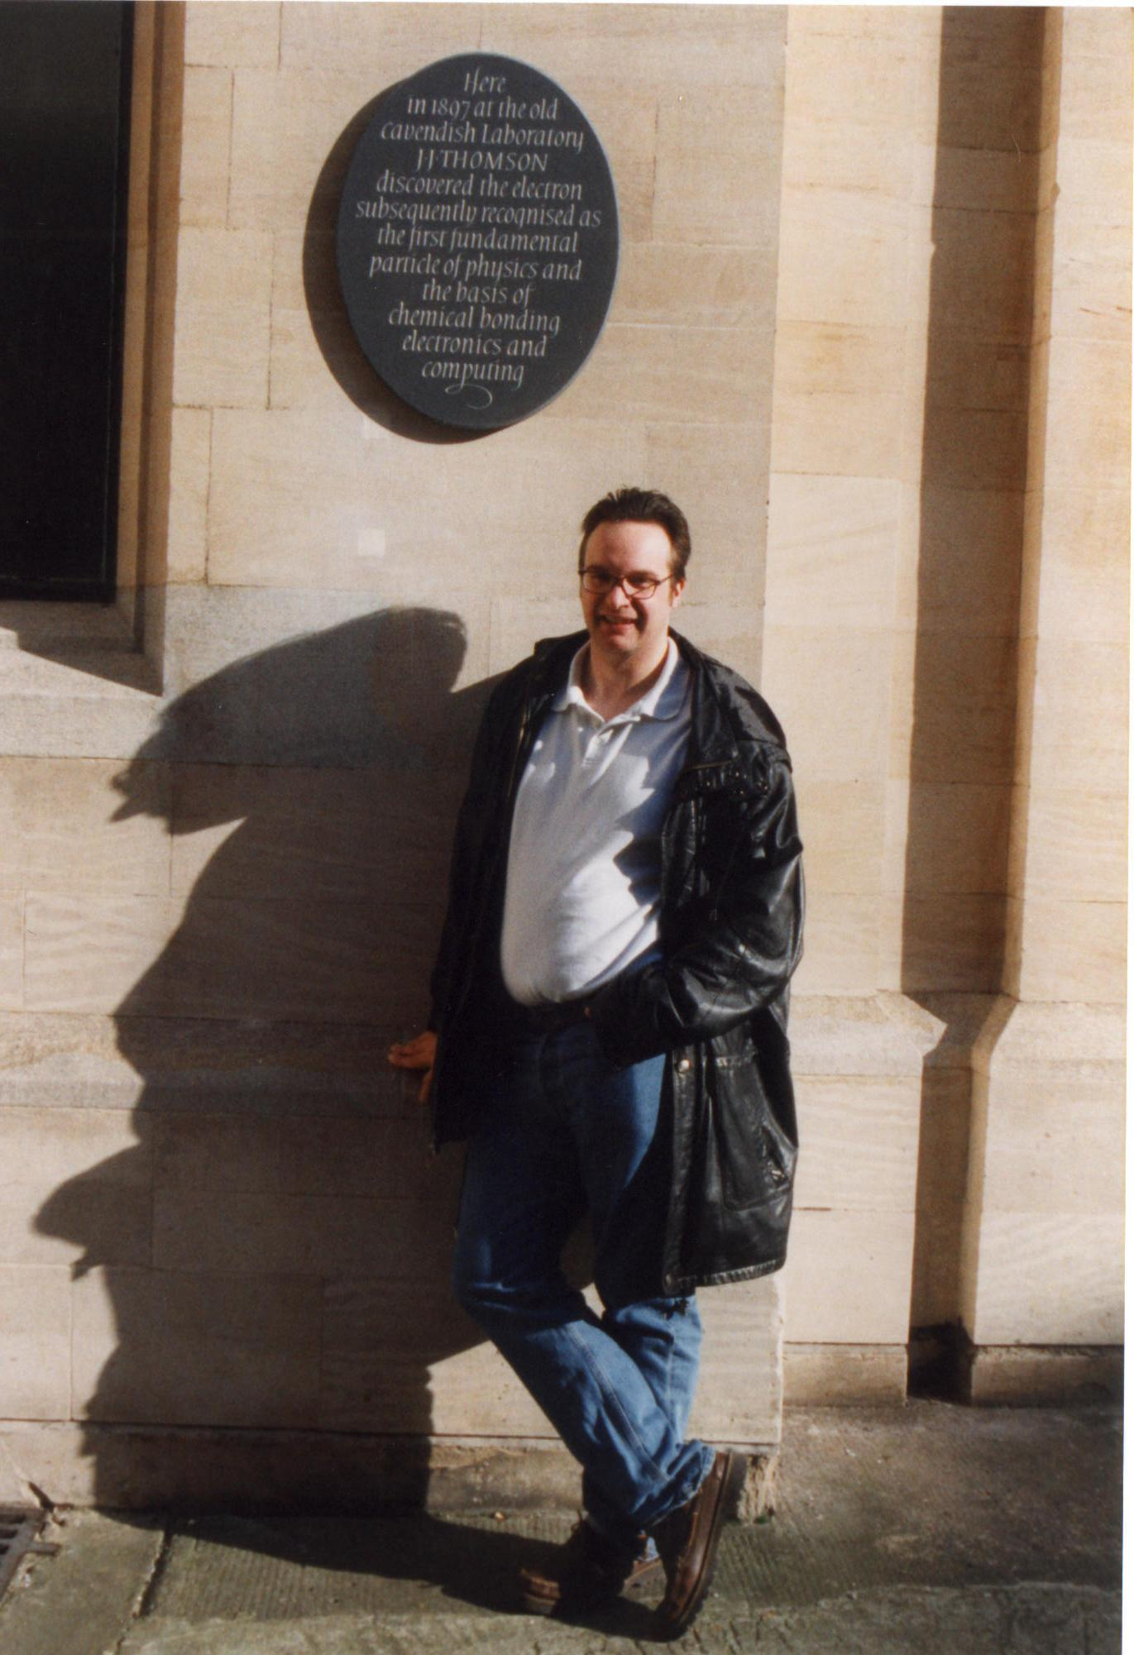 | 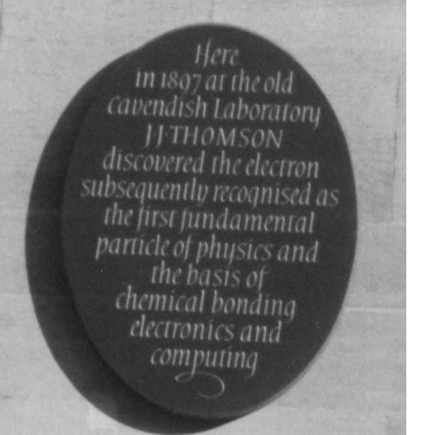 | - What ‘orbits’ the nucleus? (see slide)
- Sketch a generic diagram of an atom using the slide as a guide. Based on the slide, how many times smaller is the diameter of the nucleus than the atom as a whole?

Comparison of subatomic particles (i.e. the things atoms are made from)

Particle | Symbol | Charge | Relative mass
Electron | e | -1 | 1
Proton | p | +1 | 1836
Neutron* | n | 0 | 1839
* ask me to tell you a very poor neutron joke….

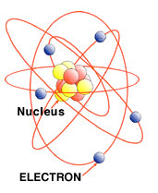 | ‘Old style’ model of the atom – electrons orbiting a central nucleus that, in turn contains protons and neutrons
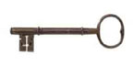 | Electrons are much lighter than the neutrons and protons (that, in turn, ‘inhabit’ the nucleus) ⇒ ELECTRONS MOVE MUCH MORE QUICKELY THAN THE NEUCLIUS EVER CAN (this is called the Born – Oppenheimer Approximation).  This is why electrons are said to either ‘orbit’ the nucleus or exist as ‘blurred out’ electron ‘clouds’.

Question: Are ATOMS* electrically charged? Answer: ______

Question: What then must be true for EVERY atom in terms of the number of electrons and protons it contains?

*Aside: We saw/ will see in lab that ions are made by electrically charging atoms or molecules, we will meet this concept later.

Question: Where can we find out the number of protons (and therefore also the number of electrons) an atom has?

The Periodic Table

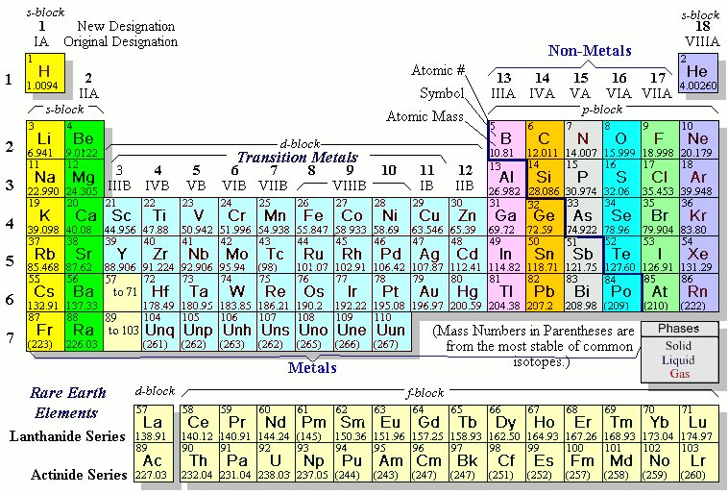

Note how the P. Table is fundamentally arranged in terms of increasing atomic number (Z)

Note: We will typically use Roman numeral notation to assign groups (columns) in the P. Table, e.g. Carbon is the first element of group IVA.
Question: How many protons and electrons do the following atoms have?

Atom | #p | #e | Atom | #p | #e | Atom | #p | #e
Carbon (C): |  |  | Silicon (Si): |  |  | Lead (Pb):

Question: What do you think the other number in an element’s periodic table ‘box’ (e.g. Oxygen has ‘16.00’) represents? How is this number determined?

This information is summarized in an atom’s COMPLETE ATOMIC SYMBOL:

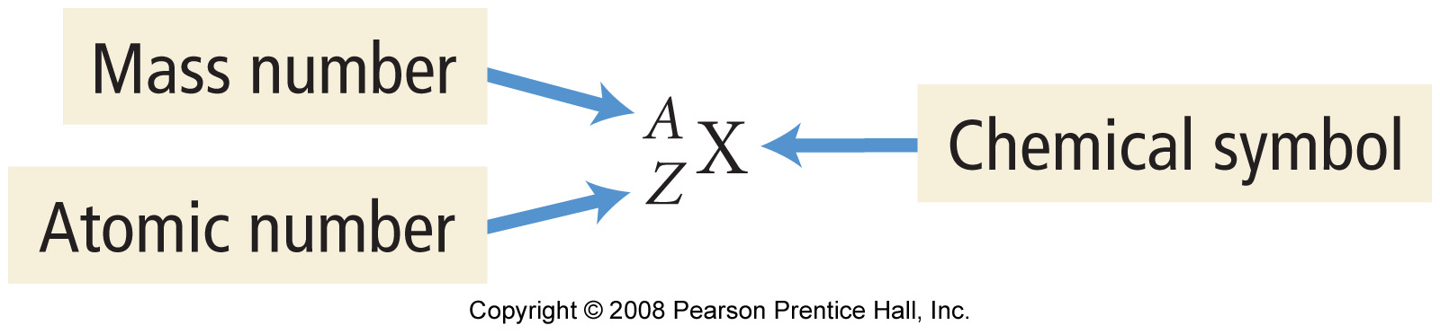

‘Shorthand’ version of the complete atomic symbol:

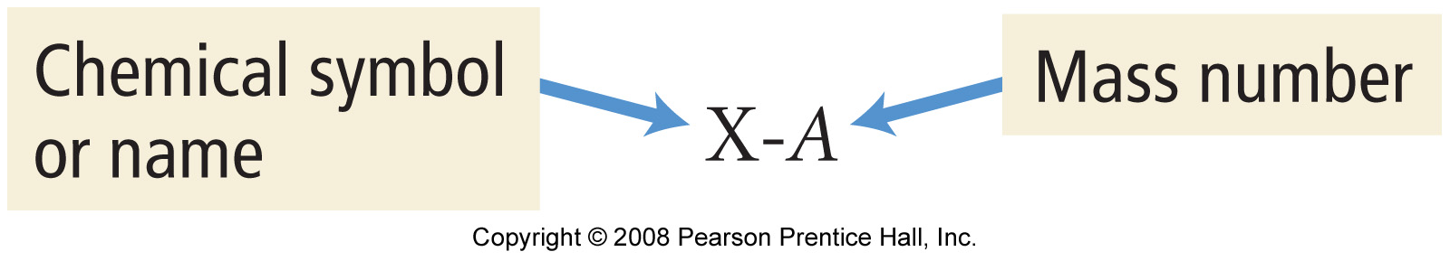

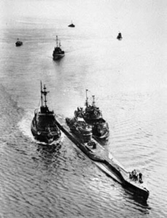 | Task: Carbon–14 has a mass number of 14. Use this information to write its complete atomic symbol. Do the same for U-235.
* remind me to tell a story about U-235 and U-234

Understanding Isotopes

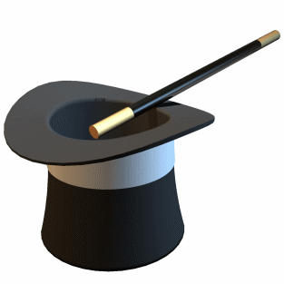 | An element has a FIXED number of protons in its nucleus.  (This information is contained within the element’s Atomic Number. Eg. All hydrogen (H) atoms have 1 proton in their nuclei, while all carbon (C) atoms have 6 protons in their nuclei).  HOWEVER, an element can have a VARIABLE number of neutrons in its nuclei.  (This does NOT alter the identity of the element (#p same), but DOES make the element heavier or lighter (# n changed))

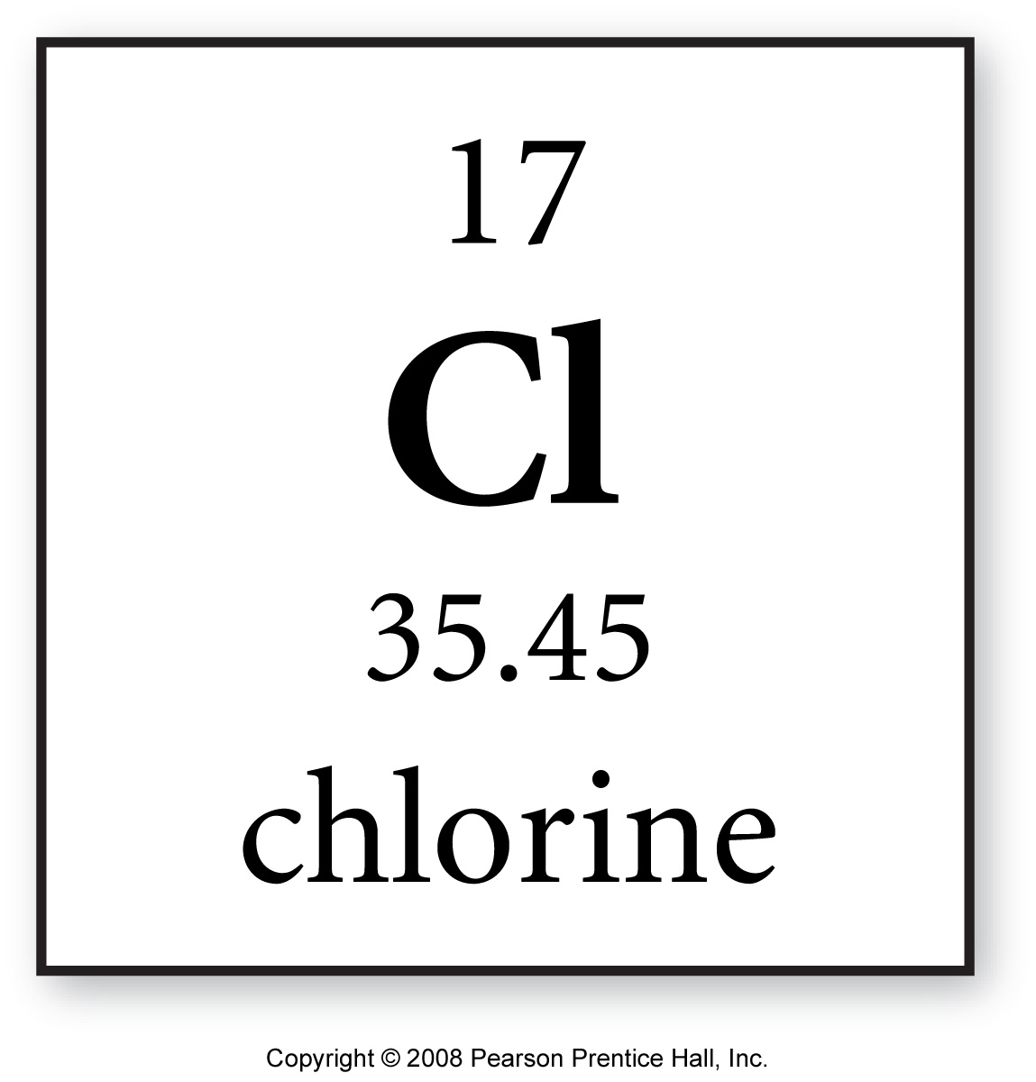 | The AVERAGE atomic mass value for ALL an element’s isotopes is displayed in the periodic table.  E.g. Chlorine has a mass number of 35.45 amu* – there are NO single chlorine atoms in existence with a mass of 35.45 amu (i.e. no such thing as 0.45 of a neutron!), but there are Cl isotopes with mass numbers of 35 and 37 – their weighted average is 35.45 amu

Note: an amu is an atomic mass unit – the mass of a single proton or neutron. This is ≈1.66053873 x 10⁻²⁴ g. It is much simpler to count atomic masses in amu – “an atom of carbon -12 (which contains 6 p and 6 n, so has a mass number of 12) weigh 12 amu” is better than saying “an atom of carbon -12 weigh 1.992648 x 10⁻²³ grams”!

Task: Complete the following table for the isotopes of Carbon. (Tip: what are the values of #p and #e ALWAYS for carbon? Where would you find this information?)

Complete atomic Symbol | #p | #e | #n
 |  |  | 5
 |  |  | 6
 |  |  | 7
 |  |  | 8

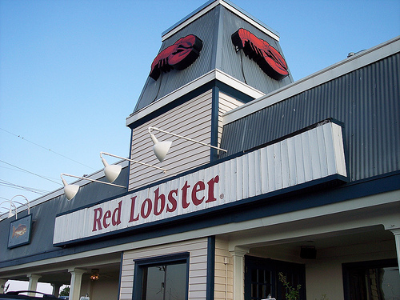 | Discussion: Carbon Dating

 | “Symbols”  The following question was taken from your 2nd practice midterm:

Question 1 (25 points): Write complete atomic symbols for the isotopes described by:

1. | A mass number of 14 and an atomic number of 6
2. | A total of 30 neutrons and 25 protons in it’s nucleus
3. | A total of 47 electrons and a mass number of 109
4. | The isotope of chlorine with a mass number of 37
5. | The isotope of potassium with 20 neutrons

