Chemical Reactions – Part 1
Reading: | Ch 6 sections 1 - 2 | Homework: | 5.3 questions 17, 18*  5.4 questions 20*,22*  6.1 questions 2, 4  6.2 questions 8, 10, 12*, 14, 16
* = ‘important’ homework question

Overview of Bonding Types

As we saw in previous work, metals react with non-metals to form ionic compounds:

Example: Na(s) + Cl₂(g) → NaCl(s) (recall slide)

(i.e. sodium metal + chlorine gas → sodium chloride)

 | Ionic compounds are only formed between metals* (forming cations) and non-metals (forming anions)  Recall: Metals appear on the LEFT of the periodic table and non-metals on the RIGHT. Thus mixing a ‘leftie’ with a ‘rightie’ results in the formation of an ionic compound (see above example).

Discussion: When two non-metals are mixed (both from the right of the periodic table) would you expect an ionic bonded product? Explain*.

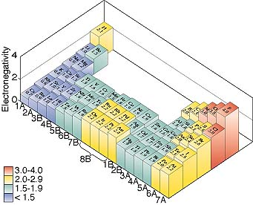
* Electronegativities: see slide at end of handout

Atoms close to one another in the P. table (two ‘righties’) have similar electronegativity values ⇒ they SHARE electrons and form COVALENTLY bonded MOLECULAR products

Example: C(s) + O₂(g) → CO₂(g) (molecular compound)

Atoms distant from to one another in the P. table (‘leftie’ and ‘rightie’) have dissimilar electronegativity values ⇒ they EXCHAGE electrons and have IONIC bonded GIANT products

Example: Na(s) + Cl₂(g) → NaCl(s) (giant ionic compound)

 | Location, Location, Location!

Metallic vs Non metallic Elements in the Periodic Table

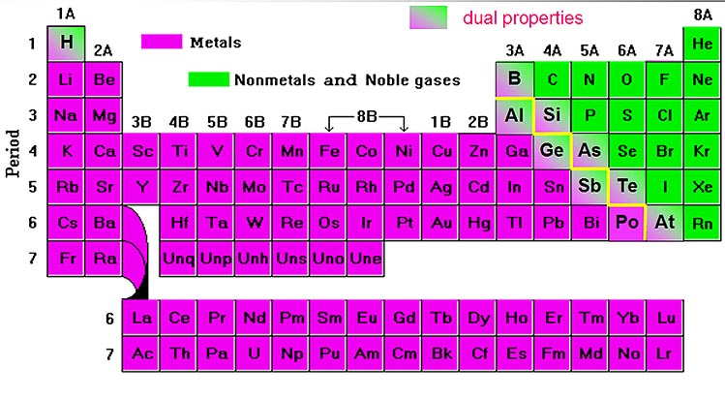

ONLY a non-metal (top RHS) bonded to metal (LHS) make giant compounds with ionic bonds. E.g. NaCl, CaO

THESE MATERIALS ARE NAMED IN ACCORDANCE WITH THE ‘IONIC’ RULES DISCUSSED PREVIOUSLY

ONLY a non-metal bonded to another non-metal (top RHS p. table) make molecular materials with covalent bonds. E.g. CO, H₂O, SO₃
THESE MATERIALS ARE NAMED IN ACCORDANCE WITH THE (BELOW) ‘MOLECULAR’ RULES

Task: Based on the following materials’ formulas, predict if each possesses either covalent or ionic bonding and if each has either a giant or molecular structure. Hint: recall the ‘dividing line’ in the p.table

Material | Bonding | Structure
Water (H₂O)

Table salt (NaCl)

Nitrogen gas

Rust (Fe₂O₃)

Question: What important relationship do you see between bonding and structure?

Naming Molecular Elements and Compounds

 | Task: Write the formula of and name as many molecular elements and compounds as you can

Formula | Name | Formula | Name

Discussion: What relationships do you see between the names and formulas of molecular compounds?

Prefix Table

Number of atoms | Prefix* | Example
1

2

3

4

5

6

*Prefixes are dropped for the first single atom in a formula. E.g. CO₂ is named ‘Carbon dioxide’, not ‘Mono Carbon dioxide’.

Tasks:

Name the Following: |  |  | Write formulas for the following:
NF₃ |  |  | Chlorine dioxide
Cl₂O |  |  | Chlorine pentafluoride
P₂O₅ |  |  | Dihydrogen mono sulfide*

* If named using ionic nomenclature, also known as _________________
Types of Chemical Reactions

Fact: There are FIVE general types of chemical reactions.

- Combination Reactions - two or more types of material become one new material:

Generic: A + Z → AZ

Example: C(s) + O₂(g) → CO₂(g)

Note: All combustion (adding oxygen) reactions are classed as combination reactions.

- Decomposition Reactions - a material becomes two or more new materials:

Generic: AZ → A + Z

Example: CaCO₃(s) → CaO(s) + CO₂(g)

Note: Decomposition reactions may be considered the reverse of combination reactions.

 | - Single Replacement (‘Prom’) reactions - a more reactive material replaces a less reactive one in a compound:  Random internet prom pic.

Generic: A + BZ → AZ + B

Example: Sn(s) + 2HCl(aq) → SnCl₂(aq) + H₂(g)

Note: The material replaced (B or H⁺ above) is said to be LESS reactive than it’s replacement (A or Sn above).

 | - Double Replacement reactions - the respective ionic partners of a pair of dissolved ionic compounds are swapped, most often resulting in the formation of solid product(s):  gerr!

Generic: AX + BZ → AZ + BX

Example: AgNO₃(aq) + NaCl(aq) → AgCl(s) + NaNO₃(aq)

Note: These types of reactions typically take place between dissolved ionic compounds, and typically result in one of the new materials forming a solid precipitate (ppt).

- Neutralization reactions - very similar to double replacement, but ALWAYS between an acid and a base:

Generic: HA + MOH → MA + HOH
(acid + base → salt + water, H₂O)

Example: HCl(aq) + NaOH(aq) → NaCl(aq) + H₂O(l)

Note: These types of reactions are called neutralizations because acid (H⁺) and basic (OH⁻) ions react with each other to form water (H₂O). Such reactions typically liberate large amounts of heat (highly exothermic).

Task: Identify the following reactions (some of which you may remember from lab) as either: combination, decomposition, single replacement, double replacement or neutralization. Additionally, write the formula equivalent of each reaction below its word equation version.

sulfur(s) + oxygen gas → sulfur dioxide gas

magnesium carbonate(s) → magnesium oxide(s) + carbon dioxide gas

zinc(s) + copper (II) nitrate sol^{n}. → metallic copper + zinc nitrate sol^{n}.

silver nitrate(aq) + sod. chloride(aq) → silver chloride(s) + sod. nitrate (aq)

sodium hydroxide solution + hydrochloric acid solution →

Electronegativity Values

Electronegativity ‘map’ of the periodic table – this and other periodic trends will be covered in more detail later in the course

