Chemical Reactions – Part 2

Reading: | Ch 6 section 3  Ch 7 sections 1 - 7 | Homework: | 6.3 questions 38*, 40*, 42, 44  7.2 questions 4, 6, 8, 12*, 14, 20, 22*  7.3 questions 26*, 28  7.4 question 40
* = ‘important’ homework question

Balancing Chemical Equations
 | Law of Conservation of Mass: Atoms are neither created nor destroyed during a chemical reaction - they just change, add or lose partners:

C (s) + O₂ (g) → CO₂ (g)

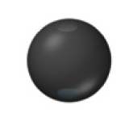 | + | 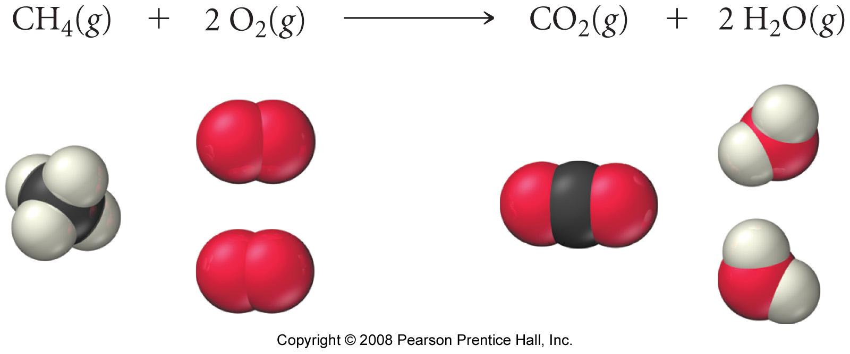 | →

What does each symbol represent in the above chemical reaction?

Symbol | Represents | Symbol | Represents
C(s) | A single atom of carbon in the charcoal brick (a reactant) | → | A chemical symbol meaning ‘goes to’ or ‘is con
O₂(g)erted in to’ | A single molecule of oxygen gas from the air (a reactant) | CO₂ (g) | A single molecule of carbon dioxide gas produced from the reaction (the product)

Since there must (by definition) be the same number and type of each atom on both sides of the equation (i.e. before and after the reaction). The reactants and products must also have equal masses. Why?

Mass Reactants lost = Mass Products gained for ANY reaction

Example: If 5.00 g of carbon is burnt in air to subsequently form 18.3g of carbon dioxide. How much oxygen gas (from the air) is used in this process?

C (s) + O₂ (g) → CO₂ (g)
Application: Rules for balancing chemical equations

1. Construct an unbalanced equation (sometimes using a word equation, as in lab). MAKE SURE THE FORMULAS ARE CORRECT, ONCE THEY ARE, DON’T ‘MESS’ WITH THEM!

 | ‘Captain, I can ‘ney change the laws ‘o physics!’  ….or chemistry either, Scotty – CORRECT CHEMICAL FORMULAS CAN NOT BE ALTERED ONCE WRITEN!

E.g.: Write an unbalanced equation using formulas for the combustion of magnesium (as seen in lab).

Magnesium metal (s) + Oxygen gas → Magnesium Oxide (s)

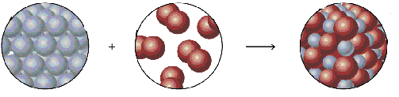

 | You know how to identify and write the name of either ionic or covalent (molecular) materials. What’s the trick?  ⇒ Simply convert names to formulas first
2. Use balancing numbers (whole numbers that appear IN FRONT of formulas) to balance the equation: i.e. ensure that the law of conservation of mass is obeyed.

UNDER NO CIRCUMSTANCES BE TEMPTED TO CHANGE THE FORMULAS!

E.g.: Balance the following equation:

___ Mg (s) + ___ O₂ (g) → ___ MgO (s)

 | Apply the ‘tennis’ approach:  Balance a single type of atom on the left, then see what happens on the right; then balance a different type of atom on the right, then see what happens on the left etc. until done. | Walk through:  Balance # Mg atoms left and right  Balance # O atoms left and right  (re) Balance # Mg atoms left and right -

Micro scale view:

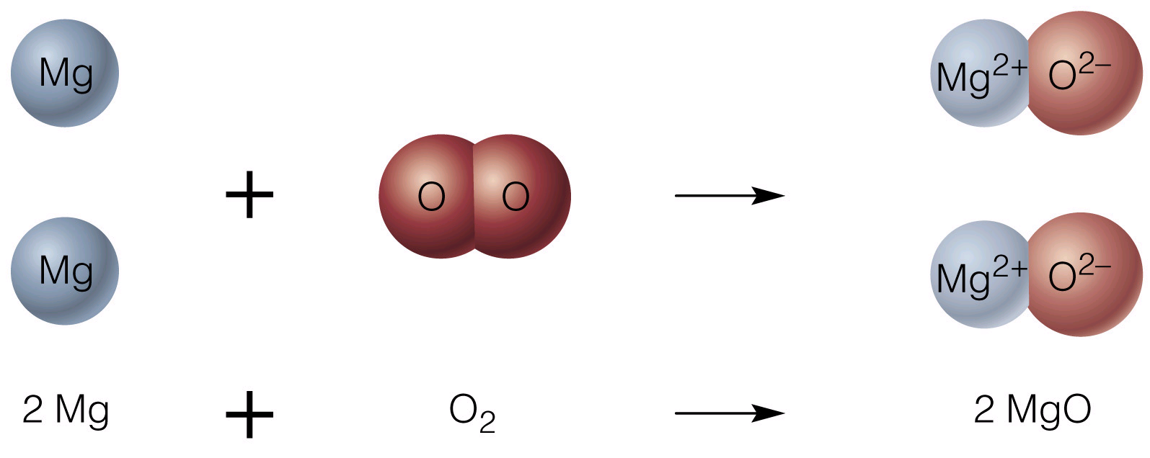

Wrap Up: Remember this?! A combined macroscopic (pictures) and microscopic (balanced chemical equation and cartoon) view of a familiar chemical reaction.

Remember: A chemist explains macro-scale phenomena in terms of a single (repeated many, many times….) microscopic description

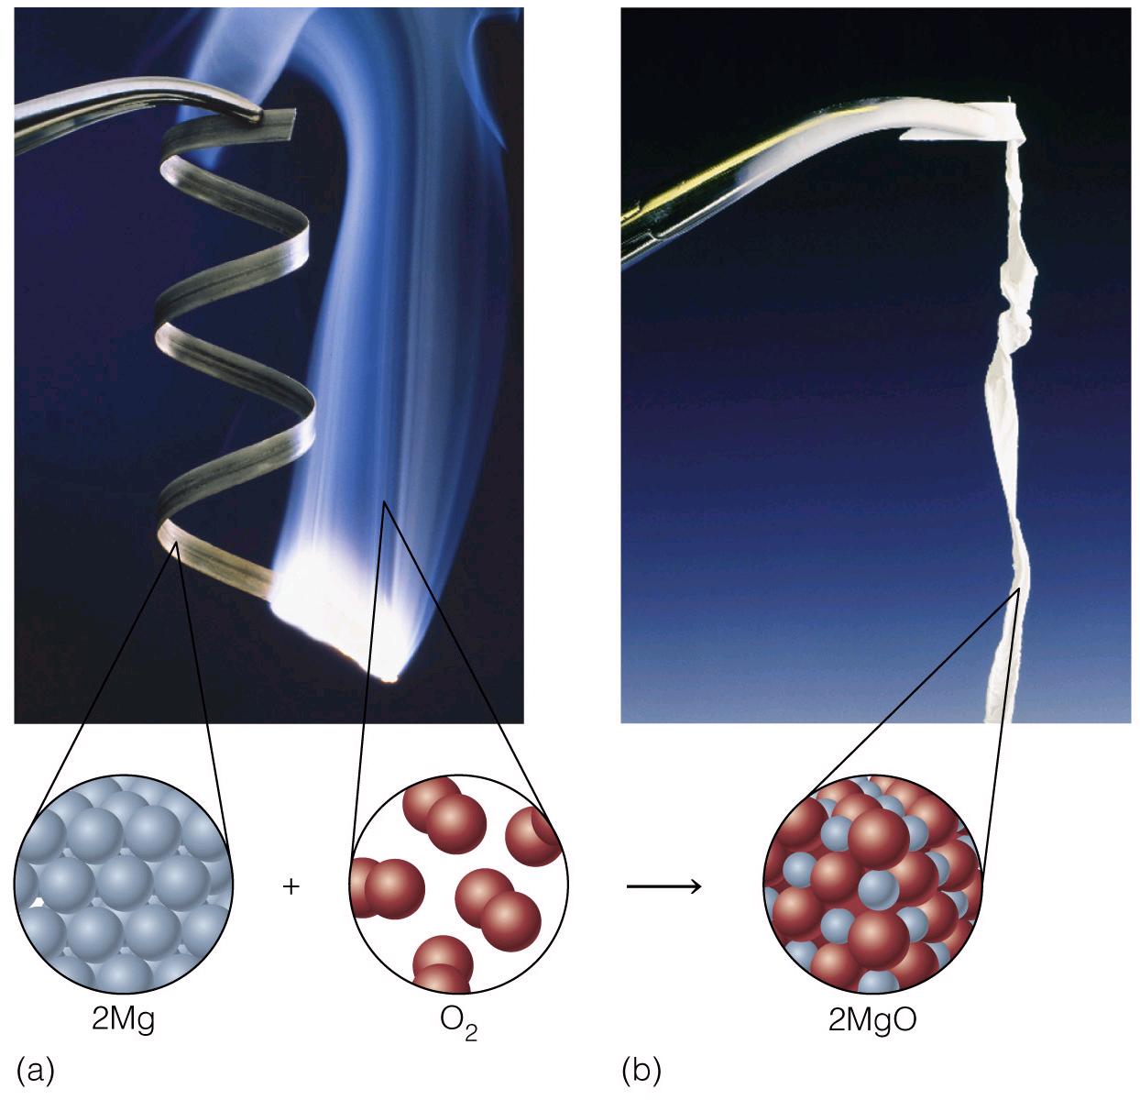

Task: Work in small groups to write balanced equations for the following.

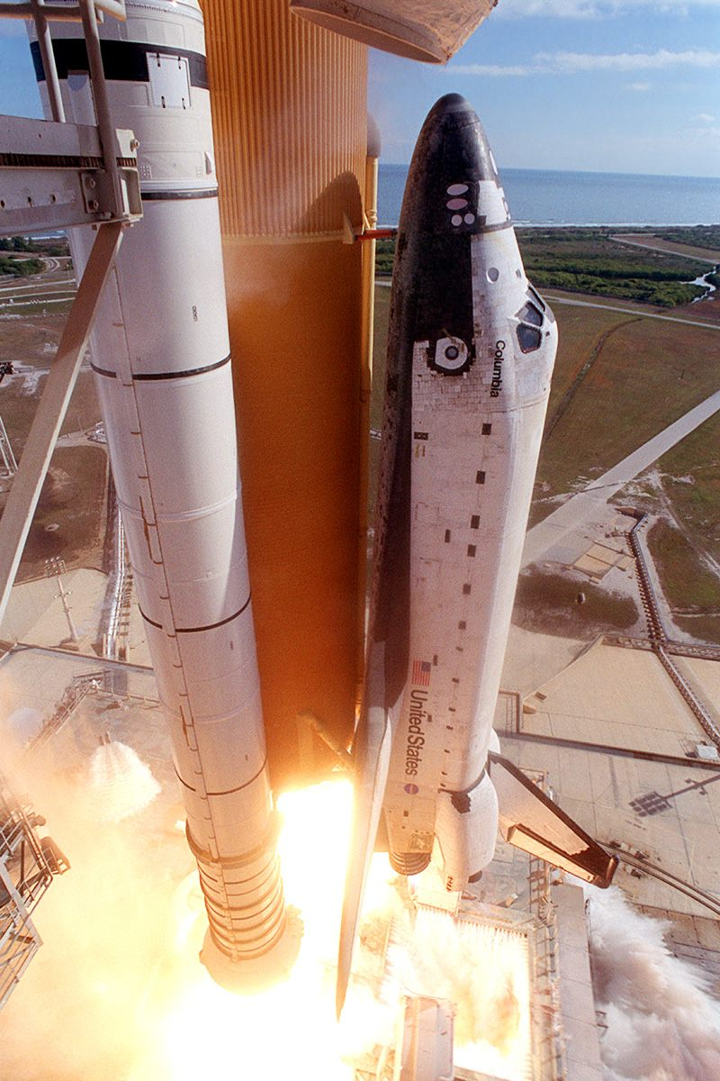
- The combustion of hydrogen gas to make water (see slides)

- The combustion of sodium metal to make its oxide

- The combustion of methane (CH₄).
The products of combustion for organic materials are carbon dioxide and water. Use the ‘tennis’ approach for balancing the C, H and then O atoms in order for organic (C, H and/or O containing) molecules

- The combustion of sugar (C₆H₁₂O₆).

- The combustion of aluminum

- The dissolving of sodium metal in water to give sodium hydroxide and hydrogen gas.

- The reaction of glass (SiO₂(s)) with hydrofluoric acid to give silicon tetrafluoride gas and water.

- (Harder) The reaction of ammonia gas (NH₃) with oxygen gas to give nitrogen monoxide gas and steam.

Recap of skills learnt so far:

- Be able to write balanced chemical equation from a word description of the chemical process (this is what you are often required to do in lab)

- Be able to identify any reaction as belonging to one of the 5 general types of reaction - combination, decomposition, single replacement, double replacement or neutralization.

Tricks

1. Construct an unbalanced equation (sometimes from a word equation). MAKE SURE THE FORMULAS ARE CORRECT. ONCE THEY ARE, DON’T ‘MESS’ WITH THEM!

2. Use balancing numbers (whole numbers that appear IN FRONT of formulas) to balance the equation: i.e. ensure that the law of conservation of mass is obeyed.

Tip: Apply the ‘tennis’ approach when balancing equations - balance a single type of atom on the left, then see what happens on the right; then balance a different type of atom on the right, then see what happens on the left etc. until done.

UNDER NO CIRCUMSTANCES BE TEMPTED TO CHANGE THE FORMULAS WHEN BALANCING AN EQUATION

Review Question: Write a balanced reaction for the combustion of ethanol (C₂H₅OH(l)) in air. What general type of reaction is this?

Reactions in Aqueous Solutions

Task: Write balanced chemical equations for the following reactions; also identify the type of reaction in each case. You may recall some reactions from lab.

- The reaction of aqueous silver nitrate with aqueous sodium chloride to give solid silver chloride and sodium nitrate solution.

- The decomposition of solid sodium hydrogen carbonate to solid sodium carbonate, water and carbon dioxide gas.

- The reaction of copper metal with aqueous silver nitrate to form solid silver and aqueous copper (II) nitrate.

- The neutralization of hydrochloric acid solution with calcium hydroxide solution.

Discussion: What do you think makes each of the above reactions ‘go’? What is the driving force in each case?

Discussion: What evidence is there that the products are more stable than the reactants in each or the above processes? How are the reactants and products different on a micro and macro scale?

1.

2.

3.

Reactions in which a solid product (precipitate, ppt.) forms

Worked example: Write balanced (molecular), complete and net ionic equations for the reaction of silver nitrate and sodium chloride solutions.

The Balanced (molecular) ionic equation

This is the balanced, ionic double replacement (‘swapping partners’) reaction you are already familiar with.

Balanced:

Question: How do we know which one of the products formed (AgCl or NaNO₃) is the solid recovered from the reaction?

Whether or not an ionic material is soluble in water is known. This data appears in the solubility chart.

⇒ Determine if the product(s) are soluble via the chart and include the appropriate state symbol(s) in the balanced equation. ALWAYS INCLUDE STATE SYMBOLS IN ALL YOUR BALANCED, COMPLETE AND NET EQUATIONS

Solubility chart (will be supplied)

Soluble Compounds |  |  | Exceptions |  | Insoluble Compounds |  |  | Exceptions
Compounds containing | NO₃⁻ | None |  |  | Compounds containing | CO₃²⁻ | NH₄⁺ & group IA cations
 | Cl⁻ | Ag⁺, Hg²⁺,Pb²⁺ |  |  |  | PO₄³⁻ | NH₄⁺ & group IA cations
 | Br⁻ | Ag⁺, Hg²⁺,Pb²⁺ |  |  |  | OH⁻ | group IA cations Ca²⁺,Sr²⁺, Ba²⁺ & NH₄⁺
 | I⁻ | Ag⁺, Hg²⁺,Pb²⁺
 | SO₄²⁻ | Ba²⁺, Hg²⁺,Pb²⁺
Task: State whether the following ionic materials are soluble or insoluble in water:

NaNO₃ |  | PbCl₂ |  | PbSO₄
AgCl |  | Ca(OH)₂ |  | AgOH

The Complete ionic equation

Recall that the state symbol (aq) means that the ions of an ionic compound are SEPARATED (dissociated) and, therefore, MOBILE when dissolved in water. Recall previous slides.

A complete ionic equation shows each type of ion dissolved in solution. Consider it to be a ‘longhand’ version of the balanced equation.

Balanced:

AgNO₃ (aq) + NaCl(aq) → AgCl(s) + NaNO₃ (aq)

Complete:

Solids (s), liquids (l) and gases (g) are NOT in the (aq), state so do not appear as individual (dissociated) ions in the complete ionic equation.

The Net ionic equation

Question: What can be done ‘algebraically’ with the complete ionic equation?

Complete:

Ag⁺_{(aq)} + NO₃⁻_{(aq)} + Na⁺_{(aq)} + Cl⁻_{(aq)} → AgCl_{(s)} + Na⁺_{(aq)} + NO₃⁻_{(aq)}

Net:

‘Cancel’ ions (spectator ions) common to both sides in the Complete ionic equation to give the Net ionic equation. This is ‘where the action is’ in any ionic reaction.

Walk Through: Write balanced, complete and net ionic equations for the following reaction:

- Lead (II) nitrate solution mixed with Potassium iodide solution (use the figure or slide as a guide)

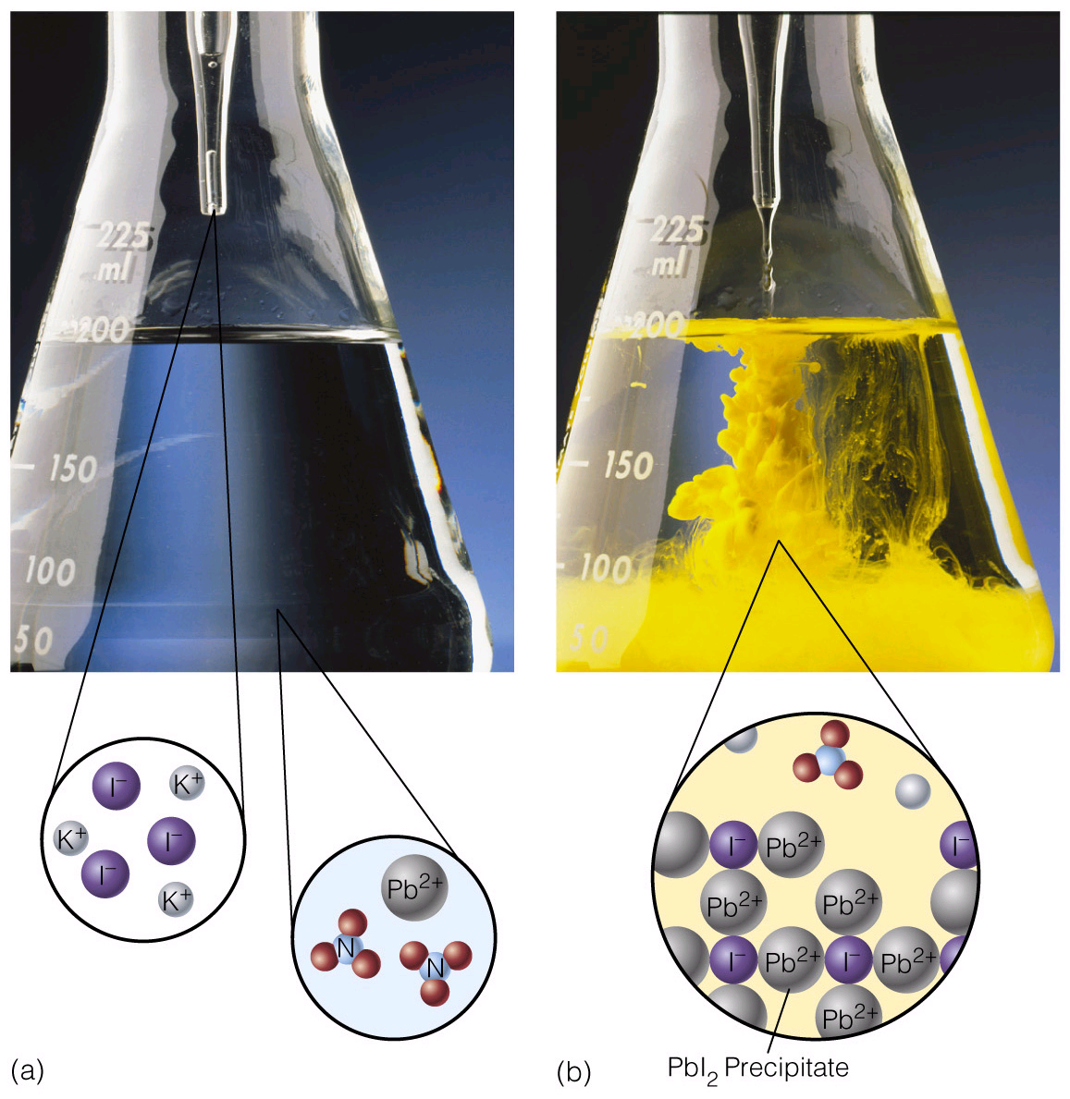

Group Task: Write balanced, complete and net ionic equations for the following reactions:

- Barium nitrate solution mixed with sulfuric acid solution

- Sulfuric acid solution mixed with sodium hydroxide solution

- Calcium chloride solution mixed with sodium phosphate solution (your recent lab).

‘Balancing Water’

Draw a picture of the combustion of H₂(g) process here

Recall that…
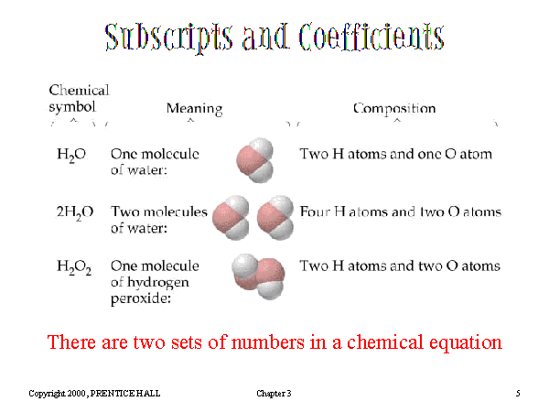

In summary…

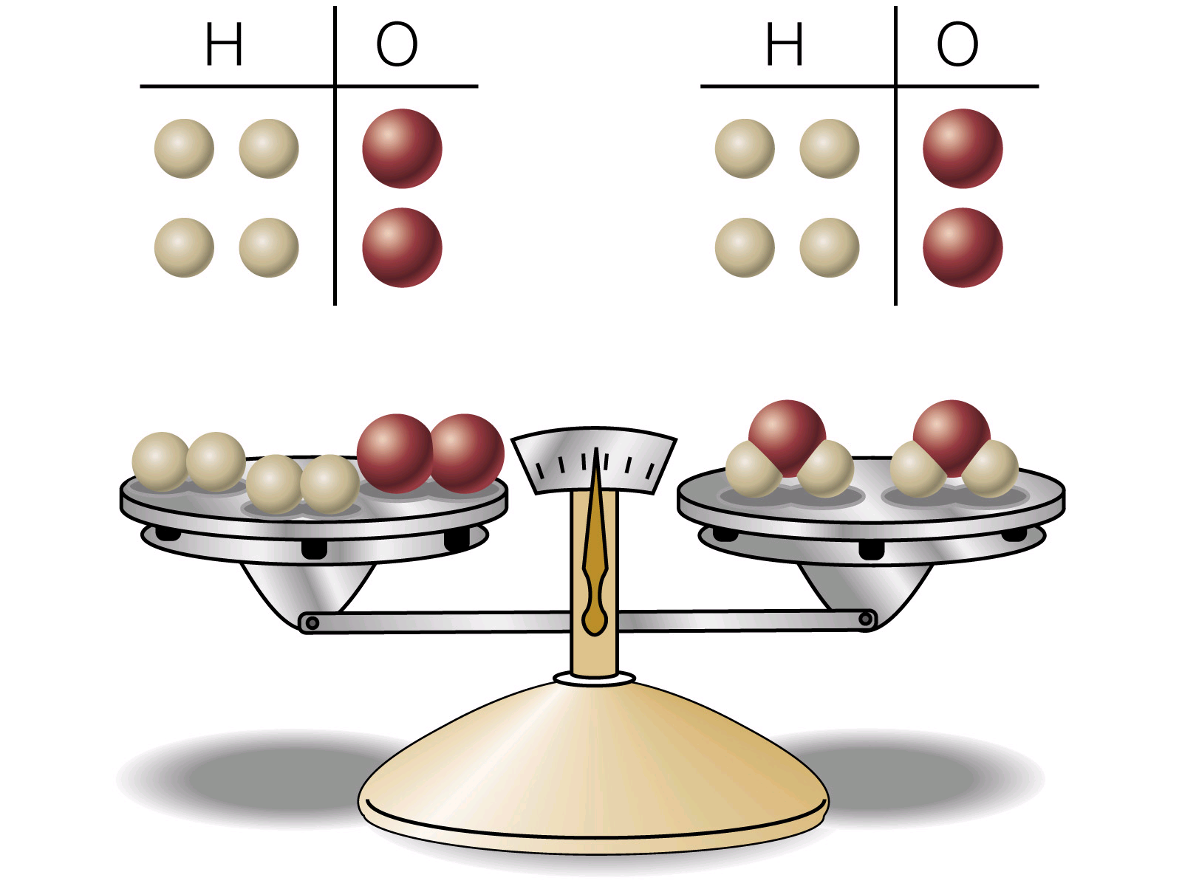

2 H₂ (g) + 1 O₂ (g) → 2 H₂O (g)

 | “Balance” & “Those Three Equations”  The following questions were taken from your 2nd practice midterm:

Question 3 (25 points): Write balanced chemical equations that describe the following processes. Remember to include state symbols in your equations:

a. | The burning of liquid propane (C₃H₈ (l)) in air
b. | The Neutralization of stomach acid (hydrochloric acid solution) with caustic soda (sodium hydroxide solution)
c. | The reaction of solid diphosphorus pentoxide with water to form aqueous phosphoric acid
d. | The decomposition of chalk (CaCO₃), when heated, to form solid calcium oxide and carbon dioxide gas
e. | The reaction of metallic zinc with aqueous sulfuric acid to form aqueous zinc sulfate and hydrogen gas

Extra Credit: State to which one of the five general classes of reaction each of the above processes belong.

Question 4a (15 points): Write balanced, complete and net ionic equations illustrating the reaction between solutions of barium nitrate and sodium sulfate.

Question 4b (10 points): List the names and formulas of five insoluble ionic compounds containing the phosphate anion.

“Balance” & “Those Three Equations”

The following questions were taken from your 2nd practice midterm:

Question 3 (25 points): Write balanced chemical equations that describe the following processes. Remember to include state symbols in your equations:

a. | The burning of liquid propane (C₃H₈ (l)) in air  C₃H₈ (l) + 5O₂ (g) → 3CO₂ (g) + 4H₂O (g)
b. | The Neutralization of stomach acid (hydrochloric acid solution) with caustic soda (sodium hydroxide solution)  HCl (aq) + NaOH (aq) → NaCl (aq) + H₂O (l)
c. | The reaction of solid diphosphorus pentoxide with water to form aqueous phosphoric acid  P₂O₅ (s) + 3H₂O (l) → 2 H₃PO₄ (aq)
d. | The decomposition of chalk (CaCO₃), when heated, to form solid calcium oxide and carbon dioxide gas  CaCO₃ (s) → CaO (s) + CO₂ (g)
e. | The reaction of metallic zinc with aqueous sulfuric acid to form aqueous zinc (II) sulfate and hydrogen gas  Zn (s) + H₂SO₄ (aq) → ZnSO₄ (aq) + H₂ (g)

Extra Credit: State to which one of the five general classes of reaction each of the above processes belong.

Question 4a (15 points): Write balanced, complete and net ionic equations illustrating the reaction between solutions of barium nitrate and sodium sulfate.

Ba(NO₃)₂ (aq) + Na₂SO₄ (aq) → BaSO₄ (s) + 2NaNO₃ (aq)

Ba²⁺ (aq) + 2NO₃⁻ (aq) + 2Na⁺ (aq) + SO₄²⁻ (aq) → BaSO₄ (s) + 2Na⁺ (aq) + 2NO₃⁻ (aq)

Ba²⁺ (aq) + SO₄²⁻ (aq) → BaSO₄ (s)

Question 4b (10 points): List the names and formulas of five insoluble ionic compounds containing the phosphate anion.

Eg Ca₃(PO₄)₂ – calcium phosphate (See solubility chart)

