Dimensional Analysis (Conversion Factors)

Reading: | Ch. 2 sections 6 | Homework: | 2.6, questions 58, 60*, 62*, 66
* = ‘important’ homework question

Background

We do simple conversions between different units on a daily basis. For example:

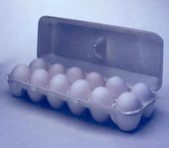 | Question:  How many eggs are there in 1 dozen eggs? ________

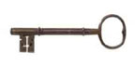 | A statement such as this can be written as an identity  1 dozen eggs = 12 eggs

Recall: Is the above identity a measured or exact relationship? How would its use affect the number of significant figures used in any answer?

Using Identities and Conversion Factors

Overview Example: How many eggs are there in 42 dozen eggs?

 | Use the appropriate identity to create a conversion factor. The conversion factor will transform the quantity into the desired form.

Math:

42 dozen eggs x = _______________

Conversion factors are simply identities written as fractions. Each conversion factor has two ‘versions’

Task: Complete the following table by transforming the stated identity into its two corresponding conversion factors. Also include at least three additional conversion factors that you have encountered.

Identity | Conversion factors |  | Exact?  (Y/N)
1 in = 2.54* cm

1 kg = 2.205 lb

1 m = 100 cm

1 ft = 12 inches


Discussion:

How do you know which version of the conversion factor to use? Why?

For none exact identities and conversion factors, how many sig. figs are implied?

Example: Use the information from above to determine how many cm there are in 12.00 inches.

12.00 inches x = _______________

The unit belonging to the quantity and the denominator of the conversion factor cancel to leave a final answer with the desired unit

Generic Form:

Extra Credit (3 pts., typed for next time): Dr. Mills gets very cranky with the text as it says “1 in = 2.54 cm exactly”. What is the source of Dr. Mills’ confusion? Hint: Is the inch really an S.I. unit? Try searching for ‘International inch’ to get started.
Task: Complete the following conversions. See your text for appropriate conversion identities.

5.51 cm to meters

23.0 ounces to pounds

50.0 nm to meters

6.56 miles to km

45.7 inches to cm

220 pounds to kg

(you choose examples)

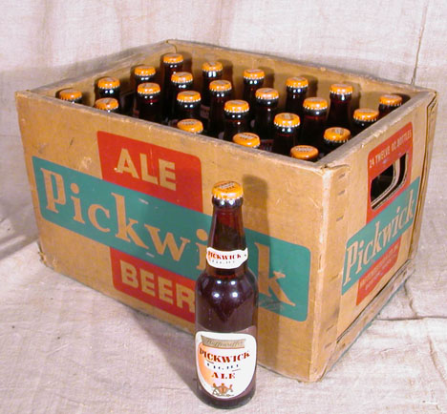

Conversion Factor ‘Chains’

Question: How do you approach a problem like “Convert 55 cm into feet” – where there is no available single conversion factor?

Answer:

55 cm x x = _______________

Link as many conversion factors as necessary together in order to crate a ‘chain’. Each ‘link’ in the chain converts one unit to another and so on until the answer is reached

Task: Complete the following ‘chain’ conversions. See your text for appropriate conversion identities.

1.68 m to inches

5.8 km to feet

4.00 ounces to grams

Question of the week: Remember that nursing question from week 1? Let’s try it now….

Example: Chlorothiazide (Diuril) is ordered b.i.d. for a infant weighing 6.5 kg. It is supplied in elixir form 100 mg/tsp. The recommended dosage for Diuril is 25 mg/kg/day. How many cc’s should the nurse give to the child for each dose?

  - 6.15 cc.
  - 8.13 cc.
  - 4.06 cc.
  - 0.81 cc.

‘Medical’ conversion factors

b.i.d.: 2 dose = 1 day
1 tsp. = 5.0 mL

*Ask me about some more extra credit…..

 | “Conversions”  The following questions were taken from your 1st practice midterm:

Complete the following conversions (include correct number of sig. figs.):

95.5 pounds to kg | ANS: 43.3 kg (3 sf)
1032 cm to meters | ANS: 10.32 m (4 sf)
12.5 miles to km | ANS: 20.0 km (3 sf)
-156 ºC to Kelvin  (see next handout) | ANS: 117 K
1300 Cal to kJ | ANS: 5439 kJ

