Energy

Reading: | Ch 10 sections 1 - 5 | Homework: | 10.1, questions 4, 6  10.2, question 10*  10.5 question 22, 24, 28, 32*
* = ‘important’ homework question

Temperature and Energy

Discussion: What is heat, what is energy? How are these things related to temperature?


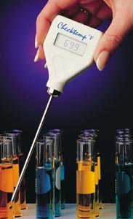
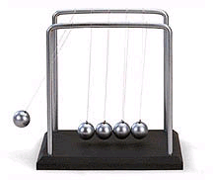

Recall: Energy Content of Foods Lab. The heat energy (-q) lost by food (when burnt) = heat energy (+q) gained by water in the soda can.

i.e. –q _{(food)} = +q _{(water)}

Notes: The sign (+ or -) indicates where the energy was lost (-) and where it was gained (+), in other words when it went ‘from’ (-) and ‘to’(+). The numerical value of q is the same, regardless of +/- signs, as the energy is transferred from the food to the water.

Remember: q is measured in ________ , the S.I. unit of energy.

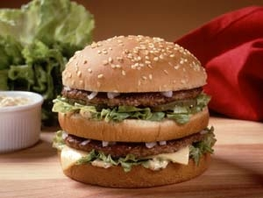 | Task: What is an average person’s daily Calorie requirement? A ‘Big Mac’ and large fries contains ~ 1100 calories - How many Big Mac extra value meals is can a person eat per day and stay within their recommended calorie limit (assume a diet coke!)? How many kJ is this equivalent to?

 | To Convert J to Calories (the ‘Jenny Craig unit of energy’), the following conversion identity must be used:  1 Cal = 4.184 kJ

Specific Heat Capacity (C_{p})

Definition: The amount of heat energy required to raise the temperature of one gram of a substance by one degree Celsius

In ‘English’:

Table of Specific heat Capacities

Substance | Sp. Ht. Cap. (J/gºC) | Substance | Sp. Ht. Cap. (J/gºC)
Water (l) | 4.18 | Mercury (l) | 0.14
Water (s) | 2.03 | Carbon (s) | 0.71
Aluminum | 0.89 | Silver (s) | 0.24
Iron (s) | 0.45 | Gold (s) | 0.13

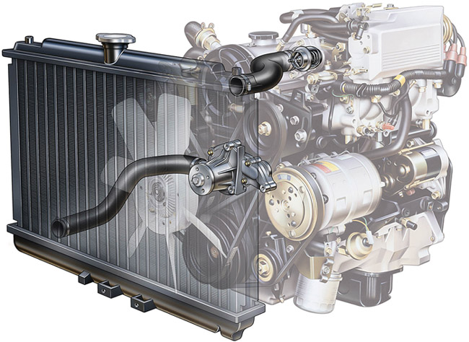 | Discussion: Would a material with a high or low heat capacity be best suited for use as radiator coolant? What other factors influence such a choice?
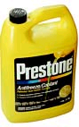
Relating Energy (q), heat capacity (C_{p}) and temperature change (ΔT)

Recall: Temperature is an intensive property – it DOES NOT depend on the amount of material (a glass of water and a swimming pool full of water can have the same temperature).

Energy is an extensive property – it DOES depend on the amount of material (a glass of water and a swimming pool full of water contain very different amounts of energy at, say, room temperature).

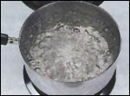 | Discussion: What properties of a material determine how much energy it can absorb before undergoes a change of state (e.g. factors influencing how fast a liquid boils)? Are these extensive or intensive properties?

 | Property | Effect and Reasoning | Intensive or Extensive? | Symbol
1
2
3

 | The amount of heat energy transferred to or from any material or object can be found if its HEAT CAPACITY (C_{p}), MASS (g) and observed temperature change, ΔT (ºC or K), it undergoes are known:  q = C_{p} x m x ΔT

Questions:

- How much heat energy is needed to raise the temperature of 25 g water by 15ºC?

- How much heat energy is needed to raise the temperature of 25 g solid iron by 15ºC?

- How much heat energy would be needed to boil a 330 mL glass of water that is initially at room temperature (25 ºC)? How many Cal. Is this? Density H₂O (l) = 1.00 g/mL

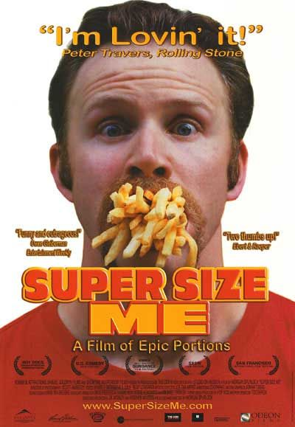 | Questions of the week: A certain Prof. was told that to lose weight he must consume no more than 1300 Cal per day and exercise for at least 60 minutes per week.

- If the Prof. eats nothing but Big Mac value meals, how many can he eat per week and remain within his Cal per day limit?

- The Prof’s exercises for 90 minutes per week on his favorite exercise machine, which burns off 725 Cal/hr. In terms of energy, how many Big Mac value meals is this amount of weekly exercise equivalent to?

