Gases

Reading: | Ch 13 sections 1 - 5 | Homework: | 13.1 questions 6, 8  13.2 questions 18*, 20, 22, 24  13.3 questions 30*, 34  13.4 questions 42, 44  13.5 questions 50*, 52*, 58, 60, 62*
* = ‘important’ homework question

Background

Discussion: What do we already know about gases? Many of the concepts to be covered are based on the interpretation of ‘everyday’ experiences.

Macroscopic View:   | Microscopic View:  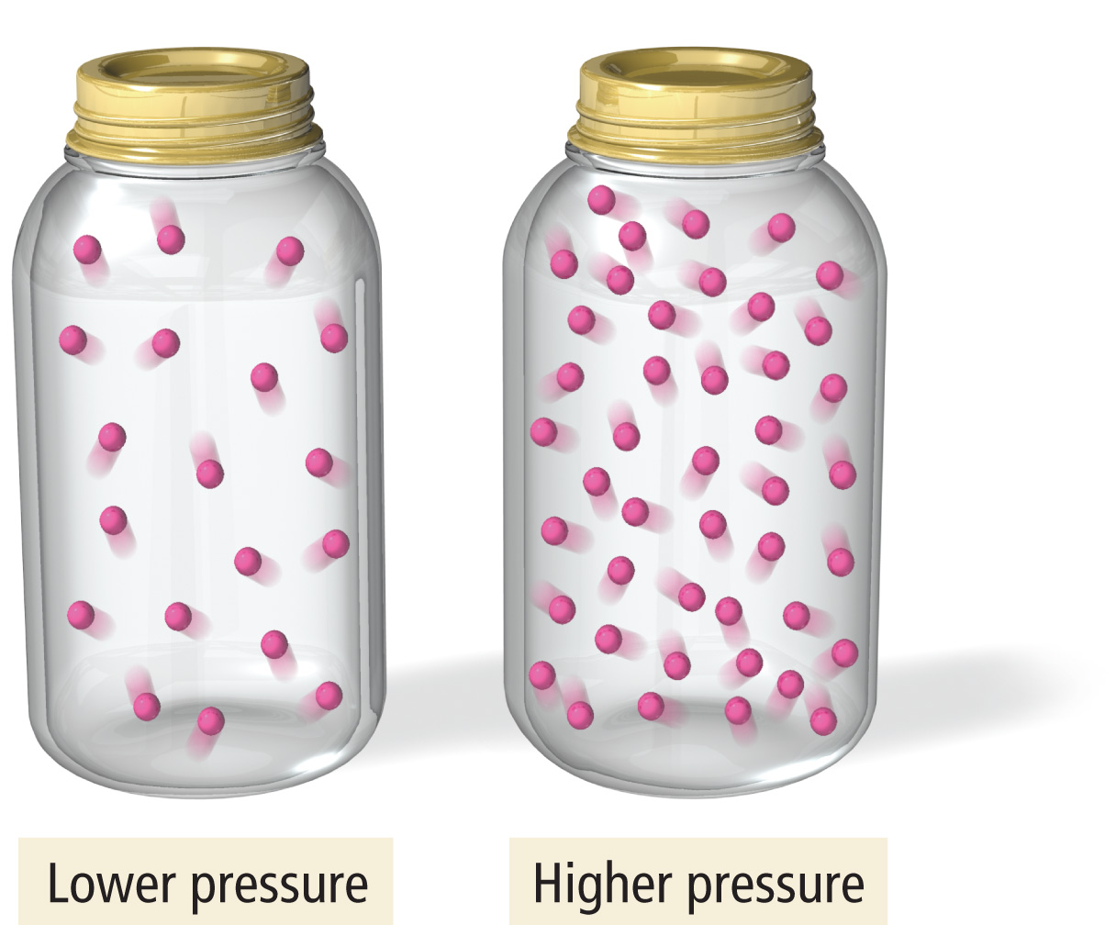

1 atm = 760 mmHg (Torr) = 101 kPa

 | The behavior of a gas can be explained in terms of:  - Its VOLUME (in liters)  - Its PRESSURE (most often in atm.)  - Its TEMPERATURE (in Kelvin)  - The number of MOLES (n) of gas present

 | Understanding gases is all about understanding the relationships between the VOLUME, PRESSURE, TEMPERATURE and # MOLES (n) of a gas sample.
The Gas Laws

Avogadro’s Law: | Relationship between # MOLES of gas and VOLUME (P and T fixed)

Everyday observation: What takes up more space, 1 mole of gas or 2 moles of gas (assume constant temp. and pressure)?

V ∝ n (# moles)

At standard temperature (273 K) and pressure (1.0 atm.), 1 mole of ANY gas occupies 22.4 L.

1 mole = 22.4 L at STP

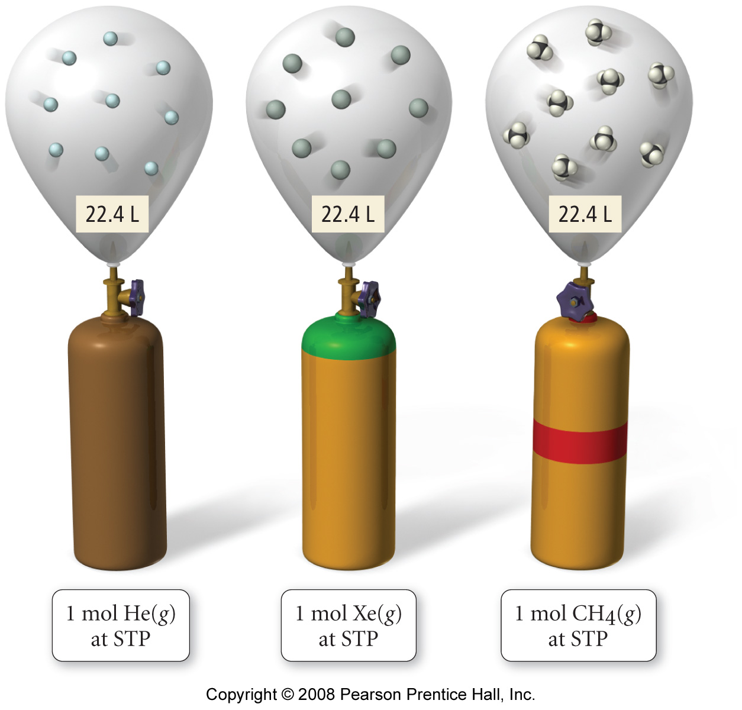

Examples:

- What volume does 3.5 moles of H₂ (g) occupy at STP?

- How many atoms of He are there in a 5.0 L party balloon at STP?

Boyles Law: | Relationship between PRESSURE and VOLUME  (n and T fixed)

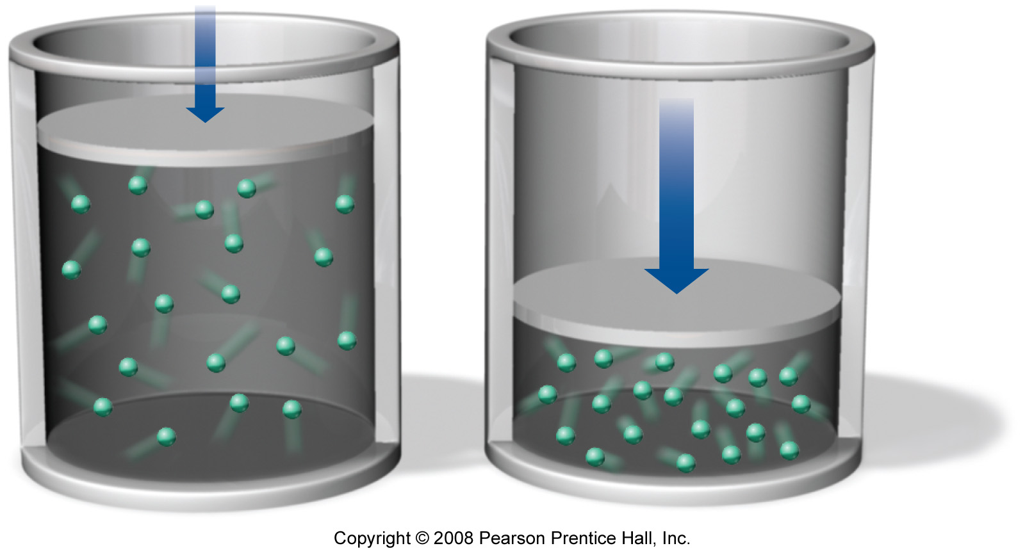 | Everyday observation: If you compress (‘squeeze’) the container a gas is in, does the gas pressure increase or decrease (assume fixed T and n).

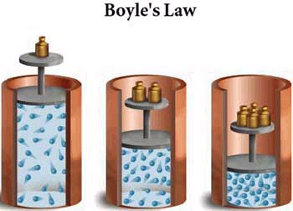

P ∝ 1/V or PV = constant (table)

Example: A sample of gas has a pressure of 2.0 atm. If the volume of the container the gas sample is in is decreased by a factor of 10, what is the new pressure of the gas inside? Assume T and n constant.

Charles’ Law: | Relationship between:  TEMPERATURE and VOLUME (n and P fixed) or TEMPERATURE and PRESSURE (n and V fixed)*

 | Everyday observation: Why does a hot air balloon rise? What time of day is best for ballooning?
 | 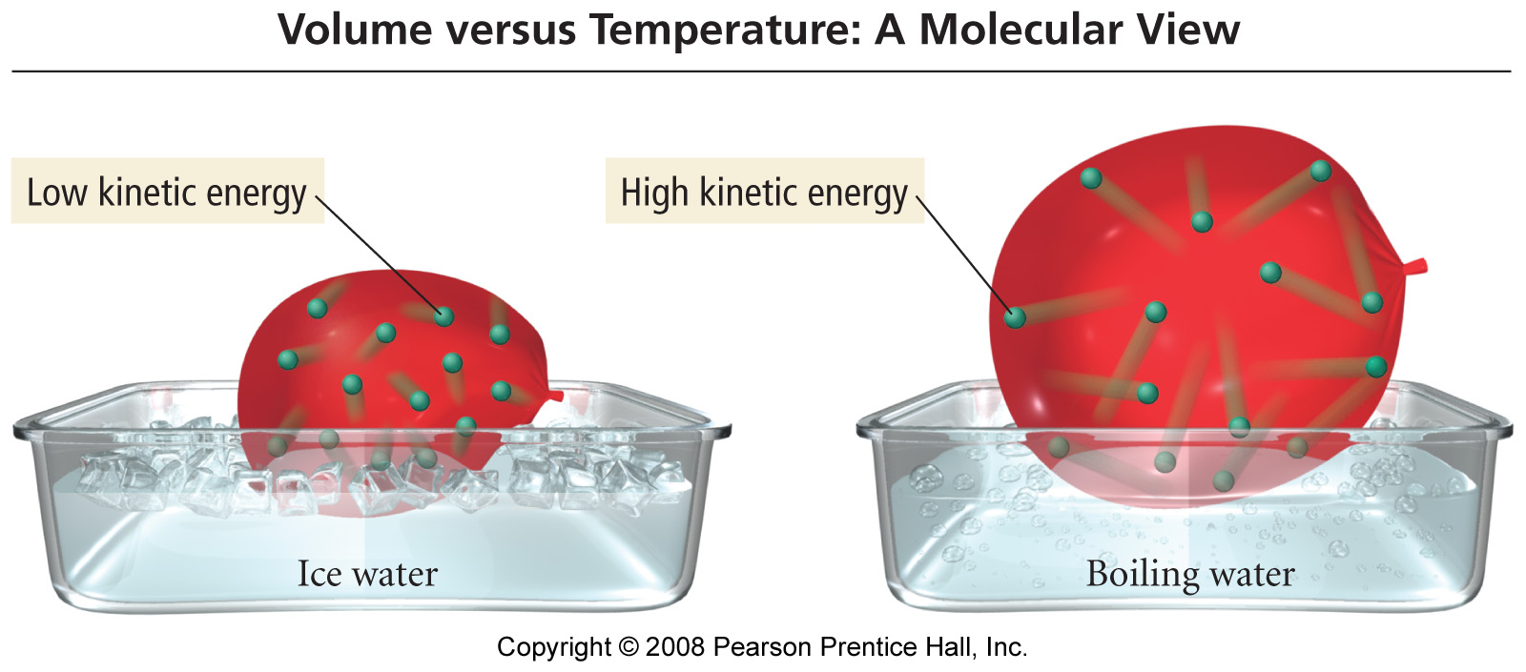

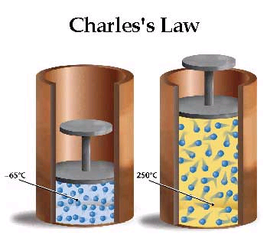

V ∝ T

Example: A sample of gas occupies 12 L at 31ºC. What volume does it occupy at 62ºC? Assume P and n are constant.
The Ideal gas Law

The three gas law equations can be combined to make a new equation (the IDEAL GAS LAW) that can be used to solve ANY ‘static*’ gas problem

Derivation of the ideal gas law

PV = nRT

Where: R = 0.08206 L atm /mol K if the atm. pressure unit is used
or R = 8.314 /mol K if the Pa or N/m² pressure unit is used

Example: Calcium carbonate decomposes when heated to give solid calcium oxide and carbon dioxide gas. If 250 mL of CO₂ (g) is collected at 31ºC and 1.3 atm pressure, then how many moles of CO₂ (g) is collected?

Write down what you are given, then solve for the unknown quantity in ‘static’ problems

P =
V =
n =
R =
T =
Dynamic Problems: changing P, V or T for a fixed number of moles of gas

Derivation of the ‘Dynamic’ (before and after) gas law

P₁V₁ | = | P₂V₂
T₁ |  | T₂
(before) |  | (after)

Example: The pressure inside an aerosol can is 1.5 atm. at 25ºC. What would the pressure inside the can be at 450ºC? Is there a moral to the story?

As with the ‘static’ problems, write down what you are given then solve for the unknown quantity in ‘dynamic’ problems

P₁ = |  | P₂ =
V₁ = |  | V₂ =
T₁ = |  | T₂ =
(before) |  | (after)

 | “Air Bag”  The following question was taken from your 3rd practice midterm:

Question 4 (25 points): Vehicle safety ‘air’ bags actually inflate with nitrogen gas during collisions. If a standard car’s ‘air’ bag has a volume of 36.0 L and inflates to a pressure of 745 Torr at 15 ºC, then:

- How many moles of N₂ (g) are contained within the inflated ‘air’ bag described above?

- If the car’s air bag described above was instead inflated at – 20 ºC (i.e. on a Chicago winter’s day), to what pressure would the ‘air’ bag inflate?

Extra credit: Do you think the process described in (b) would be dangerous? Explain.

