Modern Atomic Theory – Part 1

Reading: | Ch 12 sections 6 – 10 | Homework: | 12.6 and 12.7 questions 50, 52, 54, 56*, 58*, 60*, 62, 64*  12.8 questions 70*, 72  12.9 questions 74, 78, 80, 82*, 86*
* = ‘important’ homework question

The Electronic Structure of Atoms and Molecules

Recall: What caused Mendeleev to stack certain elements in ‘Family’ groups?

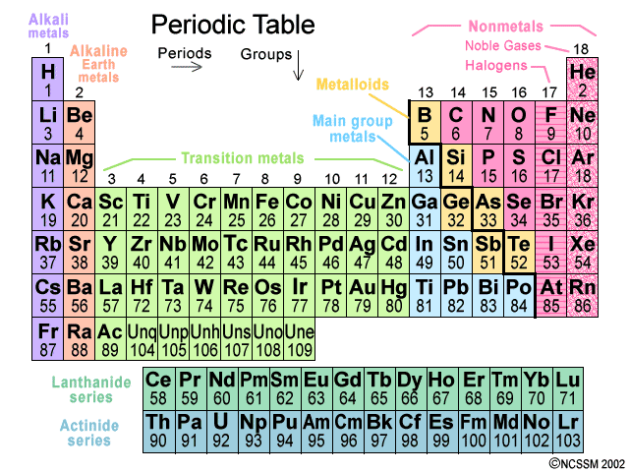

Answer:

Macroscopic properties: Elements in the same group (column) of the periodic table have similar chemical and physical properties.

e.g. All the group II elements (the alkali earths) are all metallic, form alkali solutions when mixed with water and form +2 charge cations when ionized.

Why is this? What is the underlying microscopic ‘answer’ that explains these facts?

Microscopic properties: Elements in the same group (column) of the periodic table have similar outer (valence) electronic configurations.

 | The loss /gain (ionic bonding), or the sharing (covalent bonding), of an atom’s outer most electrons IS chemistry (recall ‘old’ slide*)  Chemistry is ‘all about’ making new materials (as described by a chemical reaction’s equation) – to do this new bonds are made (in the products) and old bonds are broken (in the reactants). Bond making and breaking ONLY involves the outer valence electrons of atoms.

Remember Dr. Mills favorite saying……

 | “Chemistry is a bit like Scottish soccer – it’s basically a bunch of round things bumping into one another” | 
One time British soccer icon ‘Gazza’ with a gyro |  | Gazza playing out his career with Glasgow Rangers

The Electronic configurations of the first 20 elements

Seven Key fact

1.

2.

3.

4.

5.

6.

7.

Important definitions:

Electron ‘dot’ symbol: Includes BOTH outer (valence) AND inner (core) electrons

Lewis symbol: Includes outer (valence) electrons ONLY

Task: Draw electron ‘dot’ and Lewis symbols for:

Si

Cl

P

Add these Dot diagrams to your periodic table of electronic structure. Complete the table for all atom types up to Ca

Task: Complete the following table:

Atom | Group number | Number of valence electrons | Lewis Symbol

N

P

O

S

C

Si

 | Recall that the number of valence electrons an atom has is equal to its group number – this is why elements in the same group have similar chemical properties (similar valence configurations)

The Octet Rule (Full Valence Shell rule)

ATOMS WITH FULL OUTER (VALENCE) SHELLS ARE STABLE ⇒ Atoms will loose, gain or share electrons to have an inert gas (full valence shell) configuration.

THIS IS THE ‘DRIVING’ FORCE BEHIND ALL CHEMICAL PROCESSES (see slide).

Inert gas (stable electron shell) configurations

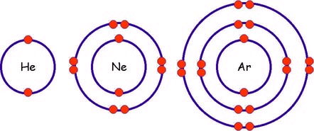
Examples:

1. Ionic bonding – the formation of LiF

Recall: Ionic bonds form between atoms (metal and non-metal, which then become ions) with a large difference in electronegativity

2. Covalent bonding – the formation of F₂ (g)

Recall: Covalent bonds form between atoms (two non-metals) with little or no difference in electronegativity

Simple Lewis Structures

Overview (recall your workshop): Lewis structures are electron ‘maps’ of molecules, which are in turn constructed from the Lewis symbols of the molecule’s component atoms.

Task: Complete the following table

Atom | Number valence electrons | Lewis Symbol | Valencey (number of bonds formed)

C

N

O

Cl

H

The number of bonds an atom forms in a molecule
≡
Number of UNPAIRED valence electrons (VALENCEY) it has

 | EZ Lewis Symbols – think of an unpaired valence electron as ‘a hand that needs to be held’ (I could not think of a more masculine analogy!). Then just have the atoms ‘hold hands’ (form bonds by converting unshared e⁻ to shared pairs of e⁻) to make the required molecule’s Lewis structure. H₂O example.

Task: Write formal Lewis symbols and ‘EZ’ Lewis symbols for the following atoms:

Atom | Formal Lewis Symbol* | ‘EZ’ Lewis Symbol**

C

N

O

Cl

H

*Always write the formal Lewis symbol on a test. **This is not to be written on any formal test!
Remember: Just have the atoms, as represented by ‘EZ’ Lewis symbols, ‘hold hands’ to make the required molecule’s Lewis structure
Task: Write Lewis structures for the following molecules.

Remember: Each atom in a molecule must have as many bonds as its valencey (number of unpaired electrons). Double or Triple bonds often arise from applying this rule.

Ammonia (NH₃) | Water (H₂O)
Methane (CH₄) | Phosphorus trichoride (PCl₃)
Oxygen gas (O₂)   | Nitrogen Gas (N₂)
Hydrogen Fluoride (HF) | Dihydrogen monosulfide (H₂S)

Recall: The total number of valence electrons in a Lewis structure is simply the some of those ‘owned’ by each of the molecule’s component atoms. Write this information next to each of the above Lewis structures.
Lewis Structures for More Complex Molecules - ‘The Rules’

Use the following rules to figure out the Lewis structure of ANY molecule (the above are simpler examples of the application of this ‘global’ set of rules)

Worked Example – Carbon Dioxide (CO₂)

- Sum the valence electrons from all the atoms in the molecule or ion.

For anions (-ve), ADD one e⁻ per negative charge on the ion
For cations (+ve), SUBTRACT one e⁻ per positive charge on the ion

⇒ For CO₂:

- Write the atoms on the page with the HIGHEST valencey atom in the center:

⇒ For CO₂:

- Connect the outer atoms to the center atom with single lines(s) – these bonds (pair of shared electrons) are the minimum requirement for a molecule to exist.

- Complete the valence shells of the ‘outside’ atoms to give them stable valence configurations.

- Count up all the electrons in the structure and compare to the number required (from rule 1). Place any excess electrons on the center atom.

- If the center atom does not have enough electrons for a complete valence shell, CONVERT ‘OUTSIDE’ LONE PAIR ELECTRONS TO DOUBLE BONDS. Remember that each outside atom’s valencey must also be obeyed.

- Double-check the valencey of all atoms and the total number of electrons in the structure.

Task: Follow the above rules to construct Lewis structures for the following molecules and ions:

- CHCl₃
- CH₂O
- CO₃²⁻

Is there more than one way to write the Lewis structure of the carbonate (CO₃²⁻) ion?

These ‘different versions’ of the Lewis structures are called resonance structures (class demonstration)

Let’s work on your molecular modeling lab now..
The Shape of Molecules – VSEPR Theory

The shape of any molecule in 3D can be determined by applying the Valence Shell Electron Pair Repulsion (VSEPR) Theory to a Lewis structure of the respective molecule

Electron pairs in the valence shell of a center atom (as drawn in a Lewis structure) repel one another as they have the same negative charge

The 3-D shape of a molecule is directly correlated to how the valence electron pairs are arranged in (3-D) in order to be as greatly separated from one another as possible

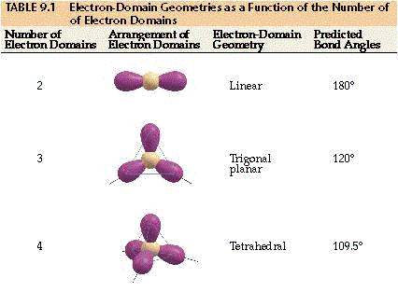

Consider each electron pair (bonded or lone) as ‘clumps’ of negative charge. These clumps adopt the above 3-D shapes in order to obey the VSEPR effect (see slide)

Examples: Draw Lewis structures and determine the 3-D molecular shapes of carbon dioxide (CO₂), methanal (CH₂O) and methane (CH₄).

Molecular shape vs Electronic shape

The molecular (where the atoms are) and electronic (where the ‘clumps’ of electrons are) shapes of molecules are often different

Recall: The valence electron pairs’ (bonded and lone) determine the overall electronic shape of the molecule

But: The positions of the molecule’s atoms relative to one another (after the electronic shape has been fixed) determine the molecular shape

Examples: Draw Lewis structures and determine the 3-D molecular and electronic shapes of methane (CH₄), water (H₂O) and ammonia (NH₃).
Question of the week: Draw Lewis structure(s) for the ozone molecule (O₃) and determine its molecular shape using VSEPR theory.

The relationship between molecular shape, electronic shape, numbers of bonding electron pairs and lone pairs of valence electrons

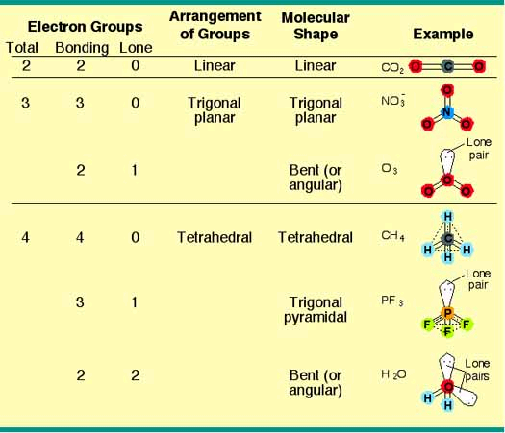
Examples of Electronic and Molecular Shapes
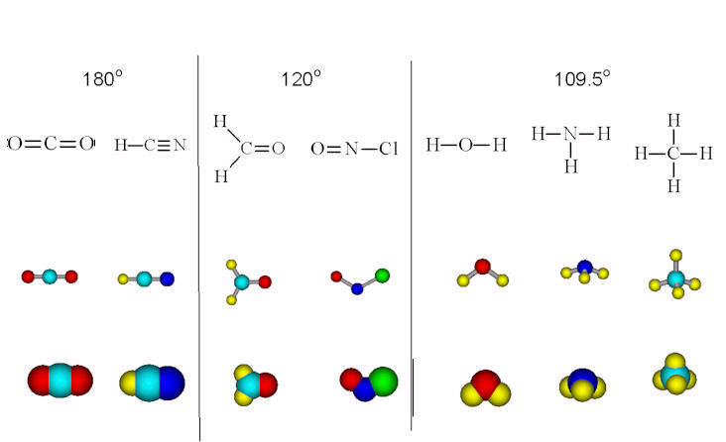

Check: Which of the above structures have ‘hidden’ lone pair electrons that, in turn, determine the respective molecular shapes illustrated? Sketch Lewis structures for one ‘new’ example.

 | “Lewis”  The following question was taken from your 3rd practice midterm:

Question 3a (20 points): Draw Lewis structure(s) for the CO₃²⁻ anion, include all possible resonance form(s).

Question 3a (5 points): Use VSEPR theory to predict the electronic and molecular shape of the carbonate (CO₃²⁻) anion.

Electronic shape:

Molecular shape:

