Modern Atomic Theory – Part 2

Reading: | Ch 11 sections 1 - 10 | Homework: | 11.2 questions 4, 6 (see lab)  11.7 questions 30, 32*, 36*  11.8 questions 40, 44  11.9 questions 50*, 52*, 54*  11.10 questions 58, 60*, 62, 64
* = ‘important’ homework question

Modern View of the Electronic Structure of Atoms – ‘Wave’ Models

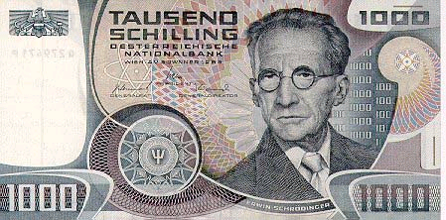  Erwin Schrödinger, as seen on a one thousand schilling Austrian bank note in the late 1930’s. | Background: The turn of the 20th century was a golden era for the physical sciences. Einstein was working towards the theory of special relativity (and was receiving all the attention), while Erwin Schrödinger was quietly ‘turning the science on its head’ by redefining how scientists fundamentally think about matter, particularly ‘small’ particles, such as electrons.

 | Schrödinger’s great genius was devising a form of math that explained the behavior of electrons (or any other ‘small particle’) in terms of WAVE, rather than PARTICLE, math. We will use the results of this ‘wave’ math (quantum mechanics) not figure it out (very hard!)
   | Instead of electrons ‘orbiting’ a nucleus (PARTICLE MODEL), they are now known to exist as waves in diffuse clouds around the nucleus (WAVE MODEL).
“So, you are telling me electrons aren’t particles anymore?”
Got proof?? Yes!

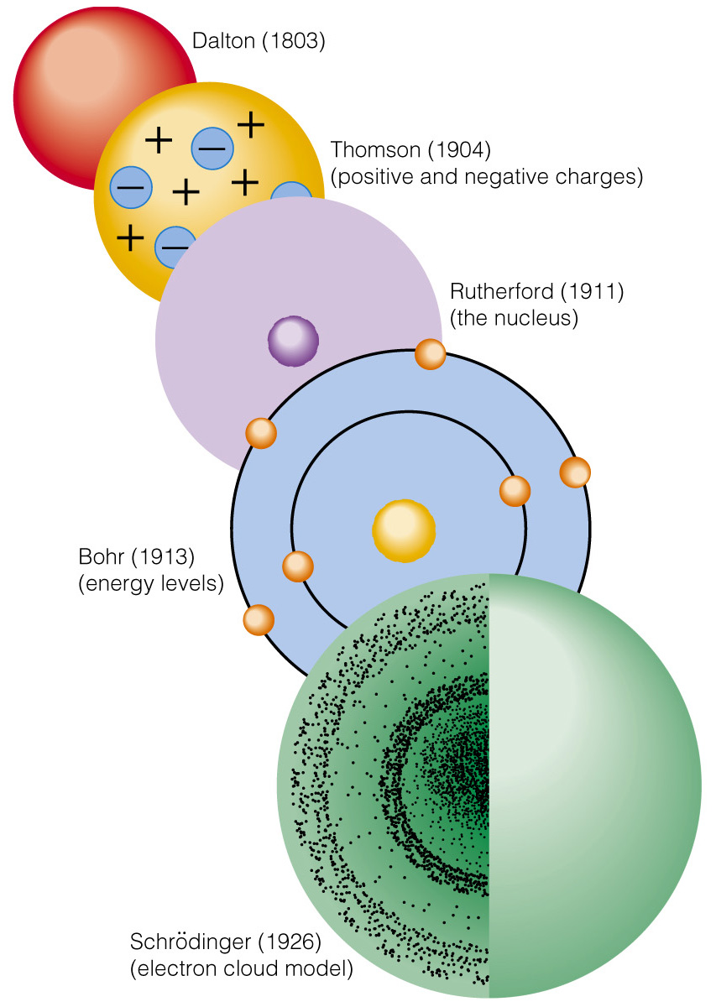 | 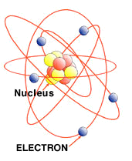
 | Classical (particle) model of a boron atom
 | 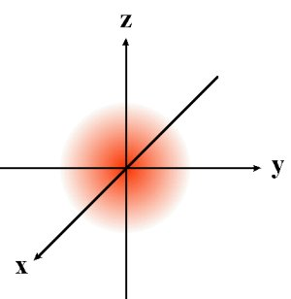
Evolution of the wave model of electron behavior | Electron density map (wave) model of a hydrogen atom

The Power of the Schrödinger Equation (‘wave’ math)

Solving the Schrödinger equation for valence electrons tells you their position and energy (i.e. everything about them). You can then determine their interactions with one another
**THIS IS CHEMISTRY**

We will use the RESULTS* from such calculations in order to better understand atomic structure (i.e. where electrons are located in atoms)

*ask me to tell you a scary story from grad. school!

The Schrödinger Equation (the new ‘wave’ math – celebrated by nerds the world over)

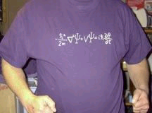 | 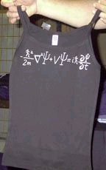 | 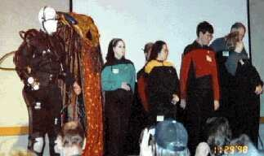
The Schrödinger equation, as seen on his and hers ‘nerd’ T shirts at Star Trek Conventions, Physics conferences etc.(left and above). Hard core ‘Trekies’ (right)

Comparison of Dot and Electronic orbital diagrams

Recap: In the 1920’s it was shown (mathematically) that the electrons exist as waves in discrete, uniquely shaped ‘clouds’ called orbitals. Thus ‘dot’ and Lewis models we have been using are empirical, in other words early chemists knew they worked, but were not sure why. The new math (called quantum mechanics) changed all that…..

The FIRST two electrons in every shell (each row in the periodic table) ‘live’ in a spherical ‘cloud’ called an ‘s’ orbital

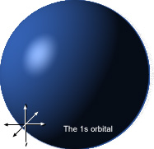 | Example: Hydrogen is in the first row of the periodic table and has 1 electron - its electron is said to be in the ‘1s’ orbital of the first shell.  Hydrogen has 1 electron, so has the electronic configuration:  H : 1s¹  Important: the ‘1’ superscript is not a mathematical power, it just says how many electrons are in the orbital.

Example: Sketch a ‘dot’ and modern orbital diagram illustrating the electronic structure of He.

Dot symbol | Orbital sketch

There can be a maximum of 2 electrons per orbital (‘cloud’), this is why there are only 2 elements in row 1 of the periodic table - H and He have a single 1s orbital (which can hold a max. of 2 electrons).

The FIRST and SECOND electrons in shells 2 and 3 (rows 2 and 3 in the periodic table) of elements ‘live’ in a spherical ‘s’ clouds (sub shells) – 2s and 3s respectively.

The further the shell is from the nucleus, the larger it is (like blowing up a balloon, they ‘inflate’)

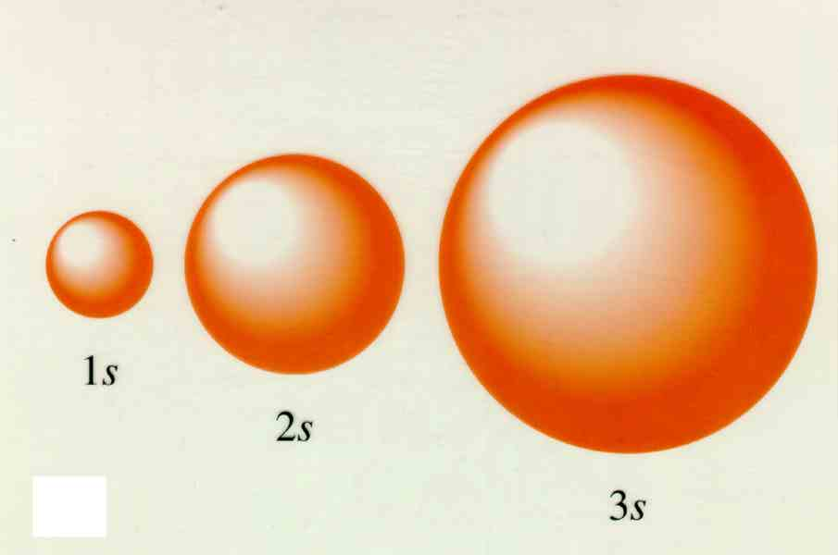 | Comparison of the 1s, 2s and 3s sub shells. Recall that even though the ‘clouds’ (orbitals) become larger, each can still hold a maximum of only 2 electrons.

Problem: The second and third rows of the periodic table have 8 elements, so they must have orbitals that can hold up to 8 electrons. Can an ‘s’ orbital hold 8 electrons?

Answer and conclusion:

The THIRD - EIGHGTH electrons in shells 2 and 3 (rows 2 and 3 in the periodic table) ‘live’ in a dumbbell shaped ‘clouds’ (sub shells) called ‘p’ orbitals.

Recall: there can be a max. of 2 electrons per ‘cloud’ (orbital), so since there are 8 elements in rows 2 and 3, these shells must contain one ‘s’ and three ‘p’ sub shells (1 x 2 electrons & 3 x 2 electrons per orbital respectively)

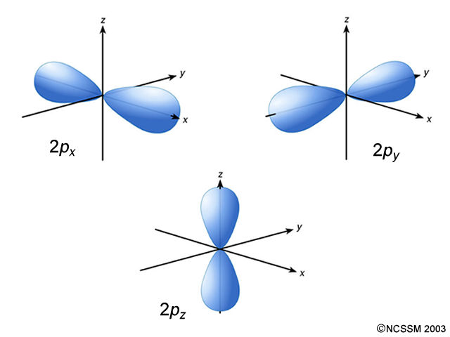 | Since there can only be 2 e⁻ per orbital, and there are 6 more elements (therefore 6 more electrons) beyond the 2 e⁻ in the ‘s’ orbital, there must be three more ‘p’ orbitals in each shell.  Fact: There are p_{x}, p_{y} and p_{z} orbitals – these make up the p sub shell  Nitrogen has the electronic configuration:  N: 1s²2s²2p³

The three 2p orbitals shown together:

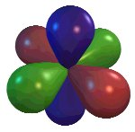
Overview comparison between dot and orbital models:

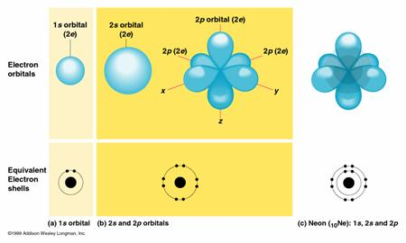

Side by Side Comparison of the Two Types of Model
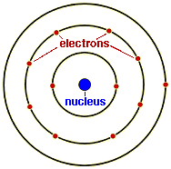 | 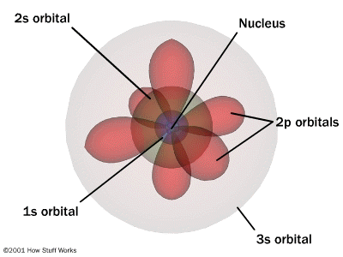
Particle model | Wave Model

Task: Sketch a ‘dot’ and modern orbital diagram illustrating the electronic structure of Oxygen.

Dot symbol | Orbital sketch

 | Think of orbitals as empty parking spaces in a very large parking lot (like at Dodger stadium). An atom has a fixed number of electrons (‘cars’), which fill these spots, starting closest to the nucleus.  Each atom has the same large parking lot, it’s just the number of filled spots that change for each atom. The location of each space can be determined mathematically by solving the Schrödinger Equation

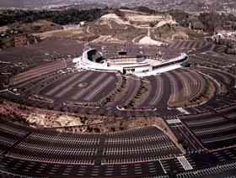 | 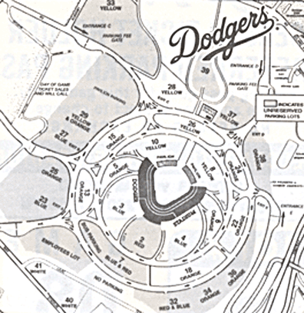
Dodger Stadium and its parking lot | The Dodger Stadium parking lot

This analogy is useful for writing electronic configurations….
Writing Electronic Configurations

‘Read across’ the period table while applying the filling of orbitals rules (i.e. ‘parking electrons’) to obtain the electronic configuration of any element. This methodology is illustrated in the following version of the periodic table:

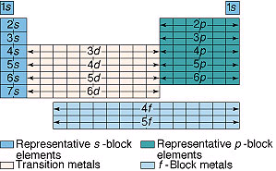

The order of filling orbitals is:

1s² 2s² 2p⁶ 3s² 3p⁶ 4s² 3d¹⁰ …….

Task: Complete the above filling scheme up to the element with its last 3 electrons in the 5p orbital. Which element is this?

Aside: Ever wondered why elements in columns 1 and 2 are called the ‘s’ block elements and those in columns 3 – 8 the ‘p’ block elements? It’s because that sub shell is the last one ‘being filled’ during the processes of assigning electron addresses (‘parking spaces’).
Task: Write electronic configurations for Li, Na, C and Si. Do you notice anything familiar about the number of electrons in each atom’s valence shell?

Li: | C:
Na: | Si:

Answer:

Note: Since the valence electrons are of most interest, electronic configurations are often abbreviated using [He], [Ne] etc. to represent the appropriate core configuration.

Electronic configurations of Chlorine (see next page for help)

‘Standard’

Cl:

‘Abbreviated’

Cl:

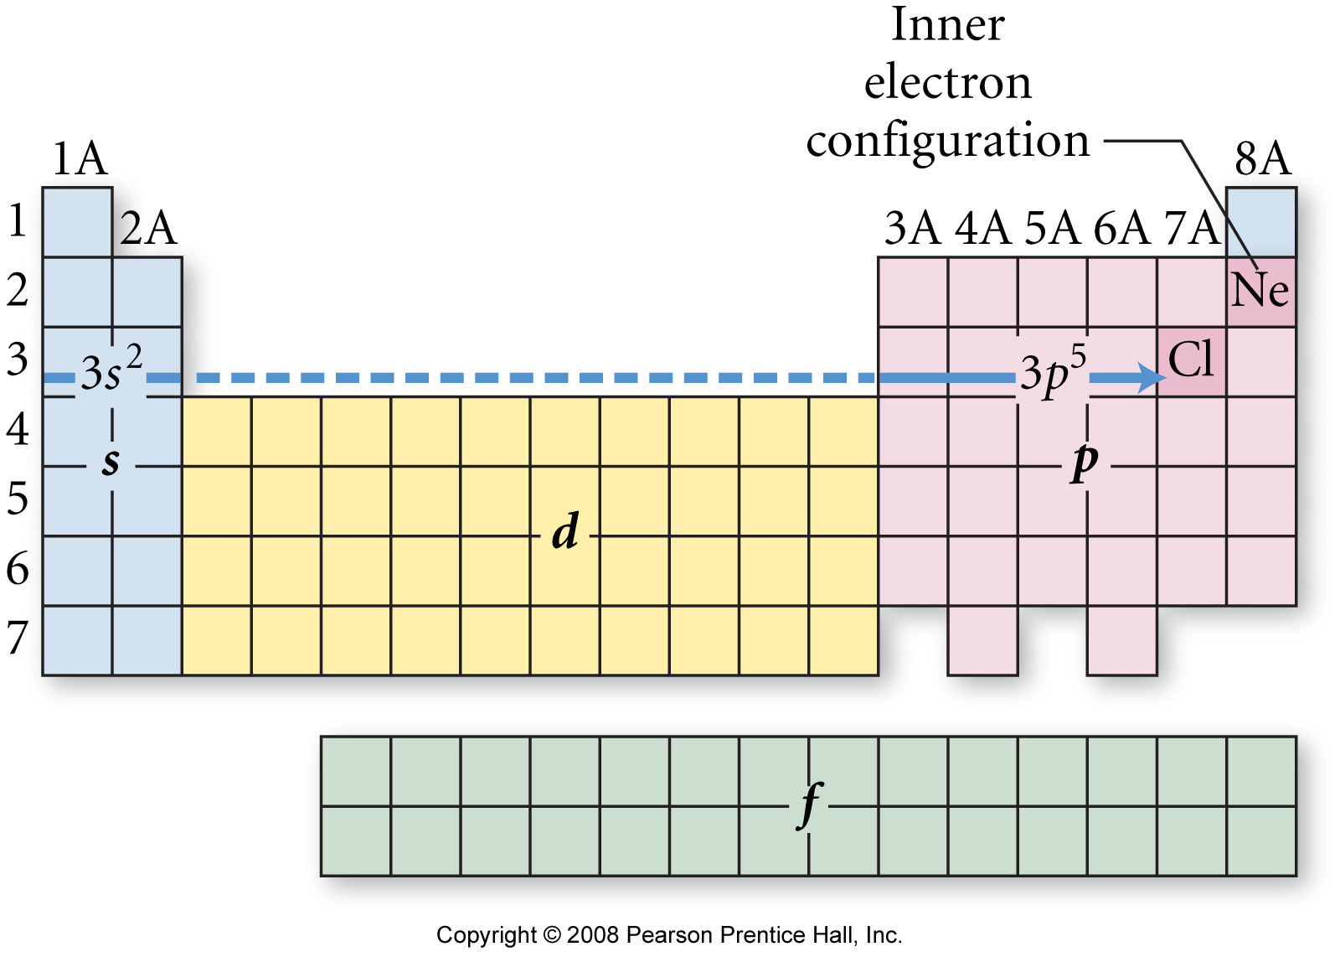

Wrap up: Determine the following atoms’ electronic configurations of the by ‘reading across’ the periodic table

Li: |  | or | Li:
Al: |  | or | Al:
Xe: |  | or | Xe:

Orbital Diagrams:

Electronic configurations can also be written as orbital ‘box’ diagrams

Each orbital (which can contain up to 2 electrons, recall) is represented by a box.

Degenerate orbitals (e.g. 2p, 3d orbitals, which just differ in ‘direction’) are written as connected boxes.

The order of filling orbitals – a comparison of styles

Electronic configuration:

X: 1s² 2s² 2p⁶ 3s² 3p⁶ 4s² 3d¹⁰ …..

Equivalent orbital sketches:

Equivalent orbital ‘box’ diagram:

X:
 |  |  | 1s |  | 2s |  | 2p |  |  |  | 3s |  | 3p |  |  |  | 4s |  | 3d

Example: Draw an orbital box diagram for Fe*

Fe:
 |  |  | 1s |  | 2s |  | 2p |  |  |  | 3s |  | 3p |  |  |  | 4s |  | 3d

Task: Write electronic configurations, orbital box diagrams, and draw ‘old style’ dot diagrams illustrating the electronic structure of:

 | Electronic configuration | ‘Orbital’ box diagram | Dot diagram
Li
N
F
Na
P
Cl

 | “Electron addresses”  The following question was taken from your 3rd practice midterm:

Question 2a (10 points): Draw Lewis symbols and ‘Dot’ structures for the following:

Atom or Ion | Lewis Symbol | Dot Structure
C

O²⁻

Question 2b (15 points): Draw orbital ‘box’ diagrams and write electronic configurations for the following atoms and ion:

Carbon atom
Orbital ‘box’ diagram:

Electronic Configuration:

Oxide anion
Orbital ‘box’ diagram:

Electronic Configuration:

Sodium atom
Orbital ‘box’ diagram:

Electronic Configuration:

