Temperature and Density

Reading: | Ch. 2 sections 7 - 8 | Homework: | 2.7, questions 70, 72, 74*, 76, 78  2.8, questions 82, 84, 88*, 90*, 94, 96
* = ‘important’ homework question

Temperature

Background: There are three temperature scales in common use today. Can you name them?

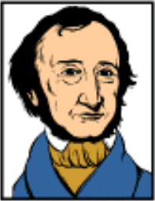 |  | 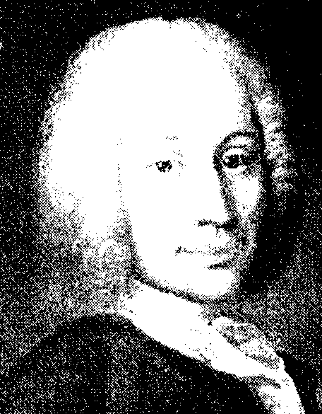 |  | 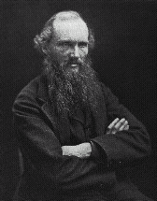

How were the end points of the two ‘metric’ scales defined? In other words, what natural conditions define these respective temperature values?

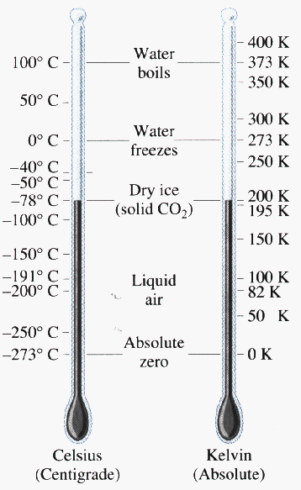 | 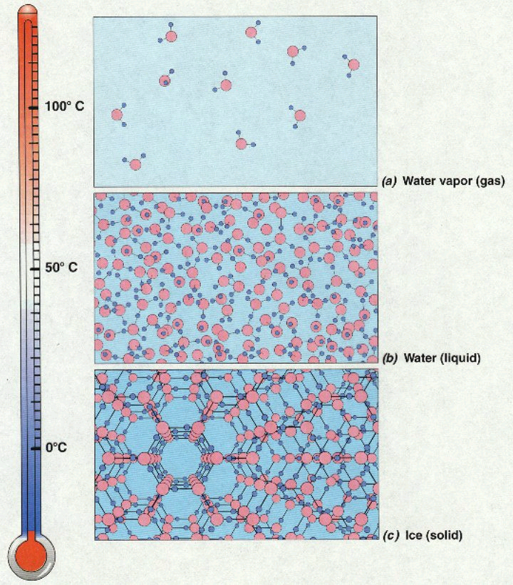
The Centigrade and Kelvin Scales | The Centigrade scale compared to the state of H₂O
Converting between Degrees Celsius and Kelvin

Task: By looking at the above graph, describe how the ºC and K scales are related. What do they have in common? What is different?

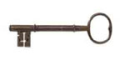 | 1.  2.

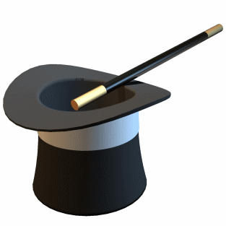 | Simply add 273.15 to ANY temp. quoted in ºC to obtain the equivalent K value  OR  Simply subtract 273.15 from ANY temp. quoted in K to obtain the equivalent ºC value

Examples:

- What is 50ºC in Kelvin?

- What is 200 K in Celsius?
Comparing the Fahrenheit, Kelvin and Celsius Temperature Scales

Discussion: We saw that the end points for the ºC scale corresponded to specific ‘natural’ temperatures – the same is true for the ºF scale. What ‘natural’ temperatures do you think 0 ºF and 100 ºF correspond to in nature. How about 212 ºF and 32 ºF?
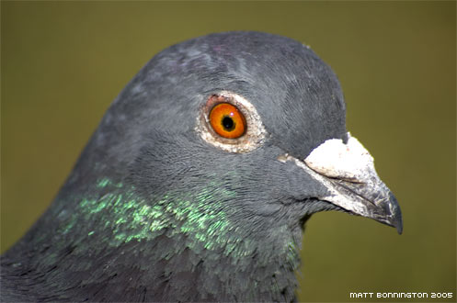
“You want to put
what,where?!..”
Diagram: Fahrenheit, Celsius and Kelvin thermometers side by side.

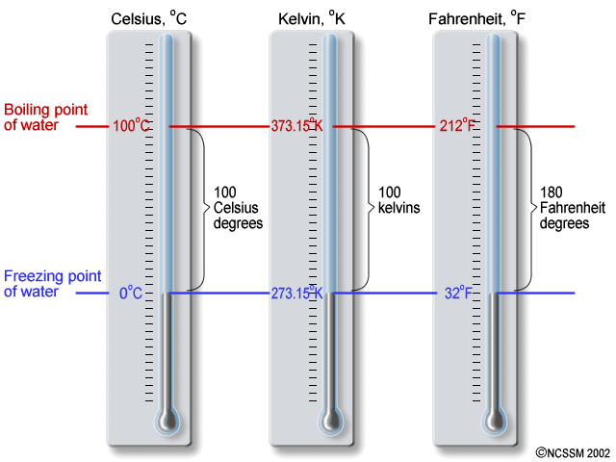

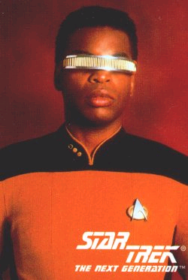 | Question: What is the obvious error in the above diagram?
Task: By looking at the previous diagram, or the slide provided, describe how the ºC and ºF scales are related. What do they have in common? What is different?

The two basic differences between the ºC and ºF scales allow for equations relating them (conversion equations) to be constructed:

For converting ºC to ºF:

For converting ºF to ºC:

Question: What is 90 ºF in ºC and in Kelvin?

Ask me about the extra credit temperature….
Temperature Ranges

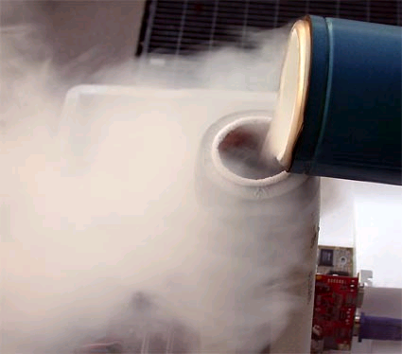 | Discussion: If something is boiling, is it necessarily ‘hot’? If it is frozen, is it necessarily ‘cold’?
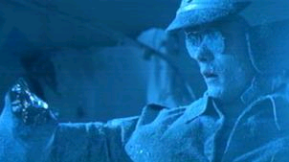

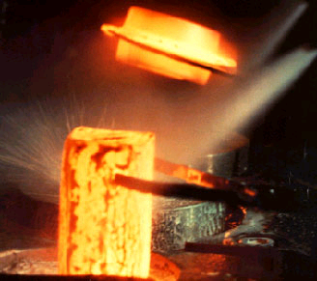

Task: View and make brief notes on the ‘temperature scale’ slide. Think of the ‘hottest’ and ‘coldest’ things you come into contact with on a daily basis – where do they fit into the ‘bigger picture’?

Density

NOTE: THE FOLLOWING IS A REVIEW OF THE MATERIAL YOU WILL LEARN DURING LAB #2.

Review: How was the property of density defined during a previous lecture?

Density:

Where: ‘amount of matter’ = _______________

Discussion: What is the S.I. unit of density? Is this a convenient unit?

⇒ Density = | __________________________________

Question: What are the two ‘convenient’ derived S.I. units of density used by chemists?

Density Math

Recall: Density is defined by a simple equation, which has three related forms:

1. | 2. | 3.

If you have problems with cross multiplication, remember that ‘pyramids’ can also be used to solve density and other 3 variable equations:

Example: 23.5 mL of a certain liquid weighs 35.062 g. What is the density of the liquid? What mass will 20mL of this liquid have?

Density Applications

Finding the Volume and / or Density of Solid Objects

NOTE: THE FOLLOWING IS A REVIEW OF THE MATERIAL YOU WILL LEARN / HAVE LEARNT DURING LAB #2.

Irregular shaped objects

Any Object will DISPLACE it’s own volume of water when submerged

Recall lab: Sketch the apparatus you used to measure the volume of the rubber stopper:

1. Before the stopper was added | 2. After the stopper was added

Example: A solid object weighing 15.250 g is submerged in water, during which time the water level rose from 50.0 mL to 60.2 mL. What is the density of the object?
Regular shaped objects

Regularly shaped objects (cubes, ‘bricks’, spheres, cylinders, cones….) have equations that define their volume.

Task: Sketch the following 3-D shapes and list the equations that define their volume (see your text book)

Sketch of 3-D Shape | Volume equation
Cube | V =
‘Brick’ | V =
Sphere | V =
Cylinder or disk | V =

1. Find the volume of the object in question via the equation that defines its volume (be sure to use cm for all length dimensions).

2. Substitute the derived volume value in D = M/V to find the object’s density (recall that mass is measured in grams).

Recall: the radius of a circle equals half of it’s diameter (i.e. dia.= 2r)
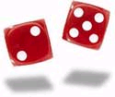 | Example: Dice used in Las Vegas weigh 2.65 g and have sides of length 1.2 cm. What is the density of a Las Vegas dice?

Densities of common materials

Material |  | State (s), (l) or (g) | Density (g/cm³)
Oxygen |  |  | 0.00133
Ethanol |  |  | 0.785
Water |  |  | 1.000
Iron |  |  | 7.87
Silver |  |  | 10.5
Lead |  |  | 11.34
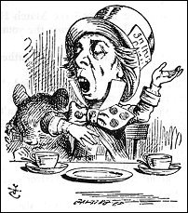 | Mercury |  | 13.6
Gold |  |  | 19.32
“Will it Float?”

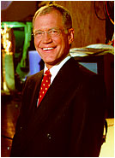 | The David Letterman Show on CBS often features a segment called ‘Will it Float’. Simply, Dave and Paul try to determine if an object, such as a refrigerator or 100 ft of insulation cable, will float when dropped into a large container of water.

Question: What physical property of a material will determine ‘if it will float’? What would be a more scientifically accurate (if less catchy) name for the ‘Will it float’ segment on Dave’s show?

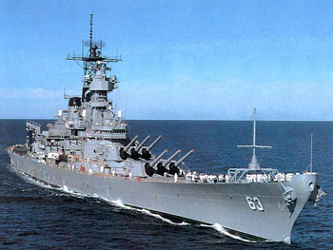 |  | Discussion: “Battleships and dating advice”

Task: Using the table supplied above, sketch a picture of what would happen if ~30 mL samples of ethanol, mercury and water, as well a silver dollar and a gold ring were added to a volumetric cylinder.

Question of the week (group work)

If a 200 mg piece of gold is hammered into a sheet measuring 2.4 ft by 1.0 ft, then what is the sheet’s thickness in meters? If a gold atom is 0.26 nm wide, how many atoms thick is the sheet?

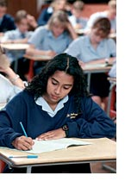 | “The Wire” & “Sketch”  The following questions were taken from your 1st practice midterm:

A copper (Cu) wire has a mass of 4.00 pounds and a diameter of 5.00 mm. Determine the wire’s mass and in the units specified below. Include any appropriate decimal prefixes in your final answers. Density of copper = 8.95 g/cm³

Mass of the wire in kg:

ANS: 1.81 kg (3 sf)
Volume of the wire in cm³:

ANS: 202 mL (3 sf)

Sketch a fully labeled diagram illustrating the appearance of a 100 mL cylinder after the following items have been added to it:

Material | Density (g/cm³)
40 mL D.I. water | 1.000
A medium sized silver ring | 10.50
40 mL liquid mercury | 13.6
A small gold coin | 19.32
20 mL Olive oil | 0.756

ANS: | Top | Olive Oil
 |  | D.I. Water
 |  | Silver ring
 |  | Mercury (l)
 | Bottom | Gold coin

