Units and Significant figures

Reading: | Ch. 2 sections 3 - 5 | Homework: | 2.2, questions 15,16, 18,  2.5, questions 38, 39, 42*, 44*
* = ‘important’ homework question

Common Units

Discussion: List some common units of measurement we use on a daily basis. How did these units originate?

 | Quantity measured | Familiar Unit
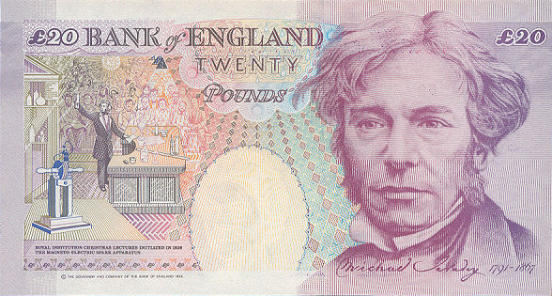 | Mass
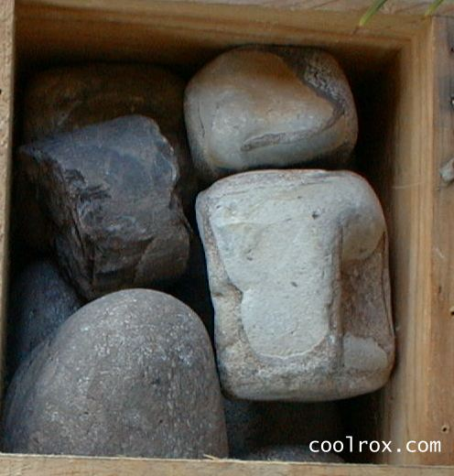

Question: What are the ‘metric’ (S.I.) versions of the everyday units listed above?

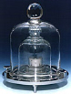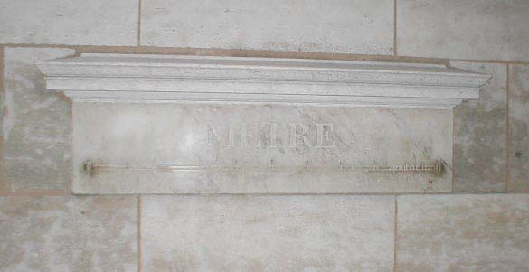 | Quantity measured | Fundamental S.I. Unit (base unit) | Symbol

Notes: SI base units are used to determine derived S.I. units, as discussed below. Some S.I. base units feature a decimal prefix – which one(s)?
Discussion: Why do scientists prefer the S.I. system?

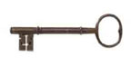

Derived S.I. Units

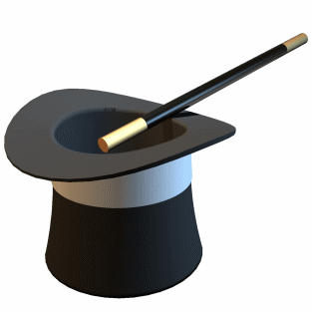 | Insert appropriate S.I. base units into an equation that defines the respective derived S.I. unit. Example:  Area = length x length = m x m = m²  ⇒ the derived S.I. unit for area is m²

Determine derived S.I. units for the following quantities

Quantity measured | Math involving S.I. base units | Derived S.I. unit

Volume

Velocity (speed)

Density

Force*

Energy*

*These are harder examples. To solve them start by inserting appropriate S.I. base units into an equation that defines the quantity sought.
Questions:

Is the S.I. unit of volume (m³) reasonable for everyday applications? Why?

What unit of volume do chemists prefer? Why?

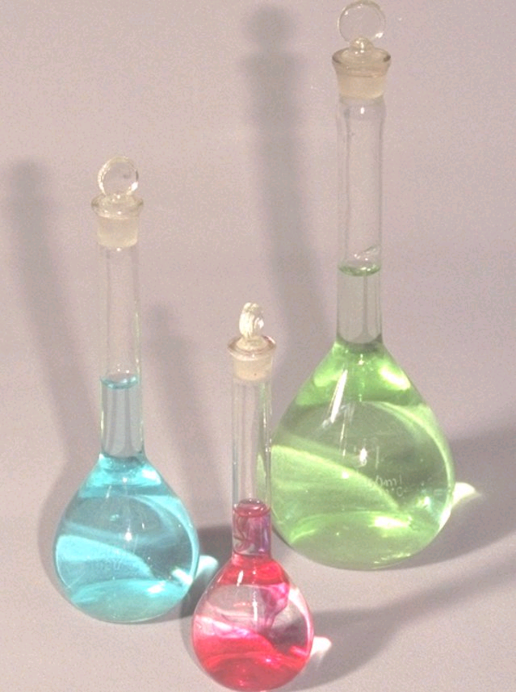

More detail on the chemist’s volume unit

Significant Figures and Rounding Off

Question: What are significant figures?

Task: Measure the length of your pencil (or some other object) in cm using a standard ruler. To how many sig. figs can you determine this value?

Object | Size of measures (cm) | Number sig. figs.

Let’s figure out the rules for sig. figs. What is:

1.002 to | 3 sig. figs.
 | 1 sig. fig.
569.74 to | 3 sig. figs.
 | 4 sig. figs.
 | 1 sig. fig.
0.00017 to | 1 sig. fig.

Zeros before the first number are NOT counted as significant

Zeros after the first number ARE counted as significant

Round UP if the number after the last significant digit is > 5

Quote numbers in SCI notation if number sig. figs. < digits before decimal point.

Multiplication and division (99% of your work is either one and/or the other)

The result of any multiplication or division has the same number of sig. figs. as the measurement with the lowest number of sig. figs. Example: A sample of lead has a mass of 2.105 g and a volume of 0.11 mL. What is the density of lead?

Answer:

Another example: What is the area (in ft²) of a 12.5 ft x 24 ft room?
What common mistake was made in the determination of length here?

