Why Chemistry?

“What’s my motivation?”

Why are you sitting in this class? In other words, why chemistry?

Task: Write down as many reasons as you can that explain why you are taking this class:
(We will also justify responses relating to 3rd party requirements during the session)

Professional programs that benefit directly from a background in chemistry

1. Nursing and allied health (pre-pharm., pre-med., pre-dentistry)

Example: Chlorothiazide (Diuril) is ordered b.i.d. for a infant weighing 6.5 kg. It is supplied in elixir form 100 mg/tsp. The recommended dosage for Diuril is 25 mg/kg/day. How many cc’s should the nurse give to the child for each dose?

  - 6.15 cc.
  - 8.13 cc.
  - 4.06 cc.
  - 0.81 cc.

2. Engineering (mechanical, civil, chemical, electrical)

Example: Your company decides to import child safety seats manufactured in Asia. Unfortunately, the safety guidelines for the seats are quoted in ‘metric’ units. The label reads: “Do not exceed a 150 N load” and you must use this information to determine the maximum weight a child must not exceed in order to be protected during a collision at 55 mph. Can you do it? A child’s life, not to mention the financial future of your employer, may depend on your ability to solve questions such as this.

3. Everyday / Real life situations

Example: It is time to re-carpet your 12 ft x 24 ft. family room. You visit a few carpet stores and select a brand that costs $ 20.50 per square meter. The sales person quotes you a total price of $749 – is this price fair, or have you just been taken advantage of?

** We will return to and solve each of these three problems at some point during the course

Discussion:

What do all three of the above examples have in common?

Which professions (or professionals) utilize such skills most commonly?


Hint, “I pretend to be one on occasion”


The “Cognitive Elite”

Discussion: What do you think the phrase “cognitive elite” actually means?

Data from ‘The Emergence of a Cognitive Elite’ (Chapters 1 and 2 of The Bell Curve).

 | - People with IQ’s of > 120 (the top 10%) preferentially enter the 10 or so ‘High IQ professions’ discussed above.  - Developing good cognitive skills is essential to entering and being successful within the ‘High IQ’ and related professions. We are the first link in the chain

Example: ‘Medical chain’

Increased Problem Solving Ability

Take home message: People with good cognitive / problem solving skills preferentially find employment within fields of their choosing that are financially rewarding and/or intellectually satisfying.

A question of some importance: How can one’s cognitive skills be improved?

Answer(s):

The Role of Chemistry as a Prerequisite Course

Key facts and results:

Fact: The problem solving skills routinely utilized in the ‘high IQ’ and related professions (such as nursing, business management, accounting, etc.) are introduced, learnt and mastered during physical science courses.

Result: Professional programs and subsequent employers insist that their candidates have a background in one of the physical sciences – both for specific (allied health, engineering) and general (your family room carpet) reasons.

Fact: Study within any of the ‘high IQ fields’ will increase cognitive skills, but only the physical sciences do so via the study of fundamental, everyday phenomena so are of broad relevance and interest (we all interact with and benefit from the manipulation of matter on a daily basis after all).

Result: Chemistry (and physics) may be considered to be the ‘gatekeepers’ of cognitive learning – chemistry in particular introduces, develops and subsequently equips students with cognitive skills necessary to succeed in their chosen careers

Take home message: While the direct relevance of chemistry to your chosen course of study may at times seem tenuous, remember that the cognitive skills developed during such programs of study are of significant importance to your professional development and employability. In essence, this is why you are here.

How Chemistry is Perceived & Skills Needed to Succeed in Chemistry

How Chemistry is Perceived:

Discussion: How did your friends and family respond when you told them you were taking a chemistry course this semester??

[“Frank” slide]

Study Skills Needed to Succeed in Chemistry:

Fact: As discussed above, chemistry is all about the student developing and learning to apply problem solving skills - your study habits should reflect this. Do NOT fall in to the trap of believing you can learn chemistry simply by memorizing the information from your text – you must practice applying this information, not just be familiar with it.

Result: Successful chemistry students typically spend most of their independent study time working assigned problems, not just reading about them. To learn chemistry you must do chemistry is a truism worth remembering. An analogy would be this: you read all the books out there on the subject of golf, but don’t get round to swinging a club – what do you think happens when you tee off for the first time?

Fact: Chemistry relies on a cumulative method of learning, i.e. theories learnt from week 1 onwards will be repeatedly applied all the way through the course. Thus, it is important that the student does not let any ‘gaps’ in their knowledge develop. This fact exemplifies the differences in philosophy between the sciences and arts, as art courses are often more modular in nature. Example: I overhead a student tell another: “Yeah, I blew off reading the first book in my English class, but read the second one and got a ‘B’”. This method of study is not recommended in chemistry!

 | Analogy: Building a tower
Result: Successful chemistry students typically have exemplary attendance records. In some cases they may not be the ‘best’ students, but guarantee themselves a better grade than more capable students, who in turn typically may miss as few as one or two lecture sessions (this is especially true with regard to 3 hr. class sessions).

Pictorial analogy of attendance vs cumulative knowledge

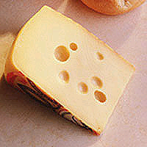 | 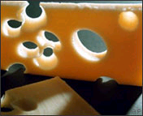 | 
‘I missed a lab’ | ‘I missed a lecture’ | ‘I missed a couple of lectures’

Don’t ‘Swiss cheese’ or ‘torpedo’ your chances of passing the course because of missed work!

Take home message: Simply by attending class regularly and completing the HWK assignments you essentially guarantee yourself a passing grade for the course, while, due to the nature of the material, deviating from this approach may ensure the opposite

What is chemistry? What do Chemists do?

Reading: | Ch 1. (all) | Homework: | 1.2 questions 5, 6  1.5 questions 14, 16*
* = ‘important’ homework question

Task: In your own words describe what you consider chemistry to be, plus make a list of what you think the job of a chemist is:

What is chemistry?

“Official” definition of what chemistry is:

Key words:

Matter: “Stuff” – anything with mass and volume. Can you think of anything without mass or volume?

The States of Matter – what are they? Are there any more?

What are the basic building blocks of all matter, be it a diamond, a tree or the air around us?

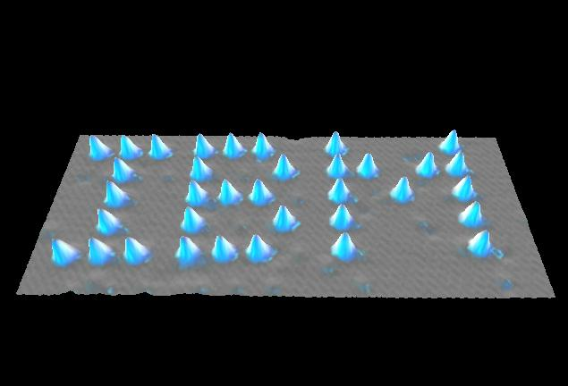 | 
‘High Tech’ science (STM or AFM, top left) is often based on simple ideas (gramophone, top right). Click logo for ‘flyby’.

 | All Matter is made from Atoms – the chemical formula of the matter tells you the number and type(s) of the atoms ‘inside’.

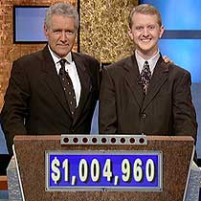 | ‘Jeopardy’ Example:  Answer: ‘H₂O is the chemical formula of this common form of matter’  Question:

Examples | Chemical Formula
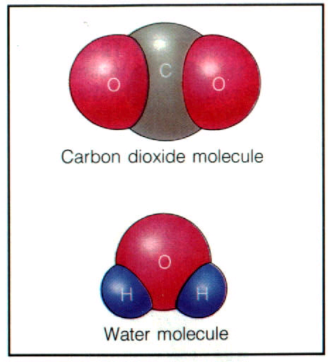

Important
 | Atoms and molecules are MICROSCOPIC particles (they are very, very small), you cannot see them with your eye!

A drop of water is a MACROSCOPIC particle (because you can see it, hold it in your hand etc.) – it contains many, many, many individual molecules of water!
What do chemists do?

“Official” definition of what chemists do:

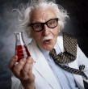 | Chemistry in action: Explaining what happens on your BBQ grill.  The burning of a charcoal brick on your backyard grill (MACRO) explained in terms of a balanced chemical equation (MICRO)

ANY large (MACRO) scale chemical process can be described using a MICRO scale chemical equation featuring individual atoms and/or molecules

Cartoon representation of the reaction of the pertinent atoms and molecules

The Chemists’ description – a balanced chemical equation. This process is repeated many billions of times (MICRO) for the burning of a charcoal briquette (MACRO)

