Chemical Bonding and Periodic Trends

Reading: | Ch 12 sections 1 – 4  Ch 11 section 11 | Homework: | 12.1 questions 4, 6  12.2 questions 8, 10, 12*, 14*, 16  12.3 questions 24, 26, 28  11.11 questions 74, 76, 80*, 82*
* = ‘important’ homework question

Discussion: In simple terms, what is a chemical bond? What does a chemical bond do?

Recall: From Modern Atomic Theory 1 we know there are two general types of bond – IONIC and COVALENT

Ionic bonds – form due to a large difference in electronegativity between the bonding atoms (which subsequently form ions via electron transfer)

Generic

Lithium Fluoride

 | Recall that ELECTRONEGATIVITY is the ability of an atom to attract electrons.  The trend is low (metal, left of p. table, electrons easily lost) → high (non-metals, right of p. table, electrons more greatly attracted)

Trends in Electronegativity*:
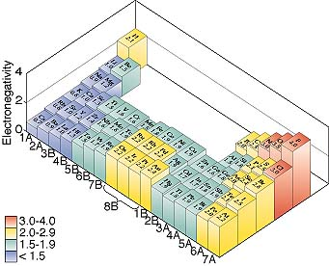
*Electronegativity is not a true atomic property – it is a derived mathematically from other atomic properties (see later)

Covalent bonds – form due to a low difference in electronegativity between the bonding atoms (which subsequently share a pair of electrons)

Examples: H₂ (slide),F₂ (both have pure covalent bonds – no difference in electronegativity)

Recall: the driving force behind the formation of covalent (and ionic) bonds is the formation of a full valence shell.
Polar Covalent Bonds - are a mixture of ionic and pure covalent bonding types. The electrons are shared (as in a covalent bond) but are drawn closer to the more electronegative atom (as in an ionic bond)

The atoms involved in POLAR covalent bonds are typically BOTH non-metals, but ALSO have a large difference in electronegativity.

Common examples of polar covalent bonds are H-F and H-O

Examples: H-F and H₂O

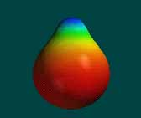 | 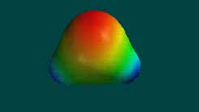
Electron density map of HF | Electron density map of H₂O

Molecules with dipoles

Polar covalent bonds create a separation of charge in the respective molecule

Such a separation of charge is known as a dipole. Molecular dipoles are represented by an arrow with a ‘+’ at the positive end of the molecule

Task: Sketch diagrams of HF and H₂O that show their respective molecular dipoles (slide)
Electronegativity Values

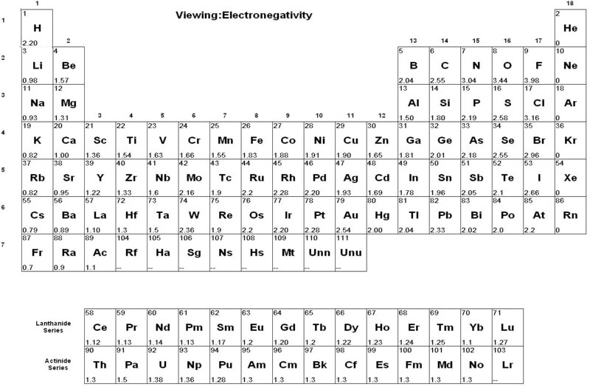

Discussion: Do you think that electronegativity values are determined experimentally or calculated? Look at the values presented in the above table to help make your decision. How can electronegativity differences between atoms be determined? How does this relate to bond type?

Electronegativity values for most atoms are known – they are calculated from a variety of atomic properties, including nuclear charge and atomic radius (see next section)
The type of bond that exists between two atoms depends on the respective atoms’ difference in electronegativity

‘Ball Park’ determination of bond type (based on electronegativity differences)

Δ Electronegativity | Bond Type
0 → 0.2 | Covalent
0.3 → 1.6 | Polar Covalent
1.7 → 3.3 | Ionic

Task: Determine the type of chemical bond that exists between the following pairs of atoms

Bonded atoms | Δ Electronegativity | Type of bond
H-Cl

Cl-Br

Na-F

N-O

C-O

The Origins of Electronegativity – ‘True’ Atomic Properties

As with electronegativity, essentially all other periodic trends follow the same general ‘bottom left to top right’ scheme. This is because electronegativity is determined from these ‘true’ atomic properties. See generic diagram the below. The periodic trends examined will be:
Atomic Size (radius) | 1st Ionization Energy

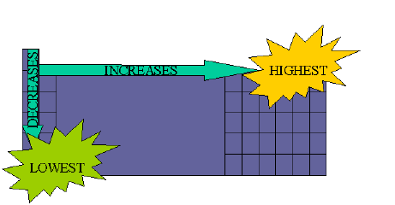

Atomic Radius

Discussion: How do trends in the size (radius) of atoms ‘across a row’ and ‘down a column’ in the periodic table vary? Use the following figures as a guide. Why do you think this is so?

1. ‘Across a Row’

2. ‘Down a Column’

Atomic Radius Trends

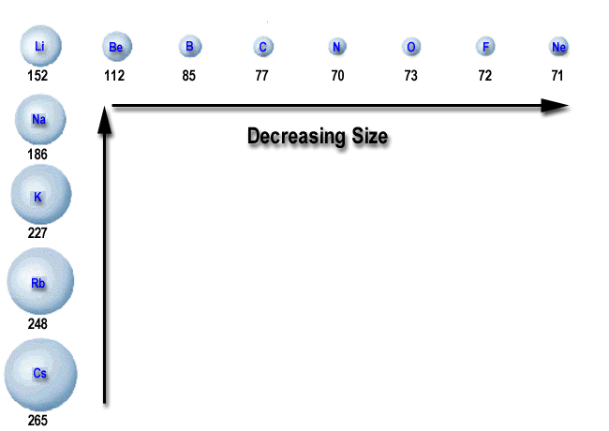 | 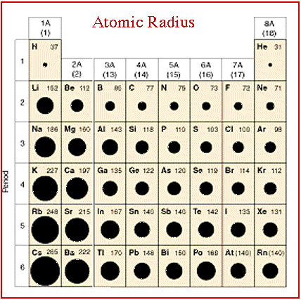
Trends and established values (pm) of atomic radii for various elements

 | Recall: The atomic radii of the atoms follow a classic ‘bottom left → top right’ periodic trend.

Typical Question: Arrange the following atoms in order of increasing atomic radii: Na, Be, Mg.

Questions of this type (as well as for other periodic trends) often select three elements from the periodic table that have a ‘triangular’ relationship. Understanding the classic ‘bottom left → top right’ periodic trend allows for the answer to be determined.
 | Be
Na | Mg

Answer:

1st Ionization Energy

Discussion: What is ionization? What then is 1st ionization energy?

1st Ionization Energy: Energy required to remove the first electron from a gaseous atom or ion.

Example: Sodium

Na (g) → Na⁺ (g) + e⁻ ; I₁ = 496 kJ/mol

Task: Draw electron dot diagrams illustrating this process

Discussion: How do trends in 1st ionization energy of atoms ‘across a row’ and ‘down a column’ in the periodic table vary? Use the following figurse as a guide. Why do you think this is so?

1. ‘Across a Row’

2. ‘Down a Column’

Trends in 1st Ionization Energy

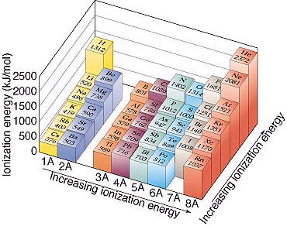 | 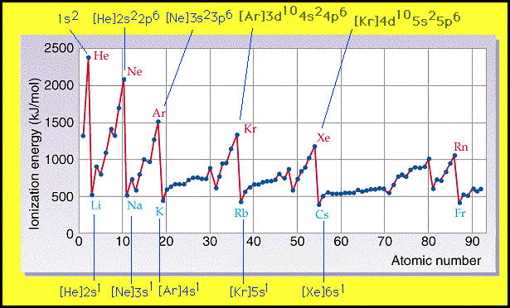
‘Geographical’ map of 1st ionization energy. Note the classic bottom left → top right trend | Line graph of I₁ vs atomic number.

Typical Question: Arrange the following atoms in order of increasing 1st ionization energy: Na, Cs, F, C.

As with similar atomic radii, understanding the classic ‘bottom left → top right’ periodic trend allows for the answer to be determined.

Answer:

