Loose Ends and Final Review

Reading: | Ch 15 sections 1 - 8  (mostly lab review)  Ch 16 sections 1 – 5  (mostly lab review) | Homework: | 15.3 questions 16, 18, 20  15.4 questions 34*, 40  15.5 question 56  16.4 questions 38, 42  16.5 questions 56, 58
* = ‘important’ homework question

Concentration and Dilution Considerations

Recall: The concentration of ANY solution is defined as:

 | Concentration = Molarity (M) = number moles of solute per Liter  of solution

i.e. Molarity = | Moles Solute | Units: mol/L or just M
 | Liters Solution

Where:

SOLUTION = SOLUTE + SOLVENT

Dilutions: If the relationship between concentration of a solution, volume of a solution and moles of solute within the solution is rearranged we arrive at:

Moles = Concentration x Volume or

Moles = CV

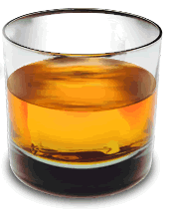 |  | Thought Experiment: After the final, you and a classmate (both over 21, of course!) head out to a bar and order a celebratory whisky and a whisky and soda, respectively. Think about the following questions regarding your beverages:

- Which drink has the largest volume? Why?

- Which drink is ‘stronger’ (most concentrated) in alcohol?

- Which drink contains the most alcohol?

Since both drinks contain one shot of whisky they contain the same # moles of alcohol. Since the whisky and soda has a larger volume (↑), it has a lower concentration (↓) of alcohol – it has been diluted. Mathematically we have:

Moles alcohol = C_{whisky}V_{whisky} = C_{whisk &soda (↓)}V_{whisky &soda (↑)}
or
Moles solute = C_{before}V_{before} = C_{after}V_{after}

 | When ever a solution is diluted, the volume of the resulting solution is greater, while its respective concentration is lower. The moles of solute remain constant. i.e. C_{before}V_{before}= C_{after}V_{after}

Example: What is the concentration of the final solution when 250 mL of D.I. water is added to 125 mL of 0.50 M NaCl (aq) solution?

C_{before} = | C_{after} =
V_{before} = | V_{after} =

The pH Scale

Recall: pH is a measure of the level of acidity (H⁺(aq) concentration) in a solution.
pH ranges: 1 – 6 (acidic), 7 (neutral), 8 – 14 (basic)
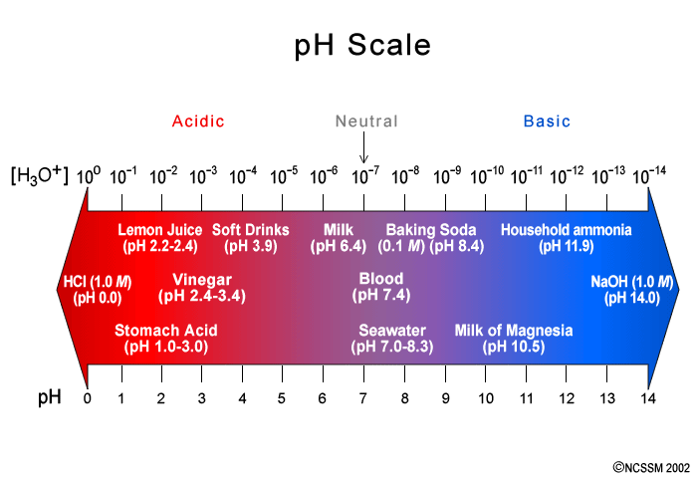

Examine the above figure. What is the simple, yet key, relationship between pH and H₃O⁺ (H⁺) ion concentration?

Observation:

‘EZ’Examples (as found on the final)

A solution has a pH of 8. What is [H⁺] in the solution?

A solution of HCl has an [H⁺] of 1 x 10⁻² M? What is the solution’s pH?

The mathematical relationship used convert between ‘powers’ and ‘regular’ numbers are the log₁₀ and 10^{x} functions on your calculator, eg:

log 1 x10³ = 3, or 10³ = 1 x10³

For the relationship between pH and [H⁺] we have a negative powers of 10, eg:

[H⁺] = 1 x 10⁻³ when pH = 3, so the relationship between the two features a (-) sign:

pH = -log [H⁺] or [H⁺] = 10^{-pH}

‘Harder’ Examples (as found in the HWK)

Problem: You can’t figure out harder examples (see below) like an ‘EZ’ example because there is number other than ‘1’ in front of the ‘x10’ part. In such cases the formula must be used…

What is the pH of a solution that has a [H⁺]value of 3.5 x 10⁻³ M

Key strokes (simple calculator): 3.5 EE +/- 3 then log₁₀ then +/-

Other Assorted ‘Loose Ends’

More ions

We committed a number of ion names and formulas to memory – the anions possess either –ide (mostly atomic anions, such as chloride, Cl⁻) or –ate (molecular anions, such as SO₄²⁻, sulfate) suffixes. There are also many ‘in between’ molecular anions containing fewer, or occasionally more, oxygen atoms than the -ate ions. For example (from p 142):

Ion formula | Name or ion
Cl⁻ | chloride
ClO⁻ | Hypochlorite
ClO₂⁻ | Chlorite
ClO₃⁻ | Chlorate
ClO₄⁻ | Perchlorate

The above table is worth memorizing, as there is likely to be one or two questions on the final regarding the ‘in between’ molecular anions of oxygen and chlorine.

Example: Lithium chlorite has the formula:

a. | LiClO | d. | LiClO₄
b. | LiClO₃ | e. | LiCl
c. | LiClO₂

Solubility

A solubility chart will NOT be provided for final, although you will have access to a periodic table. This is not a problem, however, as there are only two basic facts to remember:

Chlorides are mostly soluble - AgCl(s) is an important exception
Sulfates are mostly soluble – BaSO₄ (s) is an important exception

Use the above information to answer solubility questions on the final

Percent Composition

We looked at this topic at the beginning of the empirical formulas work, but did not study it in isolation. There is likely to be a dedicated % composition question on your final, however, so some review of this work is worthwhile.

Try and work through this question in groups or individually. Pay particular attention to the math you use to work out the answer:

 | If Dr. Phil weighs 250 pounds and his head alone weighs 25 pounds, then what % by mass (% composition or mass percent) is Dr. Phil’s head of his entire body?

In chemistry we do a very similar thing, but for molecules and formula units. This is called finding the % composition or mass percent

Example: What is the correct mass percent for each type of atom in Al₂O₃?

a. | 47% Al 53% O | d. | 84% Al 16% O
b. | 53% Al 47% O | e. | none of the above
c. | 26% Al 74% O

Final Exam Review

Information

Your Final exam is a comprehensive, 70 question multiple choice (a – e) test. Questions are graded as either correct or incorrect. No points are subtracted for wrong guesses. There are two versions of the test, so your neighbors will have a different test.
I normalize your final exam score out of 70 to a score out of 200. This score out of 200 is included in your final course total.

Tips

The questions you will encounter are not, typically, ‘super hard’. During the course I have concentrated on more challenging type questions that require you to hone your problem solving skills.

Due to the number of questions set and the time allowed, most of the multiple choice questions you will meet on the final may be considered to be ‘lite’ versions of my midterm and quiz questions. The following tips will help you record a better score on your final:

- The test is cumulative, so review everything we have covered since the beginning for the course.

- Review all the topics, but concentrate on topics you have had difficulty with. Since the questions are not ‘super hard’, this will increase your number of correct answers. Do not fall in to the trap of studying what you are good at (you’ll get those questions right regardless, most likely), so preferentially study what you are ‘bad’ at.

- Try to answer the questions in order when using a scantron sheet. It is better to guess a wrong answer (and then come back to it) than risk systematically filling out ovals ‘a line out’.

- Work out the answers on the scratch paper provided, then check the possible answers provided. This will cut down on ‘red herring’ type errors (see below)

- Watch out for obvious ‘red herrings’, as illustrated by the following example. MOST questions DO NOT have a red herring, but a reasonable fraction do:

Example: CO is the formula for:

a. | copper | d. | Monocarbon monoxide
b. | carbon monoxide | e. | None of the above
c. | cobalt

Sample Final Exam Questions

1. The correct formula for magnesium oxide is:

a. | MgO₂ | d. | Mg₃O₂
b. | Mg₂O₃ | e. | None of the above
c. | MgO

2. A solution has [H⁺] = 1 x 10⁻⁸ M, the pH of the solution is:

a. | 4 | d. | 8
b. | 0 | e. | None of the above
c. | -8

3. Which of the following is a non-metal?

a. | nitrogen | d. | calcium
b. | lithium | e. | None of the above
c. | iron

4. Which of the following compounds is not a salt:

a. | NaOH | d. | NaNO₃
b. | NaCl | e. | None of the above
c. | Al(ClO₄)₃
5. What is the mass of 10.0 moles of He:

a. | 4.00 g | d. | 6.02 x10²³ g
b. | 8.00 g | e. | None of the above
c. | 40.0 g

6. A 24.0 g sample of carbon contains how many atoms:

a. | 6.02 x10²³ | d. | 2.04 x10²⁴
b. | 1.20 x10²⁴ | e. | None of the above
c. | 3.01 x10²³

7. The electronic configuration for the Ca atom is:

a. | 1s²2s²2p⁶3s²3p⁶4s²3d² | d. | 1s²2s²2p⁶3s²3p⁶4s²3d¹⁰4p²
b. | 1s²2s²2p⁶3s² | e. | None of the above
c. | 1s²2s²2p⁶3s²3p⁶4s²

8. Two moles of any gas will occupy what volume at STP?

a. | 22.4 L | d. | 44.8 L
b. | 11.2 L | e. | None of the above
c. | 4.48 L

9. An example of a physical change is:
a. | The rusting of iron | d. | All of the above
b. | The burning of wood | e. | None of the above
c. | The melting of ice

10. The number 0.000125 expressed in Scientific notation is:

a. | 1.25 x10⁴ | d. | 12.5 x10⁻³
b. | 125 | e. | 12.5 x10³
c. | 1.25 x10⁻⁴
Answers:
1. | c. | 6. | b.
2. | d. | 7. | c.
3. | a. | 8. | d.
4. | a. | 9. | c.
5. | c. | 10. | c.

Post-Final Wrap Up

General chemistry final exams are graded immediately after they have been completed by the students. The final exam scores (out of 200), as well as overall course scores and letter grades, will be available from 10:00 am on Thursday of exam week. Students can check their scores by sending Dr. Mills an e-mail request at any time before noon on Thursday of exam week. In order to ensure confidentiality, students requesting such feedback must include the following code word(s) within their e-mail requests:

So Close, Yet so Far?

Unfortunately, it is sometimes the case that students find themselves just a few points below the C/D (55%) cut-off line after the completion of all course materials. In order for such students to achieve a passing ‘C’ grades, an optional 25 pt. extra credit assignment may be completed. Students may only complete this assignment if they are in good academic standing (no more than one missed quiz, exam or lab; plus no more than 3 extra credit deductions for lateness, texting etc.) and contact Dr. Mills, via e-mail with a grade request, no later than noon on Thursday of exam week. Such students’ final scores must have fallen no more than 25 points below the C/D cut-off in order for them to be eligible to take the assignment.

Dr. Mills will supply qualifying students with a copy of the extra credit assignment, as an e-mail attachment, via return e-mail. The hard deadline for completing this assignment is 10:00 am on Friday of exam week – no exceptions.

